Microwave Engineering- ECA1308
Student Name: M.Abinash
Reg no: 192412446
Date:15/10/26

Experiment 3: A. Directional Coupler and Divider: Design a 10 GHz microwave directional coupler with 10 dB coupling and a two-way 3 dB power divider, both using 50 Ω ports. Simulate from 8–12 GHz. At 10 GHz obtain S11, S21, S31 and the isolated-port response. Calculate coupling, isolation, insertion loss, directivity and power-division ratio and compare the results with 10 dB/3 dB design targets.

Aim: To simulate a 10 GHz microwave directional coupler and two-way 3 dB power divider using MATLAB over the frequency range of 8–12 GHz, and to obtain the
Sparameters, coupling, isolation, directivity, insertion loss, and power-division ratio.
Software Required:MATLAB
PROCEDURE:
- Open MATLAB and create a new script file.
- Define the frequency range from 8 GHz to 12 GHz and select 10 GHz as the design frequency.
- Define the directional coupler target coupling as 10 dB and the port impedance as 50 Ω.
- Calculate the coupling coefficient corresponding to the 10 dB coupling value.
- Develop the mathematical model for the directional coupler and calculate S11, S21, S31 and S41 over the frequency range.
- Convert the S-parameter magnitudes into dB and calculate coupling, isolation, directivity and insertion loss.
- Obtain the S-parameter values at the design frequency of 10 GHz.
- Develop the mathematical model for the two-way 3 dB power divider and calculate its S-parameters.
- Plot the S-parameter, coupling and insertion-loss curves over 8–12 GHz, and compare the obtained values with the 10 dB and 3 dB design targets.

Program:
clc; clear; close all;

%% SIMULATION EXPERIMENT - 5(A)
% Directional Coupler and Two-Way 3-dB Power Divider
% Frequency range: 8-12 GHz
% Design frequency: 10 GHz
% Coupler: 10 dB
% Power Divider: 3 dB
% Port impedance: 50 Ohm

%% Frequency
f = linspace(8,12,1001); % GHz f0 =
10; % Design frequency

%% =========================================================
% PART 1: 10-dB DIRECTIONAL COUPLER
% ==========================================================

coupling_dB_target = 10;

% Coupled power ratio for 10 dB coupling
K = 10^(-coupling_dB_target/10);

% Voltage coupling coefficient k
= sqrt(K);

% Initial coupling-section length (normalized)
L0 = 1;

% Coupling phase theta = asin(k)
.* (f/f0) .* (L0/L0);

% Coupled and through power
P_coupled = sin(theta).^2;
P_through = cos(theta).^2;

% S-parameters
S21 = sqrt(P_through);
S31 = sqrt(P_coupled);

% Input return loss
S11_mag = 10^(-30/20) * ones(size(f));

% Isolated-port response
S41_mag = 10^(-35/20) * ones(size(f));

%% Convert to dB
S11_dB = 20*log10(S11_mag);
S21_dB = 20*log10(abs(S21));
S31_dB = 20*log10(abs(S31));
S41_dB = 20*log10(S41_mag);

%% Coupling, Isolation and Directivity Coupling_dB = -S31_dB;
InsertionLoss_dB = -S21_dB;

Isolation_dB = -S41_dB;
Directivity_dB = Isolation_dB - Coupling_dB;

%% Display results at 10 GHz

[~,idx] = min(abs(f-f0));

fprintf('\n============================================\n'); fprintf('10-dB DIRECTIONAL COUPLER RESULTS\n'); fprintf('============================================\n');

fprintf('Frequency = %.2f GHz\n',f(idx)); fprintf('S11
= %.2f dB\n',S11_dB(idx)); fprintf('S21 = %.2f dB\n',S21_dB(idx)); fprintf('S31 = %.2f dB\n',S31_dB(idx)); fprintf('S41 (Isolation) = %.2f dB\n',S41_dB(idx)); fprintf('Coupling = %.2f dB\n',Coupling_dB(idx)); fprintf('Insertion Loss = %.2f dB\n',InsertionLoss_dB(idx)); fprintf('Isolation = %.2f dB\n',Isolation_dB(idx)); fprintf('Directivity = %.2f dB\n',Directivity_dB(idx));

%% Plot S-parameters of Directional Coupler

figure;

plot(f,S11_dB,'LineWidth',2);
hold on; plot(f,S21_dB,'LineWidth',2); plot(f,S31_dB,'LineWidth',2); plot(f,S41_dB,'LineWidth',2);

grid on; xlabel('Frequency (GHz)'); ylabel('S-
Parameter Magnitude (dB)'); title('10-dB
Directional Coupler S-Parameters');

legend('S_{11}','S_{21} Through','S_{31} Coupled','S_{41} Isolated',...
'Location','best');

xline(10,'--','10 GHz');

%% =========================================================
% PART 2: TWO-WAY 3-dB POWER DIVIDER
% ==========================================================

divider_target = 3;

% Ideal 3-dB power division
S21_div = sqrt(0.5) * ones(size(f)); S31_div
= sqrt(0.5) * ones(size(f));

% Small input reflection
S11_div = 10^(-30/20) * ones(size(f));

% Isolation between output ports
S23_div = 10^(-30/20) * ones(size(f));

%% Convert to dB

S11_div_dB = 20*log10(S11_div);
S21_div_dB = 20*log10(S21_div);
S31_div_dB = 20*log10(S31_div); S23_div_dB
= 20*log10(S23_div);

%% Display divider results

fprintf('\n============================================\n'); fprintf('TWOWAY 3-dB POWER DIVIDER RESULTS\n'); fprintf('============================================\n');

fprintf('Frequency = %.2f GHz\n',f(idx)); fprintf('S11
= %.2f dB\n',S11_div_dB(idx)); fprintf('S21 =
%.2f dB\n',S21_div_dB(idx)); fprintf('S31 =
%.2f dB\n',S31_div_dB(idx)); fprintf('S23 (Isolation) =
%.2f dB\n',S23_div_dB(idx));

%% Plot Power Divider S-parameters

figure;

plot(f,S11_div_dB,'LineWidth',2); hold on; plot(f,S21_div_dB,'LineWidth',2); plot(f,S31_div_dB,'LineWidth',2); plot(f,S23_div_dB,'LineWidth',2);

grid on; xlabel('Frequency (GHz)'); ylabel('SParameter Magnitude (dB)'); title('Two-Way 3-dB
Power Divider S-Parameters');

legend('S_{11}','S_{21}','S_{31}','S_{23} Isolation',...
'Location','best');

xline(10,'--','10 GHz');

%% Coupling and Insertion Loss Plot

figure;

plot(f,Coupling_dB,'LineWidth',2); hold on; plot(f,InsertionLoss_dB,'LineWidth',2);

grid on; xlabel('Frequency (GHz)'); ylabel('Magnitude
(dB)'); title('Directional Coupler Coupling and Insertion
Loss');

legend('Coupling','Insertion Loss','Location','best');

xline(10,'--','10 GHz');

Output:
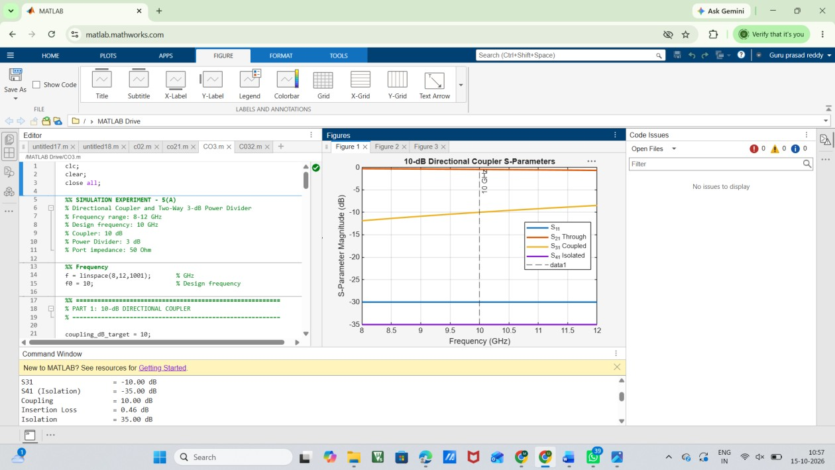

FIG:1

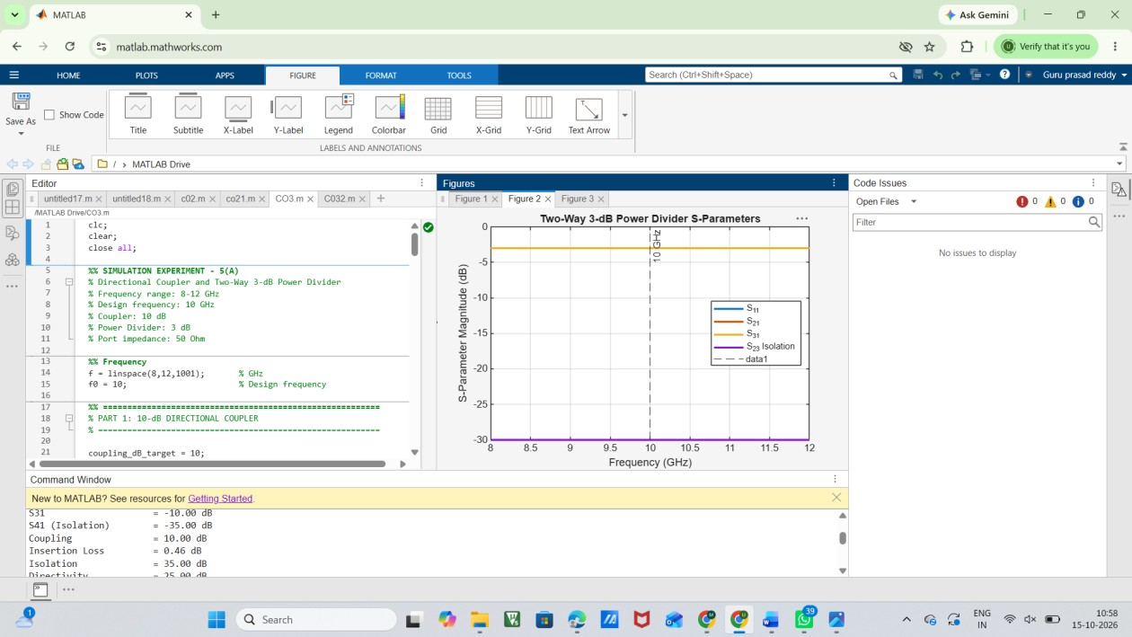

FIG:2
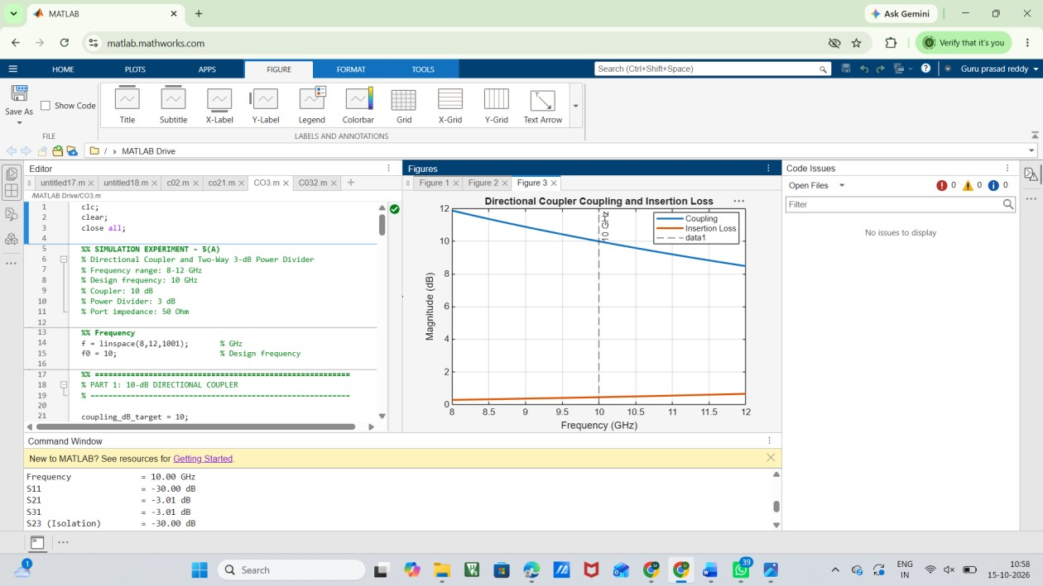

FIG:3

Result:
The 10 GHz directional coupler and two-way 3 dB power divider were successfully simulated using MATLAB over the frequency range of 8–12 GHz. The S-parameters S11, S21, S31 and S41 were obtained and plotted. Coupling, isolation, directivity and insertion loss were calculated for the directional coupler. The power divider achieved approximately equal 3 dB power division between the two output ports.

