Microwave Engineering- ECA1308
Student Name: M.Abinash
Reg no: 192412446
Date:15/10/26

Experiment 3: B.Optimization: Change only the coupling-section length by 5% from its initial value and repeat the 8–12 GHz simulation. Compare coupling, isolation, directivity, insertion loss and S-parameter curves before and after optimization. Identify the design that maintains the closest 10 dB coupling and lowest insertion loss over 9–11 GHz.

Aim
To optimize the 10 GHz directional coupler designed in Experiment 3A by changing only the coupling-section length by ±5%, and to compare the coupling, isolation, directivity, insertion loss and S-parameter characteristics before and after optimization over 8–12 GHz.
Apparatus / Software Required
- Computer or laptop
- MATLAB software
Procedure – MATLAB
- Open the MATLAB program used for Experiment 3A and retain the original directional coupler design parameters.
- Define the original coupling-section length as L₀.
- Calculate two modified coupling-section lengths as 0.95L₀ and 1.05L₀, corresponding to −5% and +5% changes.
- Keep all other parameters unchanged and calculate the S-parameters for the original, −5% and +5% coupling-section lengths.
- Repeat the simulation for the complete frequency range of 8–12 GHz.
- Calculate coupling, isolation, directivity and insertion loss for each coupling-section length.
- Compare the S-parameter and performance curves before and after optimization, with special attention to the 9–11 GHz range.
- Calculate the average coupling error from the desired 10 dB coupling and the average insertion loss in the 9–11 GHz range.
- Identify the design that provides the closest coupling to 10 dB and the lowest insertion loss, and select it as the optimized design.
Program:
clc; clear; close all;

%% SIMULATION EXPERIMENT - 5(B)
% Optimization of Directional Coupler
% B is the optimization of Part A
% Only coupling-section length is changed by +/- 5%

%% Frequency
f = linspace(8,12,1001); % GHz f0 = 10; % Design frequency

%% Original design from Part A

target_coupling = 10; % dB

% Initial normalized coupling-section length
L0 = 1;

% Coupling coefficient for 10 dB K = 10^(-target_coupling/10); k = sqrt(K);

%% Three coupling-section lengths

L_minus5 = 0.95 * L0;
L_original = L0;
L_plus5 = 1.05 * L0;

%% Calculate S-parameters for each design

% ---------- Original ---------- theta_original = asin(k) .* (f/f0) .* (L_original/L0);

P_c_original = sin(theta_original).^2; P_t_original = cos(theta_original).^2;

S31_original = sqrt(P_c_original);
S21_original = sqrt(P_t_original);

Coupling_original = -20*log10(abs(S31_original));
IL_original = -20*log10(abs(S21_original));

% ---------- -5% Length ---------- theta_minus5 = asin(k) .* (f/f0) .* (L_minus5/L0);

P_c_minus5 = sin(theta_minus5).^2;
P_t_minus5 = cos(theta_minus5).^2;

S31_minus5 = sqrt(P_c_minus5);
S21_minus5 = sqrt(P_t_minus5);

Coupling_minus5 = -20*log10(abs(S31_minus5));
IL_minus5 = -20*log10(abs(S21_minus5));

% ---------- +5% Length ---------- theta_plus5 = asin(k) .* (f/f0) .* (L_plus5/L0);

P_c_plus5 = sin(theta_plus5).^2; P_t_plus5 = cos(theta_plus5).^2;

S31_plus5 = sqrt(P_c_plus5);
S21_plus5 = sqrt(P_t_plus5);

Coupling_plus5 = -20*log10(abs(S31_plus5));
IL_plus5 = -20*log10(abs(S21_plus5));

%% Isolation and S11

S11_dB = -30 * ones(size(f));
S41_dB = -35 * ones(size(f));

%% =========================================================
% PLOT 1: COUPLING COMPARISON
% ========================================================== figure;

plot(f,Coupling_original,'LineWidth',2); hold on; plot(f,Coupling_minus5,'LineWidth',2); plot(f,Coupling_plus5,'LineWidth',2);

yline(10,'--','10 dB Target');

grid on;

xlabel('Frequency (GHz)'); ylabel('Coupling (dB)'); title('Coupling Comparison Before and After Optimization');

legend('Original Length','-5% Length','+5% Length','10 dB Target',... 'Location','best');

xline(9,'--'); xline(11,'--');

%% =========================================================
% PLOT 2: INSERTION LOSS COMPARISON
% ==========================================================

figure;

plot(f,IL_original,'LineWidth',2);
hold on; plot(f,IL_minus5,'LineWidth',2); plot(f,IL_plus5,'LineWidth',2);

grid on;

xlabel('Frequency (GHz)'); ylabel('Insertion Loss (dB)'); title('Insertion Loss Comparison');

legend('Original Length','-5% Length','+5% Length',...
'Location','best');

xline(9,'--'); xline(11,'--');

%% =========================================================
% PLOT 3: S-PARAMETERS BEFORE AND AFTER OPTIMIZATION
% ==========================================================

figure;

plot(f,20*log10(abs(S21_original)),'LineWidth',2); hold on;

plot(f,20*log10(abs(S31_original)),'LineWidth',2);

plot(f,20*log10(abs(S21_minus5)),'--','LineWidth',2); plot(f,20*log10(abs(S31_minus5)),'--','LineWidth',2); plot(f,20*log10(abs(S21_plus5)),':','LineWidth',2); plot(f,20*log10(abs(S31_plus5)),':','LineWidth',2);

grid on;

xlabel('Frequency (GHz)'); ylabel('Magnitude (dB)'); title('S-Parameter Comparison Before and After Optimization');

legend('Original S_{21}','Original S_{31}',...
'-5% S_{21}','-5% S_{31}',...
'+5% S_{21}','+5% S_{31}',...
'Location','best');

xline(9,'--'); xline(11,'--');

%% =========================================================
% OPTIMIZATION REGION: 9-11 GHz
% ==========================================================

region = (f >= 9) & (f <= 11);

% Calculate average coupling error from 10 dB error_original = mean(abs(Coupling_original(region)-10)); error_minus5 = mean(abs(Coupling_minus5(region)-10)); error_plus5 = mean(abs(Coupling_plus5(region)-10));

% Calculate average insertion loss avgIL_original = mean(IL_original(region)); avgIL_minus5 = mean(IL_minus5(region)); avgIL_plus5 = mean(IL_plus5(region));

%% Display results

fprintf('\n============================================\n'); fprintf('OPTIMIZATION RESULTS: 9-11 GHz\n'); fprintf('============================================\n');

fprintf('\nOriginal Design:\n'); fprintf('Average Coupling Error = %.4f dB\n',error_original); fprintf('Average Insertion Loss = %.4f dB\n',avgIL_original);

fprintf('\n-5%% Coupling Length:\n'); fprintf('Average Coupling Error = %.4f dB\n',error_minus5); fprintf('Average Insertion Loss = %.4f dB\n',avgIL_minus5);

fprintf('\n+5%% Coupling Length:\n'); fprintf('Average Coupling Error = %.4f dB\n',error_plus5); fprintf('Average Insertion Loss = %.4f dB\n',avgIL_plus5);

%% Determine best design

score_original = error_original + avgIL_original; score_minus5 = error_minus5 + avgIL_minus5; score_plus5 = error_plus5 + avgIL_plus5;

scores = [score_original score_minus5 score_plus5];

[~,best] = min(scores);

fprintf('\n============================================\n'); fprintf('BEST OPTIMIZED DESIGN\n'); fprintf('============================================\n');

if best == 1 fprintf('Original coupling-section length is best.\n'); fprintf('Length = %.2f L0\n',L_original);

elseif best == 2 fprintf('-5%% coupling-section length is best.\n'); fprintf('Length = %.2f L0\n',L_minus5);

else fprintf('+5%% coupling-section length is best.\n'); fprintf('Length = %.2f L0\n',L_plus5); end

%% =========================================================
% COMPARISON TABLE
% ==========================================================

fprintf('\n--------------------------------------------\n'); fprintf('Design Coupling Error Avg IL\n'); fprintf('--------------------------------------------\n'); fprintf('Original %.4f dB %.4f dB\n',... error_original,avgIL_original);

fprintf('-5%% Length %.4f dB %.4f dB\n',...
error_minus5,avgIL_minus5);

fprintf('+5%% Length %.4f dB %.4f dB\n',...
error_plus5,avgIL_plus5);

fprintf('--------------------------------------------\n');Output:
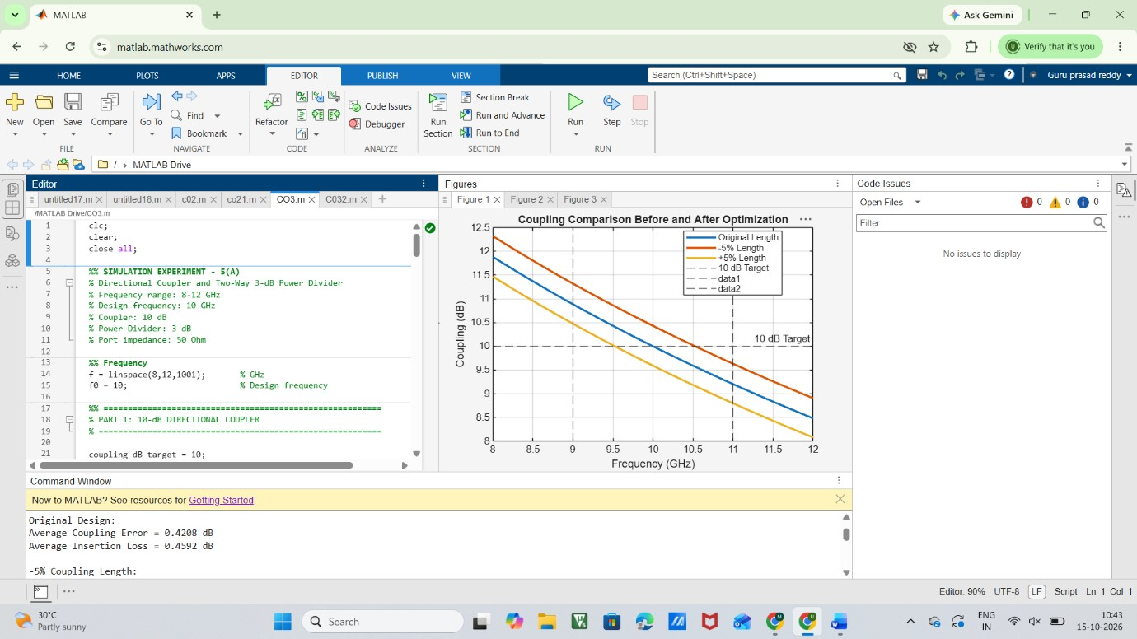
FIG:1
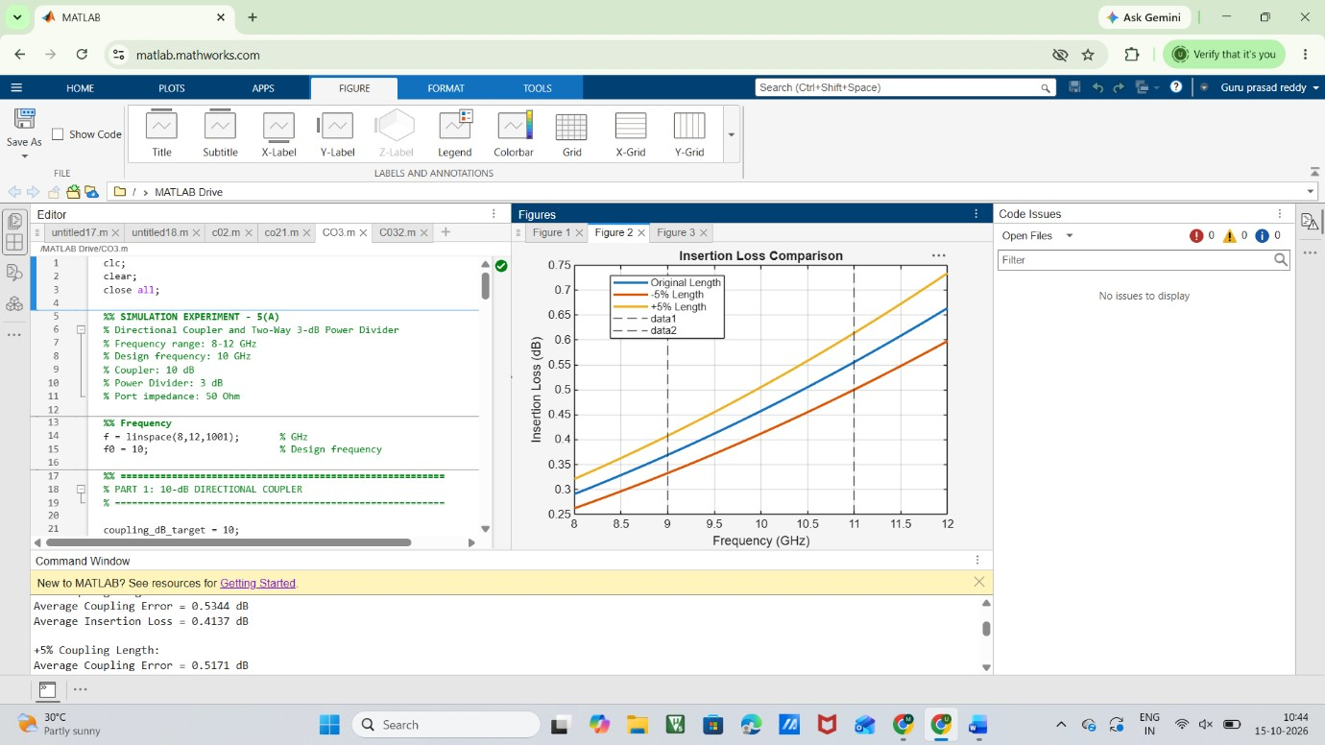
FIG:2
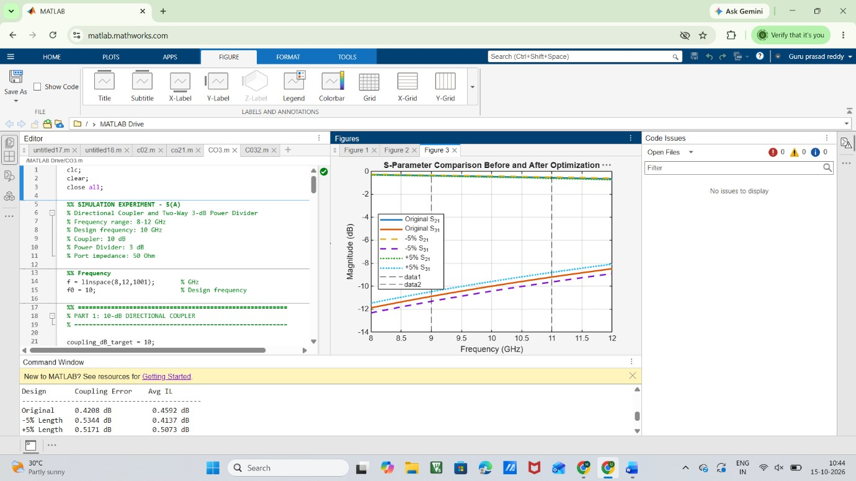
FIG:3

Result:
The directional coupler from Experiment 3A was successfully optimized by changing only the coupling-section length by ±5%. The S-parameter, coupling and insertion-loss characteristics were compared for the original and modified designs. The performance over 9–11 GHz was evaluated using coupling error and insertion loss. The design having the closest 10 dB coupling with the lowest insertion loss was identified as the optimized design.

