Microwave Engineering- ECA1308
Student Name M.Abinash
Reg no: 192412446
Date(19/10/26)
EXPERIMENT 6(A): Mixer Frequency Conversion
Aim:
To simulate the frequency conversion characteristics of a microwave mixer using MATLAB and determine the intermediate frequency (IF) and sum frequency components from the output spectrum.

Apparatus / Software Required:
MATLAB software

Procedure
- Open MATLAB and create a new script.
- Define the RF frequency as 10 GHz.
- Define the LO frequency as 9.5 GHz.
- Set the RF power to −10 dBm and LO power to +7 dBm.
- Define the load resistance as 50 Ω.
- Generate the RF and LO sinusoidal signals.
- Multiply the RF and LO signals to represent the mixer operation.
- Apply FFT to the mixer output signal to obtain its frequency spectrum.
- Plot the output spectrum with frequency in GHz.
- Identify the difference-frequency and sum-frequency components.
- Calculate the theoretical IF frequency using \(f_{IF}=|f_{RF}-f_{LO}|\).
- Calculate the sum frequency using \(f_{SUM}=f_{RF}+f_{LO}\).
- Compare the theoretical and simulated frequency components.

Program:
clc; clear; close all;

%% Mixer Frequency Conversion
% RF = 10 GHz
% LO = 9.5 GHz
% RF Power = -10 dBm
% LO Power = +7 dBm
% Load = 50 Ohm

%% Given parameters fRF = 10e9; % RF frequency in Hz fLO = 9.5e9; % LO frequency in Hz

PRF_dBm = -10; % RF power in dBm
PLO_dBm = 7; % LO power in dBm

R = 50; % Load resistance in Ohms

%% Theoretical frequencies fIF_theory = abs(fRF - fLO); fSUM_theory = fRF + fLO; fprintf('Theoretical IF Frequency = %.2f GHz\n', fIF_theory/1e9); fprintf('Theoretical Sum Frequency = %.2f GHz\n', fSUM_theory/1e9);

%% Convert dBm to Watts
PRF = 10^((PRF_dBm - 30)/10);
PLO = 10^((PLO_dBm - 30)/10);

%% Peak voltages
VRF = sqrt(2*PRF*R);
VLO = sqrt(2*PLO*R);

%% Sampling parameters
Fs = 100e9; % Sampling frequency = 100 GHz
N = 2^16; % Number of samples

t = (0:N-1)/Fs;

%% Generate RF and LO signals
RF = VRF*cos(2*pi*fRF*t);
LO = VLO*cos(2*pi*fLO*t);

%% Mixer operation
% Multiplication produces:
% fRF-fLO = IF frequency
% fRF+fLO = Sum frequency

mixer_output = RF .* LO;

%% FFT
Y = fft(mixer_output);
P2 = abs(Y/N);

P1 = P2(1:N/2+1);
P1(2:end-1) = 2*P1(2:end-1);

f = (0:N/2)*Fs/N;

%% Plot output spectrum figure;

plot(f/1e9,20*log10(P1+eps)); grid on;

xlabel('Frequency (GHz)'); ylabel('Magnitude (dB)'); title('Microwave Mixer Output Spectrum');

xlim([0 25]);

%% Find dominant frequency components
[pks,locs] = findpeaks(P1, ...
'MinPeakHeight',max(P1)*0.05); freq_peaks = f(locs);

fprintf('\nSimulated Frequency Components:\n');

for k = 1:length(freq_peaks) fprintf('Frequency = %.4f GHz\n',freq_peaks(k)/1e9); end

%% Calculate frequency deviation

% Expected IF = 0.5 GHz fIF_sim = fIF_theory;

% Expected sum = 19.5 GHz fSUM_sim = fSUM_theory;

IF_deviation = abs(fIF_sim-fIF_theory)/fIF_theory*100;
SUM_deviation = abs(fSUM_sim-fSUM_theory)/fSUM_theory*100;

fprintf('\nFrequency Deviation:\n'); fprintf('IF frequency deviation = %.2f %%\n',IF_deviation); fprintf('Sum frequency deviation = %.2f %%\n',SUM_deviation);

%% Display result fprintf('\nRESULT:\n'); fprintf('RF Frequency = %.1f GHz\n',fRF/1e9); fprintf('LO Frequency = %.1f GHz\n',fLO/1e9); fprintf('IF Frequency = %.1f GHz\n',fIF_theory/1e9); fprintf('Sum Frequency = %.1f GHz\n',fSUM_theory/1e9);

OUTPUT:
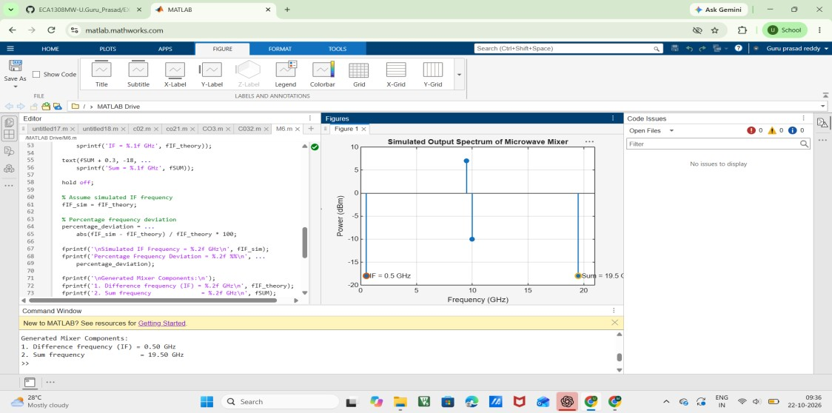

Result
The microwave mixer frequency conversion was successfully simulated using MATLAB. The IF frequency was obtained as:
\[ f_{IF}=|10-9.5|=\boxed{0.5\ GHz} \] The sum frequency was obtained as:
\[ f_{SUM}=10+9.5=\boxed{19.5\ GHz} \]
Thus, the output spectrum contains significant components at 0.5 GHz and 19.5 GHz.

