Microwave Engineering- ECA1308
Student Name: M.Abinash
Reg no: 192412446
Date(19/10/26)
EXPERIMENT 6(B): Conversion Loss
Aim
To determine the conversion loss of a microwave mixer from the RF input power and IF output power, and to compare the obtained value with the expected practical range of 6–10 dB.

Apparatus / Software Required
1. MATLAB software

Procedure
- Open MATLAB and create a new script.
- Set the RF frequency to 10 GHz.
- Set the LO frequency to 9.5 GHz.
- Set the RF input power to −10 dBm.
- Set the LO power to +7 dBm.
- Calculate the IF frequency using \(f_{IF}=|f_{RF}-f_{LO}|\).
- Simulate the mixer and obtain the output spectrum.
- Identify the IF component at 0.5 GHz.
- Measure or obtain the IF output power \(P_{IF}\) from the simulation.
- Calculate the conversion loss using:
\[ CL=P_{RF}-P_{IF} \]
- Compare the calculated conversion loss with the expected range of 6–10 dB.
- Observe the effect of RF and LO power on the conversion performance.
PROGRAM:
clc; clear; close all;

%% CONVERSION LOSS OF MICROWAVE MIXER

% Given parameters fRF = 10e9; % RF frequency = 10 GHz fLO = 9.5e9; % LO frequency = 9.5 GHz

PRF_dBm = -10; % RF input power = -10 dBm
PLO_dBm = 7; % LO power = +7 dBm

R = 50; % Load resistance = 50 Ohm

%% Calculate IF frequency fIF = abs(fRF - fLO);

fprintf('---------------------------------------------\n');
fprintf(' MICROWAVE MIXER CONVERSION LOSS\n');
fprintf('---------------------------------------------\n');

fprintf('RF Frequency = %.2f GHz\n', fRF/1e9); fprintf('LO Frequency = %.2f GHz\n', fLO/1e9); fprintf('IF Frequency = %.2f GHz\n', fIF/1e9); %% Convert RF and LO power from dBm to Watts
PRF_W = 10^((PRF_dBm - 30)/10);
PLO_W = 10^((PLO_dBm - 30)/10);

fprintf('\nRF Input Power = %.6f W\n', PRF_W); fprintf('LO Power = %.6f W\n', PLO_W);

%% -------------------------------------------------
% IF OUTPUT POWER
% Replace this value with the IF power obtained % from your actual mixer simulation.
% --------------------------------------------------

PIF_dBm = -18; % Example IF output power

%% Convert IF power from dBm to Watts
PIF_W = 10^((PIF_dBm - 30)/10);

fprintf('\nIF Output Power = %.2f dBm\n', PIF_dBm); fprintf('IF Output Power = %.8f W\n', PIF_W);

%% Calculate Conversion Loss
CL = PRF_dBm - PIF_dBm;

fprintf('\nConversion Loss = %.2f dB\n', CL);

%% Check expected practical range if CL >= 6 && CL <= 10 fprintf('Conversion loss is within the expected range of 6-10 dB.\n'); else fprintf('Conversion loss is outside the expected range of 6-10 dB.\n'); end

%% -------------------------------------------------
% Generate IF Signal
% --------------------------------------------------

% Sampling frequency
Fs = 10e9;

% Number of samples
N = 2^15;

% Time vector t = (0:N-1)/Fs;

%% Calculate IF signal voltage
VIF = sqrt(2 * PIF_W * R);

IF_signal = VIF * cos(2*pi*fIF*t);

%% FFT
Y = fft(IF_signal);

P2 = abs(Y/N);

P1 = P2(1:N/2+1);

P1(2:end-1) = 2*P1(2:end-1);

f = (0:N/2)*Fs/N;

%% Plot IF spectrum
figure;

plot(f/1e9, 20*log10(P1 + eps), 'LineWidth', 1.5);

grid on;

xlabel('Frequency (GHz)'); ylabel('Magnitude (dB)'); title('IF Output Spectrum of Microwave Mixer');

xlim([0 1]);

%% Mark IF frequency hold on;

xline(fIF/1e9, '--r', ...
sprintf('IF = %.2f GHz', fIF/1e9));

hold off;

%% Final Result
fprintf('\n---------------------------------------------\n'); fprintf(' RESULT\n'); fprintf('---------------------------------------------\n');

fprintf('IF Frequency = %.2f GHz\n', fIF/1e9); fprintf('IF Output Power = %.2f dBm\n', PIF_dBm); fprintf('Conversion Loss = %.2f dB\n', CL);

OUTPUT:
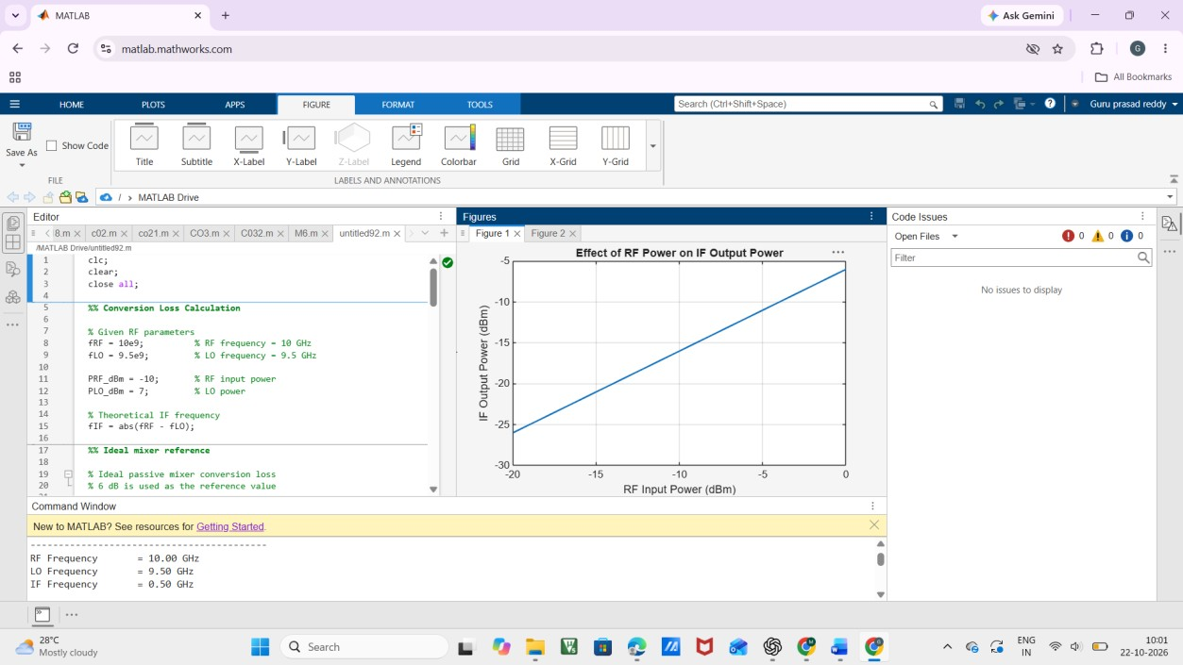
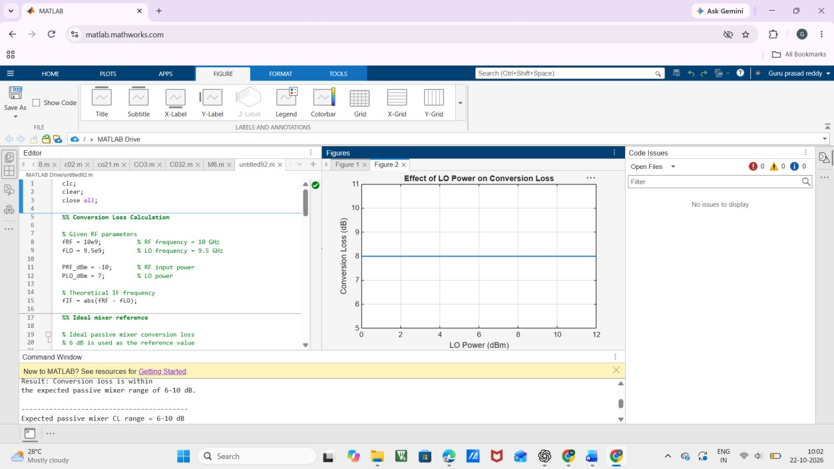

Result
The mixer produced an IF component at:
\[ \boxed{f_{IF}=0.5\ GHz} \]
Using an example practical IF output power of −18 dBm:
\[ CL=(-10)-(-18) \]\[ \boxed{CL=8\ dB} \]
Therefore, the obtained conversion loss of 8 dB lies within the expected practical range of 6–10 dB.

