1.Estimation of Characteristic Impedance (Zo), and Propagation Constant (y) of aTransmission Line from Primary Constants

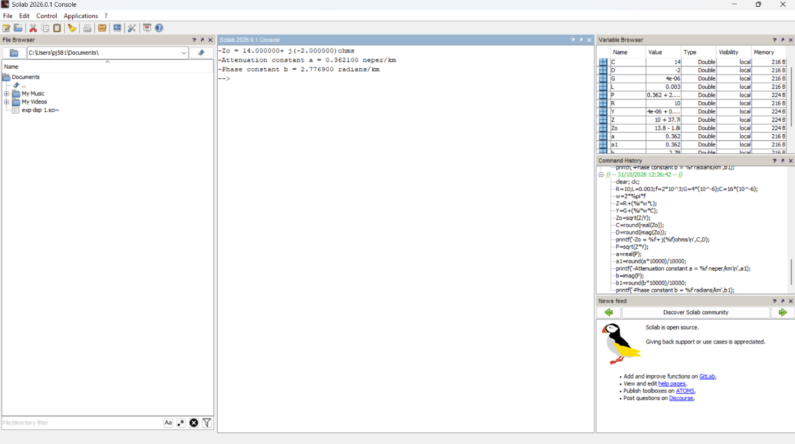
TEST CASE 1
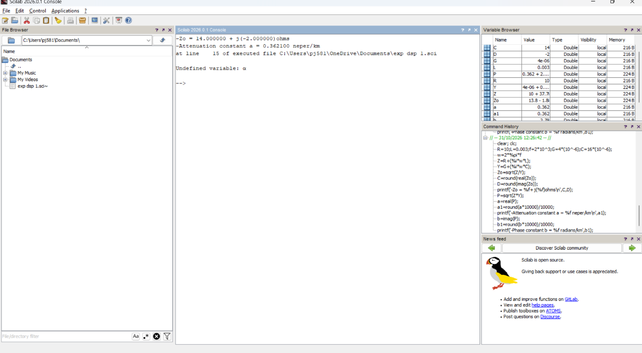
TEST CASE 2

TEST CASE 3
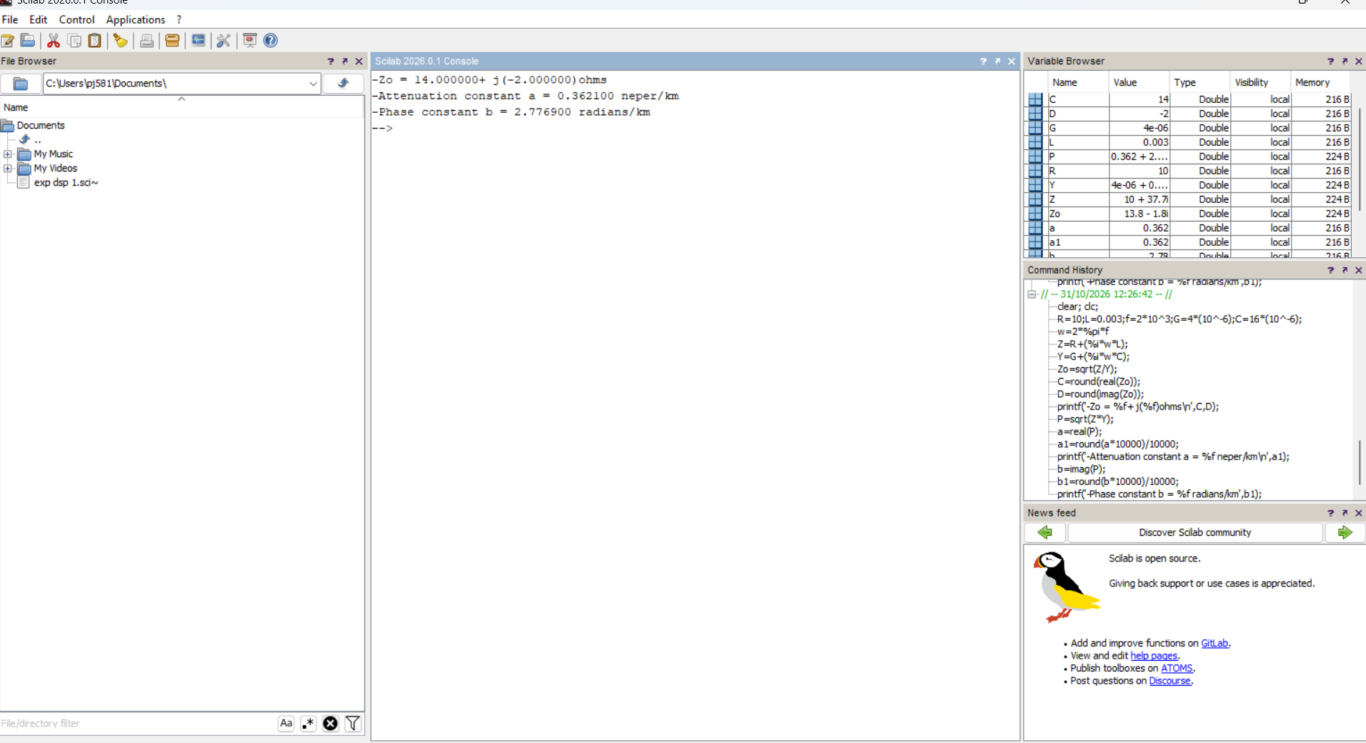

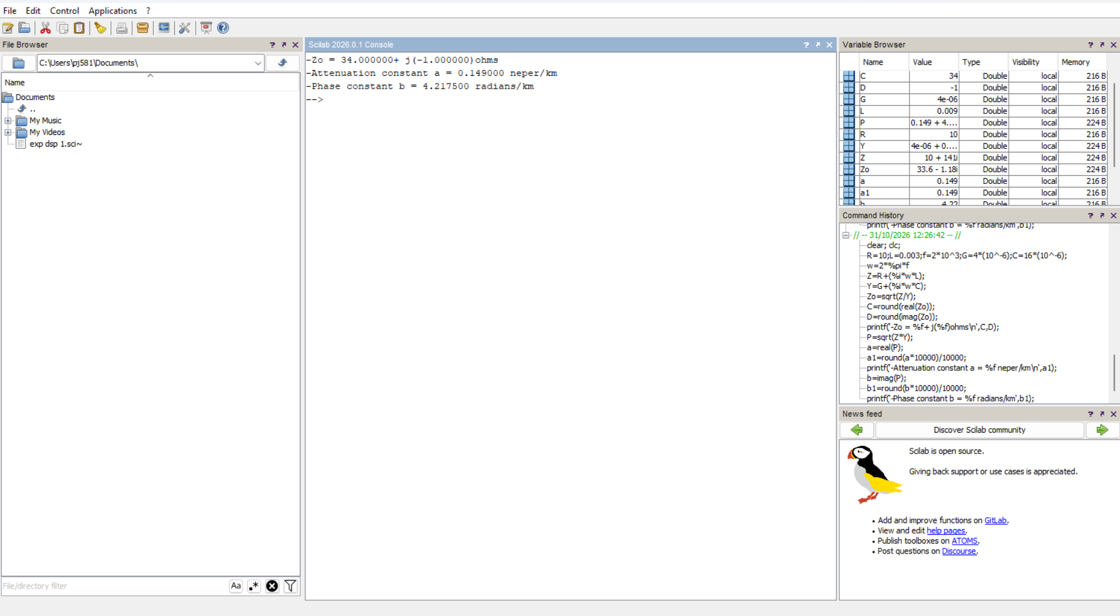

2.Estimation of Primary Constants (R,L,G &C) from Secondary Constants (Zo & y )of an open wiretransmission line
TEST CASE 1
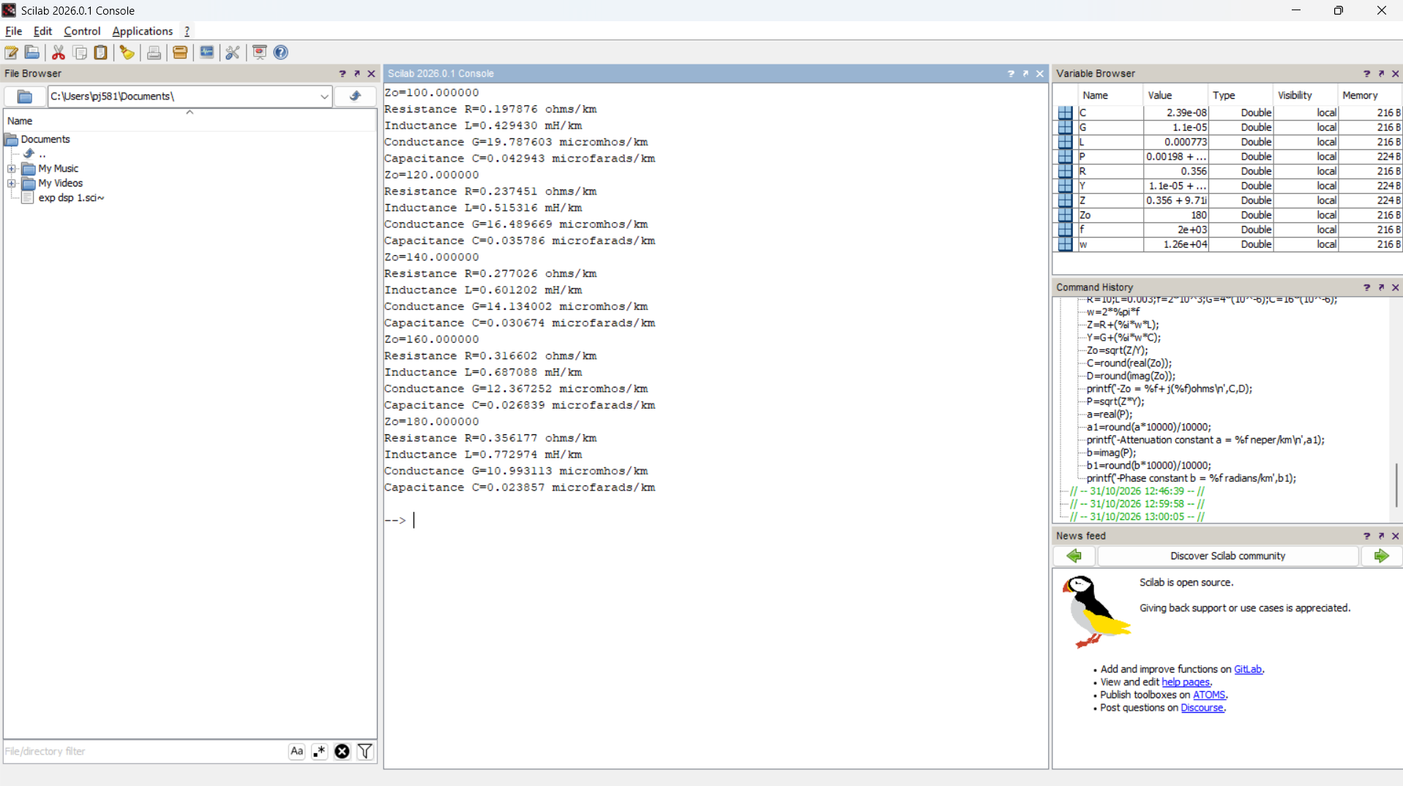
TEST CASE 2
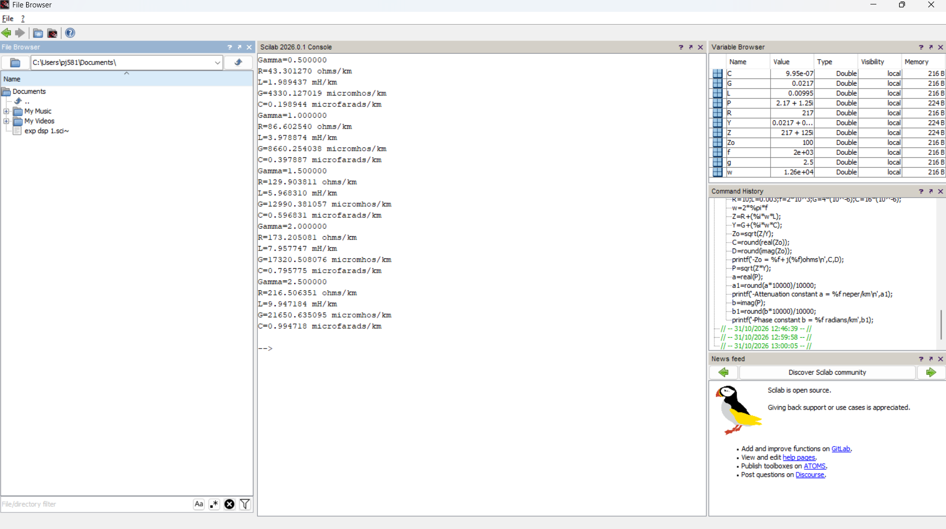

3. Evaluation of current in short circuited Lossless transmission line at the receiving end
TEST CASE 1
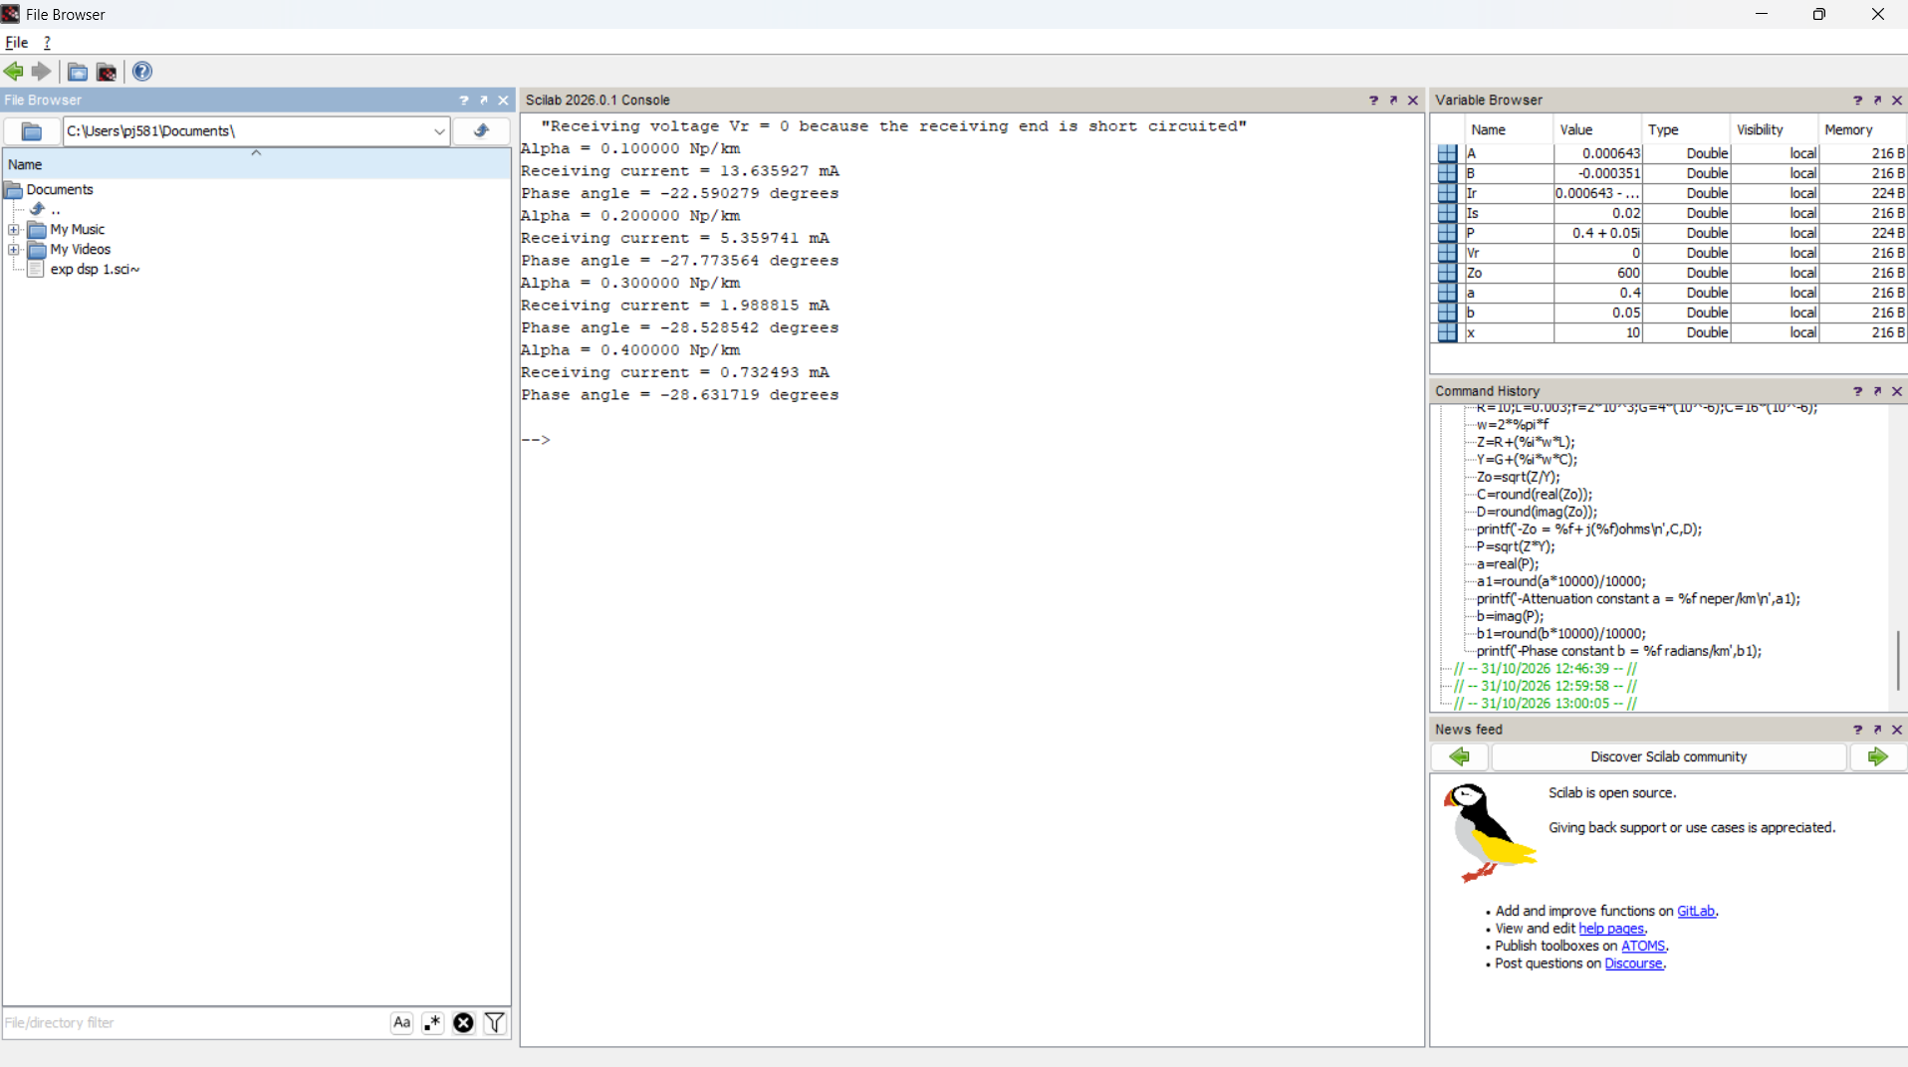
TEST CASE 2
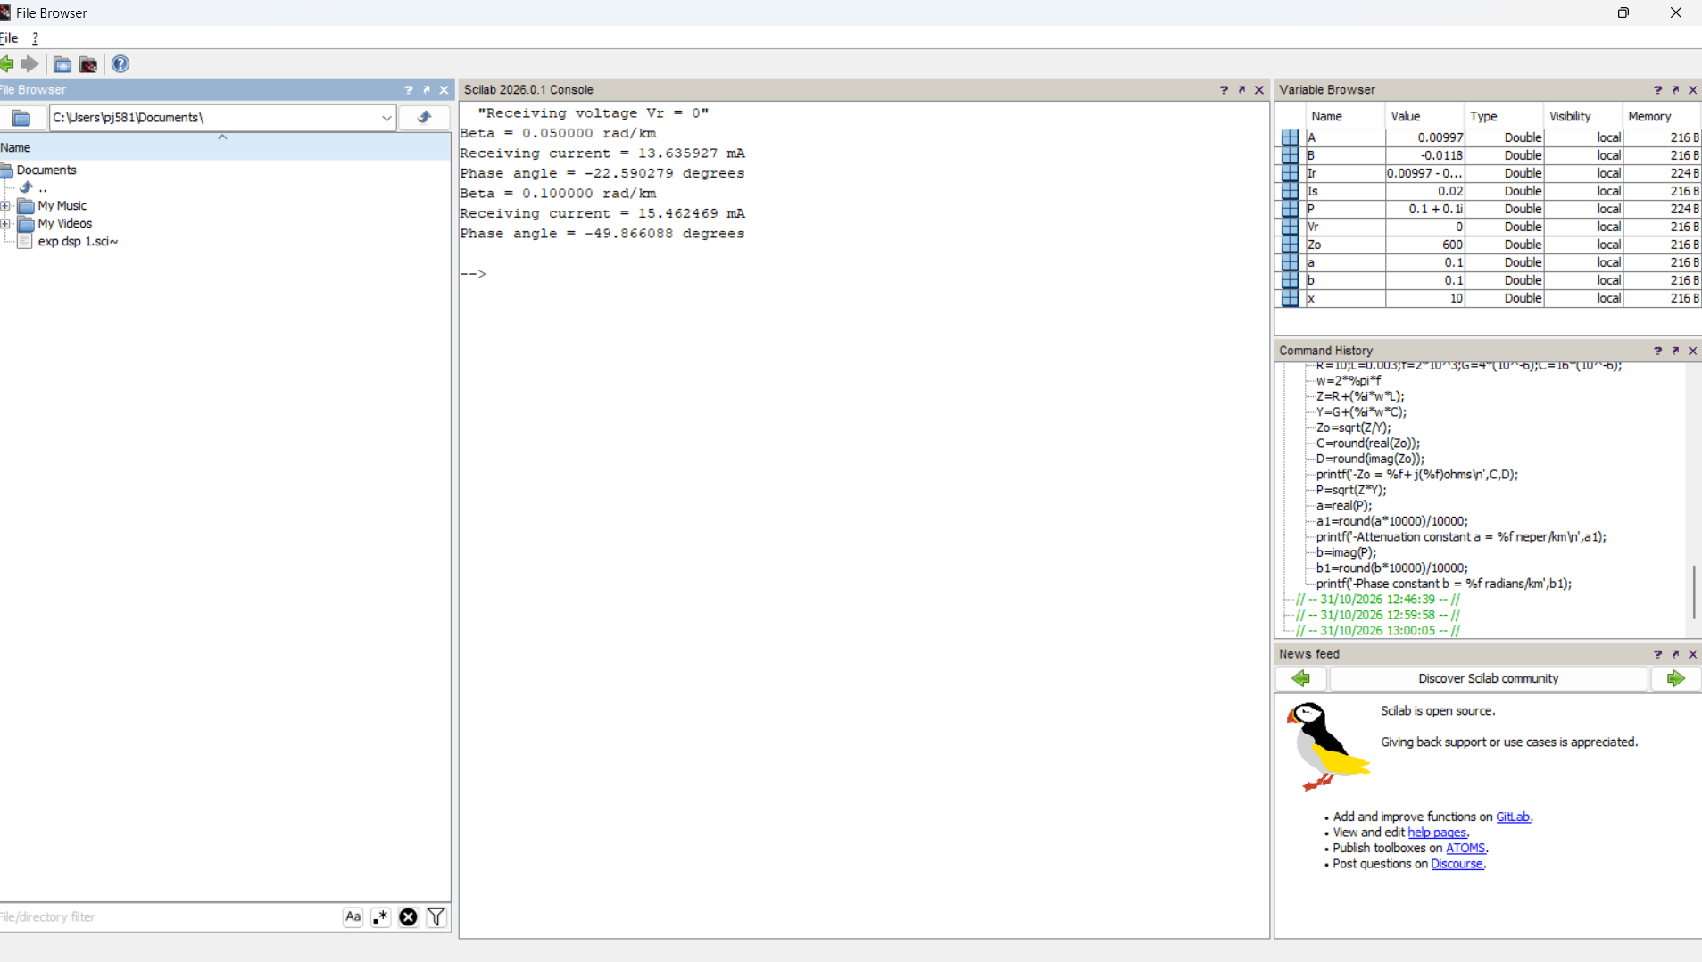

4. Analysis of SWR (Standing Wave Ratio)Transmission Lines by varying a)load impedance b) characteristic impedance
TEST CASE 1
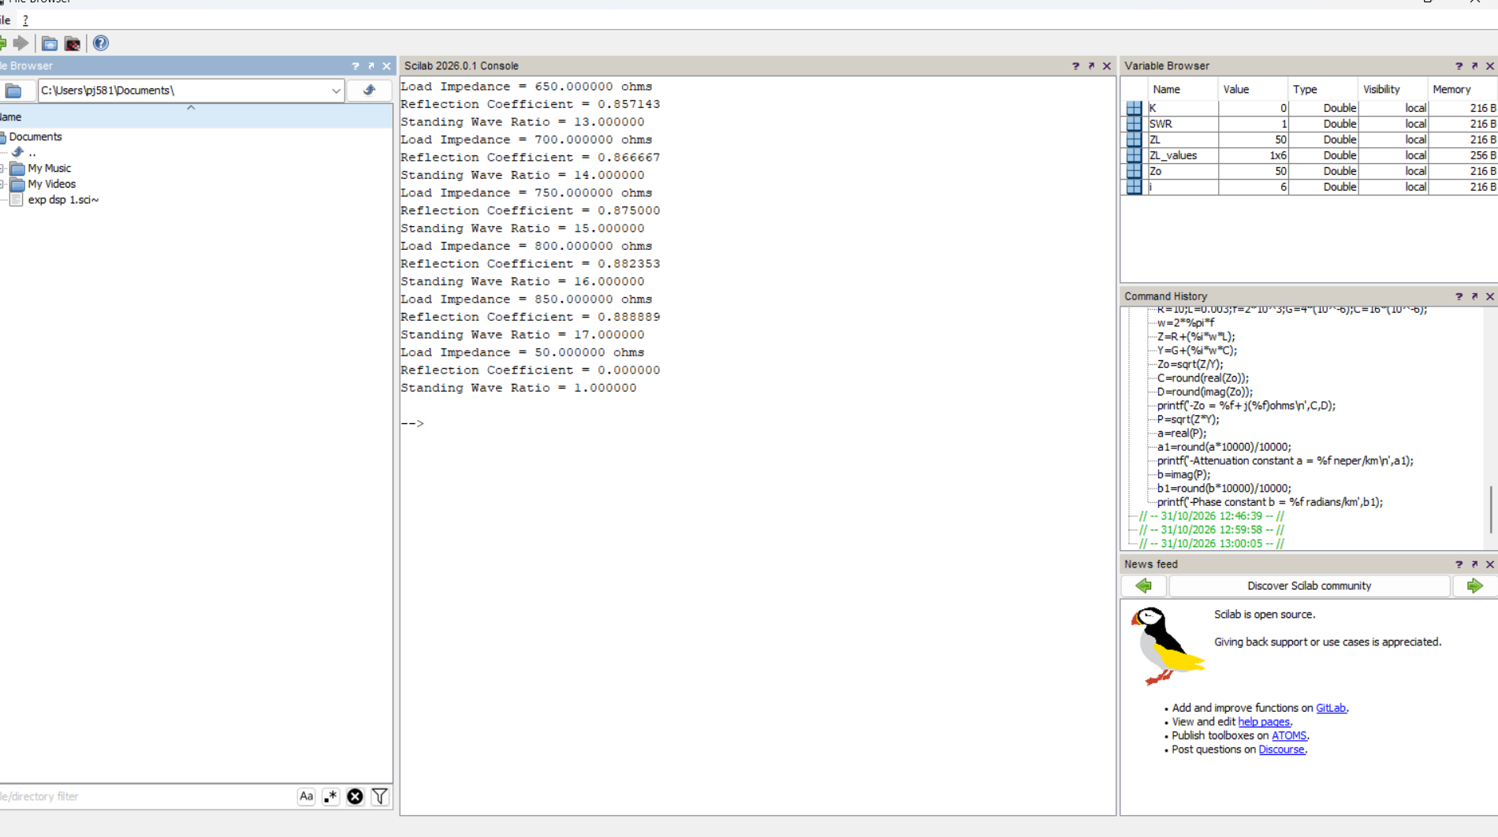
TEST CASE 2
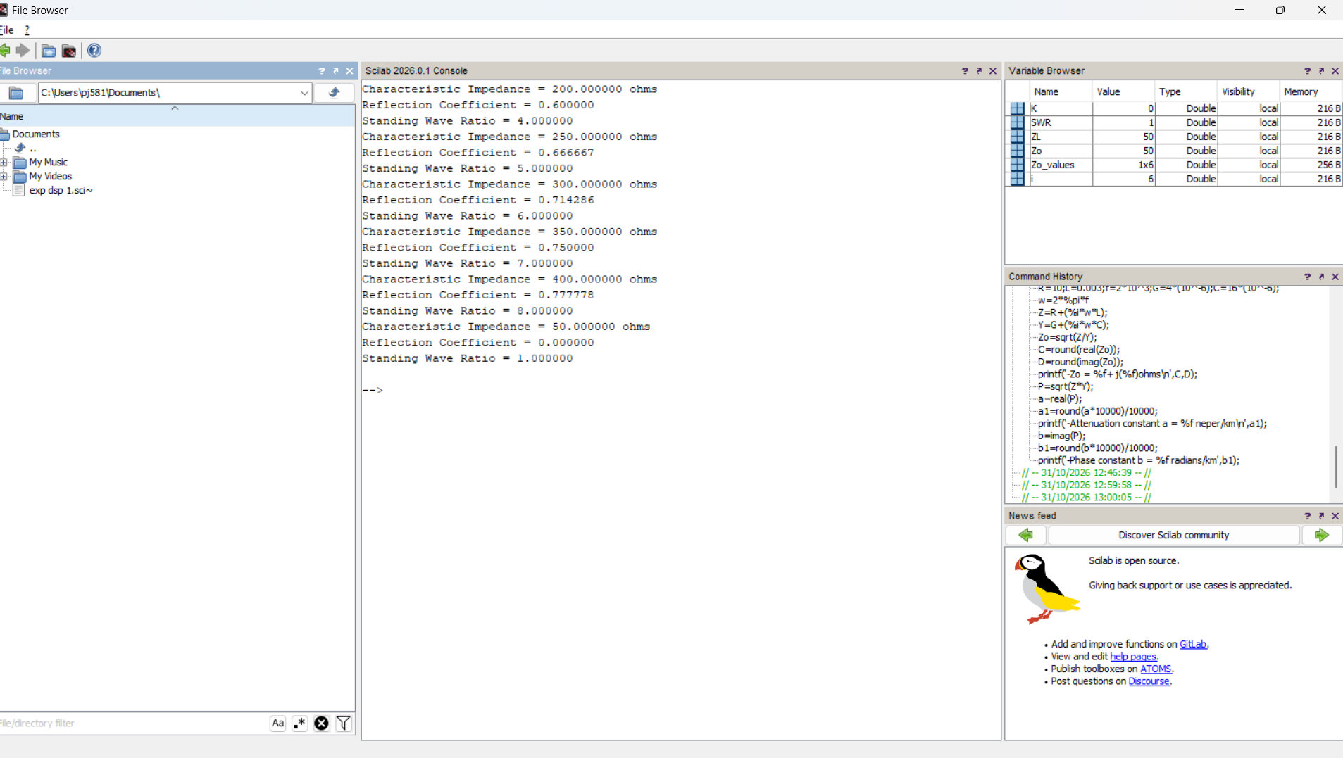

5. Exploration of the relationship between position of Voltage minima nearest to the load by varying magnitude of reflection coefficient K
TEEST CASE 1
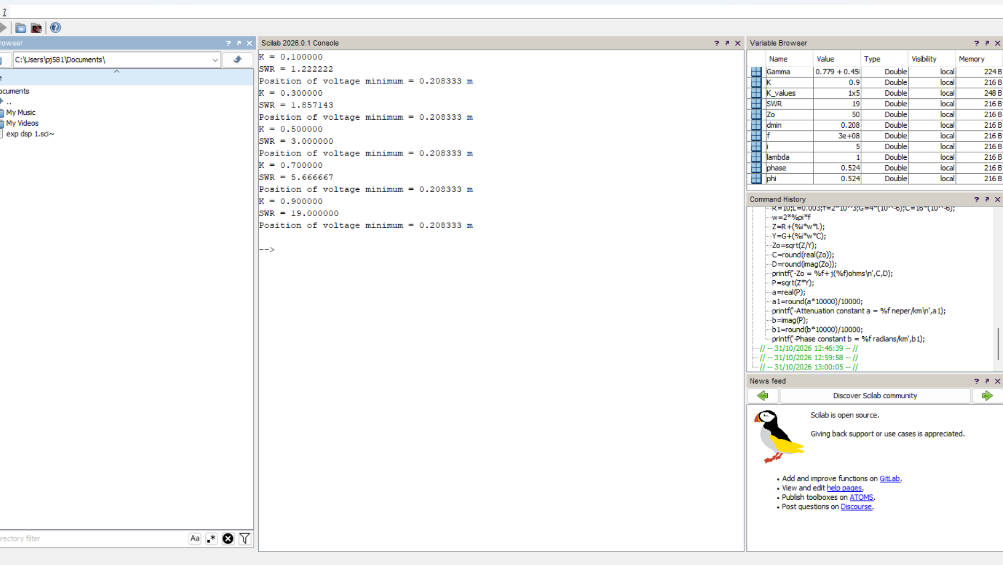
TEST CASE 2
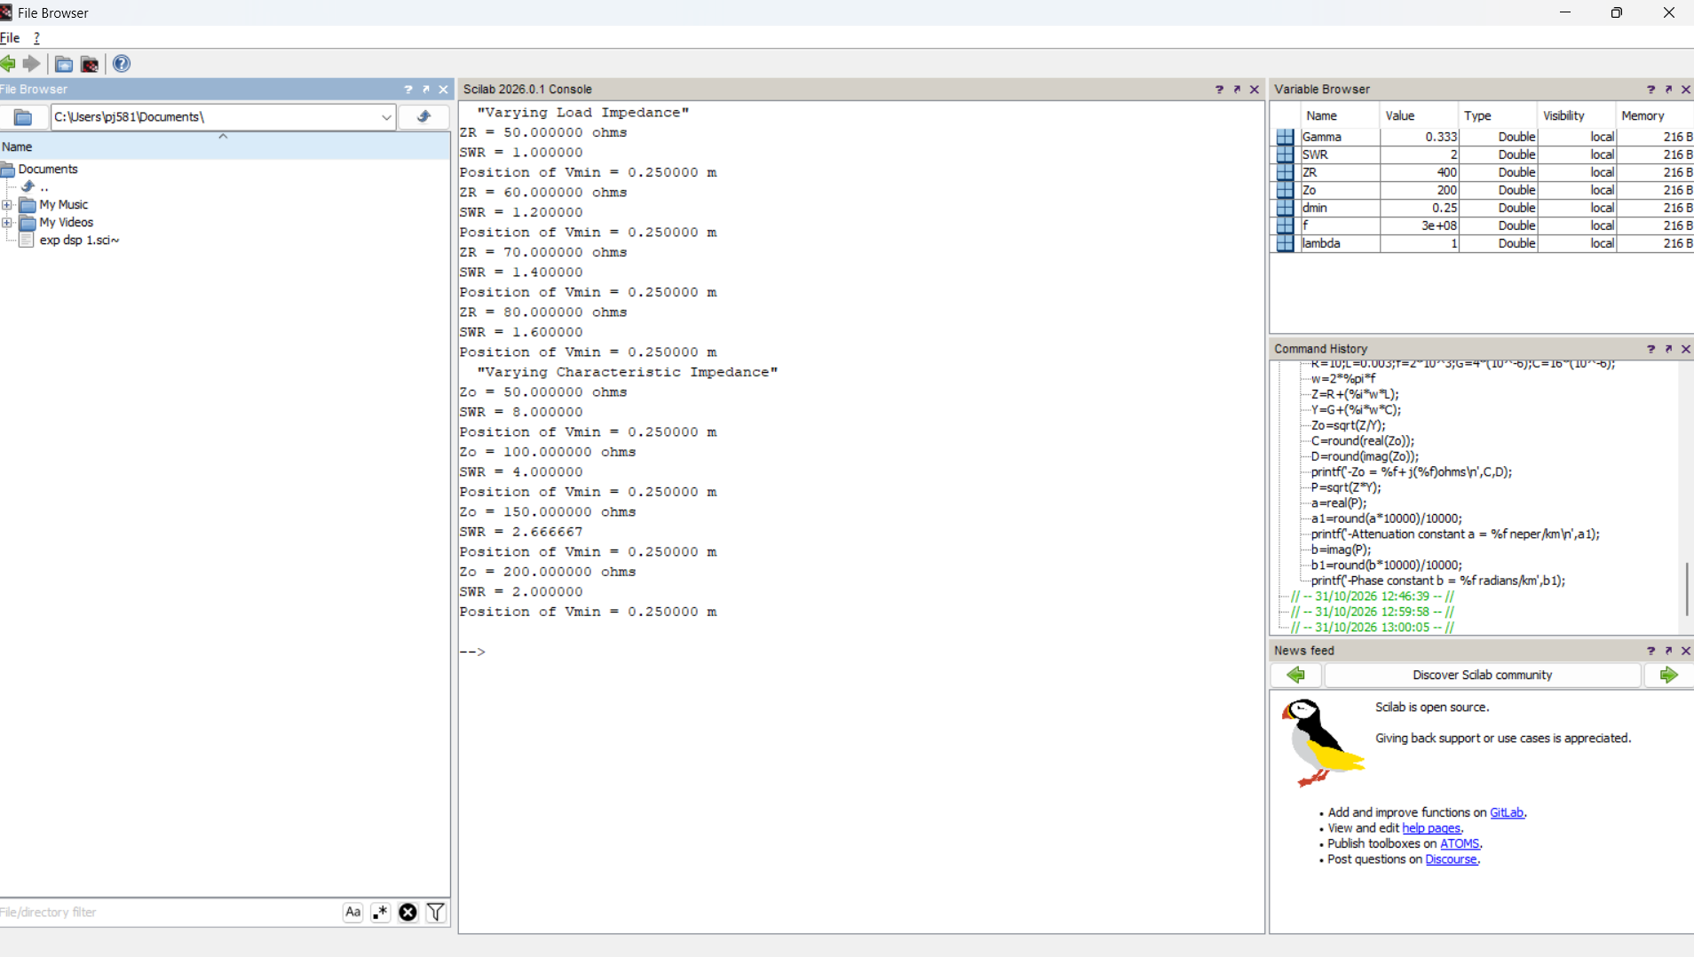

6. Designing a Quarter wave transformer by varying following parameters a) frequency b) input impedance c) characteristic impedance
TEST CASE 1
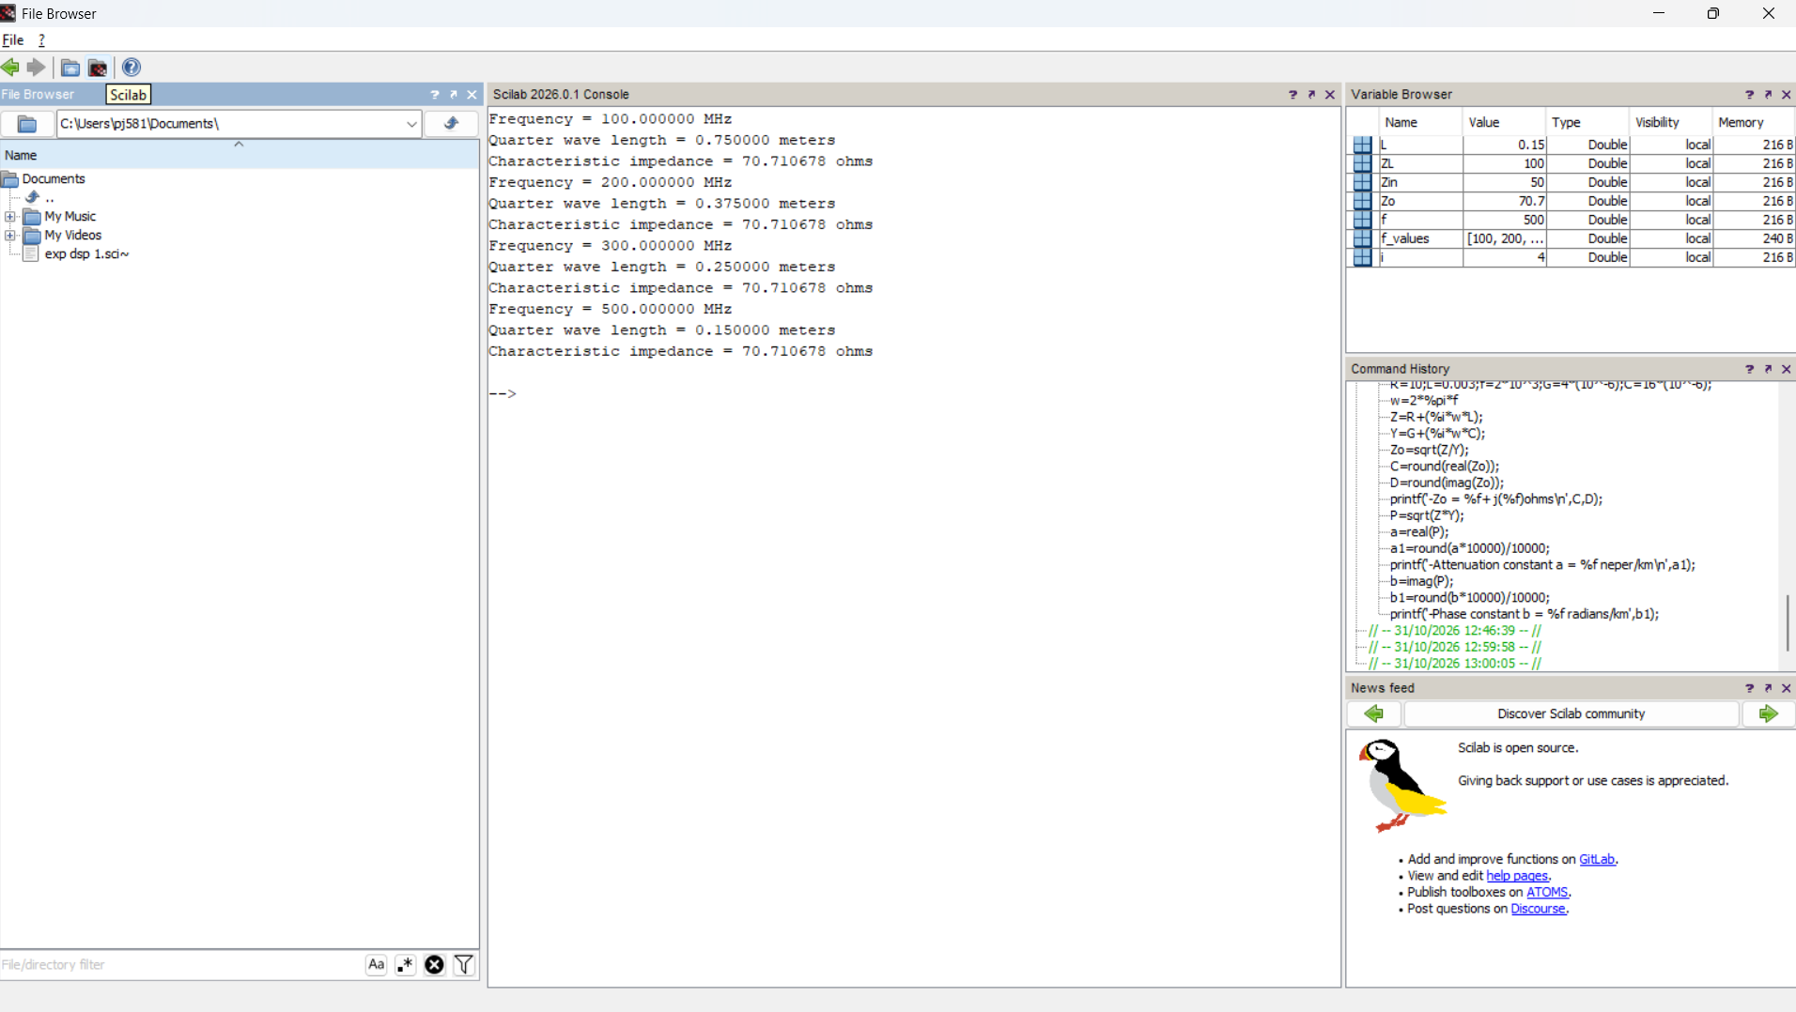
TEST CASE 2
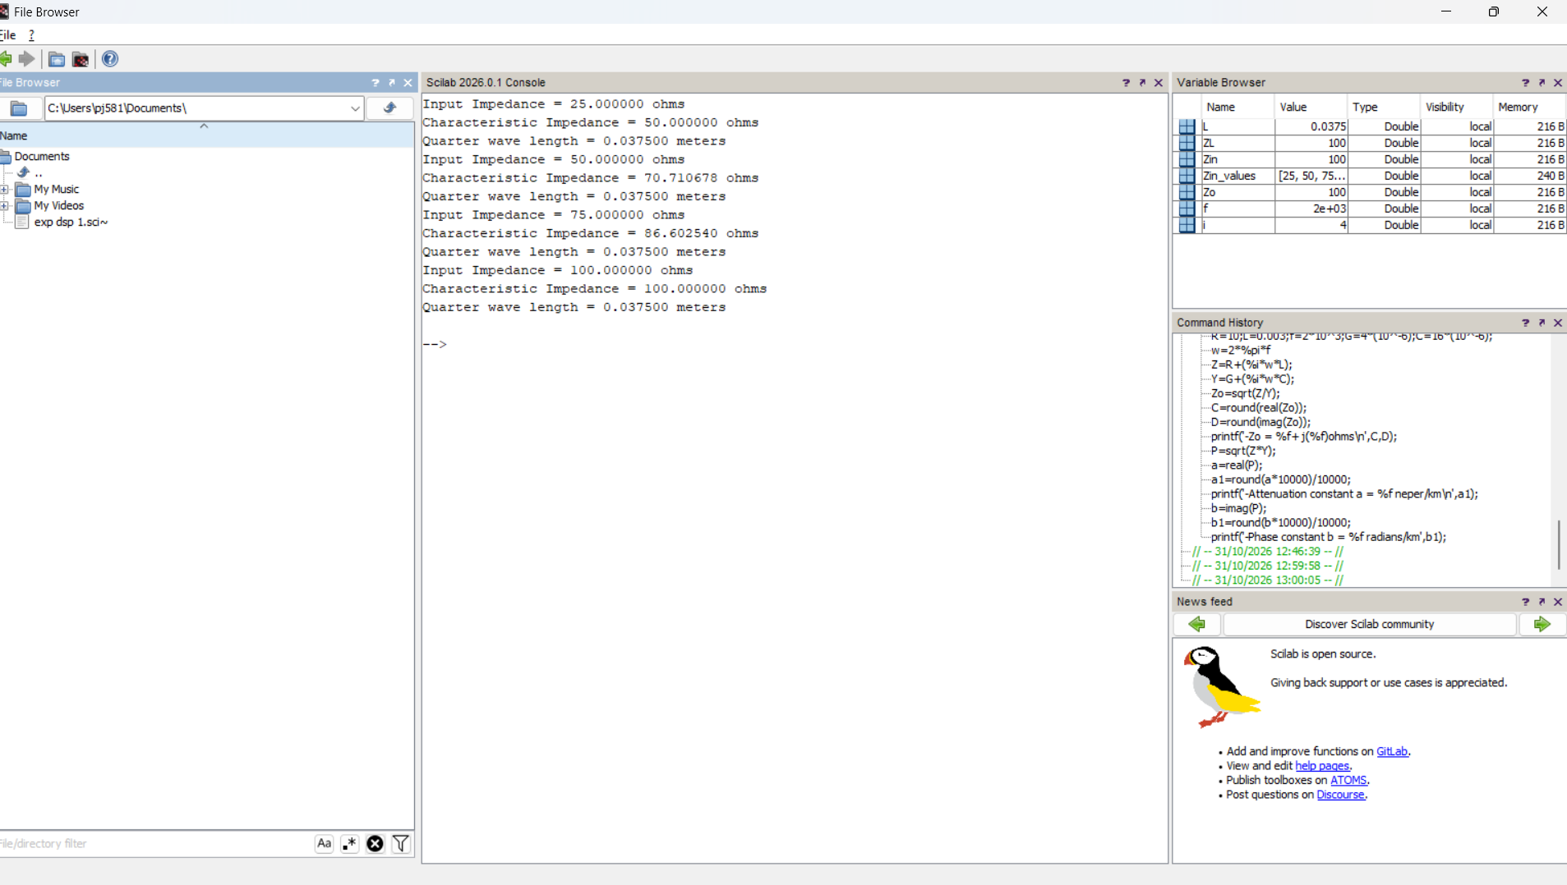

7. Strategize impedance matching with characteristic impedance and load impedance throughthe measurement of a) Location of the stub b) Length of the stu
TEST CASE 1
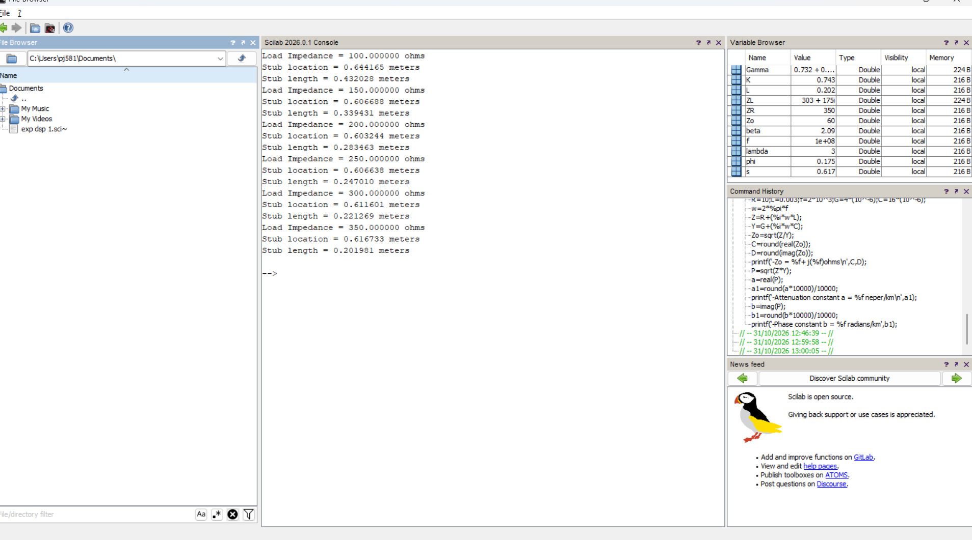
TEST CASE 2
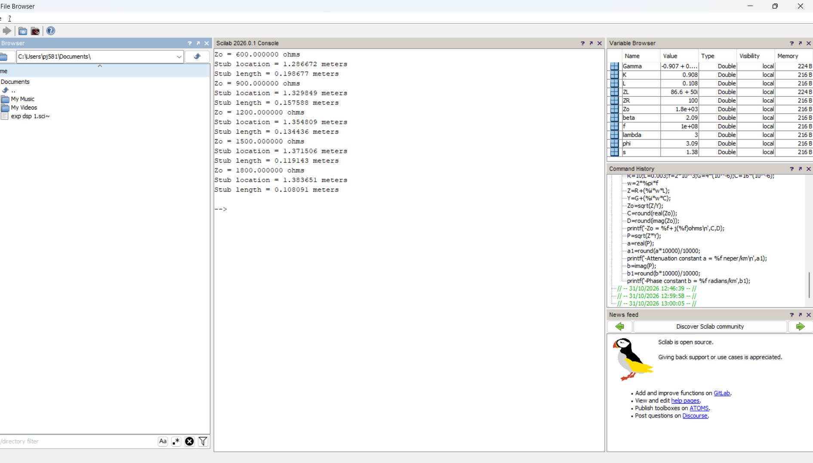

8. Analysis of Electromagnetic Waves across the two parallel plates estimating the following a) Critical Wavelength b) Guide Wavelength
TEST CASE 1
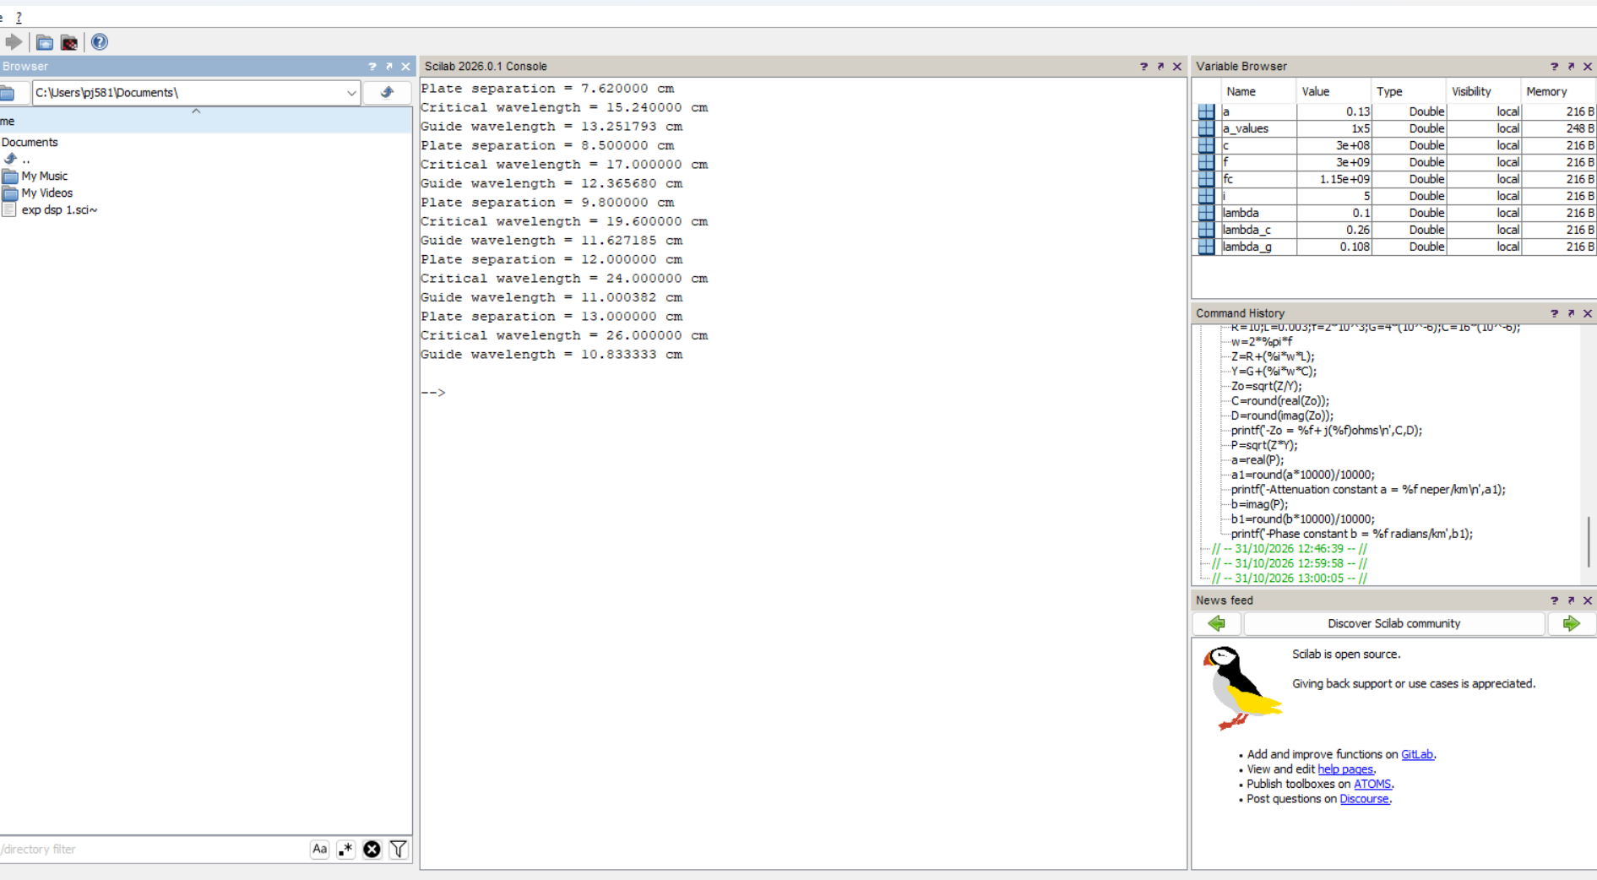
TEST CASE 2
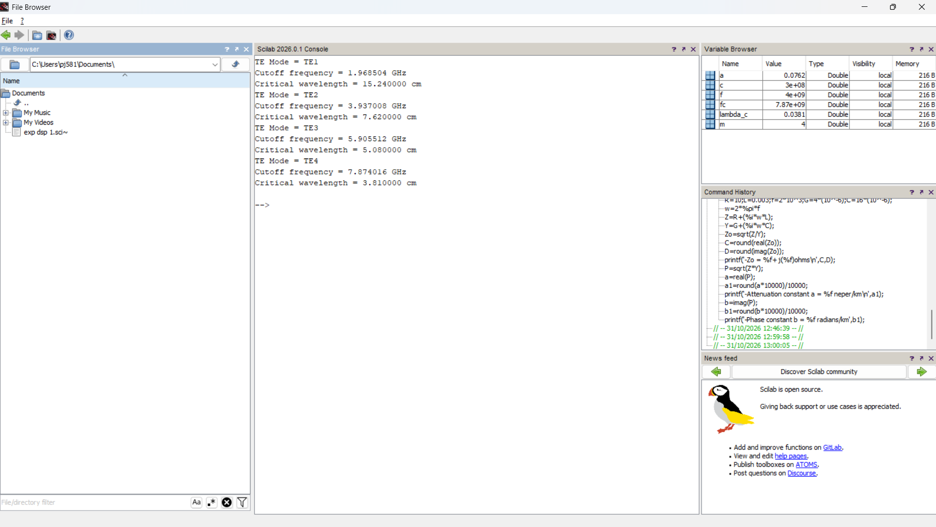

9. Calculation of Group velocity, Phase velocity and phase constant of EM waves in rectangular waveguides
TEST CASE 1
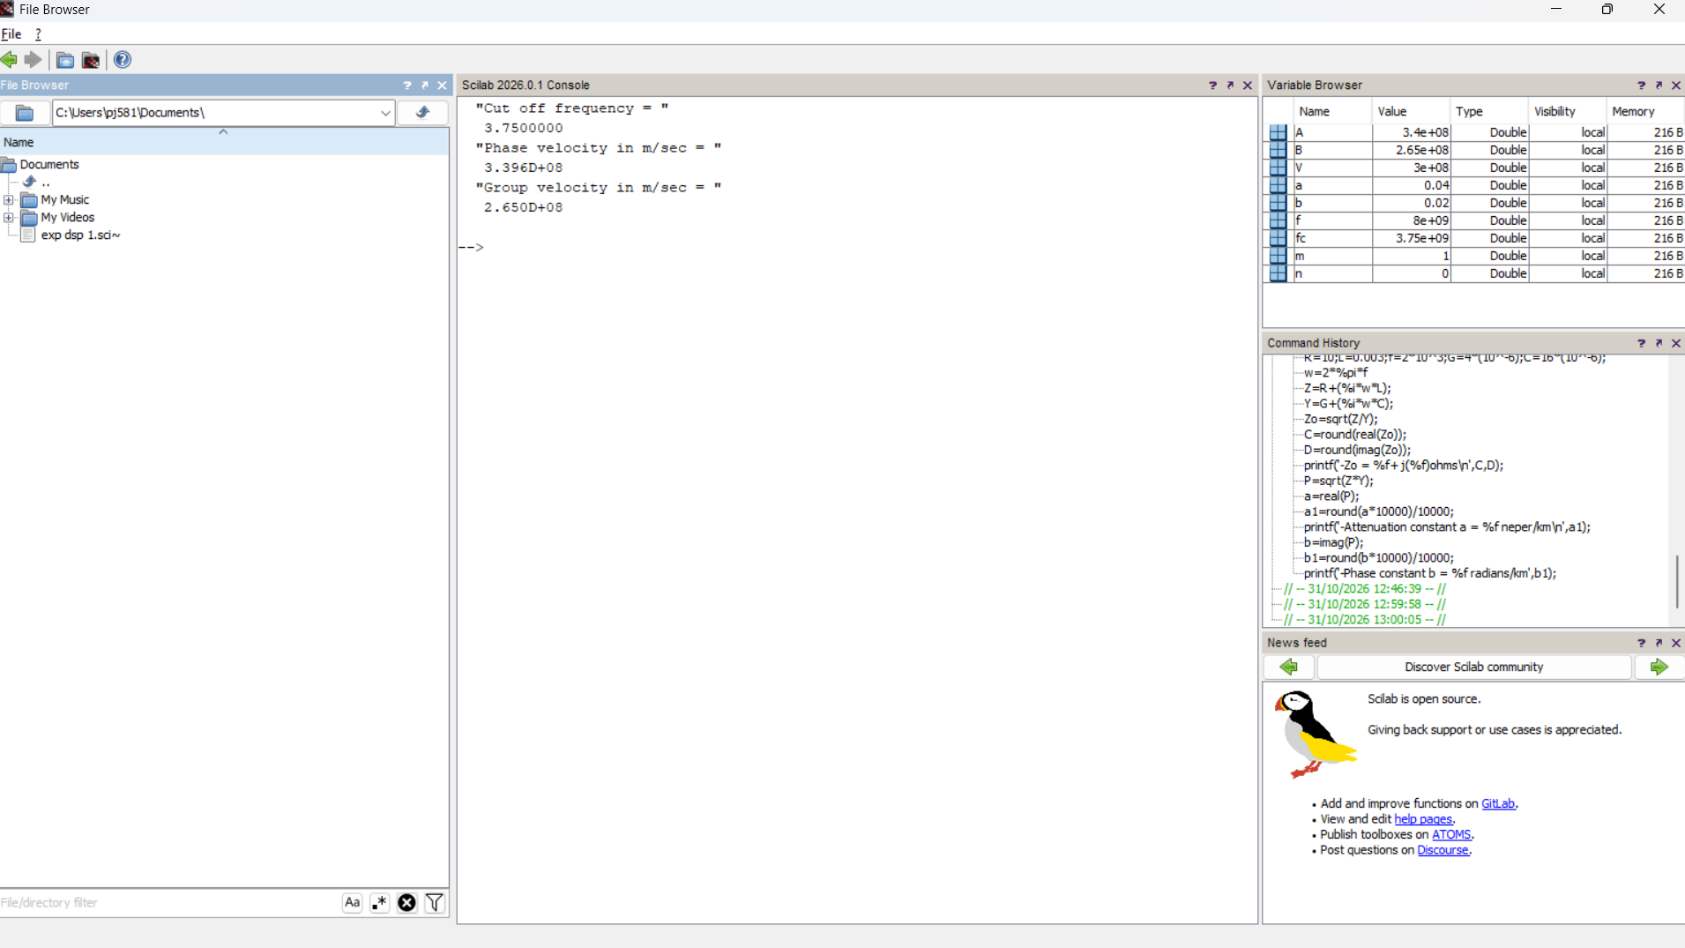
TEST CASE 2
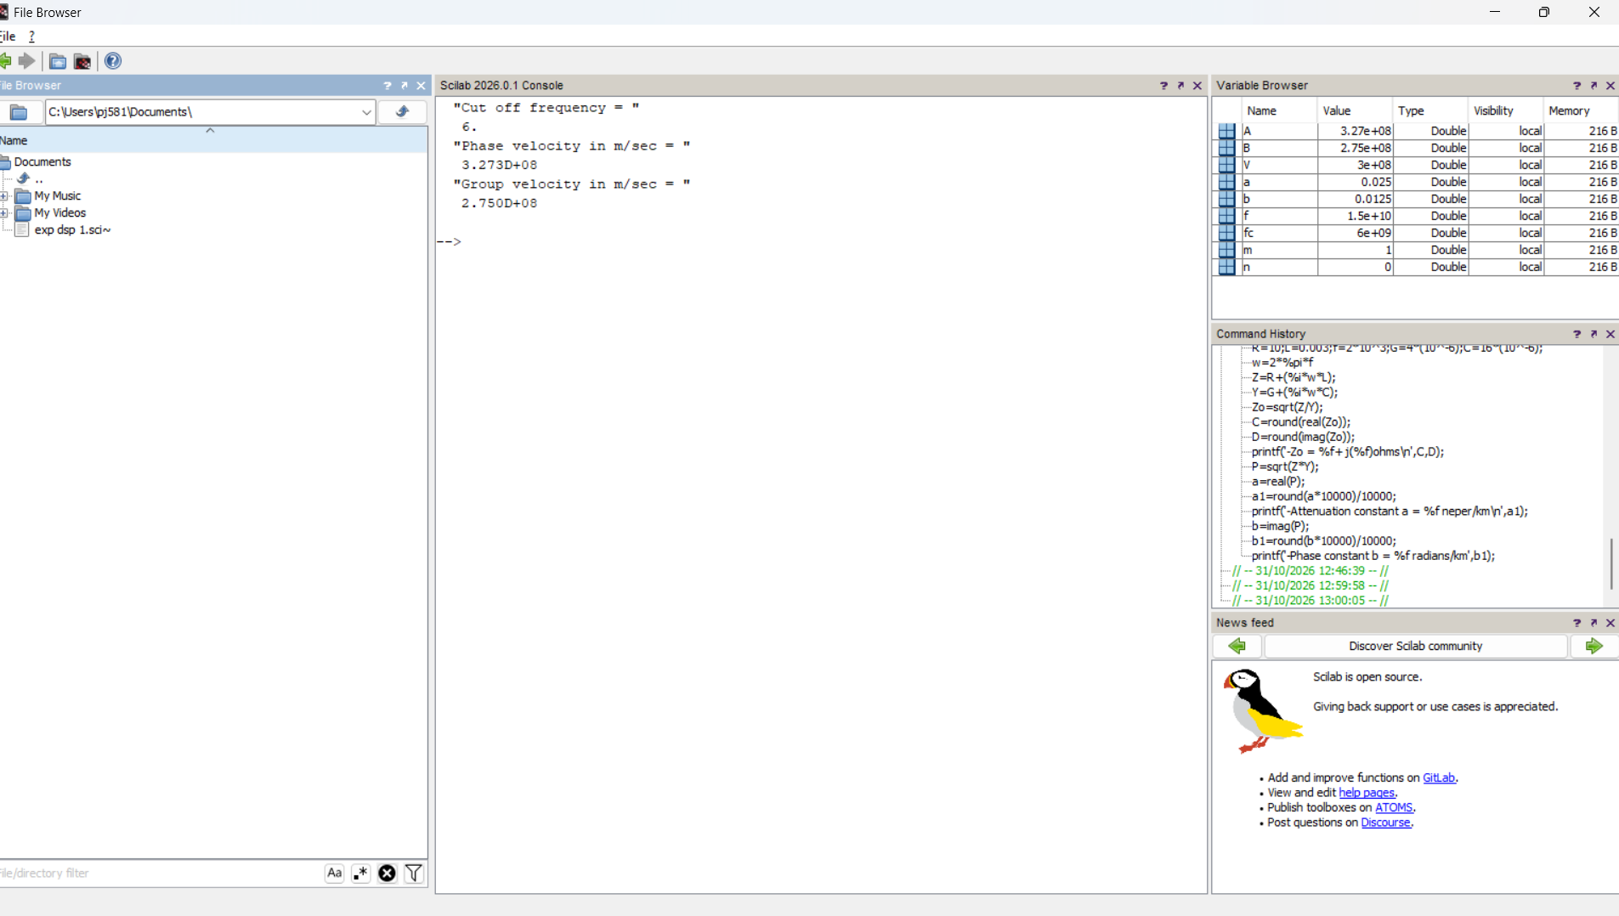

TEST CASE 3
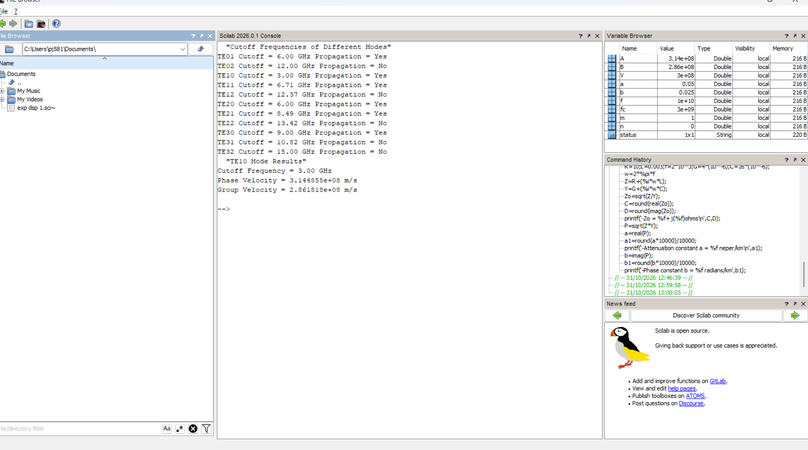
TEST CASE 4
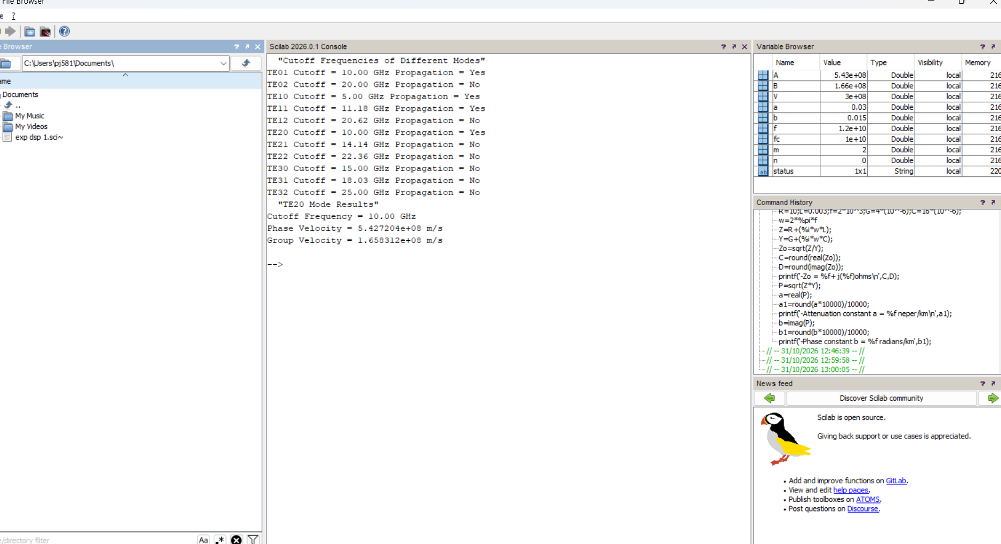

10. Examining the propagation characteristics of circular waveguide in terms of a) Cutoff wavelength d) Guide wavelength e) Characteristic impedance
TEST CASE 1
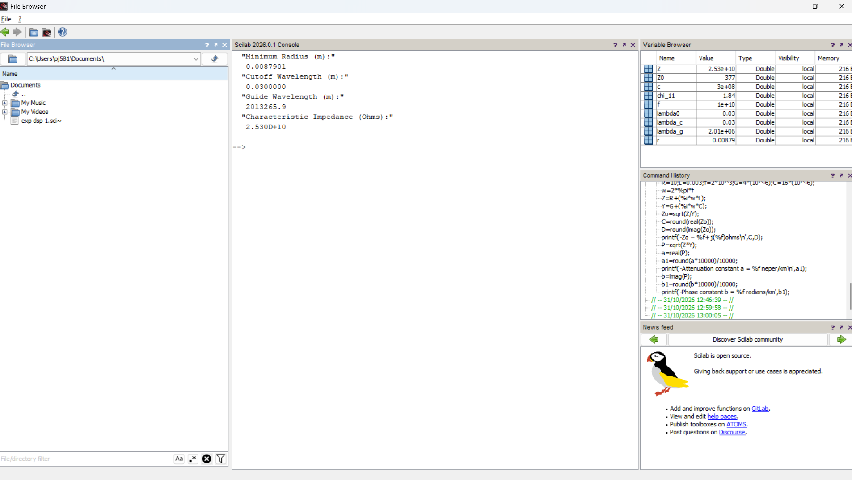
TEST CASE 2
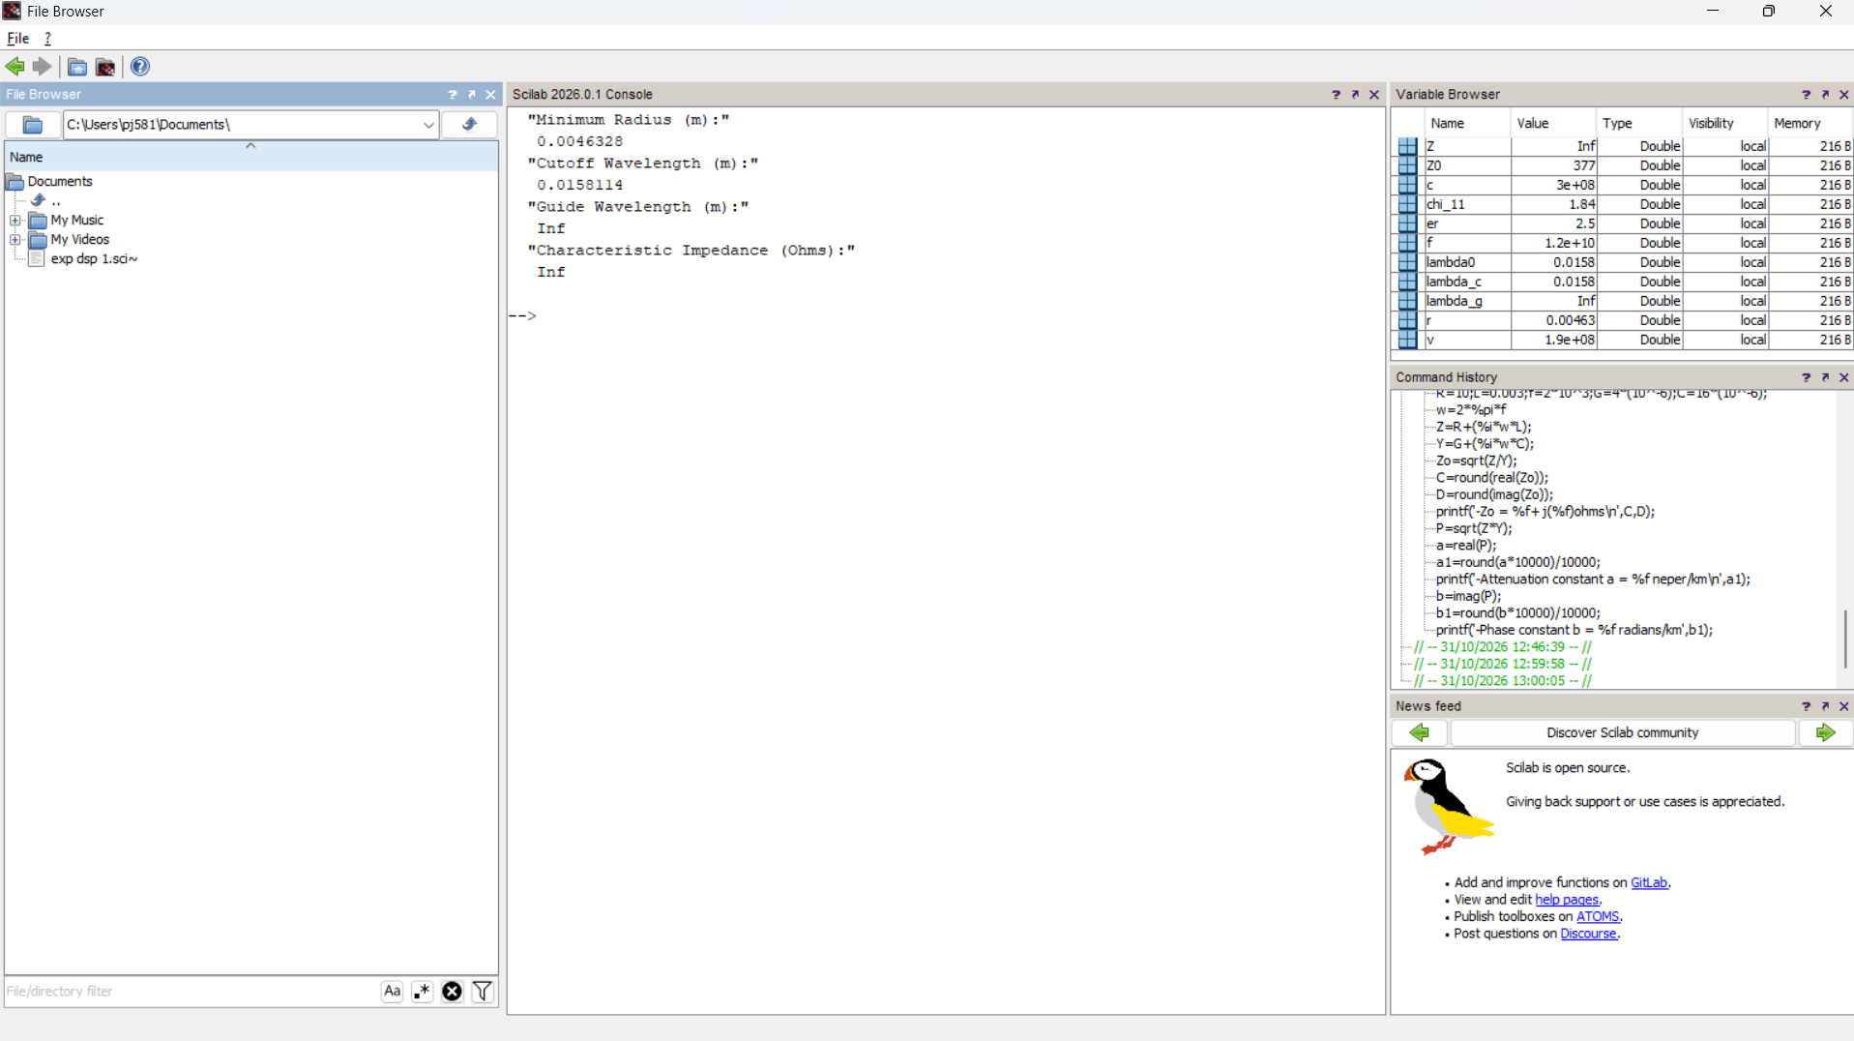

TEST CASE 3
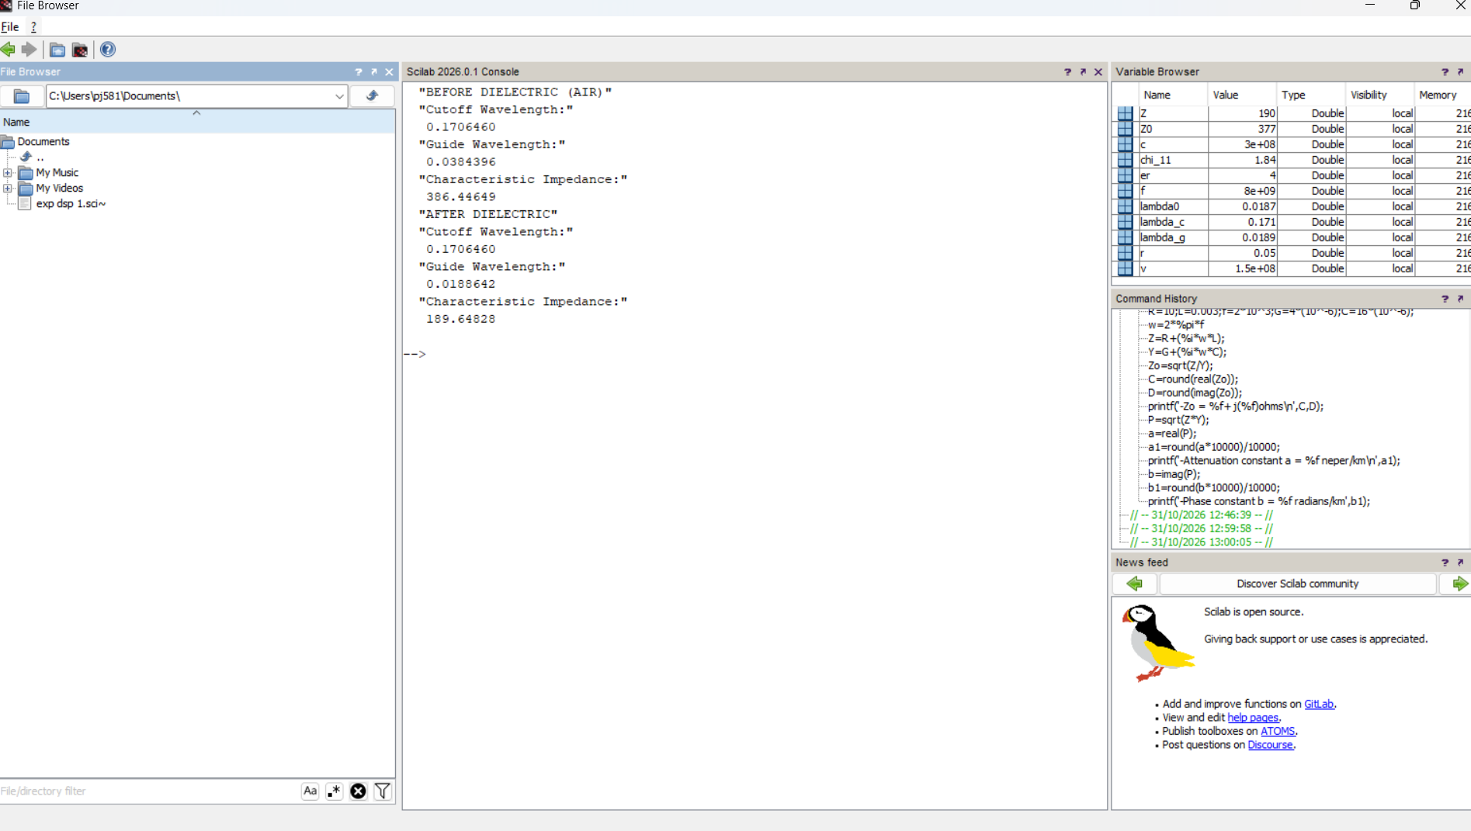
TEST CASE 4


