1.IMPLEMENT AND DEMONSTRATE THE FIND-S ALGORITHM FOR FINDING THE MOST SPECIFIC HYPOTHESIS BASED ON A GIVEN SET OF TRAINING DATA SAMPLES.
AIM:
To Implement And Demonstrate The FIND-S Algorithm For Concept Learning, Which Finds The Most Specific Hypothesis That Fits All Positive Training Examples In A Given Dataset.
PROCEDURE:
- Initialize hypothesis: Start with the most specific hypothesis (all attributes set to NULL or ϕ).
- Iterate over training examples:
  - If the example is positive, update the hypothesis:
    - For each attribute:
      - If the hypothesis attribute is NULL, replace it with the example’s attribute.
      - If the hypothesis attribute differs from the example’s attribute, generalize it to ?.
  - If the example is negative, ignore it (FIND-S only considers positive examples).
- Final hypothesis: After processing all positive examples, the hypothesis represents the most specific concept consistent with the data.
CODE:
# FIND-S Algorithm Implementation

def find_s_algorithm(training_data):
# Initialize hypothesis with the most specific values
hypothesis = ["ϕ"] * len(training_data[0][0])

for example, label in training_data:
if label == "Yes": # Only consider positive examples
for i in range(len(hypothesis)):
if hypothesis[i] == "ϕ":
hypothesis[i] = example[i]
elif hypothesis[i] != example[i]:
hypothesis[i] = "?"
return hypothesis

# Example Training Data
# Format: ([attributes], label)
training_data = [
(["Sunny", "Warm", "Normal", "Strong", "Warm", "Same"], "Yes"),
(["Sunny", "Warm", "High", "Strong", "Warm", "Same"], "Yes"),
(["Sunny", "Warm", "High", "Strong", "Cool", "Change"], "No"),
(["Sunny", "Warm", "Normal", "Strong", "Cool", "Change"], "Yes"),
]

# Run FIND-S
final_hypothesis = find_s_algorithm(training_data)

print("Final Hypothesis:", final_hypothesis)
OUTPUT:
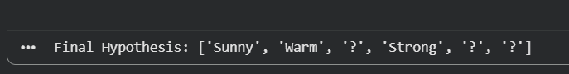

2.FOR A GIVEN SET OF TRAINING DATA EXAMPLES STORED IN A .CSV FILE, IMPLEMENT AND DEMONSTRATE THE CANDIDATE-ELIMINATION ALGORITHM IN PYTHON TO OUTPUT A DESCRIPTION OF THE SET OF ALL HYPOTHESESCONSISTENT WITH THE TRAINING EXAMPLES
AIM:
To implement and demonstrate the Candidate-Elimination algorithm, which outputs the version space — the set of all hypotheses consistent with the given training examples stored in a .CSV file.
PROCEDURE:
1. Initialize boundaries:
- S (Specific boundary): Start with the most specific hypothesis (all attributes set to ϕ).
- G (General boundary): Start with the most general hypothesis (all attributes set to ?).
2.Iterate over training examples:
- If the example is positive:
  - Update S to be more general if needed (to cover the example).
  - Remove inconsistent hypotheses from G.
- If the example is negative:
  - Update G to be more specific (exclude the negative example).
  - Remove inconsistent hypotheses from S.
3. Maintain consistency: Ensure that every hypothesis in S is more specific than at least one hypothesis in G, and vice versa.
4. Final version space: The set of hypotheses between S and G that remain consistent with all training examples.
CODE:
# Candidate Elimination Algorithm

def candidate_elimination(data):

concepts = [row[:-1] for row in data]
target = [row[-1] for row in data]

# Initialize Specific and General Hypothesis
S = concepts[0].copy()
G = [["?" for _ in range(len(S))]]

print("Initial Specific Hypothesis (S):", S)
print("Initial General Hypothesis (G):", G)

for i, h in enumerate(concepts):

if target[i] == "Yes":

# Update S
for j in range(len(S)):
if h[j] != S[j]:
S[j] = "?"

# Remove inconsistent hypotheses from G
G = [g for g in G if all(g[k] == "?" or g[k] == h[k]
for k in range(len(S)))]

else:

G_new = []

for g in G:
for j in range(len(S)):
if g[j] == "?":
if S[j] != "?":
new_g = g.copy()
new_g[j] = S[j]
G_new.append(new_g)

G = G_new

print("\nAfter Example", i + 1)
print("S =", S)
print("G =", G)

return S, G

# ------------------ Training Data ------------------

training_data = [
["Sunny", "Warm", "Normal", "Strong", "Warm", "Same", "Yes"],
["Sunny", "Warm", "High", "Strong", "Warm", "Same", "Yes"],
["Rainy", "Cold", "High", "Strong", "Warm", "Change", "No"],
["Sunny", "Warm", "High", "Strong", "Cool", "Change", "Yes"]
]

# ------------------ Run Algorithm ------------------

S, G = candidate_elimination(training_data)

print("\nFinal Specific Hypothesis:")
print(S)

print("\nFinal General Hypothesis:")
for g in G:
print(g)
OUTPUT
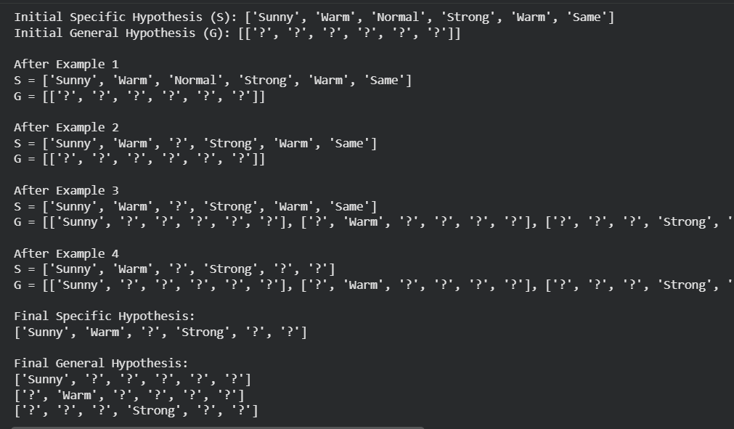

3.Demonstrate The Working Of The Decision Tree Based Id3 Algorithm. Use An Appropriate Data Set For Building The Decision Tree And Apply This Knowledge To Classify A New Sample.
AIM:
To implement and demonstrate the ID3 algorithm for building a decision tree from a dataset, and then use the tree to classify a new sample.
PROCEDURE:
- Entropy Calculation
  - Entropy measures impurity in the dataset.
  - Formula:
Entropy(S)=−∑pilog⁡2(pi)
where pi is the proportion of class i.
- Information Gain
  - For each attribute, calculate how much entropy is reduced if we split on that attribute.
  - Formula:
Gain(S,A)=Entropy(S)−∑∣Sv∣∣S∣Entropy(Sv)
where Sv is the subset after splitting on attribute A.
- Tree Construction
  - Choose the attribute with the highest information gain.
  - Create a node for that attribute.
  - Recursively repeat for each branch until all examples are classified or no attributes remain.
- Classification
  - Traverse the tree using attribute values of the new sample until reaching a leaf node (class label).
CODE:
import math
import pandas as pd

# Calculate entropy
def entropy(data, target):
values = data[target].unique()
ent = 0
for val in values:
p = len(data[data[target] == val]) / len(data)
ent -= p * math.log2(p)
return ent

# Calculate information gain
def info_gain(data, attr, target):
total_entropy = entropy(data, target)
values = data[attr].unique()
weighted_entropy = 0
for val in values:
subset = data[data[attr] == val]
weighted_entropy += (len(subset)/len(data)) * entropy(subset, target)
return total_entropy - weighted_entropy

# Build decision tree using ID3
def id3(data, attributes, target):
# If all examples have same class
if len(data[target].unique()) == 1:
return data[target].iloc[0]

# If no attributes left
if not attributes:
return data[target].mode()[0]

# Choose best attribute
gains = [info_gain(data, attr, target) for attr in attributes]
best_attr = attributes[gains.index(max(gains))]

tree = {best_attr: {}}
for val in data[best_attr].unique():
subset = data[data[best_attr] == val]
subtree = id3(subset, [a for a in attributes if a != best_attr], target)
tree[best_attr][val] = subtree
return tree

# Example dataset (Play Tennis)
data = pd.DataFrame([
["Sunny","Hot","High","Weak","No"],
["Sunny","Hot","High","Strong","No"],
["Overcast","Hot","High","Weak","Yes"],
["Rain","Mild","High","Weak","Yes"],
["Rain","Cool","Normal","Weak","Yes"],
["Rain","Cool","Normal","Strong","No"],
["Overcast","Cool","Normal","Strong","Yes"],
["Sunny","Mild","High","Weak","No"],
["Sunny","Cool","Normal","Weak","Yes"],
["Rain","Mild","Normal","Weak","Yes"],
["Sunny","Mild","Normal","Strong","Yes"],
["Overcast","Mild","High","Strong","Yes"],
["Overcast","Hot","Normal","Weak","Yes"],
["Rain","Mild","High","Strong","No"]
], columns=["Outlook","Temperature","Humidity","Wind","PlayTennis"])

# Build tree
attributes = ["Outlook","Temperature","Humidity","Wind"]
tree = id3(data, attributes, "PlayTennis")

print("Decision Tree:", tree)

# Classify new sample
def classify(tree, sample):
if isinstance(tree, str):
return tree
attr = list(tree.keys())[0]
val = sample[attr]
if val in tree[attr]:
return classify(tree[attr][val], sample)
else:
return "Unknown"

new_sample = {"Outlook":"Sunny","Temperature":"Cool","Humidity":"High","Wind":"Strong"}
print("Classification:", classify(tree, new_sample))
OUTPUT:
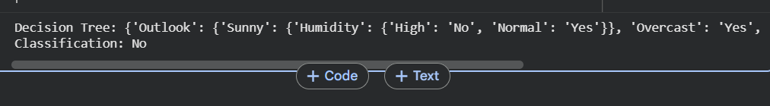

4.Build an Artificial Neural Network by implementing the Backpropagation algorithm and test the same using appropriate data sets.
AIM:
To implement an Artificial Neural Network (ANN) using the Backpropagation algorithm and test it on a dataset to classify new samples.
PROCEDURE:
- Initialize the network
  - Define the number of input neurons, hidden neurons, and output neurons.
  - Randomly initialize weights and biases.
- Forward Propagation
  - Compute weighted sums at each layer.
  - Apply activation functions (e.g., sigmoid, ReLU).
  - Output predicted values.
- Error Calculation
  - Compute error using a loss function (e.g., Mean Squared Error or Cross-Entropy).
- Backward Propagation
  - Calculate gradients of error with respect to weights using the chain rule.
  - Update weights and biases using gradient descent.
- Training Loop
  - Repeat forward and backward propagation for multiple epochs until convergence.
- Testing
  - Use the trained network to classify new samples.
CODE:
import numpy as np
from sklearn.datasets import load_iris
from sklearn.model_selection import train_test_split
from sklearn.preprocessing import OneHotEncoder, StandardScaler

# Activation functions
def sigmoid(x):
return 1 / (1 + np.exp(-x))

def sigmoid_derivative(x):
return x * (1 - x)

# Load dataset
iris = load_iris()
X = iris.data
y = iris.target.reshape(-1, 1)

# One-hot encode target
encoder = OneHotEncoder(sparse_output=False)
y = encoder.fit_transform(y)

# Normalize features
scaler = StandardScaler()
X = scaler.fit_transform(X)

# Train-test split
X_train, X_test, y_train, y_test = train_test_split(X, y, test_size=0.2, random_state=42)

# Network architecture
input_neurons = X.shape[1] # 4 features
hidden_neurons = 6
output_neurons = y.shape[1] # 3 classes

# Initialize weights
np.random.seed(42)
W1 = np.random.uniform(size=(input_neurons, hidden_neurons))
W2 = np.random.uniform(size=(hidden_neurons, output_neurons))

# Training
epochs = 1000
lr = 0.1

for epoch in range(epochs):
# Forward pass
hidden_input = np.dot(X_train, W1)
hidden_output = sigmoid(hidden_input)

final_input = np.dot(hidden_output, W2)
final_output = sigmoid(final_input)

# Error
error = y_train - final_output

# Backpropagation
d_output = error * sigmoid_derivative(final_output)
error_hidden = d_output.dot(W2.T)
d_hidden = error_hidden * sigmoid_derivative(hidden_output)

# Update weights
W2 += hidden_output.T.dot(d_output) * lr
W1 += X_train.T.dot(d_hidden) * lr

# Testing
hidden_output_test = sigmoid(np.dot(X_test, W1))
final_output_test = sigmoid(np.dot(hidden_output_test, W2))

predictions = np.argmax(final_output_test, axis=1)
actual = np.argmax(y_test, axis=1)

accuracy = np.mean(predictions == actual)
print("Test Accuracy:", accuracy)

# Classify a new sample
new_sample = np.array([[5.1, 3.5, 1.4, 0.2]]) # Example Iris flower
new_sample = scaler.transform(new_sample)
hidden_new = sigmoid(np.dot(new_sample, W1))
final_new = sigmoid(np.dot(hidden_new, W2))
print("New Sample Classification:", np.argmax(final_new))

OUTPUT:
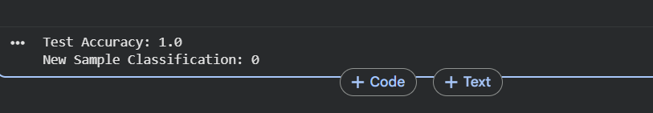

6.Write A Program To Implement Naïve Bayes Algorithm In Python And To Display The Results Using Confusion Matrix And Accuracy.
AIM:
To implement the Naïve Bayes classifier in Python and evaluate its performance using a dataset, displaying results with a confusion matrix and accuracy.
PROCEDURE:
- Load an appropriate dataset (e.g., Iris dataset from scikit-learn).
- Split the dataset into training and testing sets.
- Train a Naïve Bayes classifier.
- Predict outcomes on the test set.
- Evaluate performance using:
- Confusion Matrix
- Accuracy Score
CODE:
import numpy as np
from sklearn.datasets import load_iris
from sklearn.model_selection import train_test_split
from sklearn.naive_bayes import GaussianNB
from sklearn.metrics import confusion_matrix, accuracy_score

# Load dataset
iris = load_iris()
X = iris.data
y = iris.target

# Split dataset into train and test sets
X_train, X_test, y_train, y_test = train_test_split(
X, y, test_size=0.3, random_state=42
)

# Initialize Naïve Bayes classifier
model = GaussianNB()

# Train the model
model.fit(X_train, y_train)

# Predict on test set
y_pred = model.predict(X_test)

# Evaluate results
conf_matrix = confusion_matrix(y_test, y_pred)
accuracy = accuracy_score(y_test, y_pred)

print("Confusion Matrix:\n", conf_matrix)
print("Accuracy:", accuracy)
OUTPUT:
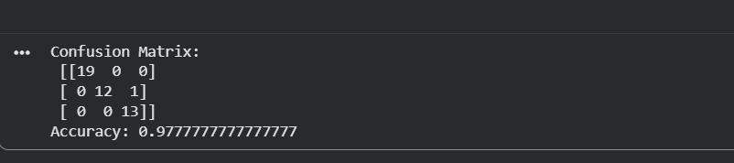

7.Write A Program To Implement Logistic Regression (LR) Algorithm In Python
AIM:
To implement the Logistic Regression algorithm in Python and evaluate its performance on a dataset.
PROCEDURE:
- Load a dataset (e.g., Iris dataset or any binary/multiclass dataset).
- Split the dataset into training and testing sets.
- Train a Logistic Regression model.
- Predict outcomes on the test set.
- Evaluate performance using accuracy and confusion matrix.
CODE:
import numpy as np
from sklearn.datasets import load_iris
from sklearn.model_selection import train_test_split
from sklearn.linear_model import LogisticRegression
from sklearn.metrics import confusion_matrix, accuracy_score

# Load dataset
iris = load_iris()
X = iris.data
y = iris.target

# Split dataset into train and test sets
X_train, X_test, y_train, y_test = train_test_split(
X, y, test_size=0.3, random_state=42
)

# Initialize Logistic Regression model
model = LogisticRegression(max_iter=200)

# Train the model
model.fit(X_train, y_train)

# Predict on test set
y_pred = model.predict(X_test)

# Evaluate results
conf_matrix = confusion_matrix(y_test, y_pred)
accuracy = accuracy_score(y_test, y_pred)

print("Confusion Matrix:\n", conf_matrix)
print("Accuracy:", accuracy)

# Classify a new sample
new_sample = np.array([[5.1, 3.5, 1.4, 0.2]]) # Example Iris flower
prediction = model.predict(new_sample)
print("New Sample Classification:", prediction)
OUTPUT:
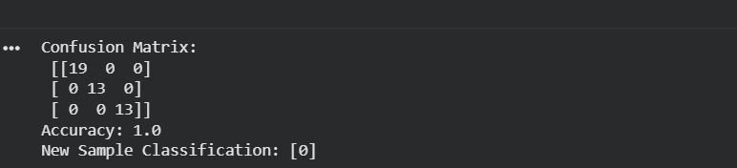

8.Write a program to implement Linear Regression (LR) algorithm in python
AIM:
To implement the Linear Regression algorithm in Python and evaluate its performance on a dataset.
PROCEDURE:
• Load a dataset (e.g., Boston Housing or a synthetic dataset).
• Split the dataset into training and testing sets.
• Train a Linear Regression model.
• Predict outcomes on the test set.
• Evaluate performance using metrics like Mean Squared Error (MSE) and R² score.
CODE:
import numpy as np
import pandas as pd
from sklearn.datasets import fetch_california_housing
from sklearn.model_selection import train_test_split
from sklearn.linear_model import LinearRegression
from sklearn.metrics import mean_squared_error, r2_score

# Load California Housing dataset
housing = fetch_california_housing()

# Features and target
X = housing.data
y = housing.target

# Split dataset into training and testing sets
X_train, X_test, y_train, y_test = train_test_split(
X, y, test_size=0.3, random_state=42
)

# Create Linear Regression model
model = LinearRegression()

# Train the model
model.fit(X_train, y_train)

# Predict on test data
y_pred = model.predict(X_test)

# Evaluate the model
mse = mean_squared_error(y_test, y_pred)
r2 = r2_score(y_test, y_pred)

print("Mean Squared Error:", mse)
print("R² Score:", r2)

# Predict for a new sample
new_sample = X_test[0].reshape(1, -1)
prediction = model.predict(new_sample)

print("Actual Value:", y_test[0])
print("Predicted Value:", prediction[0])
OUTPUT:
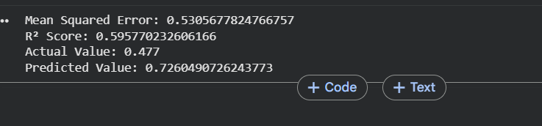
9.COMPARE LINEAR AND POLYNOMIAL REGRESSION USING PYTHON
AIM:
To implement Linear Regression and Polynomial Regression, compare their performance, and visualize the difference in fitting.
PROCEDURE:
• Generate or load a dataset (we’ll use a synthetic dataset for clarity).
• Fit a Linear Regression model.
• Fit a Polynomial Regression model (transform features into polynomial terms).
• Compare predictions and performance using metrics like Mean Squared Error (MSE) and R² score.
• Visualize the regression lines/curves.
CODE:
import numpy as np
import matplotlib.pyplot as plt
from sklearn.linear_model import LinearRegression
from sklearn.preprocessing import PolynomialFeatures
from sklearn.metrics import mean_squared_error, r2_score

# Generate synthetic dataset
np.random.seed(42)
X = np.linspace(0, 10, 50).reshape(-1, 1)
y = 2 + 0.5 * X + 3 * np.sin(X) + np.random.normal(0, 0.5, X.shape)

# Linear Regression
lin_reg = LinearRegression()
lin_reg.fit(X, y)
y_pred_lin = lin_reg.predict(X)

# Polynomial Regression (degree 4)
poly = PolynomialFeatures(degree=4)
X_poly = poly.fit_transform(X)
poly_reg = LinearRegression()
poly_reg.fit(X_poly, y)
y_pred_poly = poly_reg.predict(X_poly)

# Evaluation
mse_lin = mean_squared_error(y, y_pred_lin)
r2_lin = r2_score(y, y_pred_lin)

mse_poly = mean_squared_error(y, y_pred_poly)
r2_poly = r2_score(y, y_pred_poly)

print("Linear Regression -> MSE:", mse_lin, "R²:", r2_lin)
print("Polynomial Regression -> MSE:", mse_poly, "R²:", r2_poly)

# Visualization
plt.scatter(X, y, color="blue", label="Data")
plt.plot(X, y_pred_lin, color="red", label="Linear Regression")
plt.plot(X, y_pred_poly, color="green", label="Polynomial Regression (deg=4)")
plt.legend()
plt.xlabel("X")
plt.ylabel("y")
plt.title("Linear vs Polynomial Regression")
plt.show()

OUTPUT:
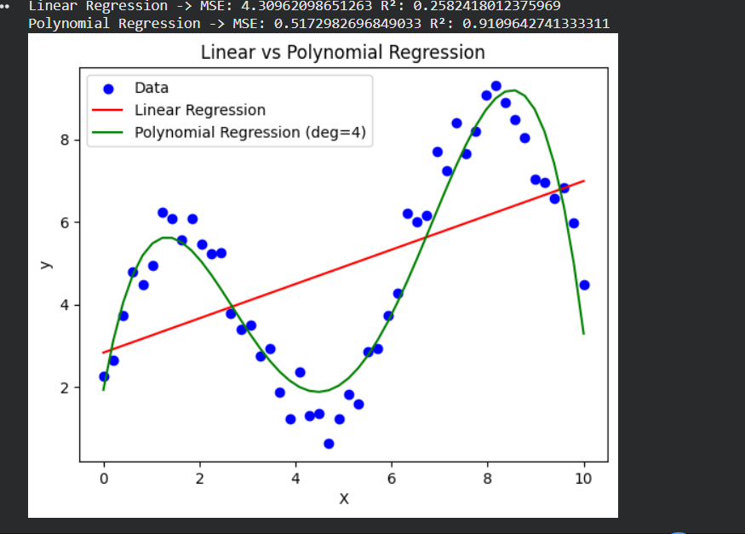
10.Write a Python Program to Implement Expectation & Maximization Algorithm
AIM:
To implement the Expectation-Maximization (EM) algorithm for clustering data, and test it using a dataset
PROCEDURE:
• Initialization
- Choose the number of clusters (components).
- Initialize parameters (means, variances, and mixing coefficients).
• Expectation Step (E-step)
- Compute the probability (responsibility) that each data point belongs to each cluster using current parameters.
• Maximization Step (M-step)
- Update parameters (means, variances, mixing coefficients) to maximize the likelihood given the responsibilities.
• Repeat
- Alternate between E-step and M-step until convergence (parameters stabilize or likelihood stops improving).
• Classification
- Assign each data point to the cluster with the highest responsibility.
CODE:
import numpy as np
from sklearn.mixture import GaussianMixture
import matplotlib.pyplot as plt

# Generate synthetic dataset
np.random.seed(42)
X = np.concatenate([
np.random.normal(0, 1, 100),
np.random.normal(5, 1, 100)
]).reshape(-1, 1)

# Fit Gaussian Mixture Model (EM algorithm)
gmm = GaussianMixture(n_components=2, random_state=42)
gmm.fit(X)

# Predict cluster assignments
labels = gmm.predict(X)

# Print parameters
print("Means:", gmm.means_.ravel())
print("Variances:", gmm.covariances_.ravel())
print("Mixing Coefficients:", gmm.weights_)

# Visualization
plt.scatter(X, np.zeros_like(X), c=labels, cmap="viridis")
plt.title("Clustering using EM Algorithm (GMM)")
plt.show()
OUTPUT
