EXPERIMENT-5
OBJECTIVE:1
Program code:
clc;
clear;
close all;
BW1 = 20; % Component carrier bandwidth (MHz)
SE = 4; % Spectral efficiency (bits/s/Hz)
Ncc = 1; % Number of component carriers
BWagg = BW1 * Ncc;
Throughput = BWagg * SE;
disp('Single Component Carrier')
disp(['Bandwidth = ', num2str(BWagg), ' MHz'])
disp(['Estimated Throughput = ', num2str(Throughput), ' Mbps'])
figure;
bar(Ncc, Throughput);
grid on;
xlabel('Number of Component Carriers');
ylabel('Estimated Throughput (Mbps)');
title('LTE-Advanced Single Carrier Throughput');

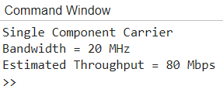
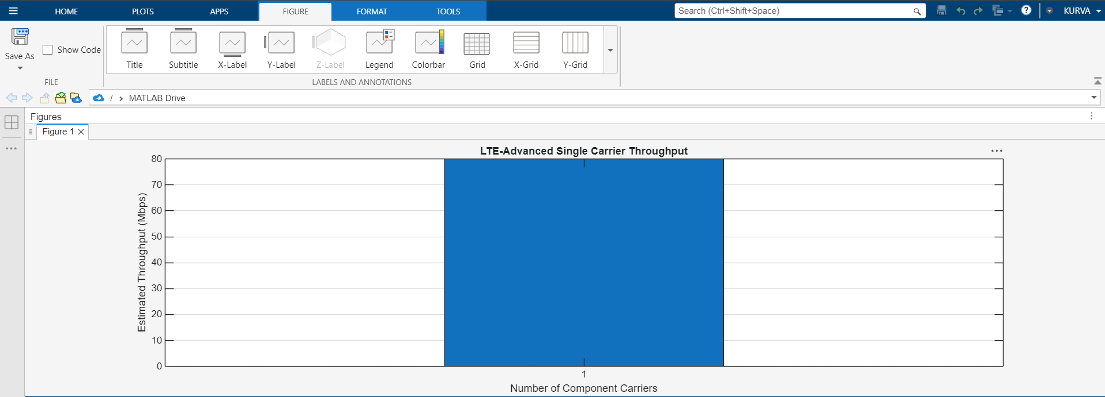
OBJECTIVE 2:
clc;
clear;
close all;
BWcc = 20; % MHz per component carrier
SE = 4; % bits/s/Hz
CC = [1 2 3]; % Number of component carriers
AggBW = BWcc .* CC; % MHz
Throughput = AggBW .* SE; % Mbps
disp('CC Aggregated BW (MHz) Estimated Throughput (Mbps)')
disp([CC' AggBW' Throughput'])
figure;
bar(CC, Throughput);

grid on;
xlabel('Number of Aggregated Component Carriers');
ylabel('Estimated Throughput (Mbps)');
title('LTE-Advanced Carrier Aggregation Throughput');

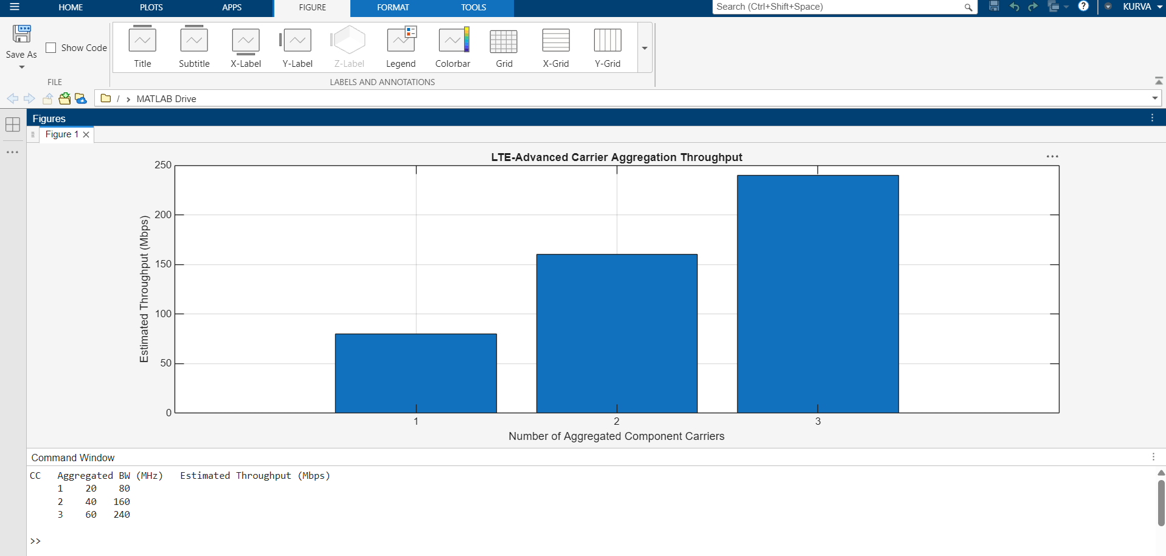
OBJECTIVE-3
clc;
clear;
close all;
BW = [5 10 15 20]; % Carrier bandwidths (MHz)
SE = 4; % Spectral efficiency (bits/s/Hz)
TP = BW .* SE; % Estimated throughput (Mbps)
disp('Bandwidth (MHz) Throughput (Mbps)')
disp([BW' TP'])
figure;
plot(BW, TP, 'o-', 'LineWidth', 2);
grid on;
xlabel('Carrier Bandwidth (MHz)');
ylabel('Estimated Throughput (Mbps)');
title('Throughput vs Component Carrier Bandwidth');
