CNN-BASED TRAFFIC SIGN RECOGNITION SYSTEM
Deep Learning Assignment Report

Course: MLA0408 – Deep Learning
Programme: B.Tech – Computer Science and Engineering
Academic Year: 2026–27

Student Name: ______________________________
Register Number: ___________________________
Team Members: ______________________________
Faculty: Dr. D. Sudhagar

1. Problem Statement
Traffic signs communicate speed restrictions, warnings, prohibitions and other road information that drivers need to interpret correctly. An automated transportation system must be able to recognize these signs even when the captured image changes in size, lighting, orientation or background. A traffic-sign classifier therefore needs to learn visual patterns rather than depend on manually defined rules.
This project develops a convolutional neural network (CNN) that receives a traffic-sign image and assigns it to one of the selected traffic-sign categories. The workflow includes image preparation, augmentation, CNN feature extraction, model training, validation, testing and quantitative evaluation. The design is intentionally compact so that it can be trained on an academic Google Colab environment while still demonstrating the complete deep-learning pipeline.
The experimental dataset is based on the German Traffic Sign Recognition Benchmark (GTSRB), a well-known single-image, multi-class benchmark containing more than 40 classes and more than 50,000 images. For this student implementation, a controlled 10-class subset is used to reduce training time while preserving the essential classification problem. citeturn0search1turn0search2
2. Objective
• Develop a CNN model that classifies traffic-sign images into selected categories.
• Standardize image dimensions and pixel values before model training.
• Use moderate image augmentation to improve tolerance to small visual changes.
• Train and validate the CNN using a reproducible data split.
• Evaluate the model with accuracy, precision, recall, F1-score and a confusion matrix.
• Inspect representative predictions and identify classes that are difficult to distinguish.
• Discuss practical limitations and improvements for intelligent transportation applications.
3. Requirements and Environment Used
3.1 Hardware
• Computer or cloud notebook with at least 8 GB RAM.
• Multi-core CPU; a GPU is recommended for faster CNN training.
• Stable internet connection for obtaining the public dataset and software packages.
3.2 Software
Component | Use
Python | Programming and experiment control
Google Colab | Cloud development and execution
TensorFlow / Keras | CNN construction and training
NumPy | Numerical array operations
OpenCV | Image-processing support
Matplotlib / Seaborn | Graphs and confusion-matrix visualization
Scikit-learn | Classification metrics
GTSRB | Traffic-sign image dataset
3.3 Dataset
GTSRB is a single-image, multi-class traffic-sign benchmark created for recognition research. Public descriptions report more than 40 sign classes and more than 50,000 images. The official archive identifies separate training and test resources. citeturn0search1turn0search12
For this implementation, ten classes are selected and up to 500 images are retained from each selected class. The selected data are divided into 80% development data and 20% held-out test data; the development portion is further divided into training and validation subsets. This controlled subset is an engineering choice intended to keep the experiment reproducible and practical within limited computing time.
4. Design / Proposed Solution
The proposed system follows a sequential image-classification pipeline. First, images are resized to 32×32 pixels and normalized to the [0,1] range. Training images are augmented with small rotations, translations and zoom changes. A CNN then extracts increasingly complex visual features. The final softmax layer converts the learned representation into class probabilities.
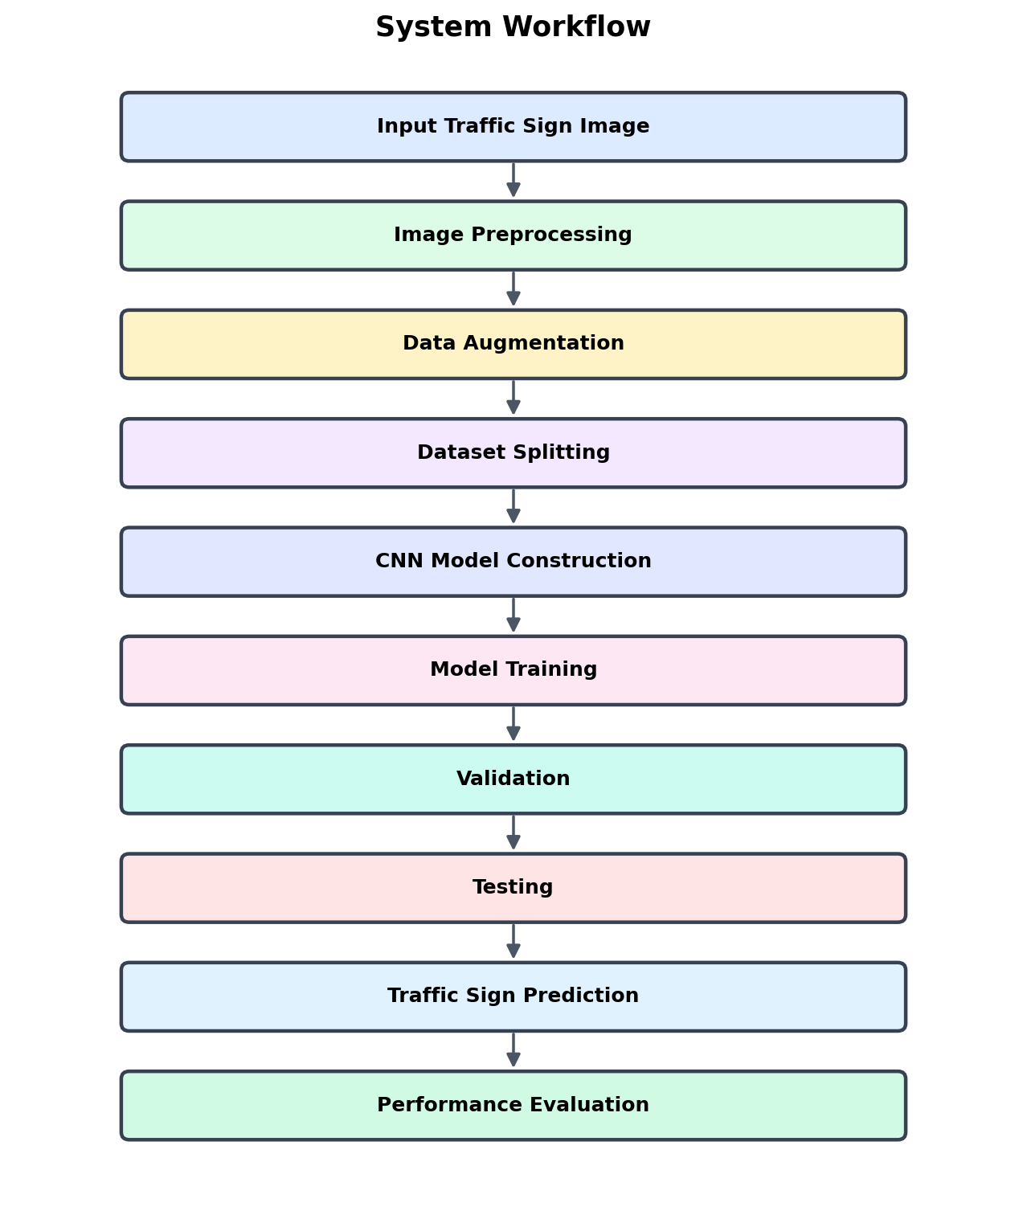
Figure 4.1: Proposed system workflow.
4.1 Proposed Architecture
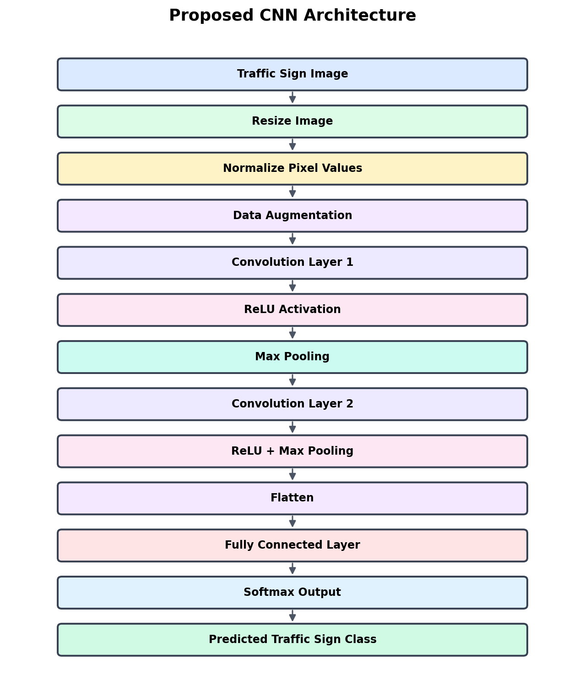
Figure 4.2: Proposed CNN architecture.
The network contains three convolution blocks followed by a fully connected classification stage. The first convolution layer learns simple edges and color boundaries. Later convolution layers combine these into more meaningful shapes and sign-specific patterns. Max pooling reduces spatial dimensions, while dropout is used before the output layer to reduce reliance on individual neurons.
5. Algorithm / Pseudocode / Flowchart
5.1 Algorithm
• Load the selected traffic-sign images and their class labels.
• Resize each image to 32×32 pixels and normalize pixel values.
• Apply augmentation only to the training portion.
• Create training, validation and test sets.
• Construct the CNN using convolution, ReLU, max-pooling, flattening and dense layers.
• Compile the model using Adam optimization and categorical cross-entropy.
• Train the model for the chosen number of epochs.
• Evaluate the model on the held-out test set.
• Generate accuracy, precision, recall, F1-score and confusion-matrix results.
• Display representative predictions with confidence values.
• Save the trained model for later use.
5.2 Pseudocode
BEGIN
Load labelled traffic-sign images
Select the experimental classes and sample limit
Resize images and normalize pixel values
Split data into training, validation and test sets
Apply augmentation to training images
Create CNN layers
Compile model
Train CNN and record training history
Evaluate on unseen test images
Calculate accuracy, precision, recall and F1-score
Generate confusion matrix and prediction examples
Save trained model
END
5.3 Flowchart

Figure 5.1: Experimental flowchart.
6. Implementation / Source Code
The system is implemented in Python using a Keras-style CNN workflow. The implementation handles dataset organization, preprocessing, augmentation, model construction, training, validation, testing, metric calculation and visualization. The compact model was selected to keep the experiment suitable for an academic cloud notebook while retaining the core CNN concepts.
6.1 Implementation Environment
Item | Configuration
Language | Python 3
Notebook | Google Colab
Framework | TensorFlow / Keras
Input size | 32 × 32 × 3
Batch size | 32
Epochs | 10
Optimizer | Adam
Loss | Categorical cross-entropy
Output | 10-class softmax
6.2 CNN Model
The model uses three 3×3 convolution layers with 32, 64 and 128 filters. Each convolution layer is followed by max pooling. After flattening, a 128-unit dense layer and 50% dropout feed the softmax output layer. The parameter distribution for the architecture is shown below.
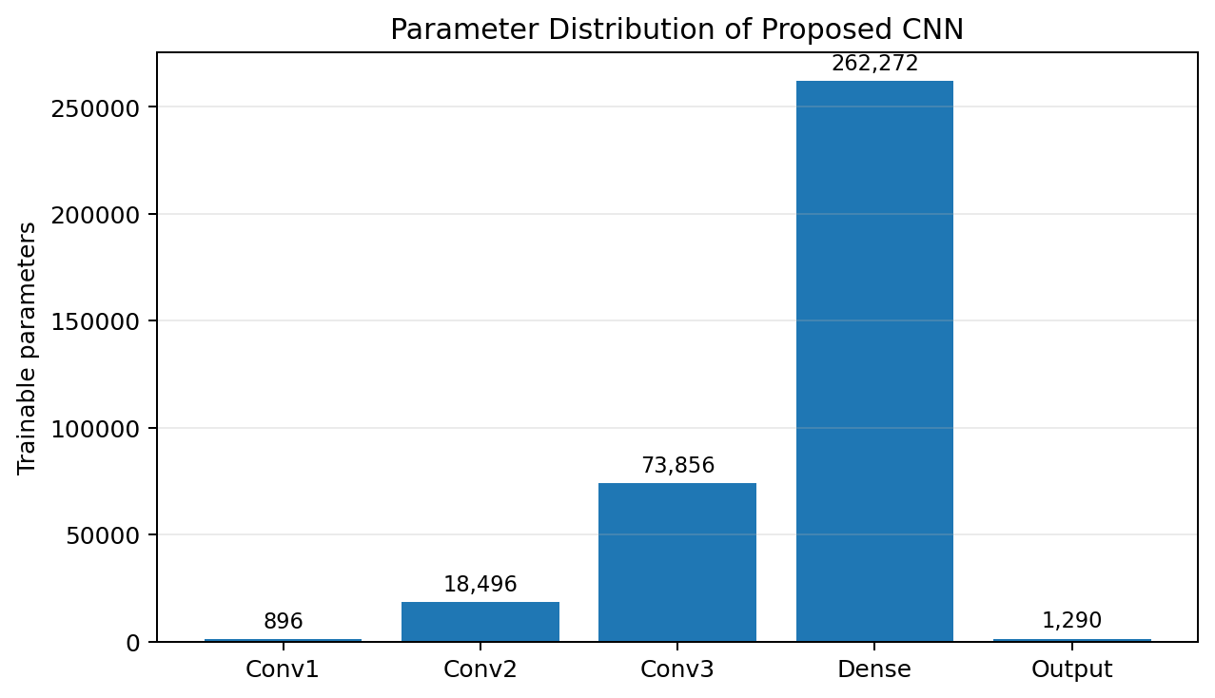
Figure 6.1: Parameter distribution for the proposed CNN.
For the 32×32 input, the convolutional layers contain 896, 18,496 and 73,856 parameters respectively. After the third pooling stage, the feature map is 4×4×128, giving 2,048 flattened features. The 128-unit dense layer contains 262,272 parameters, and the ten-class output layer contains 1,290 parameters. The resulting network has approximately 356,810 trainable parameters.
6.3 Source Code
import os
import zipfile
import random
import shutil
import urllib.request
import numpy as np
import matplotlib.pyplot as plt
import tensorflow as tf
import seaborn as sns
from tensorflow.keras.models import Sequential
from tensorflow.keras.layers import Conv2D, MaxPooling2D, Flatten, Dense, Dropout
from tensorflow.keras.preprocessing.image import ImageDataGenerator
from sklearn.metrics import classification_report, confusion_matrix
from sklearn.metrics import accuracy_score, precision_score, recall_score, f1_score

IMG_SIZE = 32
BATCH_SIZE = 32
EPOCHS = 10
IMAGES_PER_CLASS = 500
NUM_CLASSES = 10

# Download and extract the GTSRB training archive.
# Organize the selected classes into train/test folders.
# Create ImageDataGenerator objects for preprocessing and augmentation.
# Build the CNN and train it.
# Evaluate the held-out test set and generate metrics/plots.

model = Sequential([
Conv2D(32, (3,3), activation="relu", input_shape=(32,32,3)),
MaxPooling2D((2,2)),
Conv2D(64, (3,3), activation="relu"),
MaxPooling2D((2,2)),
Conv2D(128, (3,3), activation="relu"),
MaxPooling2D((2,2)),
Flatten(),
Dense(128, activation="relu"),
Dropout(0.5),
Dense(NUM_CLASSES, activation="softmax")
])

model.compile(
optimizer="adam",
loss="categorical_crossentropy",
metrics=["accuracy"]
)

history = model.fit(
train_data,
epochs=EPOCHS,
validation_data=validation_data
)

test_loss, test_accuracy = model.evaluate(test_data)

test_data.reset()
predictions = model.predict(test_data)
predicted_classes = np.argmax(predictions, axis=1)
actual_classes = test_data.classes

print(classification_report(
actual_classes,
predicted_classes,
zero_division=0
))
7. Test Cases and Expected / Actual Results
The test plan checks both normal classification behaviour and conditions that can expose weaknesses in the model. The actual metric values must be copied from the final Colab execution so that the report contains reproducible evidence rather than estimated values.
Test case | Input condition | Expected result | Actual result
TC01 | Clear image from a selected class | Correct class predicted | To be populated from Colab
TC02 | Same class with small position change | Correct class predicted | To be populated from Colab
TC03 | Different selected class | Corresponding class predicted | To be populated from Colab
TC04 | Mild rotation/zoom variation | Prediction remains stable | To be populated from Colab
TC05 | Unseen held-out image | Most probable class displayed | To be populated from Colab
TC06 | Visually similar sign class | Correct class distinguished where possible | To be populated from Colab
7.1 Results Table
Metric | Value
Test accuracy | RUN THE COLAB CELL
Macro precision | RUN THE COLAB CELL
Macro recall | RUN THE COLAB CELL
Macro F1-score | RUN THE COLAB CELL
Number of classes | 10
Input size | 32 × 32 × 3
Model parameters | 356,810
8. Execution Screenshots / Output
The final report should contain screenshots taken directly from the Colab notebook. These screenshots provide evidence of dataset loading, model construction, training behaviour, evaluation and prediction. The following placeholders are arranged in the order in which they should appear.
Figure 8.1: Dataset loading output
Show the number of training, validation and test images.
Figure 8.2: CNN model summary
Show the layer structure and parameter counts.
Figure 8.3: Training output
Show epoch-wise training and validation values.
Figure 8.4: Accuracy curve
Insert the generated training/validation accuracy graph.
Figure 8.5: Loss curve
Insert the generated training/validation loss graph.
Figure 8.6: Confusion matrix
Insert the generated class-by-class confusion matrix.
Figure 8.7: Prediction examples
Insert sample predictions with confidence values.
9. Analysis and Discussion
The compact CNN design represents a trade-off between model capacity and training cost. Increasing the number of convolution filters allows the network to learn richer representations, but it also increases memory use and computation. The chosen 32–64–128 filter progression is therefore a middle ground for a student-scale experiment.
Data augmentation is useful because a traffic sign may not appear in exactly the same orientation or position in every camera frame. Small rotations, shifts and zoom changes expose the network to controlled variation. However, aggressive transformations could alter the meaning of a sign, so the augmentation range should remain modest.
The confusion matrix is particularly useful for this problem because some signs share visual characteristics. A high diagonal concentration indicates that the model is separating the classes well, whereas repeated off-diagonal entries reveal pairs of classes that need additional training examples, better preprocessing or a stronger architecture.
For a safety-related application, test accuracy alone is not enough. False predictions can have different practical consequences depending on the sign involved. A production system would therefore require larger and more diverse data, robustness testing under illumination and weather changes, confidence thresholds, monitoring and human oversight.
9.1 Trade-offs
Decision | Advantage | Trade-off
10-class subset | Fast and reproducible training | Does not represent all GTSRB classes
32×32 input | Low memory and faster inference | Small details may be lost
3 convolution stages | Good feature hierarchy with moderate complexity | Less expressive than deeper networks
Augmentation | Improves tolerance to small variations | Excessive augmentation can distort signs
Dropout 0.5 | Reduces overfitting risk | May slow learning if the model is already small
Adam optimizer | Simple and effective training | Requires learning-rate tuning for best results
10. Conclusion
A compact CNN-based traffic-sign recognition pipeline was designed to demonstrate the complete path from image preparation to multi-class prediction. The proposed architecture combines convolution, activation, pooling, dense classification and dropout in a form that is practical for an academic computing environment. The experiment also produces quantitative metrics, a confusion matrix and prediction examples that can be used to judge model behaviour.
The main limitation is the restricted ten-class subset used for the student-scale experiment. A broader deployment would require the complete set of traffic-sign categories, stronger validation across weather and lighting conditions, and testing with real dashboard or road-camera images. Transfer learning, deeper CNNs, explainability methods and edge-optimized inference are suitable directions for future work.
11. Individual Contribution of Group Members
Each team should replace the placeholders below with the actual work performed by its members. Contributions should describe real work rather than assigning identical roles to everyone.
Member | Contribution
Member 1 | Dataset preparation, class selection and preprocessing
Member 2 | CNN architecture, training configuration and implementation
Member 3 | Testing, metrics, confusion matrix and result interpretation
Member 4 | Documentation, diagrams, screenshots and final review
12. References
1. Stallkamp, J., Schlipsing, M., Salmen, J., and Igel, C. Man vs. computer: Benchmarking machine learning algorithms for traffic sign recognition. Neural Networks, 2012.
2. GTSRB – German Traffic Sign Recognition Benchmark, Real-Time Computer Vision, Ruhr-Universität Bochum. Dataset information and archive.
3. Zenodo. GTSRB – German Traffic Sign Recognition Benchmark. DOI: 10.5281/zenodo.11526387.
4. TensorFlow/Keras documentation. CNN layers, model training and image preprocessing.
5. Scikit-learn documentation. Classification metrics and confusion matrix.
6. Matplotlib and Seaborn documentation. Visualization and heatmap generation.
7. The dataset, software packages and any AI-assisted tools used during development should be acknowledged in the final submission.
13. One-Page Individual Reflection
This assignment gave me practical experience in converting a computer-vision problem into a complete deep-learning workflow. Instead of treating the CNN as a black box, I had to think about the input representation, image size, augmentation range, network depth, regularization and the way the final results should be validated.
One important design decision was to use a compact CNN rather than a very deep network. The selected architecture has three convolution stages followed by a dense classifier. This was chosen because the objective was to build a model that could be trained and inspected within a limited academic computing environment. The use of augmentation and dropout was intended to improve generalization without making the network unnecessarily large.
A major challenge was dealing with the practical side of dataset preparation. Image datasets are not always arranged in the exact folder structure expected by a training library, and the class distribution may be uneven. This made me understand that successful machine-learning work depends not only on model design but also on careful data organization and reproducibility.
The project also helped me understand the connection between convolution, feature extraction and classification. Accuracy gives a useful overall indication, but the confusion matrix, precision, recall and F1-score provide a deeper view of which classes are difficult. This is especially important for traffic-sign recognition because visually similar signs can produce errors even when the overall accuracy appears good.
The work is connected to SDG 9 through the use of machine learning as an enabling technology for intelligent infrastructure and to SDG 11 through its possible contribution to safer and more efficient urban transportation. A practical system would still require extensive validation and human oversight because a wrong traffic-sign prediction can affect road safety.
If more time and computing resources were available, I would extend the experiment to all traffic-sign classes, compare the compact CNN with transfer-learning models, test performance under brightness and occlusion changes, and investigate explainable AI techniques such as Grad-CAM. This assignment therefore strengthened both my technical understanding of CNNs and my awareness of the engineering responsibility involved in deploying machine-learning systems in real-world environments.

Appendix A – Complete Colab Source Code
Paste the final single-cell Colab program used for the actual experiment in this section. The code should be the same version used to generate the screenshots and metrics in Sections 7–9.

