Name: P.Jeeva
Reg No: 192412636
Course Code:ITA0609

CO4-AT1-CODING CHALLENGE

1.import numpy as np
from sklearn.datasets import load_wine
from sklearn.model_selection import train_test_split
from sklearn.metrics import accuracy_score

# Load dataset
data = load_wine()
X = data.data
y = data.target

# Split dataset
X_train, X_test, y_train, y_test = train_test_split(
X, y, test_size=0.2, random_state=42
)

# Euclidean distance
def distance(a, b):
return np.sqrt(np.sum((a - b) ** 2))

# KNN function
def knn_predict(X_train, y_train, test, k):
distances = []

for i in range(len(X_train)):
d = distance(X_train[i], test)
distances.append((d, y_train[i]))

distances.sort()

neighbors = distances[:k]
labels = [x[1] for x in neighbors]

return max(set(labels), key=labels.count)

# User enters K
k = int(input("Enter value of K: "))

# Predictions
predictions = []

for test in X_test:
predictions.append(knn_predict(X_train, y_train, test, k))

# Display results
print("\nPredicted Class Labels:")
print([int(x) for x in predictions])

print("\nActual Class Labels:")
print([int(x) for x in y_test])
accuracy = accuracy_score(y_test, predictions)

print("\nAccuracy:", accuracy)
print("Accuracy Percentage:", accuracy * 100)
Output
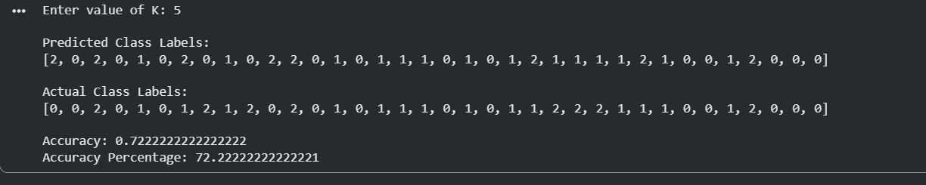

2 .
import numpy as np
from sklearn.datasets import load_breast_cancer
from sklearn.model_selection import train_test_split
from sklearn.preprocessing import StandardScaler
from sklearn.metrics import accuracy_score

# Load dataset
data = load_breast_cancer()
X = data.data
y = data.target

print("Dataset Shape:", X.shape)

# Split dataset
X_train, X_test, y_train, y_test = train_test_split(
X, y, test_size=0.2, random_state=42
)

# Scale data
scaler = StandardScaler()
X_train = scaler.fit_transform(X_train)
X_test = scaler.transform(X_test)

# Add bias
X_train = np.c_[np.ones(X_train.shape[0]), X_train]
X_test = np.c_[np.ones(X_test.shape[0]), X_test]

# Sigmoid function
def sigmoid(z):
return 1 / (1 + np.exp(-z))

# Initialize weights
weights = np.zeros(X_train.shape[1])

# Learning parameters
learning_rate = 0.01
epochs = 1000

# Gradient Descent
for i in range(epochs):
z = np.dot(X_train, weights)
y_pred = sigmoid(z)

gradient = np.dot(X_train.T, (y_pred - y_train)) / len(y_train)

weights = weights - learning_rate * gradient

# Prediction
probability = sigmoid(np.dot(X_test, weights))
prediction = (probability >= 0.5).astype(int)

# Display results
print("\nSigmoid Output:")
print(probability[:10])

print("\nPredicted Classes:")
print(prediction[:10])

print("\nActual Classes:")
print(y_test[:10])

# Accuracy
accuracy = accuracy_score(y_test, prediction)

print("\nAccuracy:", accuracy)
print("Accuracy Percentage:", accuracy * 100)
Output
