Name: P.Jeeva
Reg No:192412636
Course Code:ITA0609

C04-AT2-INDUSTRY PROBLEM SOLVING

1. Telecommunications Data Plan Recommendation Using K-Nearest Neighbour
1.1 Introduction
Telecommunication companies provide different data plans such as low-data, medium-data, high-data, and unlimited plans. However, every customer has different usage behaviour.
For example:
- A student may use large amounts of mobile data for videos and online classes.
- A customer who mainly makes calls may require a smaller data plan.
- A business customer may require a high-data plan.
- A customer whose usage increases every month may need to upgrade their plan.
Therefore, a recommendation system can be developed using K-Nearest Neighbour (KNN) to recommend a suitable data plan based on the behaviour of similar customers.
KNN is a supervised machine-learning algorithm that predicts the class of a new customer by comparing the customer with previously known customers.

1.2 Objective
The main objectives are:
- To collect customer usage information.
- To identify customers with similar usage patterns.
- To measure similarity between customers.
- To recommend a suitable data plan.
- To continuously update recommendations as customer behaviour changes.
- To provide personalized plans and improve customer satisfaction.

1.3 Input Parameters
The system can use the following customer features:
Feature | Description
Monthly Data Usage | Amount of internet data consumed
Call Duration | Total monthly calling time
SMS Usage | Number of SMS messages
Video Usage | Time spent streaming videos
Social Media Usage | Time spent on social media
Previous Plan | Customer's current plan
Recharge Frequency | Number of recharges
Usage Frequency | How frequently the customer uses mobile services
The output is:
Recommended Data Plan
For example:
- Basic Plan
- Standard Plan
- Premium Plan
- Unlimited Plan

1.4 KNN Method
KNN works on the principle:
Customers with similar usage patterns are likely to prefer similar data plans.
Suppose a new customer has:
- Data usage = 40 GB/month
- Call duration = 300 minutes
- SMS = 50/month
The system compares this customer with existing customers and finds the most similar users.

1.5 Similarity Measurement
Similarity can be calculated using Euclidean distance.
For two customers:
and
the distance is:
For three features:
where:
- = data usage
- = call duration
- = SMS usage
Important
A smaller distance means the customers are more similar.
Before calculating distance, features should normally be normalized, because data usage and SMS counts may have very different numerical ranges.

1.6 KNN Algorithm Steps
Step 1: Collect historical data
The company collects information from existing customers.
Step 2: Prepare the data
Missing values and abnormal records are handled.
Step 3: Normalize features
The features are converted into comparable ranges.
Step 4: Select K
For example:
Step 5: Calculate distance
Calculate the distance between the new customer and every existing customer.
Step 6: Select nearest customers
Select the 5 customers having the smallest distances.
Step 7: Perform majority voting
Check which data plan is most common among the nearest customers.
Step 8: Generate recommendation
The most frequently selected plan is recommended.

1.7 Example
Assume the system finds the following 5 nearest customers:
Customer | Distance | Existing Plan
C1 | 0.20 | Premium
C2 | 0.35 | Premium
C3 | 0.40 | Standard
C4 | 0.45 | Premium
C5 | 0.50 | Standard
Voting:
- Premium = 3
- Standard = 2
Therefore:

1.8 Weighted KNN
A better version is distance-weighted KNN.
Here, closer customers receive greater importance.
A common weight is:
where:
- = weight of customer
- = distance
- = small value to avoid division by zero
Thus, a customer at distance 0.2 has more influence than a customer at distance 0.8.

1.9 How the System Adapts to Changing Behaviour
Customer behaviour can change over time.
For example:
Month 1 → 10 GB
Month 2 → 15 GB
Month 3 → 25 GB
Month 4 → 40 GB
The customer's data requirement is increasing.
The system stores the latest usage information and uses it in future recommendations.
Adaptation process
New Customer Usage
↓
Update Customer Record
↓
Add Latest Usage Data
↓
Calculate New Similarities
↓
Find New Nearest Customers
↓
Generate Updated Recommendation
Therefore, the system can recommend an upgraded plan when the customer's usage increases.

1.10 Complete KNN System Diagram
Draw this diagram in your record:
┌──────────────────────┐
│ Customer Information │
└──────────┬───────────┘
↓
┌─────────────────────┐
│ Usage Data Collection│
└──────────┬──────────┘
↓
┌─────────────────────┐
│ Data Preprocessing │
│ & Normalization │
└──────────┬──────────┘
↓
┌─────────────────────┐
│ Calculate Distance │
└──────────┬──────────┘
↓
┌─────────────────────┐
│ Find K Neighbours │
└──────────┬──────────┘
↓
┌─────────────────────┐
│ Majority Voting │
└──────────┬──────────┘
↓
┌─────────────────────┐
│ Recommended Plan │
└──────────┬──────────┘
↓
┌─────────────────────┐
│ Customer Feedback │
└──────────┬──────────┘
↓
┌─────────────────────┐
│ Update User Profile │
└─────────────────────┘
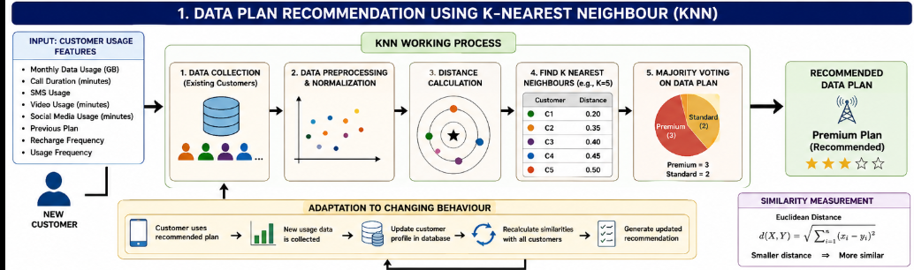

1.11 Advantages
- Simple and easy to understand.
- Does not require a complicated training process.
- Provides personalized recommendations.
- Can handle multiple customer features.
- New customer records can be added easily.
- Suitable for changing customer behaviour.
- Can be extended using weighted KNN.

1.12 Limitations
- Large datasets can make prediction slower.
- Choosing the correct value is important.
- Irrelevant features can affect the result.
- Feature scaling is required.
- Noisy customer data can reduce accuracy.
1.13 Conclusion
KNN provides an effective solution for telecom data-plan recommendation. It measures the similarity between a new customer and existing customers using distance measures. The plans selected by the nearest customers are used to generate the recommendation. Since new usage information can continuously be added to the database, the system can adapt to changes in customer behaviour.

2. Electricity Consumption Prediction Using Locally Weighted Regression
2.1 Introduction
Electricity consumption varies throughout the day and depends on many factors such as:
- Time
- Temperature
- Weather
- Number of appliances being used
- Day of the week
- Season
- Previous electricity consumption
For example, electricity consumption may be low during midnight but increase significantly during morning and evening hours.
A conventional global regression model may not capture all these local variations effectively.
Therefore, Locally Weighted Regression (LWR) can be used.
LWR is a local learning technique that gives greater importance to historical observations that are similar to the current prediction condition.

2.2 Objective
The objectives are:
- Predict future electricity consumption.
- Use time and weather information.
- Capture local consumption patterns.
- Handle daily and seasonal variations.
- Reduce the influence of irrelevant observations.
- Handle noisy electricity measurements.
- Improve energy management and planning.

2.3 Input Parameters
The model can use:
Input | Example
Time | 7:00 PM
Temperature | 30°C
Humidity | 70%
Weather | Cloudy
Day | Monday
Season | Summer
Appliance Usage | High
Previous Consumption | 4.5 kWh
Output
For example:

2.4 What is Locally Weighted Regression?
Ordinary regression attempts to find a general relationship using the entire dataset.
LWR instead focuses on the local region around the input being predicted.
For example, suppose we need to predict electricity consumption at:
Data at:
- 6:30 PM
- 7:00 PM
- 7:30 PM
is more relevant than data at:
- 2:00 AM
- 3:00 AM
Therefore, nearby observations receive higher weights.

2.5 Local Learning Concept
The main idea is:
Nearby Data
↓
Higher Weight
↓
Greater Influence
↓
Better Local Prediction
Distant data receives a smaller weight.
This allows the model to learn different patterns for different time periods.

2.6 Weight Calculation
A commonly used Gaussian weighting function is:
where:
- = weight of historical observation
- = current input
- = historical observation
- = bandwidth parameter
When is close to :
When is far from :

2.7 Weighted Regression
The regression parameters are estimated by minimizing the weighted error:
where:
- = actual electricity consumption
- = input features
- = regression parameters
- = local weight
The prediction is then:

2.8 Step-by-Step Working
Step 1: Collect historical data
Collect electricity consumption data over several days or months.
Step 2: Collect environmental data
Collect:
- Temperature
- Humidity
- Weather
- Season
Step 3: Collect usage information
Record appliance usage and previous electricity consumption.
Step 4: Preprocess data
Handle missing values, abnormal measurements and normalize features.
Step 5: Select prediction point
For example:
Step 6: Calculate similarity/distance
Compare the current condition with historical observations.
Step 7: Assign weights
Nearby observations receive high weights.
Step 8: Perform weighted regression
Use the weighted observations to calculate the local relationship.
Step 9: Generate prediction
Predict the electricity consumption.
Step 10: Compare prediction with actual value
The prediction error can be calculated and used for monitoring model performance.

2.9 Example
Suppose we want to predict consumption at 7 PM.
Historical Time | Consumption | Relative Distance | Weight
6:30 PM | 4.5 kWh | Small | High
7:00 PM | 5.0 kWh | Very Small | Very High
7:30 PM | 5.2 kWh | Small | High
2:00 PM | 2.8 kWh | Large | Low
3:00 AM | 1.1 kWh | Very Large | Very Low
The prediction is mainly influenced by the observations near 7 PM.
This allows LWR to capture the evening peak pattern.

2.10 Handling Daily Variation
Electricity usage changes according to time.
12 AM → Low
6 AM → Increasing
9 AM → Moderate
1 PM → Moderate
6 PM → High
8 PM → Very High
11 PM → Decreasing
LWR can create different local models for different periods.
Therefore, it can capture:
- Morning demand
- Afternoon demand
- Evening peak
- Night-time low demand

2.11 Handling Seasonal Variation
Electricity consumption also changes with seasons.
Summer
High temperature can increase cooling requirements.
High Temperature
↓
More Cooling
↓
More Electricity Consumption
Winter
Heating-related usage may change the consumption pattern.
Rainy Season
Weather conditions can change appliance usage and overall consumption.
By including season and weather as input features, LWR can find historical observations with similar conditions.

2.12 Handling Noisy Data
Electricity data can contain noise because of:
- Sensor errors
- Sudden appliance switching
- Communication errors
- Missing measurements
- Unusual consumption
- Temporary power conditions
LWR reduces the effect of irrelevant observations through weighting.
A distant or less relevant observation receives a lower weight and therefore has less effect on the prediction.
Additional preprocessing can include:
Raw Data
↓
Missing Value Handling
↓
Noise/Outlier Detection
↓
Normalization
↓
Locally Weighted Regression
↓
Prediction

2.13 Required System Architecture Diagram
Draw this diagram:
┌──────────────────────┐
│ Time Information │
└──────────┬───────────┘
│
┌──────────▼───────────┐
│ Weather Information │
└──────────┬───────────┘
│
┌──────────▼───────────┐
│ Temperature/Humidity │
└──────────┬───────────┘
│
┌──────────▼───────────┐
│ Appliance Usage │
└──────────┬───────────┘
│
┌──────────▼───────────┐
│ Historical Power Data│
└──────────┬───────────┘
↓
┌──────────────────────┐
│ Data Preprocessing │
└──────────┬───────────┘
↓
┌──────────────────────┐
│ Calculate Distance │
└──────────┬───────────┘
↓
┌──────────────────────┐
│ Assign Local Weights │
└──────────┬───────────┘
↓
┌──────────────────────┐
│ Weighted Regression │
└──────────┬───────────┘
↓
┌──────────────────────┐
│ Electricity │
│ Consumption │
│ Prediction │
└──────────────────────┘

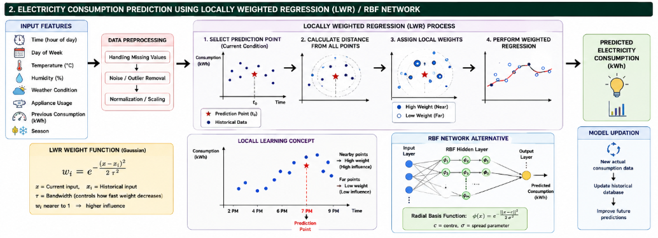
2.14 Local Learning Diagram
This is another useful diagram to include because the question specifically asks how local learning captures variations.
You can draw it simply as:
Electricity
Consumption
│
6 │ ●
5 │ ● ● ● ← High weight
4 │ ● ●
3 │ ● ← Low weight
2 │ ●
1 │●
└──────────────────────────── Time
2PM 4PM 6PM 7PM 9PM

↑
Prediction Point
7 PM

Nearby points → High weight
Far points → Low weight

2.15 RBF Network Alternative
The question also allows an RBF Network.
An RBF network is useful because electricity consumption is often nonlinear.
Structure
Time ────────────────┐
Temperature ─────────┤
Weather ─────────────┤
Appliance Usage ─────┤
Previous Consumption ┤
Season ──────────────┘
↓
INPUT LAYER
↓
┌───────────────────────┐
│ RBF HIDDEN LAYER │
│ │
│ φ1 φ2 φ3 φ4 │
└───────────┬───────────┘
↓
OUTPUT LAYER
↓
Predicted Electricity
Consumption
The radial basis function can be written as:
where:
- = input vector
- = centre of RBF
- = spread parameter

2.16 LWR vs RBF
Parameter | LWR | RBF Network
Learning type | Local learning | Local basis-function learning
Main principle | Nearby observations get higher weight | Nearby inputs activate RBF units
Model complexity | Low | Medium/High
Nonlinear patterns | Limited | Excellent
Seasonal patterns | Good | Very good
Noise handling | Weight-based | Depends on training
Training requirement | Low | Higher
Interpretability | Easier | More difficult
Suitable for | Local trends | Complex nonlinear patterns

2.17 Advantages of LWR
- Simple concept.
- Captures local variations.
- Suitable for changing electricity patterns.
- Gives more importance to relevant historical data.
- Can model different time periods.
- Can incorporate weather information.
- Useful for nonlinear or changing local relationships.
- Does not require one global model for every condition.

2.18 Limitations of LWR
- Prediction can be computationally expensive for large datasets.
- Selection of bandwidth is important.
- Sensitive to irrelevant features.
- Requires suitable preprocessing.
- Very sparse historical data can reduce prediction quality.

2.19 Applications
The proposed system can be used for:
- Smart homes
- Smart buildings
- Electricity distribution
- Industrial energy management
- Smart grids
- Demand forecasting
- Peak-load management
- Energy-saving systems

2.20 Conclusion
Locally Weighted Regression provides an effective approach for predicting electricity consumption because it focuses on historically similar conditions rather than treating every observation equally. Time, temperature, weather, appliance usage, season and previous consumption can be used as input features.
The local weighting mechanism allows the system to capture morning, afternoon, evening, weekday, weekend and seasonal variations. Noisy or irrelevant observations have less influence when they receive smaller weights. An RBF network can also be used when the electricity consumption relationship is highly nonlinear.

