Experiment 7: Breadth First Search (BFS):

Aim
To implement the Breadth First Search (BFS) traversal algorithm to visit all the nodes of a graph, level by level, starting from a given source node.

Objective
- To understand the concept of graph traversal in Artificial Intelligence.
- To implement the BFS algorithm using a queue data structure.
- To find the order in which nodes are visited using BFS from a given source node.

Algorithm
- Read the graph as an adjacency list and the starting node.
- Create an empty queue and an empty visited set.
- Insert the starting node into the queue and mark it as visited.
- Repeat steps 5 to 7 while the queue is not empty.
- Dequeue a node from the front of the queue and add it to the traversal path.
- Find all unvisited neighbours of the dequeued node.
- Mark each unvisited neighbour as visited and insert it into the queue.
- Display the BFS traversal path.
- Stop.

Flowchart
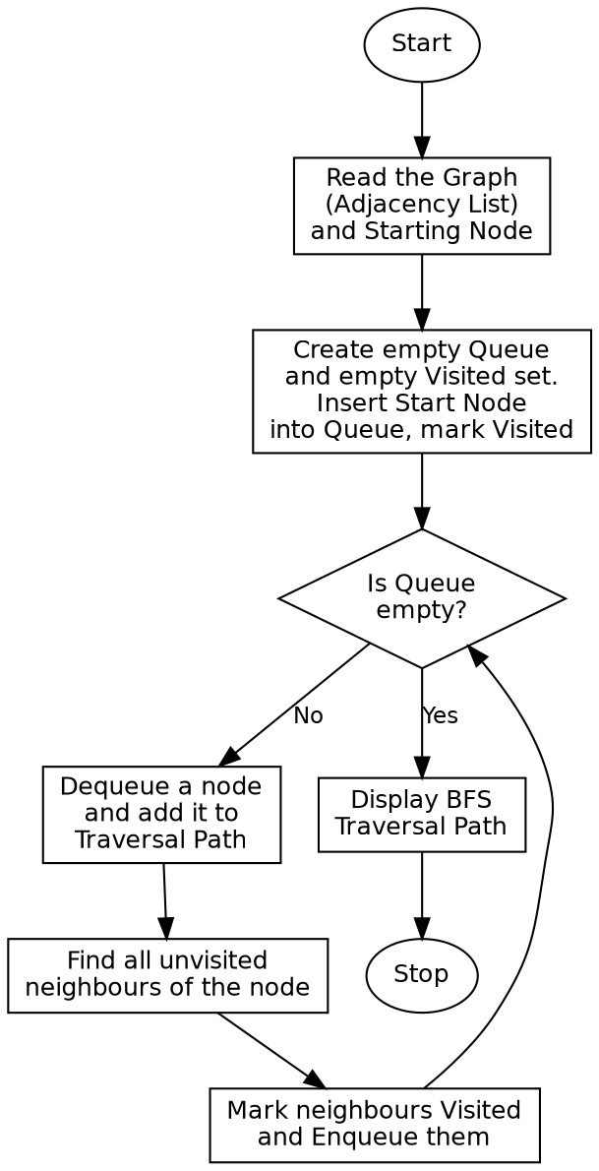

Program:

from collections import deque
def bfs(graph, start):
visited = {start}
queue = deque([start])
traversal = []
while queue:
node = queue.popleft()
traversal.append(node)
for neighbour in graph[node]:
if neighbour not in visited:
visited.add(neighbour)
queue.append(neighbour)
return traversal
if __name__ == "__main__":
graph = {
'A': ['B', 'C'],
'B': ['A', 'D', 'E'],
'C': ['A', 'F'],
'D': ['B'],
'E': ['B', 'F'],
'F': ['C', 'E']
}
start_node = 'A'
print("Graph (Adjacency List):")
for node in graph:
print(f"{node}: {graph[node]}")
print()
print(f"Starting Node: {start_node}\n")
result = bfs(graph, start_node)
print("BFS Traversal Order:")
print(" -> ".join(result))

Sample Input
Graph (Adjacency List): A-B, A-C, B-D, B-E, C-F, E-F
Starting Node: A

Sample Output
Graph (Adjacency List):
A: ['B', 'C']
B: ['A', 'D', 'E']
C: ['A', 'F']
D: ['B']
E: ['B', 'F']
F: ['C', 'E']
Starting Node: A
BFS Traversal Order:
A -> B -> C -> D -> E -> F

Result
The Breadth First Search algorithm was successfully implemented and all nodes of the given graph were traversed level by level from the source node.

Conclusion
The Breadth First Search algorithm demonstrates level-order graph traversal in Artificial Intelligence using a queue data structure, and shows how it systematically explores all neighbouring nodes before moving to the next level.

