Experiment 8: Depth First Search (DFS):

Aim
To implement the Depth First Search (DFS) traversal algorithm to visit all the nodes of a graph by exploring as far as possible along each branch before backtracking.

Objective
- To understand the concept of depth-first graph traversal in Artificial Intelligence.
- To implement the DFS algorithm using recursion.
- To find the order in which nodes are visited using DFS from a given source node.

Algorithm
- Read the graph as an adjacency list and the starting node.
- Create an empty visited set and an empty traversal path.
- Mark the starting node as visited and add it to the traversal path.
- For each unvisited neighbour of the current node, recursively repeat step 3.
- Backtrack to the previous node when all neighbours of the current node have been visited.
- Repeat steps 3 to 5 until all reachable nodes have been visited.
- Display the DFS traversal path.
- Stop.

Flowchart
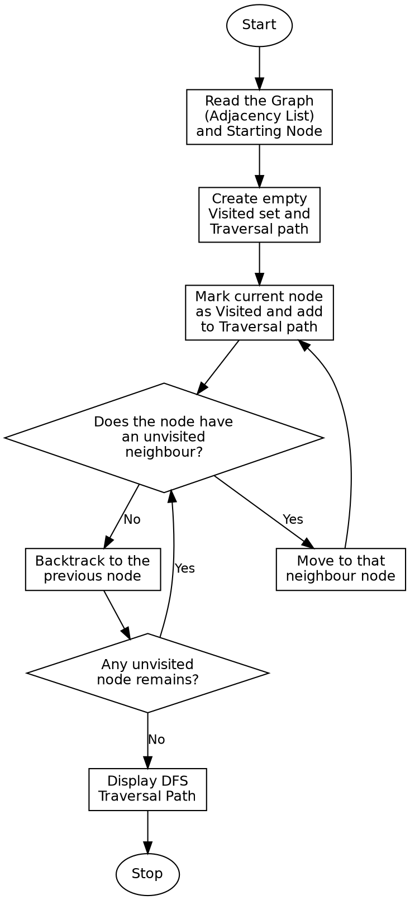

Program:

def dfs(graph, node, visited=None, traversal=None):
if visited is None:
visited = set()
if traversal is None:
traversal = []
visited.add(node)
traversal.append(node)
for neighbour in graph[node]:
if neighbour not in visited:
dfs(graph, neighbour, visited, traversal)
return traversal
if __name__ == "__main__":
graph = {
'A': ['B', 'C'],
'B': ['A', 'D', 'E'],
'C': ['A', 'F'],
'D': ['B'],
'E': ['B', 'F'],
'F': ['C', 'E']
}
start_node = 'A'
print("Graph (Adjacency List):")
for node in graph:
print(f"{node}: {graph[node]}")
print()
print(f"Starting Node: {start_node}\n")
result = dfs(graph, start_node)
print("DFS Traversal Order:")
print(" -> ".join(result))

Sample Input
Graph (Adjacency List): A-B, A-C, B-D, B-E, C-F, E-F
Starting Node: A

Sample Output
Graph (Adjacency List):
A: ['B', 'C']
B: ['A', 'D', 'E']
C: ['A', 'F']
D: ['B']
E: ['B', 'F']
F: ['C', 'E']
Starting Node: A
DFS Traversal Order:
A -> B -> D -> E -> F -> C

Result
The Depth First Search algorithm was successfully implemented and all nodes of the given graph were traversed by exploring each branch fully before backtracking.

Conclusion
The Depth First Search algorithm demonstrates depth-oriented graph traversal in Artificial Intelligence using recursion, and shows how it explores one branch completely before backtracking to explore other branches.

