Experiment 16: Feed Forward Neural Network:

Aim
To implement a Feed Forward Neural Network using Artificial Intelligence to compute an output by propagating input values through weighted connections and activation functions.

Objective
- To understand the concept and structure of a Feed Forward Neural Network in Artificial Intelligence.
- To implement forward propagation using weights, biases and an activation function.
- To compute the network's final output for a given set of inputs.

Algorithm
- Read the input values for the input layer.
- Initialize the weights and biases for each layer (input-to-hidden and hidden-to-output).
- For each neuron in the hidden layer, compute the weighted sum of inputs plus the bias.
- Apply the activation function (Sigmoid) to the weighted sum to get the hidden layer output.
- For each neuron in the output layer, compute the weighted sum of the hidden layer outputs plus the bias.
- Apply the activation function to the weighted sum to get the final output.
- Display the output of the hidden layer and the output layer.
- Stop.

Flowchart
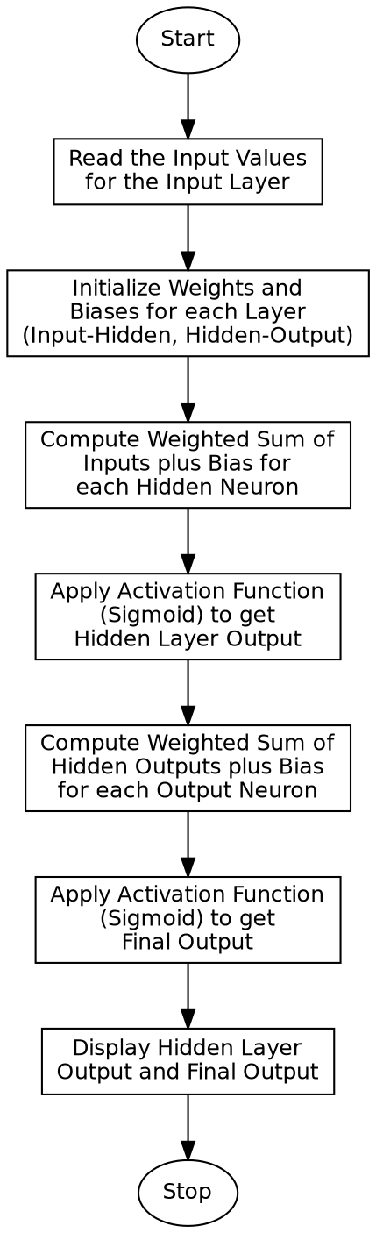

Program:

import numpy as np
def sigmoid(x):
return 1 / (1 + np.exp(-x))
def forward_propagation(inputs, weights_hidden, bias_hidden, weights_output, bias_output):
hidden_input = np.dot(inputs, weights_hidden) + bias_hidden
hidden_output = sigmoid(hidden_input)
final_input = np.dot(hidden_output, weights_output) + bias_output
final_output = sigmoid(final_input)
return hidden_output, final_output
if __name__ == "__main__":
inputs = np.array([0.5, 0.8])
# Weights: 2 input neurons -> 2 hidden neurons
weights_hidden = np.array([
[0.2, 0.4],
[0.6, 0.1]
])
bias_hidden = np.array([0.1, 0.3])
# Weights: 2 hidden neurons -> 1 output neuron
weights_output = np.array([[0.7], [0.5]])
bias_output = np.array([0.2])
print("Input Layer Values:", inputs)
print("\nHidden Layer Weights:\n", weights_hidden)
print("Hidden Layer Bias:", bias_hidden)
print("\nOutput Layer Weights:\n", weights_output)
print("Output Layer Bias:", bias_output)
hidden_output, final_output = forward_propagation(
inputs, weights_hidden, bias_hidden, weights_output, bias_output
)
print("\nHidden Layer Output (after Sigmoid):", hidden_output)
print("Final Output (after Sigmoid):", final_output)

Sample Input
Input Layer Values: [0.5, 0.8]
Hidden Layer Weights: [[0.2, 0.4], [0.6, 0.1]] Hidden Layer Bias: [0.1, 0.3]
Output Layer Weights: [[0.7], [0.5]] Output Layer Bias: [0.2]

Sample Output
Input Layer Values: [0.5 0.8]
Hidden Layer Weights:
[[0.2 0.4]
[0.6 0.1]]
Hidden Layer Bias: [0.1 0.3]
Output Layer Weights:
[[0.7]
[0.5]]
Output Layer Bias: [0.2]
Hidden Layer Output (after Sigmoid): [0.6637387 0.64106741]
Final Output (after Sigmoid): [0.72812905]

Result
The Feed Forward Neural Network was successfully implemented, and the network correctly computed the hidden layer output and the final output using forward propagation.

Conclusion
The Feed Forward Neural Network experiment demonstrates the basic structure of an Artificial Neural Network and shows how input signals are propagated through weighted connections and activation functions to produce an output.

