Experiment 17: Prolog Program to Find the Sum of First N Integers:

Aim
To write a Prolog program to find the sum of the first N natural numbers using recursion.

Objective
- To understand the concept of recursion and facts/rules in Prolog.
- To implement a recursive predicate to compute the sum of first N integers.
- To trace how Prolog evaluates recursive predicates using backtracking.

Algorithm
- Read the value of N.
- If N is 0, the Sum is 0 (base case).
- Otherwise, recursively find Sum1, the sum of the first (N-1) integers.
- Compute Sum = Sum1 + N.
- Display the Sum of the first N integers.
- Stop.

Flowchart
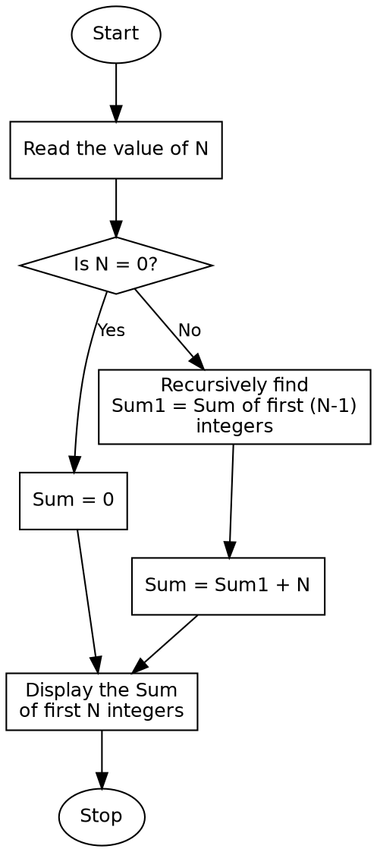

Program:

% Program to find the sum of first N integers
sum_n(0, 0) :- !.
sum_n(N, Sum) :-
N > 0,
N1 is N - 1,
sum_n(N1, Sum1),
Sum is Sum1 + N.
:- initialization(main).
main :-
write('Enter the value of N: '),
read(N),
sum_n(N, Sum),
write('Sum of first '), write(N), write(' integers is: '), write(Sum), nl,
halt.

Sample Input
N = 10

Sample Output
Enter the value of N: 10.
Sum of first 10 integers is: 55

Result
The Prolog program to find the sum of the first N integers was successfully written and executed, and the correct sum was obtained using recursion.

Conclusion
This experiment demonstrates the use of recursion in Prolog to solve a numeric computation problem and shows how a recursive predicate builds up a result through repeated rule application until a base case is reached.

