Experiment 18: Prolog Program to Create a Database (Name and DOB):

Aim
To write a Prolog program to create a simple database of names and dates of birth using facts, and to query the database.

Objective
- To understand the concept of facts and knowledge representation in Prolog.
- To create a database of Name-DOB pairs using Prolog facts.
- To query the database and retrieve information using pattern matching.

Algorithm
- Define a set of facts representing each person's Name and Date of Birth (DOB).
- Read the query (a name whose DOB is to be found).
- Match the query against the facts in the database using unification.
- If a match is found, retrieve and display the corresponding DOB.
- If no match is found, display 'No record found'.
- Repeat for all queries.
- Stop.

Flowchart
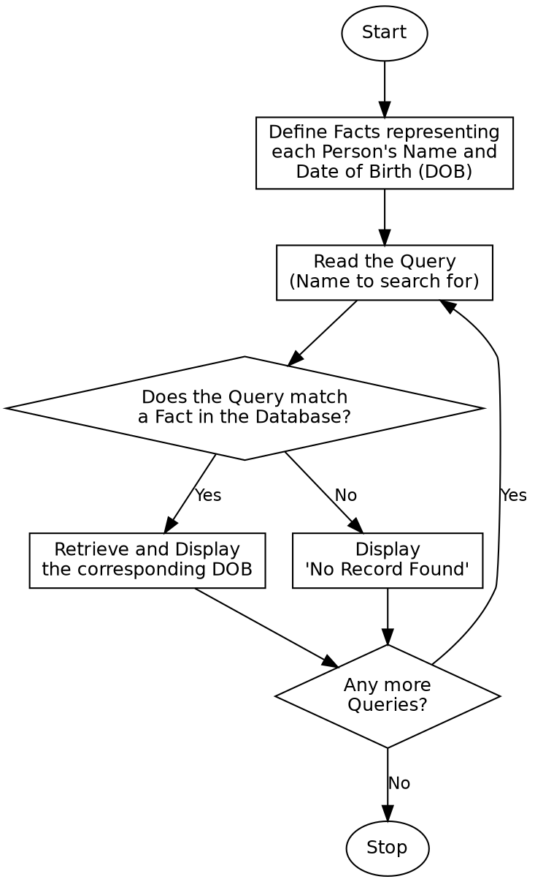

Program:

% Program to create a database of Name and Date of Birth (DOB)
dob('Arun', 15, 6, 1998).
dob('Divya', 22, 11, 2000).
dob('Karthik', 3, 9, 1999).
dob('Priya', 30, 1, 2001).
dob('Suresh', 18, 4, 1997).
find_dob(Name) :-
dob(Name, D, M, Y),
!,
format("~w was born on ~w-~w-~w~n", [Name, D, M, Y]).
find_dob(Name) :-
format("No record found for ~w~n", [Name]).
list_all :-
dob(Name, D, M, Y),
format("~w -> ~w-~w-~w~n", [Name, D, M, Y]),
fail.
list_all :-
nl.
:- initialization(main).
main :-
write('All Records in the Database:'), nl,
list_all,
write('Query: DOB of Karthik'), nl,
find_dob('Karthik'),
write('Query: DOB of Ramesh'), nl,
find_dob('Ramesh'),
halt.

Sample Input
Database Facts: dob(Name, Day, Month, Year) for 5 people
Queries: DOB of 'Karthik', DOB of 'Ramesh' (not in database)

Sample Output
All Records in the Database:
Arun -> 15-6-1998
Divya -> 22-11-2000
Karthik -> 3-9-1999
Priya -> 30-1-2001
Suresh -> 18-4-1997
Query: DOB of Karthik
Karthik was born on 3-9-1999
Query: DOB of Ramesh
No record found for Ramesh

Result
The Prolog program to create and query a Name-DOB database was successfully written and executed, and the correct records were retrieved for valid and invalid queries.

Conclusion
This experiment demonstrates knowledge representation using facts in Prolog and shows how unification and pattern matching are used to query a simple database.

