Experiment 19: Prolog Program to Create a Student-Teacher-Subject Database:

Aim
To write a Prolog program to create a database representing relationships between Students, Teachers and Subjects using facts, and to query the database.

Objective
- To understand how to represent multi-entity relationships using Prolog facts.
- To create a Student-Teacher-Subject database using facts and rules.
- To query the database to find relationships, such as which teacher teaches a subject to a student.

Algorithm
- Define facts representing which Teacher teaches which Subject.
- Define facts representing which Student studies which Subject.
- Read the query (a Student and Subject whose Teacher is to be found).
- Match the query against the facts using unification, combining the studies and teaches facts through a rule.
- If a match is found, display the corresponding Teacher.
- If no match is found, display 'No record found'.
- Repeat for all queries.
- Stop.

Flowchart
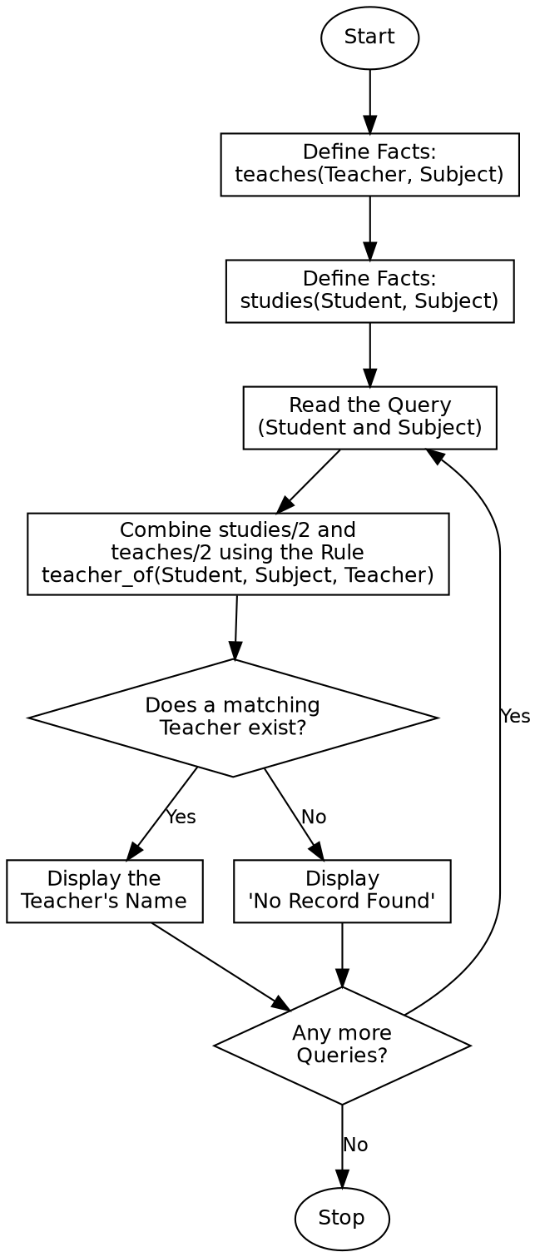

Program:

% Program to create a Student-Teacher-Subject database
teaches('Mr. Raman', 'Mathematics').
teaches('Ms. Kavitha', 'Physics').
teaches('Mr. Suresh', 'Chemistry').
teaches('Ms. Anitha', 'Computer Science').
studies('Arun', 'Mathematics').
studies('Arun', 'Computer Science').
studies('Divya', 'Physics').
studies('Divya', 'Mathematics').
studies('Karthik', 'Chemistry').
teacher_of(Student, Subject, Teacher) :-
studies(Student, Subject),
teaches(Teacher, Subject).
subjects_of(Student, Subjects) :-
findall(Subject, studies(Student, Subject), Subjects).
:- initialization(main).
main :-
write('Query: Who teaches Arun Mathematics?'), nl,
( teacher_of('Arun', 'Mathematics', Teacher) ->
format("Teacher: ~w~n", [Teacher])
; write('No record found'), nl
),
nl,
write('Query: Subjects studied by Arun'), nl,
subjects_of('Arun', Subjects),
format("Subjects: ~w~n", [Subjects]),
nl,
write('Query: Who teaches Karthik Physics?'), nl,
( teacher_of('Karthik', 'Physics', Teacher2) ->
format("Teacher: ~w~n", [Teacher2])
; write('No record found'), nl
),
halt.

Sample Input
Database Facts: teaches(Teacher, Subject) and studies(Student, Subject)
Queries: Teacher of Arun-Mathematics, Subjects studied by Arun, Teacher of Karthik-Physics (no record)

Sample Output
Query: Who teaches Arun Mathematics?
Teacher: Mr. Raman
Query: Subjects studied by Arun
Subjects: [Mathematics,Computer Science]
Query: Who teaches Karthik Physics?
No record found

Result
The Prolog program to create and query a Student-Teacher-Subject database was successfully written and executed, and the correct relationships were retrieved for valid and invalid queries.

Conclusion
This experiment demonstrates how multiple related facts can be combined through rules in Prolog to represent and query relationships between different entities in a database.

