Experiment 20: Prolog Program to Create a Planets Database:

Aim
To write a Prolog program to create a database of planets and their properties, such as position from the Sun and type, using facts, and to query the database.

Objective
- To understand knowledge representation of a domain using Prolog facts.
- To create a Planets database with multiple attributes.
- To query the database to retrieve planets based on given conditions.

Algorithm
- Define facts representing each planet's Name, Position (order from the Sun), and Type (Terrestrial, Gas Giant or Ice Giant).
- Read the query, such as the planet at a given position or all planets of a given type.
- Match the query against the facts using unification.
- If a match is found, display the result.
- If no match is found, display 'No record found'.
- Repeat for all queries.
- Stop.

Flowchart
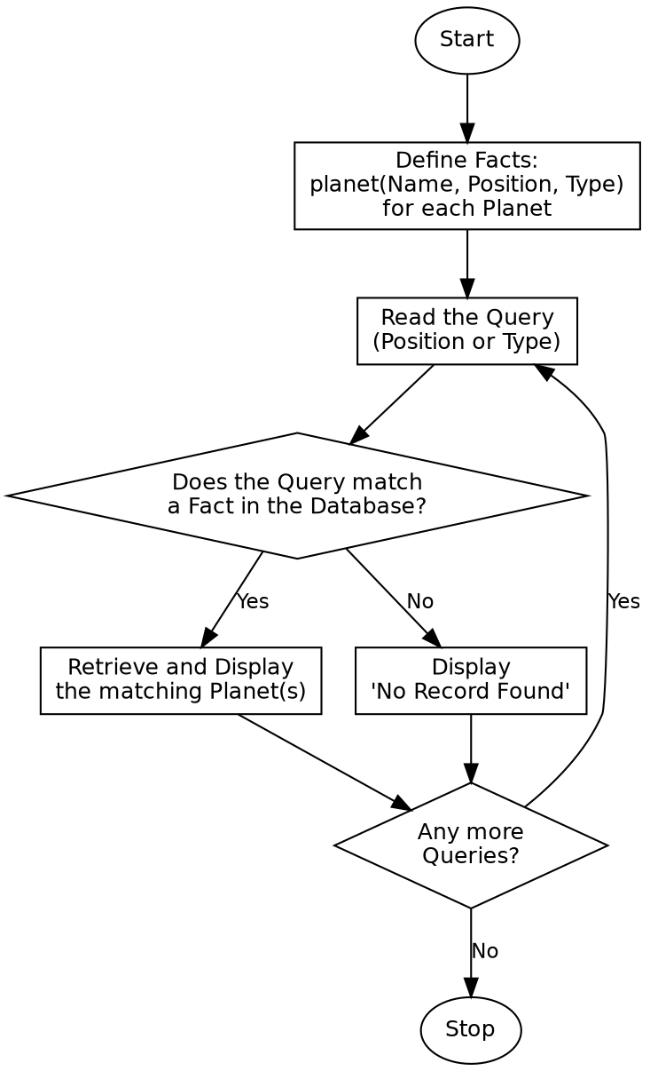

Program:

% Program to create a database of Planets
planet('Mercury', 1, 'Terrestrial').
planet('Venus', 2, 'Terrestrial').
planet('Earth', 3, 'Terrestrial').
planet('Mars', 4, 'Terrestrial').
planet('Jupiter', 5, 'Gas Giant').
planet('Saturn', 6, 'Gas Giant').
planet('Uranus', 7, 'Ice Giant').
planet('Neptune', 8, 'Ice Giant').
planet_at(Position, Name) :-
planet(Name, Position, _).
planets_of_type(Type, Name) :-
planet(Name, _, Type).
:- initialization(main).
main :-
write('Query: Planet at Position 3'), nl,
( planet_at(3, Name) ->
format("Planet: ~w~n", [Name])
; write('No record found'), nl
),
nl,
write('Query: All Terrestrial Planets'), nl,
findall(P, planets_of_type('Terrestrial', P), TerrestrialList),
format("Planets: ~w~n", [TerrestrialList]),
nl,
write('Query: Planet at Position 9'), nl,
( planet_at(9, Name2) ->
format("Planet: ~w~n", [Name2])
; write('No record found'), nl
),
halt.

Sample Input
Database Facts: planet(Name, Position, Type) for 8 planets
Queries: Planet at Position 3, All Terrestrial planets, Planet at Position 9 (no record)

Sample Output
Query: Planet at Position 3
Planet: Earth
Query: All Terrestrial Planets
Planets: [Mercury,Venus,Earth,Mars]
Query: Planet at Position 9
No record found

Result
The Prolog program to create and query a Planets database was successfully written and executed, and the correct records were retrieved for valid and invalid queries.

Conclusion
This experiment demonstrates knowledge representation of a real-world domain using facts in Prolog and shows how unification and pattern matching are used to retrieve records based on given conditions.

