Experiment 21: Prolog Program to Solve the Towers of Hanoi:

Aim
To write a Prolog program to solve the Towers of Hanoi puzzle and display the sequence of moves required to transfer N disks from the Source peg to the Destination peg using an Auxiliary peg.

Objective
- To understand the concept of recursion in solving classic AI puzzles using Prolog.
- To implement the Towers of Hanoi problem using recursive predicates.
- To display the sequence of moves and the total number of moves.

Algorithm
- Read the number of disks N, and the names of the Source, Auxiliary and Destination pegs.
- If N = 1, move the single disk directly from Source to Destination and stop this branch.
- Otherwise, recursively move the top (N-1) disks from Source to Auxiliary, using Destination as the helper peg.
- Move the remaining largest disk from Source to Destination.
- Recursively move the (N-1) disks from Auxiliary to Destination, using Source as the helper peg.
- Repeat steps 2 to 5 until all disks are moved.
- Display each move and the total count of moves.
- Stop.

Flowchart
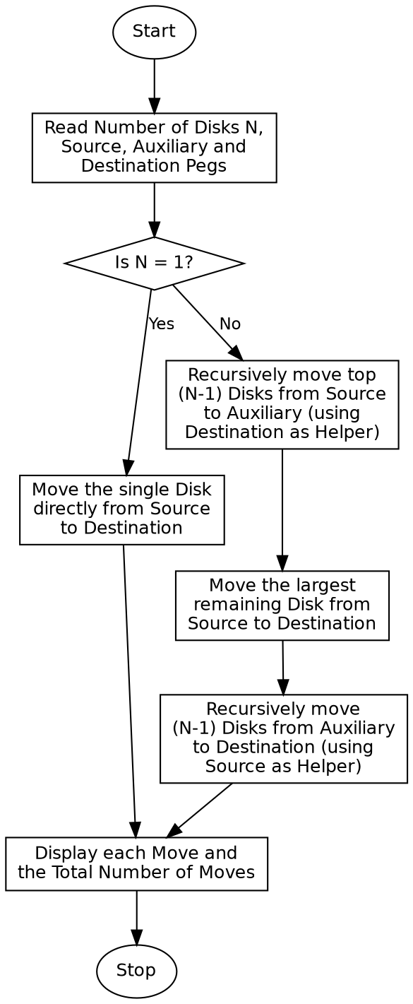

Program:

% Program to solve the Towers of Hanoi puzzle
hanoi(1, Source, _, Destination) :-
!,
format("Move disk 1 from ~w to ~w~n", [Source, Destination]).
hanoi(N, Source, Auxiliary, Destination) :-
N > 1,
N1 is N - 1,
hanoi(N1, Source, Destination, Auxiliary),
format("Move disk ~w from ~w to ~w~n", [N, Source, Destination]),
hanoi(N1, Auxiliary, Source, Destination).
:- initialization(main).
main :-
N = 3,
format("Towers of Hanoi for ~w disks~n", [N]),
format("Source = A, Auxiliary = B, Destination = C~n~n", []),
hanoi(N, 'A', 'B', 'C'),
Total is (2 ^ N) - 1,
format("~nTotal number of moves: ~w~n", [Total]),
halt.

Sample Input
Number of Disks N = 3
Source = A, Auxiliary = B, Destination = C

Sample Output
Towers of Hanoi for 3 disks
Source = A, Auxiliary = B, Destination = C
Move disk 1 from A to C
Move disk 2 from A to B
Move disk 1 from C to B
Move disk 3 from A to C
Move disk 1 from B to A
Move disk 2 from B to C
Move disk 1 from A to C
Total number of moves: 7

Result
The Prolog program to solve the Towers of Hanoi puzzle was successfully written and executed, and the correct sequence of moves along with the total move count was obtained.

Conclusion
This experiment demonstrates the power of recursion in Prolog to solve a classic AI puzzle, and shows how a problem can be broken down into smaller sub-problems that are solved recursively and combined.

