Experiment 22: Prolog Program to Determine Whether a Bird Can Fly:

Aim
To write a Prolog program to determine whether a given bird can fly, using facts and rules based on the bird's characteristics.

Objective
- To understand how to represent knowledge and rules for classification in Prolog.
- To implement a Prolog program that determines whether a bird can fly based on given facts and exceptions.
- To handle exceptions, such as flightless birds, using negation as failure.

Algorithm
- Define facts representing that an entity is a bird, bird(X).
- Define facts representing flightless birds, flightless(X), such as penguin, ostrich and kiwi.
- Define a rule: a bird can fly if it is a bird AND it is not in the list of flightless birds.
- Read the query (the name of the bird to check).
- Apply the rule using unification and negation as failure to check the condition.
- If the bird can fly, display 'X can fly'.
- If the bird cannot fly, display 'X cannot fly'.
- Repeat for all queries.
- Stop.

Flowchart
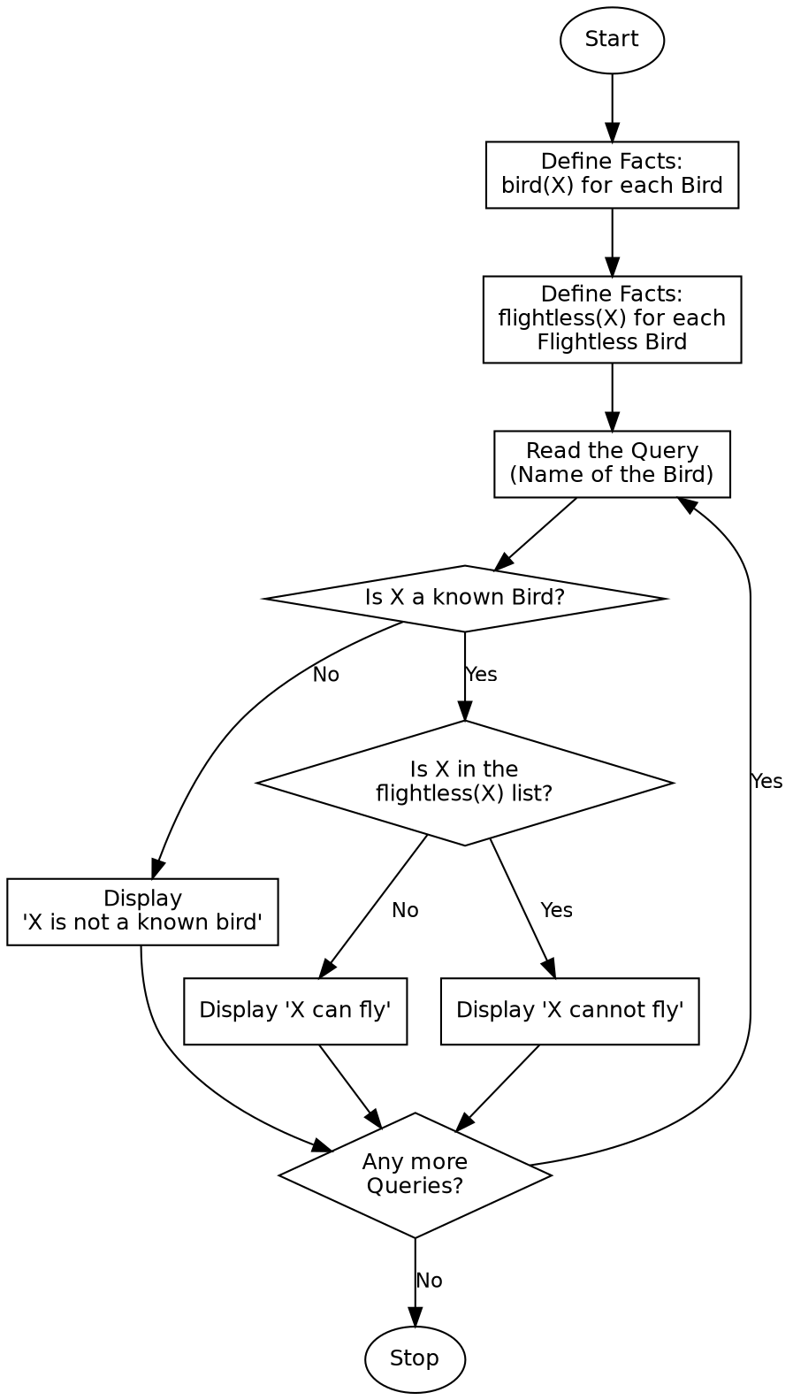

Program:

% Program to determine whether a given bird can fly
bird(sparrow).
bird(eagle).
bird(parrot).
bird(penguin).
bird(ostrich).
bird(kiwi).
flightless(penguin).
flightless(ostrich).
flightless(kiwi).
can_fly(X) :-
bird(X),
\+ flightless(X).
check_fly(X) :-
can_fly(X),
!,
format("~w can fly.~n", [X]).
check_fly(X) :-
bird(X),
!,
format("~w cannot fly.~n", [X]).
check_fly(X) :-
format("~w is not a known bird.~n", [X]).
:- initialization(main).
main :-
check_fly(sparrow),
check_fly(penguin),
check_fly(eagle),
check_fly(ostrich),
check_fly(cat),
halt.

Sample Input
Database Facts: bird(X) for 6 birds, flightless(X) for 3 flightless birds
Queries: sparrow, penguin, eagle, ostrich, cat (not a known bird)

Sample Output
sparrow can fly.
penguin cannot fly.
eagle can fly.
ostrich cannot fly.
cat is not a known bird.

Result
The Prolog program to determine whether a bird can fly was successfully written and executed, and the correct result was obtained for each queried bird, including exceptions and unknown entities.

Conclusion
This experiment demonstrates rule-based classification and the use of negation as failure in Prolog, and shows how exceptions to a general rule can be handled cleanly using facts.

