Experiment 23: Prolog Program to Represent Family Relationships:

Aim
To write a Prolog program to represent family relationships using facts and rules, and to query relationships such as father, mother, grandparent and sibling.

Objective
- To understand how to represent hierarchical relationships using Prolog facts.
- To define rules for derived relationships based on basic facts.
- To query the family database to retrieve specific relationships.

Algorithm
- Define basic facts representing parent(Parent, Child) relationships.
- Define facts representing the gender of each person, male(X) and female(X).
- Define a rule for father(X, Y): X is male and X is a parent of Y.
- Define a rule for mother(X, Y): X is female and X is a parent of Y.
- Define a rule for grandparent(X, Y): X is a parent of some Z, and Z is a parent of Y.
- Define a rule for sibling(X, Y): X and Y have the same parent, and X is not Y.
- Read the query and match it against the appropriate rule.
- Display the result.
- Repeat for all queries.
- Stop.

Flowchart
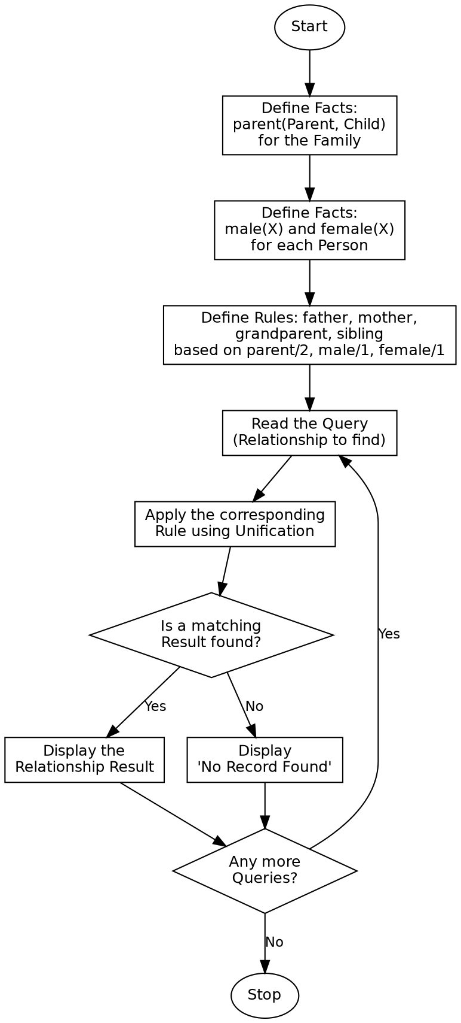

Program:

% Program to represent Family Relationships
parent('John', 'Mary').
parent('John', 'Mike').
parent('Susan', 'Mary').
parent('Susan', 'Mike').
parent('Mary', 'Anna').
parent('Mary', 'Tom').
parent('David', 'Anna').
parent('David', 'Tom').
male('John').
male('Mike').
male('Tom').
male('David').
female('Susan').
female('Mary').
female('Anna').
father(X, Y) :-
parent(X, Y),
male(X).
mother(X, Y) :-
parent(X, Y),
female(X).
grandparent(X, Y) :-
parent(X, Z),
parent(Z, Y).
sibling(X, Y) :-
parent(P, X),
parent(P, Y),
X \== Y.
remove_duplicates([], []).
remove_duplicates([H|T], Result) :-
member(H, T),
!,
remove_duplicates(T, Result).
remove_duplicates([H|T], [H|Result]) :-
remove_duplicates(T, Result).
:- initialization(main).
main :-
write('Query: Father of Mary'), nl,
( father(F, 'Mary') -> format("Father: ~w~n", [F]) ; write('No record'), nl ),
nl,
write('Query: Grandparent of Anna'), nl,
findall(G, grandparent(G, 'Anna'), Grandparents),
format("Grandparents: ~w~n", [Grandparents]),
nl,
write('Query: Siblings of Mary'), nl,
findall(S, sibling('Mary', S), SiblingsRaw),
remove_duplicates(SiblingsRaw, Siblings),
format("Siblings: ~w~n", [Siblings]),
halt.

Sample Input
Database Facts: parent(Parent, Child) for 8 relationships, male(X)/female(X) for 7 people
Queries: Father of Mary, Grandparents of Anna, Siblings of Mary

Sample Output
Query: Father of Mary
Father: John
Query: Grandparent of Anna
Grandparents: [John,Susan]
Query: Siblings of Mary
Siblings: [Mike]

Result
The Prolog program to represent and query family relationships was successfully written and executed, and the correct father, grandparent and sibling relationships were retrieved.

Conclusion
This experiment demonstrates how basic facts can be combined through rules in Prolog to derive complex family relationships, showing the power of unification and recursive rule definitions in knowledge representation.

