Experiment 24: Prolog Program for a Dieting System:

Aim
To write a Prolog program that acts as an expert system to recommend a diet plan based on a person's Body Mass Index (BMI) using facts and rules.

Objective
- To understand how Prolog can be used to build simple rule-based expert systems.
- To implement a dieting recommendation system using facts and rules based on BMI category.
- To query the system to get diet recommendations for different individuals.

Algorithm
- Read the person's Name, Weight and Height.
- Compute the Body Mass Index (BMI) using the formula BMI = Weight / (Height * Height).
- Classify the BMI into a category: Underweight, Normal, Overweight, or Obese, using defined rules.
- Based on the category, apply the appropriate diet_plan rule.
- Display the BMI value, category, and the recommended diet plan.
- Repeat for all persons/queries.
- Stop.

Flowchart
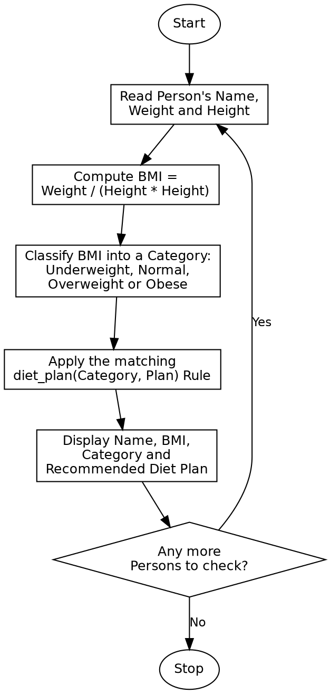

Program:

% Program for a Dieting System (BMI-based Expert System)
bmi_category(BMI, 'Underweight') :- BMI < 18.5, !.
bmi_category(BMI, 'Normal') :- BMI >= 18.5, BMI < 25.0, !.
bmi_category(BMI, 'Overweight') :- BMI >= 25.0, BMI < 30.0, !.
bmi_category(_, 'Obese').
diet_plan('Underweight', 'Increase calorie intake with protein-rich foods, nuts, and dairy.').
diet_plan('Normal', 'Maintain a balanced diet with regular exercise.').
diet_plan('Overweight', 'Reduce calorie intake, increase fiber, and exercise regularly.').
diet_plan('Obese', 'Follow a strict low-calorie diet plan and consult a physician.').
recommend(Name, Weight, Height) :-
BMI is Weight / (Height * Height),
bmi_category(BMI, Category),
diet_plan(Category, Plan),
format("Name: ~w~n", [Name]),
format("BMI: ~2f~n", [BMI]),
format("Category: ~w~n", [Category]),
format("Recommended Diet: ~w~n~n", [Plan]).
:- initialization(main).
main :-
recommend('Arun', 50, 1.70),
recommend('Divya', 65, 1.65),
recommend('Karthik', 90, 1.75),
halt.

Sample Input
Arun: Weight=50 kg, Height=1.70 m
Divya: Weight=65 kg, Height=1.65 m
Karthik: Weight=90 kg, Height=1.75 m

Sample Output
Name: Arun
BMI: 17.30
Category: Underweight
Recommended Diet: Increase calorie intake with protein-rich foods, nuts, and dairy.
Name: Divya
BMI: 23.88
Category: Normal
Recommended Diet: Maintain a balanced diet with regular exercise.
Name: Karthik
BMI: 29.39
Category: Overweight
Recommended Diet: Reduce calorie intake, increase fiber, and exercise regularly.

Result
The Prolog dieting expert system was successfully written and executed, and it correctly computed the BMI, classified each person's category, and recommended a suitable diet plan.

Conclusion
This experiment demonstrates how Prolog can be used to build a simple rule-based expert system, showing how numeric computation, classification and recommendation rules can be combined to reach a decision.

