Experiment 25: Prolog Program for the Monkey and Banana Problem:

Aim
To write a Prolog program to solve the Monkey and Banana problem using state-space search, where the monkey performs a sequence of actions to reach and obtain the banana.

Objective
- To understand state-space representation and problem solving using Prolog.
- To implement a sequence of actions using recursive predicates to reach a goal state.
- To determine whether the monkey can successfully grab the banana from a given initial state.

Algorithm
- Represent the current state as state(MonkeyPosition, BoxPosition, OnBox, HasBanana).
- Define the goal state as the state where HasBanana = has.
- If the current state matches the goal state, stop and report success.
- Otherwise, try each possible action (walk, push box, climb, grab) using rules that define valid transitions between states.
- Apply the action that leads to a valid next state, and recursively repeat step 3 for the new state.
- If a sequence of actions leads to the goal state, display the plan (sequence of moves).
- If no sequence of actions leads to the goal, report failure.
- Stop.

Flowchart
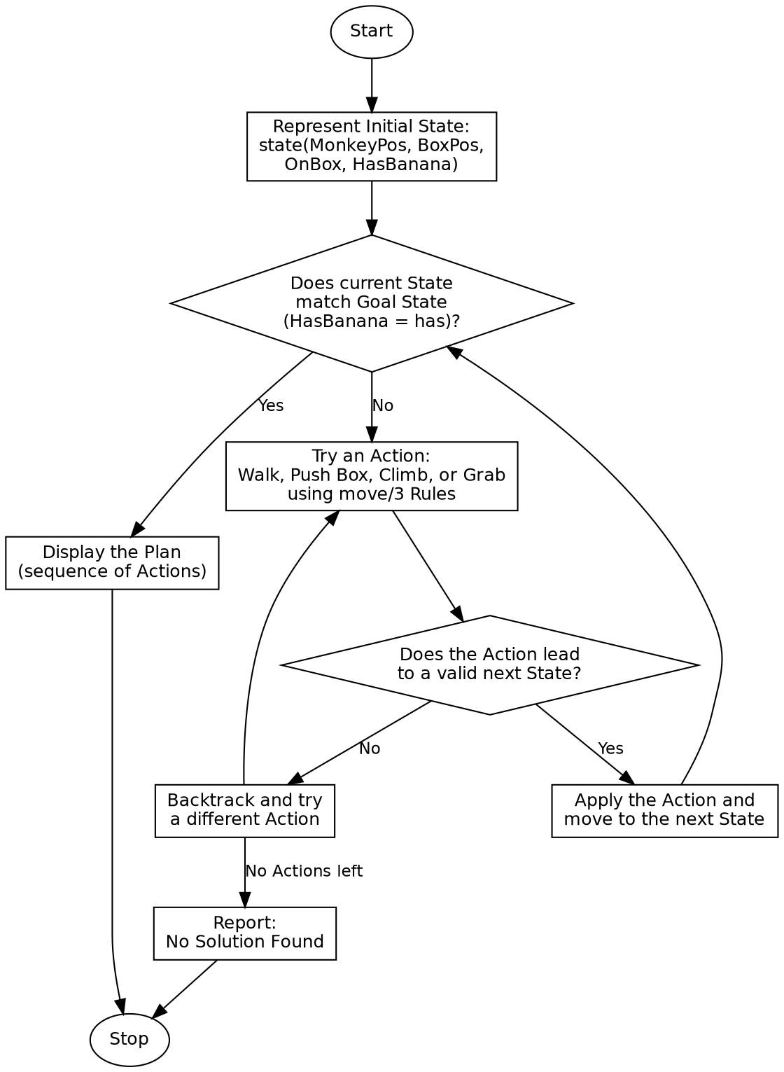

Program:

% Program to solve the Monkey and Banana Problem
% State: state(MonkeyPosition, BoxPosition, OnBox, HasBanana)
move(state(middle, middle, onbox, has_not),
grab,
state(middle, middle, onbox, has)).
move(state(P, P, onfloor, H),
climb,
state(P, P, onbox, H)).
move(state(P1, P1, onfloor, H),
push(P1, middle),
state(middle, middle, onfloor, H)) :-
P1 \== middle.
move(state(P1, B, onfloor, H),
walk(P1, B),
state(B, B, onfloor, H)) :-
P1 \== B.
canget(state(_, _, _, has), []) :- !.
canget(State1, [Action|Rest]) :-
move(State1, Action, State2),
canget(State2, Rest).
:- initialization(main).
main :-
write('Initial State: Monkey=door, Box=window, OnFloor, No Banana'), nl,
write('Goal: Monkey has the Banana'), nl,
nl,
InitialState = state(door, window, onfloor, has_not),
( canget(InitialState, Plan) ->
write('Plan of Actions:'), nl,
print_plan(Plan),
nl, write('Result: Monkey successfully grabbed the banana!'), nl
; write('Result: No solution found.'), nl
),
halt.
print_plan([]).
print_plan([Action|Rest]) :-
format("Action: ~w~n", [Action]),
print_plan(Rest).

Sample Input
Initial State: Monkey at door, Box at window, Monkey on floor, No Banana
Goal State: Monkey has the Banana

Sample Output
Initial State: Monkey=door, Box=window, OnFloor, No Banana
Goal: Monkey has the Banana
Plan of Actions:
Action: walk(door,window)
Action: push(window,middle)
Action: climb
Action: grab
Result: Monkey successfully grabbed the banana!

Result
The Prolog program to solve the Monkey and Banana problem was successfully written and executed, and the correct sequence of actions (walk, push, climb, grab) needed to obtain the banana was obtained.

Conclusion
This experiment demonstrates state-space search and planning in Prolog, and shows how a sequence of valid actions can be derived recursively to transform an initial state into a goal state.

