Experiment 2: N-Queen Problem

Aim
To solve the N-Queen Problem using Artificial Intelligence techniques.

Objective
- Understand the problem.
- Apply AI search/backtracking.
- Obtain the required solution.

Algorithm
- Read N.
- Place queens row by row.
- Check row/diagonal safety.
- Backtrack until solution found.
- Display board.

Program
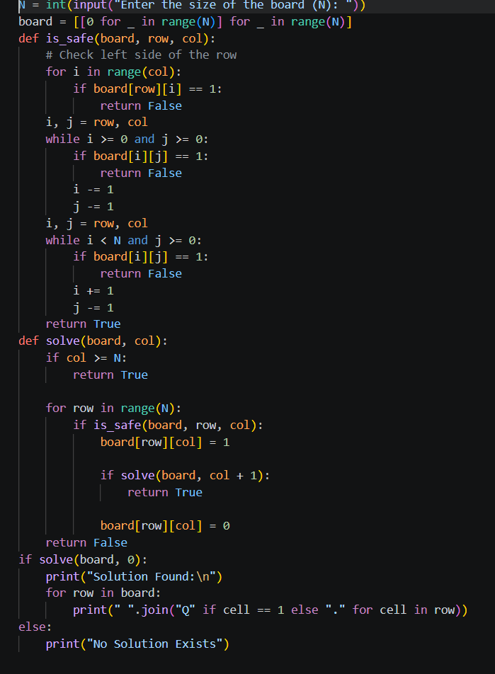

Program (Python)

Flow chart:

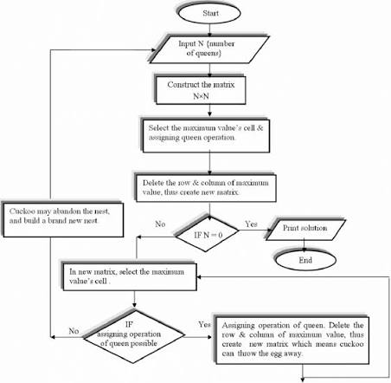

Sample Input
4

Sample Output
One valid 4x4 queen arrangement

Result
N-Queen solved.

Conclusion
The problem was successfully solved using AI techniques.

