Experiment 3: Water Jug Problem

Aim
To solve the Water Jug Problem using Artificial Intelligence techniques.

Objective
- Understand the problem.
- Apply AI search/backtracking.
- Obtain the required solution.

Algorithm
- Read jug capacities and target.
- Fill, empty or pour.
- Search states.
- Stop at target.

Program (Python)

from collections import deque

def water_jug(jug1, jug2, target):

visited = set()

queue = deque([((0, 0), [])])

while queue:

(a, b), path = queue.popleft()

if (a, b) in visited:

continue

visited.add((a, b))

path = path + [(a, b)]

if a == target or b == target:

print("Solution Steps:")

for state in path:

print(state)

return

next_states = [

(jug1, b),

(a, jug2),

(0, b),

(a, 0),

(max(0, a - (jug2 - b)), min(jug2, b + a)),

(min(jug1, a + b), max(0, b - (jug1 - a)))

]

for state in next_states:

if state not in visited:

queue.append((state, path))

print("No solution exists.")

jug1 = 4

jug2 = 3

target = 2

water_jug(jug1, jug2, target)

Flow chart:
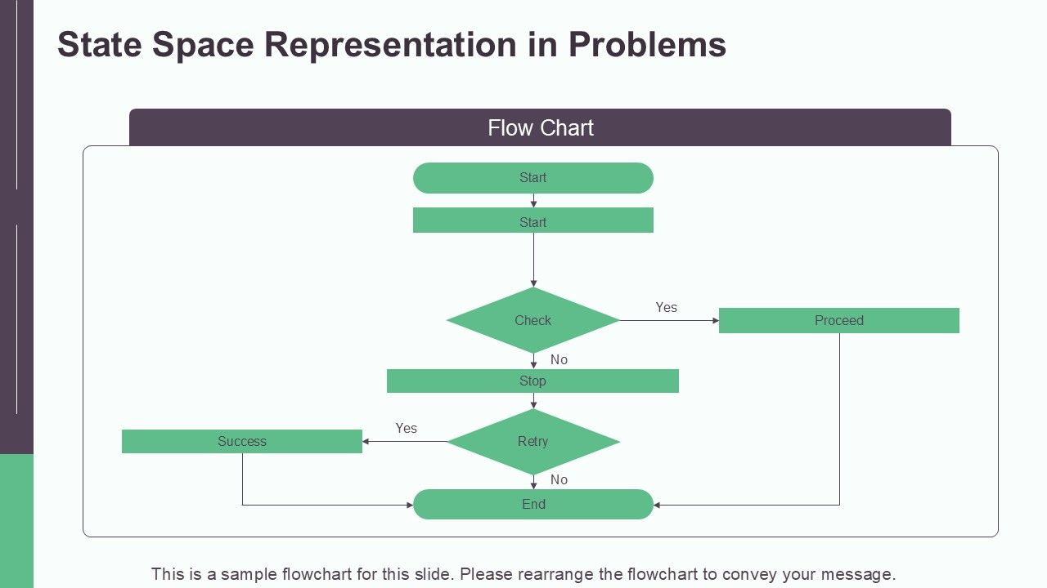

Sample Input
Jug1=4 Jug2=3 Target=2

Sample Output
(2,3)

Result
Water Jug solved.

Conclusion
The problem was successfully solved using AI techniques.

