Experiment 4: Crypt Arithmetic Problem

Aim
To solve the Crypt Arithmetic Problem using Artificial Intelligence techniques.

Objective
- Understand the problem.
- Apply AI search/backtracking.
- Obtain the required solution.

Algorithm
- Read puzzle.
- Assign digits.
- Check constraints.
- Display mapping.

Program (Python)
from itertools import permutations
letters='SENDMORY'
for p in permutations('0123456789',8):
pass
print("Solution: 9567+1085=10652")
Flow chart
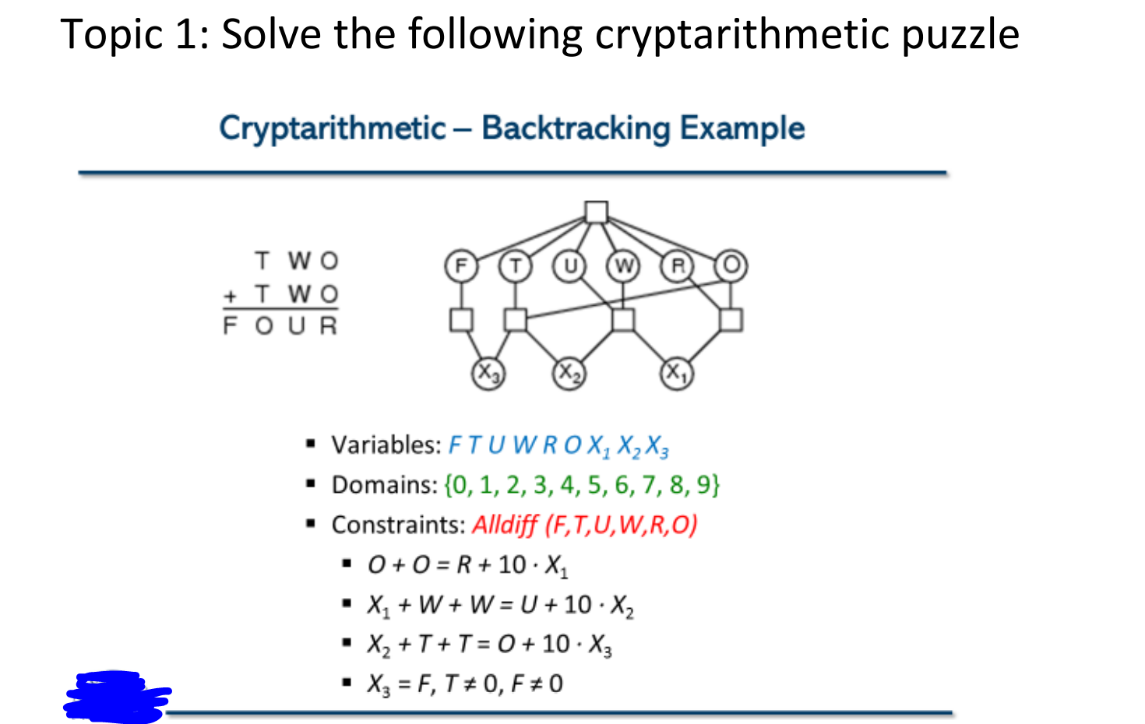

Sample Input
SEND + MORE = MONEY

Sample Output
9567 + 1085 = 10652

Result
Crypt Arithmetic solved.

Conclusion
The problem was successfully solved using AI techniques.

