Experiment 6: Vacuum Cleaner Problem:

Aim
To solve the Vacuum Cleaner problem using an Artificial Intelligence agent that cleans dirty rooms by moving between them and performing the appropriate action based on the current state, until both rooms are clean.

Objective
- To understand the concept of a simple reflex agent and state-space search.
- To solve the Vacuum Cleaner problem using AI techniques.
- To find the sequence of actions that leads to both rooms being clean.

Algorithm
- Read the initial state of Room A, Room B (Clean/Dirty) and the initial position of the vacuum agent.
- Check the status of the current room.
- If the current room is dirty, perform the Suck action to clean it.
- If the current room is clean, move the vacuum agent to the other room.
- Repeat steps 2 to 4 until both Room A and Room B are clean.
- Display the sequence of actions performed to reach the goal state.
- Stop.

Flowchart
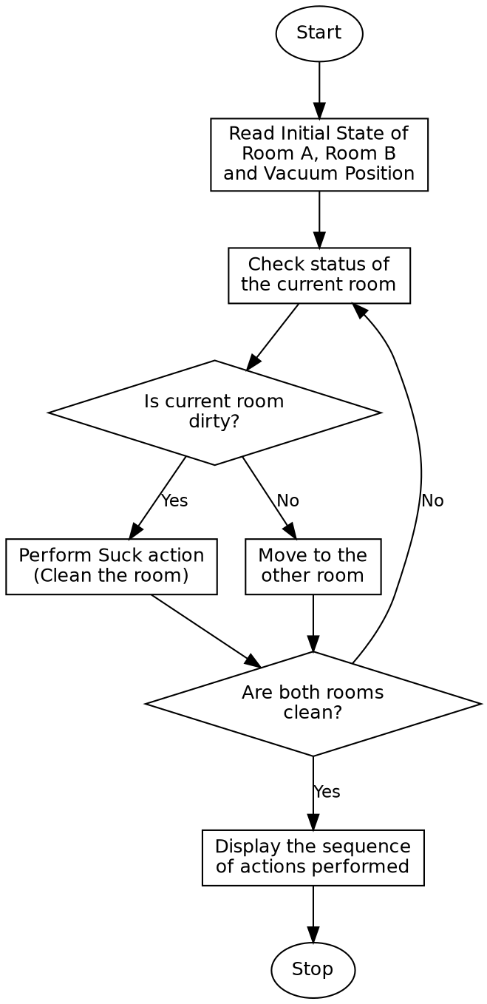

Program:

from collections import deque
def is_goal(state):
loc, a, b = state
return a == "Clean" and b == "Clean"
def get_actions(state):
loc, a, b = state
results = []
if loc == "A" and a == "Dirty":
results.append(("Suck", ("A", "Clean", b)))
if loc == "B" and b == "Dirty":
results.append(("Suck", (loc, a, "Clean")))
if loc == "A":
results.append(("Move Right", ("B", a, b)))
if loc == "B":
results.append(("Move Left", ("A", a, b)))
return results
def bfs(start):
queue = deque([(start, [])])
visited = {start}
while queue:
state, path = queue.popleft()
if is_goal(state):
return path
for action, new_state in get_actions(state):
if new_state not in visited:
visited.add(new_state)
queue.append((new_state, path + [(action, new_state)]))
return None
def describe(state):
loc, a, b = state
return f"Vacuum at Room {loc} | Room A: {a} | Room B: {b}"
if __name__ == "__main__":
start = ("A", "Dirty", "Dirty")
print("Initial State:")
print(describe(start))
print()
solution = bfs(start)
if solution:
print(f"Solution found in {len(solution)} actions!\n")
state = start
for step, (action, new_state) in enumerate(solution, 1):
print(f"Step {step}: {action}")
print(describe(new_state))
print()
else:
print("No solution exists.")

Sample Input
Room A = Dirty, Room B = Dirty, Vacuum Initial Position = Room A

Sample Output
Initial State:
Vacuum at Room A | Room A: Dirty | Room B: Dirty
Solution found in 3 actions!
Step 1: Suck
Vacuum at Room A | Room A: Clean | Room B: Dirty
Step 2: Move Right
Vacuum at Room B | Room A: Clean | Room B: Dirty
Step 3: Suck
Vacuum at Room B | Room A: Clean | Room B: Clean

Result
The given Vacuum Cleaner problem was successfully solved and the sequence of actions needed to clean both rooms was obtained.

Conclusion
The Vacuum Cleaner problem demonstrates the working of a simple reflex agent in Artificial Intelligence and shows how an agent perceives its environment and acts to achieve a clean, goal-satisfying state.

