Experiment 10: A* Search Algorithm:

Aim
To implement the A* Search Algorithm to find the least-cost path from a start node to a goal node in a graph, using both the actual path cost and a heuristic estimate.

Objective
- To understand the concept of informed (heuristic-based) search in Artificial Intelligence.
- To implement the A* Search algorithm using AI techniques.
- To find the least-cost path from the start node to the goal node.

Algorithm
- Read the graph with edge costs and the heuristic value of each node.
- Read the start node and the goal node.
- Initialize the Open List with the start node, where f(n) = g(n) + h(n) and g(n) = 0.
- Initialize an empty Closed List.
- Repeat steps 6 to 9 while the Open List is not empty.
- Select the node with the lowest f(n) value from the Open List.
- If this node is the goal node, trace back through parent pointers to display the path and stop.
- Otherwise, move this node to the Closed List and generate its neighbouring nodes.
- For each neighbour not in the Closed List, compute g(n), h(n) and f(n), and add or update it in the Open List.
- If the Open List becomes empty without reaching the goal, report that no path exists.
- Stop.

Flowchart
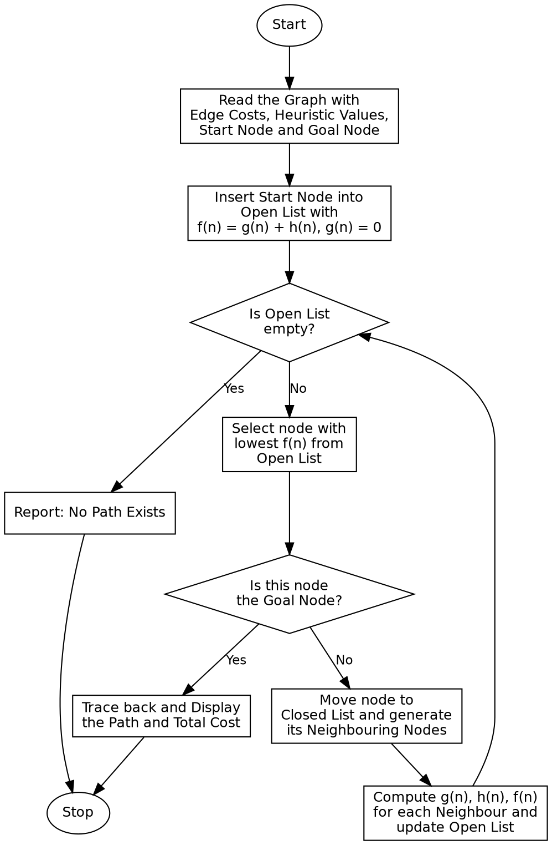

Program:

import heapq
def a_star(graph, heuristic, start, goal):
open_list = [(heuristic[start], 0, start, [start])]
closed_set = set()
while open_list:
f, g, node, path = heapq.heappop(open_list)
if node == goal:
return path, g
if node in closed_set:
continue
closed_set.add(node)
for neighbour, cost in graph[node]:
if neighbour not in closed_set:
new_g = g + cost
new_f = new_g + heuristic[neighbour]
heapq.heappush(open_list, (new_f, new_g, neighbour, path + [neighbour]))
return None, float('inf')
if __name__ == "__main__":
graph = {
'A': [('B', 4), ('C', 3)],
'B': [('A', 4), ('D', 5), ('E', 6)],
'C': [('A', 3), ('F', 7)],
'D': [('B', 5), ('G', 8)],
'E': [('B', 6), ('G', 5)],
'F': [('C', 7), ('G', 4)],
'G': [('D', 8), ('E', 5), ('F', 4)]
}
heuristic = {
'A': 10, 'B': 8, 'C': 9,
'D': 6, 'E': 4, 'F': 5, 'G': 0
}
start_node = 'A'
goal_node = 'G'
print("Graph (Adjacency List with Edge Costs):")
for node in graph:
print(f"{node}: {graph[node]}")
print()
print("Heuristic Values:")
for node in heuristic:
print(f"h({node}) = {heuristic[node]}")
print()
print(f"Start Node: {start_node} Goal Node: {goal_node}\n")
path, cost = a_star(graph, heuristic, start_node, goal_node)
if path:
print("Path Found:", " -> ".join(path))
print("Total Cost:", cost)
else:
print("No path exists.")

Sample Input
Graph (Adjacency List with Edge Costs): A-B=4, A-C=3, B-D=5, B-E=6, C-F=7, D-G=8, E-G=5, F-G=4
Heuristic Values: h(A)=10, h(B)=8, h(C)=9, h(D)=6, h(E)=4, h(F)=5, h(G)=0
Start Node: A Goal Node: G

Sample Output
Graph (Adjacency List with Edge Costs):
A: [('B', 4), ('C', 3)]
B: [('A', 4), ('D', 5), ('E', 6)]
C: [('A', 3), ('F', 7)]
D: [('B', 5), ('G', 8)]
E: [('B', 6), ('G', 5)]
F: [('C', 7), ('G', 4)]
G: [('D', 8), ('E', 5), ('F', 4)]
Heuristic Values:
h(A) = 10
h(B) = 8
h(C) = 9
h(D) = 6
h(E) = 4
h(F) = 5
h(G) = 0
Start Node: A Goal Node: G
Path Found: A -> C -> F -> G
Total Cost: 14

Result
The A* Search Algorithm was successfully implemented and the least-cost path from the start node to the goal node was found using the combined actual cost and heuristic estimate.

Conclusion
The A* Search Algorithm demonstrates informed search in Artificial Intelligence and shows how combining the actual path cost with a heuristic estimate leads to an efficient and optimal solution compared to uninformed search methods.

