Experiment 11: Map Coloring Problem (Constraint Satisfaction Problem):

Aim
To solve the Map Coloring Problem using a Constraint Satisfaction approach in Artificial Intelligence, such that no two adjacent regions on the map are assigned the same color.

Objective
- To understand the concept of Constraint Satisfaction Problems (CSP) in Artificial Intelligence.
- To solve the Map Coloring Problem using backtracking search.
- To assign colors to regions such that no two adjacent regions share the same color.

Algorithm
- Read the map as a graph, where regions are nodes and adjacency between regions is represented as edges.
- Read the list of available colors.
- Select an uncolored region (variable).
- Try assigning the next available color to the region.
- Check whether this color assignment is consistent with the constraint that no adjacent region has the same color.
- If consistent, assign the color and move to the next uncolored region.
- If not consistent, try the next available color.
- If no color can be assigned to a region, backtrack to the previous region and try a different color.
- Repeat steps 3 to 8 until all regions are colored or no solution exists.
- Display the final color assignment for each region.
- Stop.

Flowchart
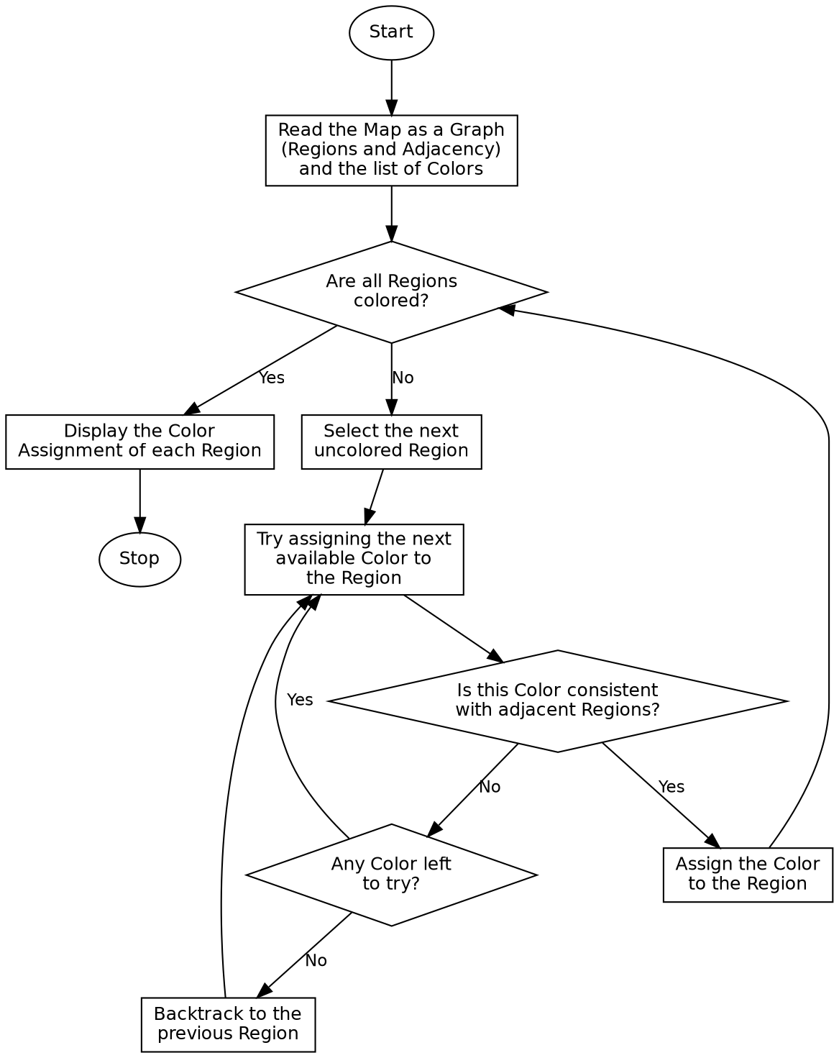

Program:

def is_valid(graph, colors, region, color, assignment):
for neighbour in graph[region]:
if assignment.get(neighbour) == color:
return False
return True
def backtrack(graph, colors, regions, assignment):
if len(assignment) == len(regions):
return assignment
unassigned = [r for r in regions if r not in assignment]
region = unassigned[0]
for color in colors:
if is_valid(graph, colors, region, color, assignment):
assignment[region] = color
result = backtrack(graph, colors, regions, assignment)
if result:
return result
del assignment[region]
return None
if __name__ == "__main__":
graph = {
'WA': ['NT', 'SA'],
'NT': ['WA', 'SA', 'Q'],
'SA': ['WA', 'NT', 'Q', 'NSW', 'V'],
'Q': ['NT', 'SA', 'NSW'],
'NSW': ['SA', 'Q', 'V'],
'V': ['SA', 'NSW']
}
colors = ['Red', 'Green', 'Blue']
regions = list(graph.keys())
print("Map Regions (Adjacency List):")
for region in graph:
print(f"{region}: {graph[region]}")
print()
print(f"Available Colors: {colors}\n")
solution = backtrack(graph, colors, regions, {})
if solution:
print("Color Assignment:")
for region in regions:
print(f"{region} -> {solution[region]}")
else:
print("No solution exists.")

Sample Input
Map Regions (Adjacency List): WA-NT, WA-SA, NT-SA, NT-Q, SA-Q, SA-NSW, SA-V, Q-NSW, NSW-V
Available Colors: Red, Green, Blue

Sample Output
Map Regions (Adjacency List):
WA: ['NT', 'SA']
NT: ['WA', 'SA', 'Q']
SA: ['WA', 'NT', 'Q', 'NSW', 'V']
Q: ['NT', 'SA', 'NSW']
NSW: ['SA', 'Q', 'V']
V: ['SA', 'NSW']
Available Colors: ['Red', 'Green', 'Blue']
Color Assignment:
WA -> Red
NT -> Green
SA -> Blue
Q -> Red
NSW -> Green
V -> Red

Result
The Map Coloring Problem was successfully solved using the backtracking algorithm, and each region was assigned a color such that no two adjacent regions share the same color.

Conclusion
The Map Coloring Problem demonstrates a Constraint Satisfaction Problem in Artificial Intelligence and shows how backtracking search systematically assigns values to variables while satisfying the given constraints.

