Experiment 12: Tic-Tac-Toe Game:

Aim
To implement a Tic-Tac-Toe game between two players using Artificial Intelligence, where the program checks the board state after every move and declares the winner or a draw.

Objective
- To understand the representation of the game state in Artificial Intelligence.
- To implement the Tic-Tac-Toe game logic using AI techniques.
- To determine the winner or a draw by checking the win conditions after every move.

Algorithm
- Initialize a 3x3 empty board.
- Display the current state of the board.
- Read the current player's move (row and column).
- Check whether the selected cell is empty and valid.
- Place the current player's symbol (X or O) in the selected cell.
- Check all rows, columns and diagonals for a winning combination.
- If a player has won, declare that player as the winner and stop.
- If all cells are filled and no player has won, declare the game a draw and stop.
- Otherwise, switch to the other player and repeat steps 2 to 8.
- Stop.

Flowchart
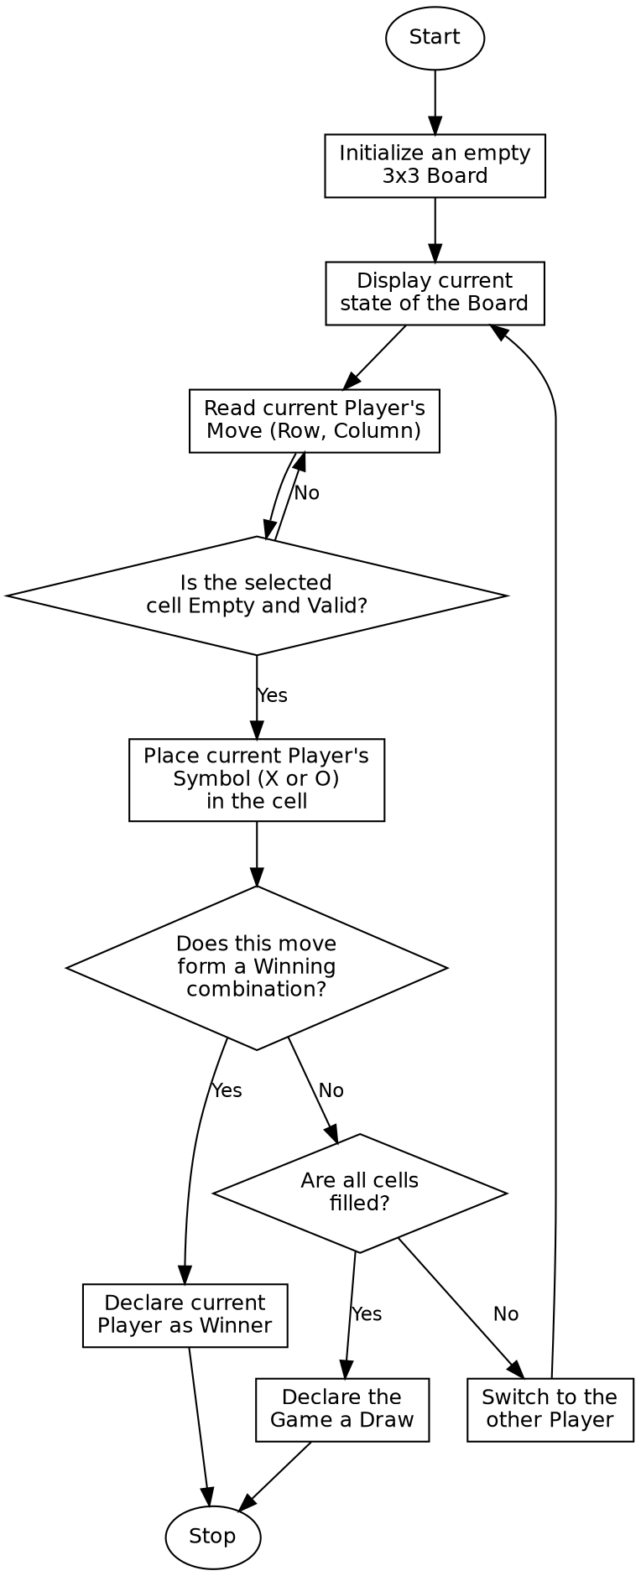

Program:

def print_board(board):
for i in range(0, 9, 3):
row = board[i:i + 3]
print(" | ".join(cell if cell != " " else "_" for cell in row))
print()
def check_winner(board, player):
wins = [
(0, 1, 2), (3, 4, 5), (6, 7, 8), # rows
(0, 3, 6), (1, 4, 7), (2, 5, 8), # columns
(0, 4, 8), (2, 4, 6) # diagonals
]
for a, b, c in wins:
if board[a] == board[b] == board[c] == player:
return True
return False
def play_game(moves):
board = [" "] * 9
player = "X"
for move in moves:
board[move] = player
print(f"Player {player} plays position {move}:")
print_board(board)
if check_winner(board, player):
print(f"Player {player} wins!")
return
player = "O" if player == "X" else "X"
if " " not in board:
print("The game is a Draw!")
if __name__ == "__main__":
# Predefined move sequence (cell positions 0-8, left to right, top to bottom)
moves = [0, 4, 1, 5, 2]
print("Tic-Tac-Toe Game\n")
play_game(moves)

Sample Input
Board Size: 3x3
Move Sequence (Player X starts): Position 0, 4, 1, 5, 2

Sample Output
Tic-Tac-Toe Game
Player X plays position 0:
X | _ | _
_ | _ | _
_ | _ | _
Player O plays position 4:
X | _ | _
_ | O | _
_ | _ | _
Player X plays position 1:
X | X | _
_ | O | _
_ | _ | _
Player O plays position 5:
X | X | _
_ | O | O
_ | _ | _
Player X plays position 2:
X | X | X
_ | O | O
_ | _ | _
Player X wins!

Result
The Tic-Tac-Toe game was successfully implemented, and the program correctly identified the winning player by checking the board after every move.

Conclusion
The Tic-Tac-Toe game demonstrates game-state representation and win-condition checking in Artificial Intelligence, forming the basis for adversarial search techniques such as the Minimax algorithm.

