Experiment 13: Minimax Algorithm:

Aim
To implement the Minimax algorithm to determine the optimal move for a player in a two-player, zero-sum game such as Tic-Tac-Toe, by exploring all possible future moves.

Objective
- To understand the concept of adversarial search in game-playing Artificial Intelligence.
- To implement the Minimax algorithm using recursion.
- To determine the optimal move for the maximizing player.

Algorithm
- Read the current state of the game board.
- If the current state is a terminal state (win, loss or draw), return its utility value.
- If it is the Maximizer's turn, initialize the best value as -infinity.
- For each possible move, recursively call Minimax on the resulting state and update the best value with the maximum of the returned values.
- If it is the Minimizer's turn, initialize the best value as +infinity.
- For each possible move, recursively call Minimax on the resulting state and update the best value with the minimum of the returned values.
- Return the best value obtained.
- Repeat this process for every available move from the current state, and choose the move with the best value for the Maximizer.
- Display the optimal move and its Minimax value.
- Stop.

Flowchart
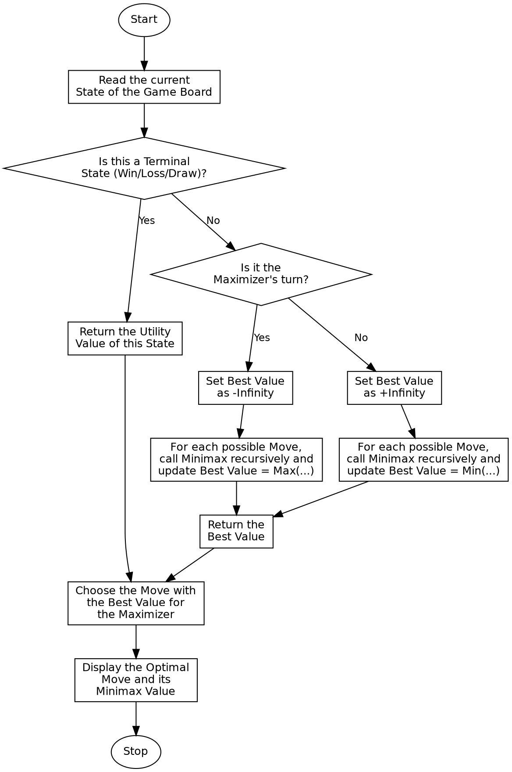

Program:

def print_board(board):
for i in range(0, 9, 3):
row = board[i:i + 3]
print(" | ".join(cell if cell != " " else "_" for cell in row))
print()
def check_winner(board):
wins = [
(0, 1, 2), (3, 4, 5), (6, 7, 8),
(0, 3, 6), (1, 4, 7), (2, 5, 8),
(0, 4, 8), (2, 4, 6)
]
for a, b, c in wins:
if board[a] == board[b] == board[c] != " ":
return board[a]
return None
def minimax(board, is_maximizing):
winner = check_winner(board)
if winner == "X":
return 1
if winner == "O":
return -1
if " " not in board:
return 0
if is_maximizing:
best = -float('inf')
for i in range(9):
if board[i] == " ":
board[i] = "X"
value = minimax(board, False)
board[i] = " "
best = max(best, value)
return best
else:
best = float('inf')
for i in range(9):
if board[i] == " ":
board[i] = "O"
value = minimax(board, True)
board[i] = " "
best = min(best, value)
return best
def find_best_move(board):
best_value = -float('inf')
best_move = None
for i in range(9):
if board[i] == " ":
board[i] = "X"
move_value = minimax(board, False)
board[i] = " "
if move_value > best_value:
best_value = move_value
best_move = i
return best_move, best_value
if __name__ == "__main__":
board = [
"X", "O", "X",
"X", "O", " ",
" ", " ", "O"
]
print("Current Board State:")
print_board(board)
best_move, best_value = find_best_move(board)
print(f"Optimal Move for Player X: Position {best_move}")
print(f"Minimax Value: {best_value}")

Sample Input
Board (row-wise): X O X / X O _ / _ _ O
Player to move: X (Maximizer)

Sample Output
Current Board State:
X | O | X
X | O | _
_ | _ | O
Optimal Move for Player X: Position 6
Minimax Value: 1

Result
The Minimax algorithm was successfully implemented, and the optimal move along with its Minimax value was correctly determined for the maximizing player.

Conclusion
The Minimax algorithm demonstrates adversarial search in Artificial Intelligence and shows how a game-playing agent explores all possible future moves to choose the optimal move against an optimal opponent.

