Experiment 14: Alpha-Beta Pruning:

Aim
To implement the Alpha-Beta Pruning algorithm to optimize the Minimax algorithm by eliminating branches of the game tree that do not affect the final decision.

Objective
- To understand the concept of pruning in adversarial search.
- To implement the Alpha-Beta Pruning algorithm using AI techniques.
- To reduce the number of nodes evaluated compared to plain Minimax while obtaining the same optimal result.

Algorithm
- Read the current state of the game tree, along with Alpha (-infinity) and Beta (+infinity).
- If the current state is a terminal state or the maximum depth is reached, return its utility value.
- If it is the Maximizer's turn, initialize the best value as -infinity.
- For each possible move, recursively call Alpha-Beta with the updated Alpha and Beta, and update the best value with the maximum of the returned values.
- Update Alpha = max(Alpha, best value). If Beta <= Alpha, prune the remaining branches.
- If it is the Minimizer's turn, initialize the best value as +infinity.
- For each possible move, recursively call Alpha-Beta with the updated Alpha and Beta, and update the best value with the minimum of the returned values.
- Update Beta = min(Beta, best value). If Beta <= Alpha, prune the remaining branches.
- Return the best value obtained.
- Display the optimal move, its value, and the number of nodes pruned.
- Stop.

Flowchart
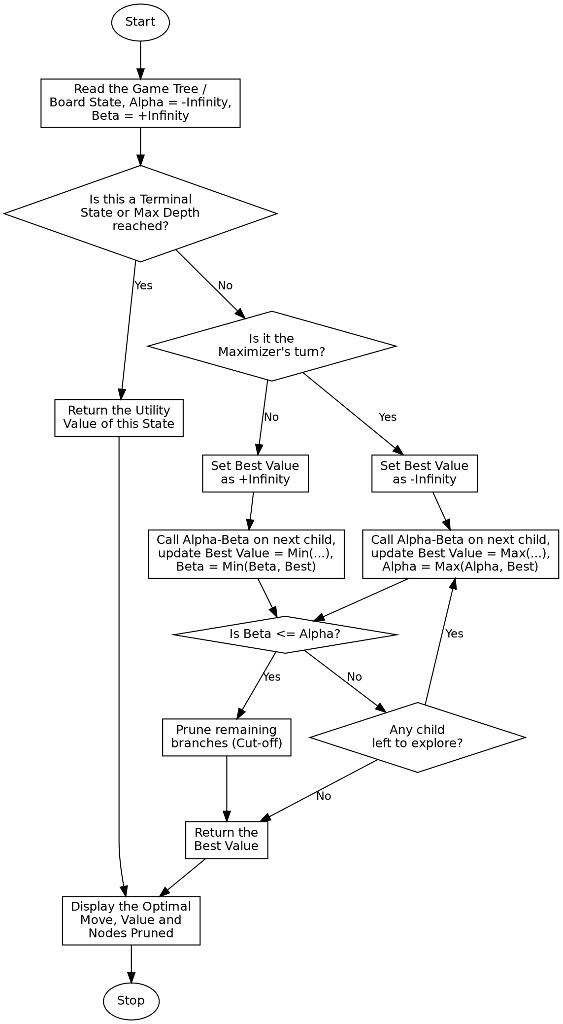

Program:

import math
nodes_evaluated = 0
def alpha_beta(depth, node_index, is_maximizing, leaf_values, max_depth, alpha, beta):
global nodes_evaluated
if depth == max_depth:
nodes_evaluated += 1
return leaf_values[node_index]
if is_maximizing:
best = -math.inf
for i in range(2):
value = alpha_beta(depth + 1, node_index * 2 + i, False, leaf_values, max_depth, alpha, beta)
best = max(best, value)
alpha = max(alpha, best)
if beta <= alpha:
break # Beta cut-off (prune remaining branch)
return best
else:
best = math.inf
for i in range(2):
value = alpha_beta(depth + 1, node_index * 2 + i, True, leaf_values, max_depth, alpha, beta)
best = min(best, value)
beta = min(beta, best)
if beta <= alpha:
break # Alpha cut-off (prune remaining branch)
return best
if __name__ == "__main__":
leaf_values = [3, 5, 6, 9, 1, 2, 0, -1]
max_depth = 3
print("Leaf Node Values:", leaf_values)
print(f"Tree Depth: {max_depth}\n")
optimal_value = alpha_beta(0, 0, True, leaf_values, max_depth, -math.inf, math.inf)
print("Optimal Value for the Maximizer at the Root:", optimal_value)
print("Number of Leaf Nodes Evaluated (after Pruning):", nodes_evaluated)
print(f"Total Leaf Nodes in Tree: {len(leaf_values)}")

Sample Input
Leaf Node Values (Game Tree): [3, 5, 6, 9, 1, 2, 0, -1]
Tree Depth: 3, Alpha = -Infinity, Beta = +Infinity

Sample Output
Leaf Node Values: [3, 5, 6, 9, 1, 2, 0, -1]
Tree Depth: 3
Optimal Value for the Maximizer at the Root: 5
Number of Leaf Nodes Evaluated (after Pruning): 5
Total Leaf Nodes in Tree: 8

Result
The Alpha-Beta Pruning algorithm was successfully implemented, and the same optimal value as Minimax was obtained while evaluating fewer leaf nodes.

Conclusion
The Alpha-Beta Pruning algorithm demonstrates an optimized adversarial search technique in Artificial Intelligence and shows how pruning branches that cannot influence the final decision improves the efficiency of Minimax without changing its result.

