Experiment 15: Decision Tree:

Aim
To implement a Decision Tree classifier using Artificial Intelligence to classify data based on a set of features by recursively splitting the dataset.

Objective
- To understand the concept of decision tree learning in Artificial Intelligence.
- To implement a Decision Tree classifier using entropy and information gain (the ID3 algorithm).
- To classify a given sample based on the trained decision tree.

Algorithm
- Read the training dataset with features and their corresponding class labels.
- Calculate the entropy of the entire dataset based on the class labels.
- For each feature, calculate the information gain obtained by splitting the dataset on that feature.
- Select the feature with the highest information gain as the decision node (root).
- Split the dataset into subsets based on the values of the selected feature.
- Repeat steps 2 to 5 recursively for each subset to build the child nodes.
- Stop splitting a branch when all samples in a subset belong to the same class, or no features remain.
- Assign the majority class as the leaf node's label.
- Use the constructed tree to classify a new sample by traversing from the root to a leaf.
- Display the decision tree structure and the predicted class.
- Stop.

Flowchart
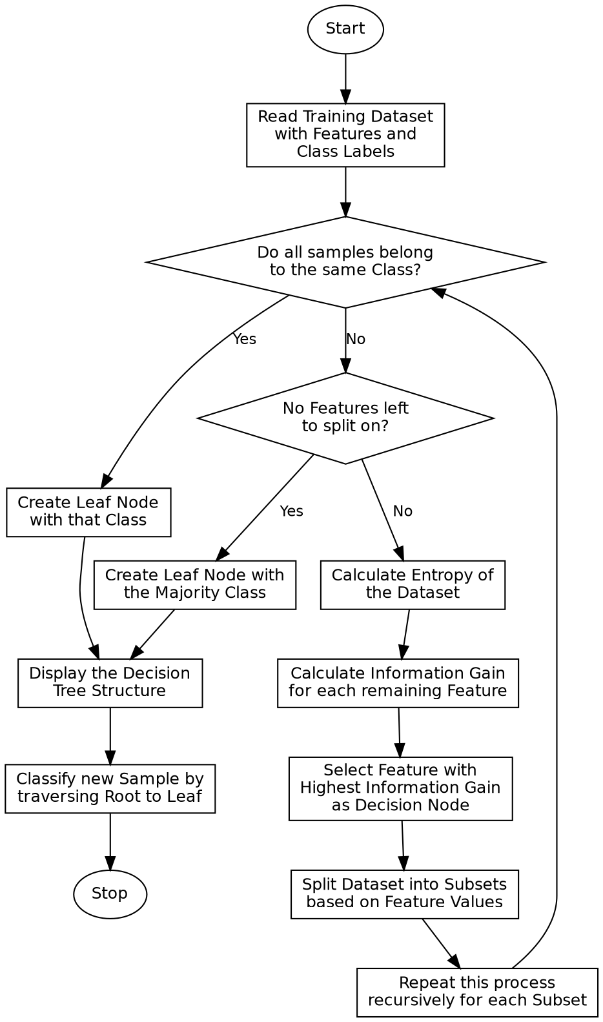

Program:

import math
from collections import Counter
def entropy(labels):
counts = Counter(labels)
total = len(labels)
return -sum((count / total) * math.log2(count / total) for count in counts.values())
def information_gain(data, feature_index, labels):
total_entropy = entropy(labels)
values = [row[feature_index] for row in data]
unique_values = set(values)
weighted_entropy = 0
for value in unique_values:
subset_labels = [labels[i] for i in range(len(data)) if data[i][feature_index] == value]
weighted_entropy += (len(subset_labels) / len(labels)) * entropy(subset_labels)
return total_entropy - weighted_entropy
def build_tree(data, labels, features):
if len(set(labels)) == 1:
return labels[0]
if not features:
return Counter(labels).most_common(1)[0][0]
gains = [information_gain(data, i, labels) for i in range(len(features))]
best_index = gains.index(max(gains))
best_feature = features[best_index]
tree = {best_feature: {}}
values = set(row[best_index] for row in data)
for value in values:
sub_data = [row[:best_index] + row[best_index + 1:] for row in data if row[best_index] == value]
sub_labels = [labels[i] for i in range(len(data)) if data[i][best_index] == value]
remaining_features = features[:best_index] + features[best_index + 1:]
tree[best_feature][value] = build_tree(sub_data, sub_labels, remaining_features)
return tree
def predict(tree, sample, features):
if not isinstance(tree, dict):
return tree
feature = next(iter(tree))
feature_index = features.index(feature)
value = sample[feature_index]
subtree = tree[feature].get(value)
if subtree is None:
return "Unknown"
remaining_features = features[:feature_index] + features[feature_index + 1:]
remaining_sample = sample[:feature_index] + sample[feature_index + 1:]
return predict(subtree, remaining_sample, remaining_features)
if __name__ == "__main__":
features = ["Outlook", "Temperature", "Humidity", "Wind"]
data = [
["Sunny", "Hot", "High", "Weak"],
["Sunny", "Hot", "High", "Strong"],
["Overcast", "Hot", "High", "Weak"],
["Rain", "Mild", "High", "Weak"],
["Rain", "Cool", "Normal", "Weak"],
["Rain", "Cool", "Normal", "Strong"],
["Overcast", "Cool", "Normal", "Strong"],
["Sunny", "Mild", "High", "Weak"],
["Sunny", "Cool", "Normal", "Weak"],
["Rain", "Mild", "Normal", "Weak"],
["Sunny", "Mild", "Normal", "Strong"],
["Overcast", "Mild", "High", "Strong"],
["Overcast", "Hot", "Normal", "Weak"],
["Rain", "Mild", "High", "Strong"],
]
labels = ["No", "No", "Yes", "Yes", "Yes", "No", "Yes", "No",
"Yes", "Yes", "Yes", "Yes", "Yes", "No"]
print("Training Dataset (Features: Outlook, Temperature, Humidity, Wind):")
for row, label in zip(data, labels):
print(row, "->", label)
print()
tree = build_tree(data, labels, features)
print("Decision Tree Structure:")
print(tree)
print()
sample = ["Sunny", "Cool", "High", "Strong"]
prediction = predict(tree, sample, features)
print(f"New Sample: {sample}")
print(f"Predicted Class: {prediction}")

Sample Input
Dataset: Play Tennis (14 samples)
Features: Outlook, Temperature, Humidity, Wind Class Label: PlayTennis (Yes/No)
New Sample to Classify: Outlook=Sunny, Temperature=Cool, Humidity=High, Wind=Strong

Sample Output
Training Dataset (Features: Outlook, Temperature, Humidity, Wind):
['Sunny', 'Hot', 'High', 'Weak'] -> No
['Sunny', 'Hot', 'High', 'Strong'] -> No
['Overcast', 'Hot', 'High', 'Weak'] -> Yes
['Rain', 'Mild', 'High', 'Weak'] -> Yes
['Rain', 'Cool', 'Normal', 'Weak'] -> Yes
['Rain', 'Cool', 'Normal', 'Strong'] -> No
['Overcast', 'Cool', 'Normal', 'Strong'] -> Yes
['Sunny', 'Mild', 'High', 'Weak'] -> No
['Sunny', 'Cool', 'Normal', 'Weak'] -> Yes
['Rain', 'Mild', 'Normal', 'Weak'] -> Yes
['Sunny', 'Mild', 'Normal', 'Strong'] -> Yes
['Overcast', 'Mild', 'High', 'Strong'] -> Yes
['Overcast', 'Hot', 'Normal', 'Weak'] -> Yes
['Rain', 'Mild', 'High', 'Strong'] -> No
Decision Tree Structure:
{'Outlook': {'Rain': {'Wind': {'Weak': 'Yes', 'Strong': 'No'}}, 'Sunny': {'Humidity': {'High': 'No', 'Normal': 'Yes'}}, 'Overcast': 'Yes'}}
New Sample: ['Sunny', 'Cool', 'High', 'Strong']
Predicted Class: No

Result
The Decision Tree classifier was successfully implemented using the ID3 algorithm, and the tree correctly classified the new sample based on entropy and information gain.

Conclusion
The Decision Tree experiment demonstrates supervised learning in Artificial Intelligence and shows how a dataset can be recursively split using entropy and information gain to build an interpretable classification model.

