Experiment 9: Travelling Salesman Problem (TSP):

Aim
To solve the Travelling Salesman Problem (TSP) using an Artificial Intelligence search technique to find the shortest possible route that visits every city exactly once and returns to the starting city.

Objective
- To understand the concept of combinatorial optimization problems.
- To solve the Travelling Salesman Problem using AI techniques.
- To find the minimum cost route that visits all cities exactly once.

Algorithm
- Read the number of cities and the distance matrix between them.
- Fix a starting city.
- Generate all possible permutations of the remaining cities.
- For each permutation, compute the total distance of the route, including the return to the starting city.
- Compare the computed distance with the minimum distance found so far.
- If the current route's distance is smaller, update the minimum distance and store the route.
- Repeat steps 4 to 6 for all permutations.
- Display the route with the minimum distance and its cost.
- Stop.

Flowchart
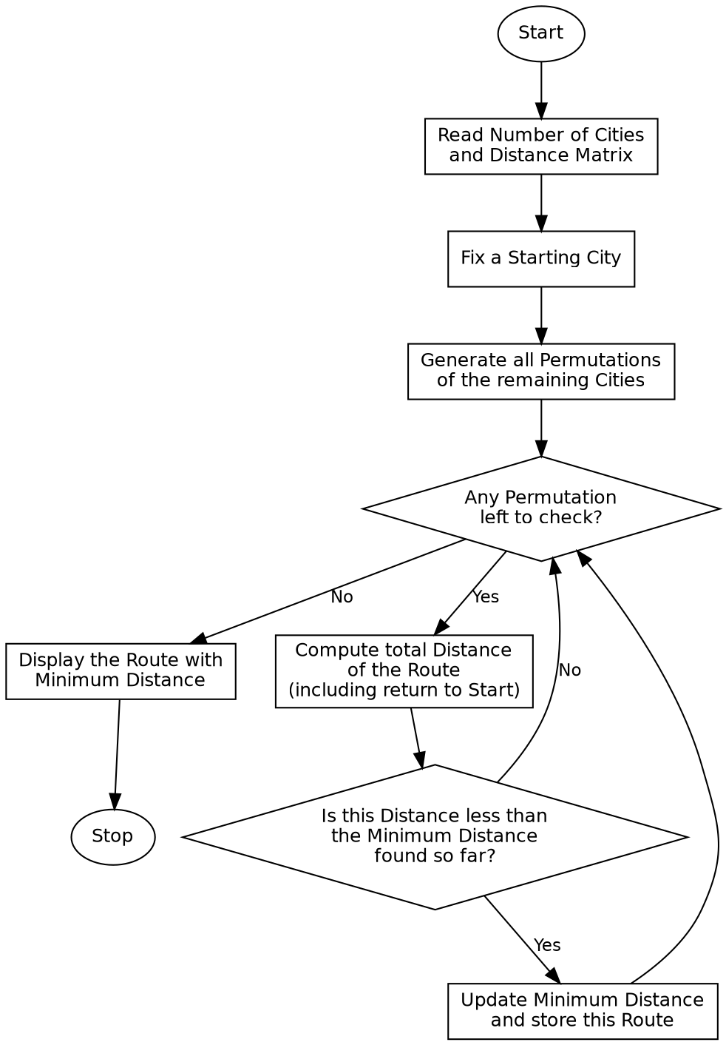

Program:

from itertools import permutations
def tsp_brute_force(graph, start, n):
cities = list(range(n))
cities.remove(start)
min_cost = float('inf')
best_route = None
for perm in permutations(cities):
route = [start] + list(perm) + [start]
cost = 0
for i in range(len(route) - 1):
cost += graph[route[i]][route[i + 1]]
if cost < min_cost:
min_cost = cost
best_route = route
return best_route, min_cost
if __name__ == "__main__":
labels = ['A', 'B', 'C', 'D']
graph = [
[0, 10, 15, 20],
[10, 0, 35, 25],
[15, 35, 0, 30],
[20, 25, 30, 0]
]
n = len(graph)
start = 0
print("Distance Matrix:")
for row in graph:
print(row)
print()
print(f"Starting City: {labels[start]}\n")
route, cost = tsp_brute_force(graph, start, n)
route_names = " -> ".join(labels[i] for i in route)
print(f"Optimal Route: {route_names}")
print(f"Minimum Distance: {cost}")

Sample Input
Cities: A, B, C, D
Distance Matrix: A-B=10, A-C=15, A-D=20, B-C=35, B-D=25, C-D=30
Starting City: A

Sample Output
Distance Matrix:
[0, 10, 15, 20]
[10, 0, 35, 25]
[15, 35, 0, 30]
[20, 25, 30, 0]
Starting City: A
Optimal Route: A -> B -> D -> C -> A
Minimum Distance: 80

Result
The Travelling Salesman Problem was successfully solved and the shortest route covering all cities exactly once, along with its minimum distance, was obtained.

Conclusion
The Travelling Salesman Problem demonstrates a combinatorial optimization problem in Artificial Intelligence and shows how a brute-force search evaluates all possible routes to guarantee the optimal solution.

