R Programming Assignment

Name: T. Jayasuriya
Registration No: 192420037

Q1 - If-Else, Arithmetic & Boolean Operators
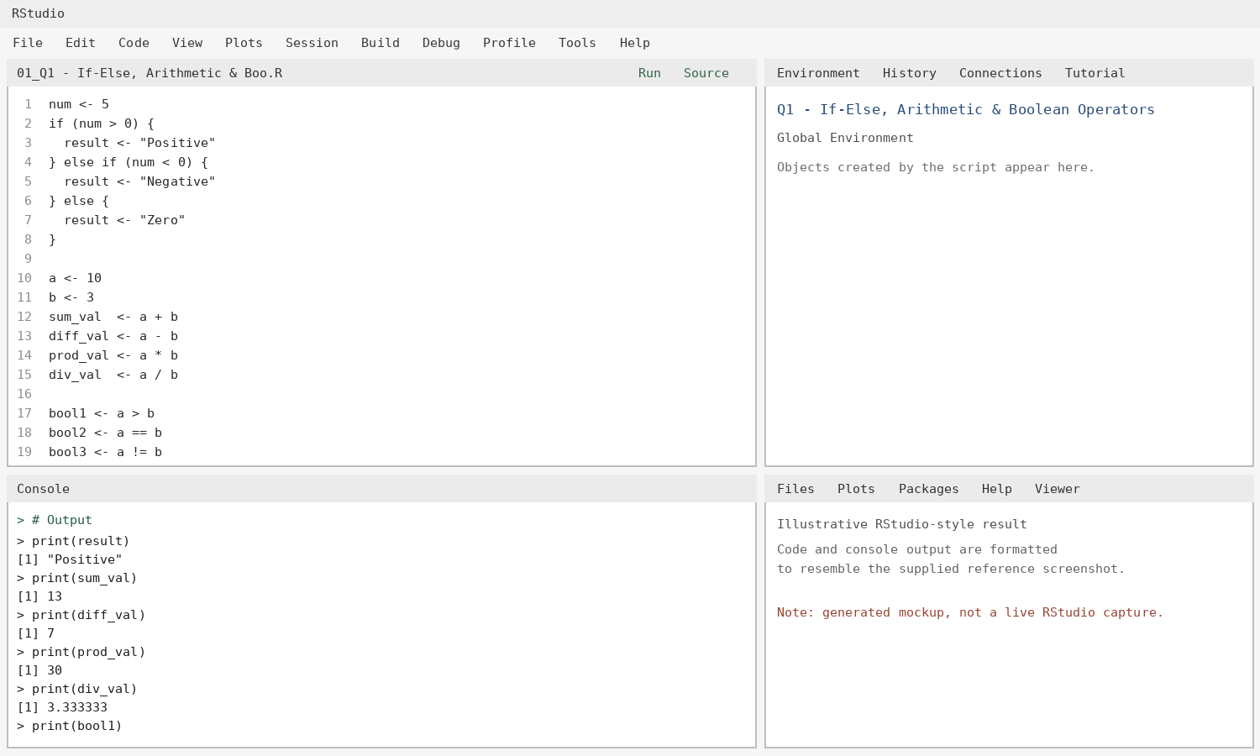

Q2 - For Loop: Multiplication Table
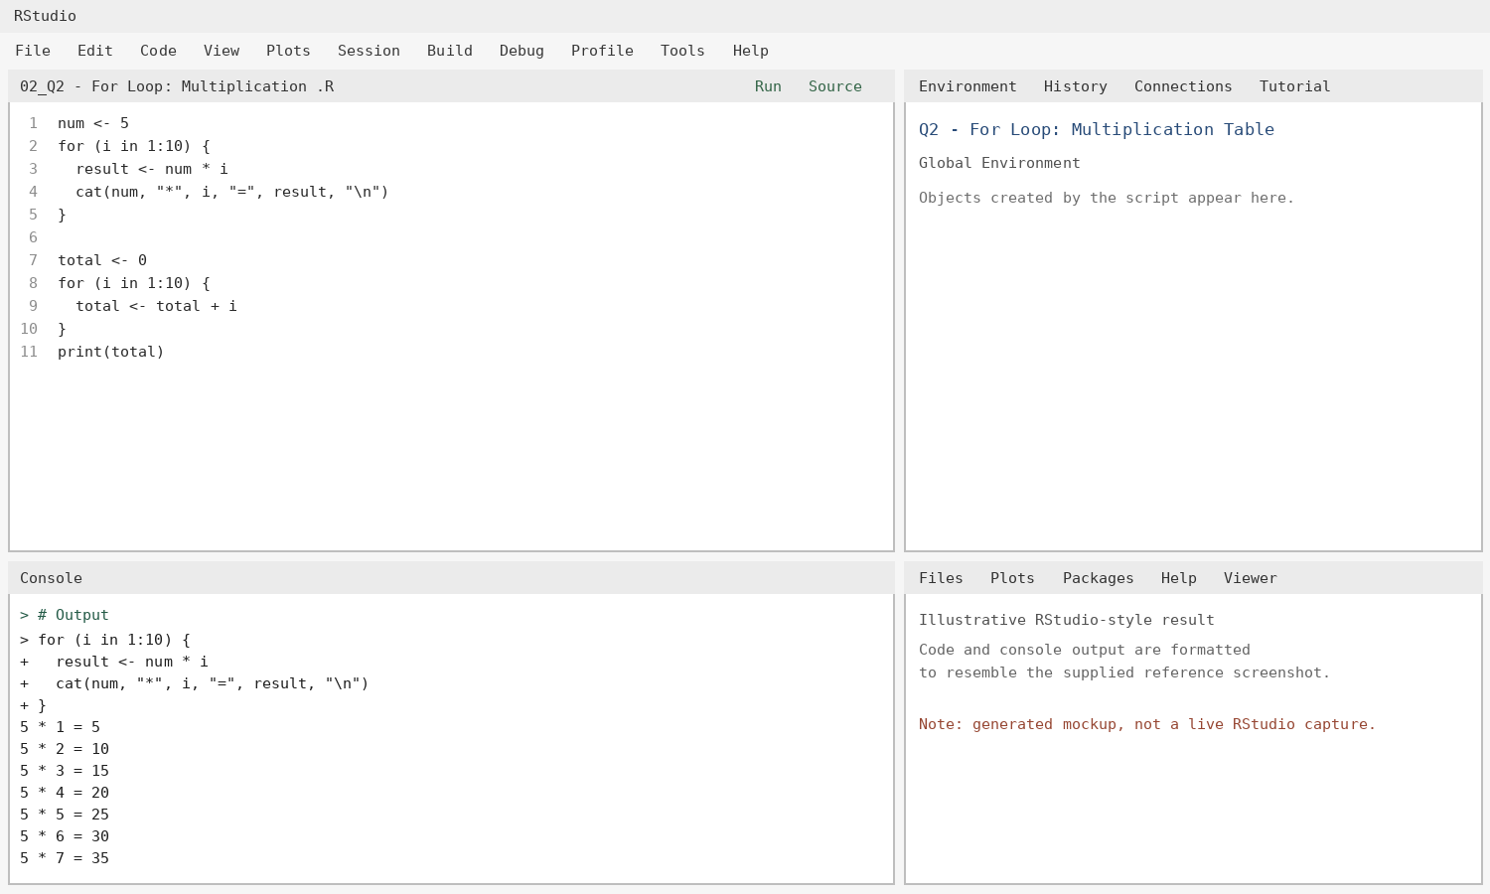

Q3 - While Loop: Sum of Digits
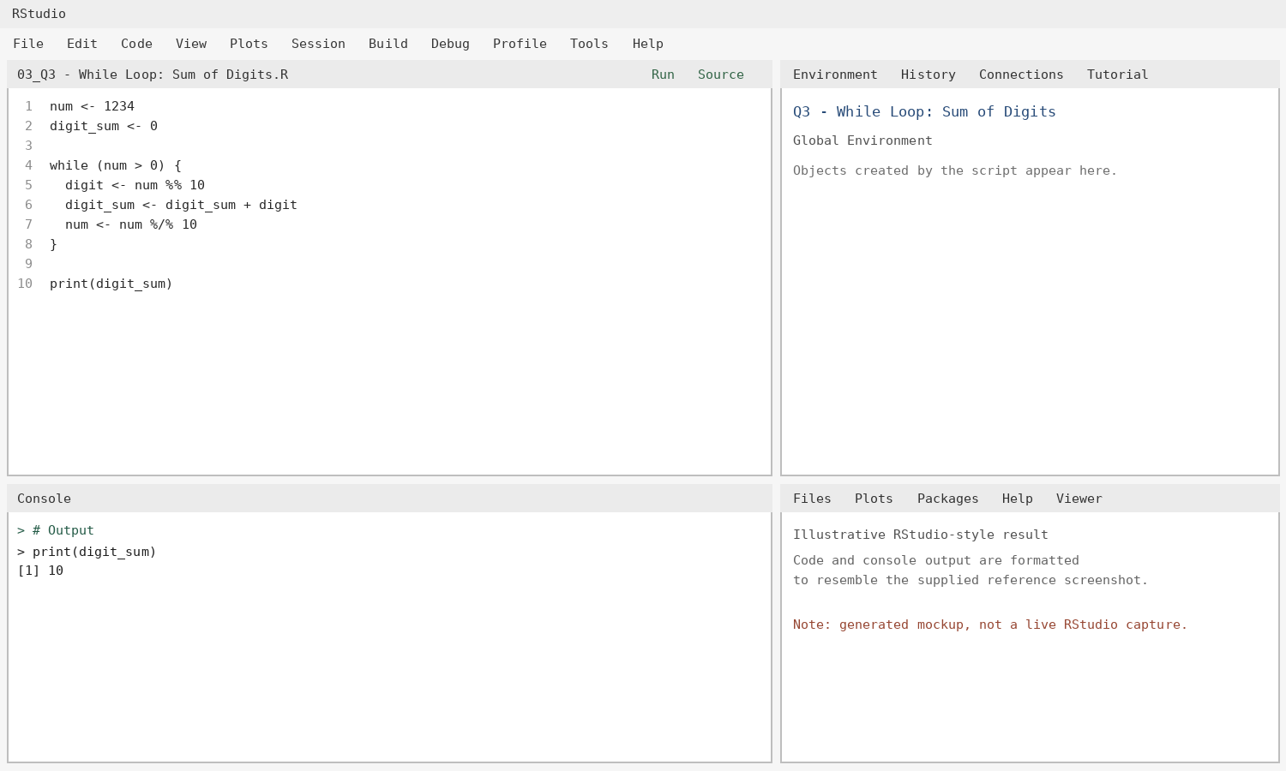

Q4 - Control Statements: break and next
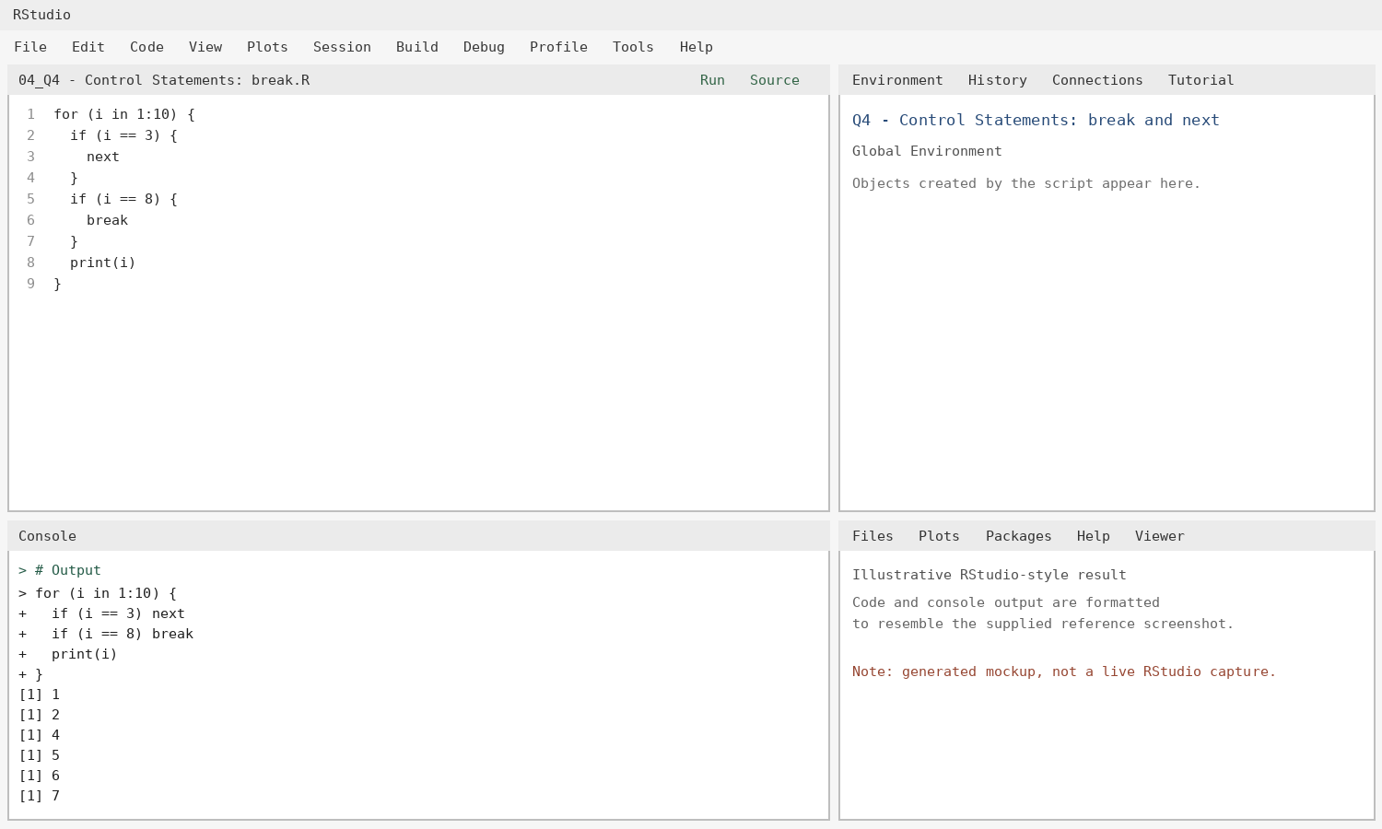

Q5 - Looping Over Elements of a List
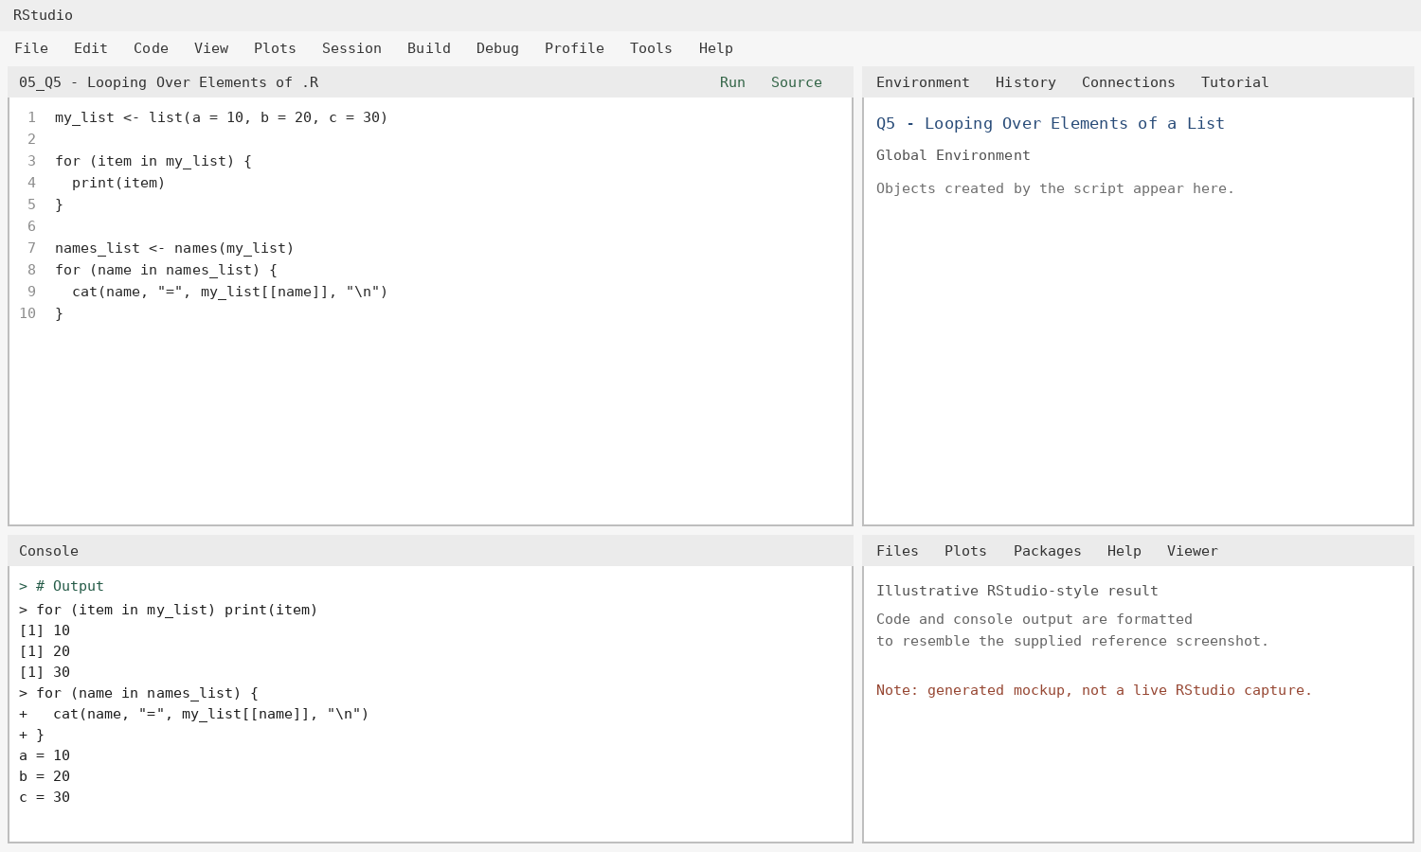

Q6 - Function with Default Argument Values
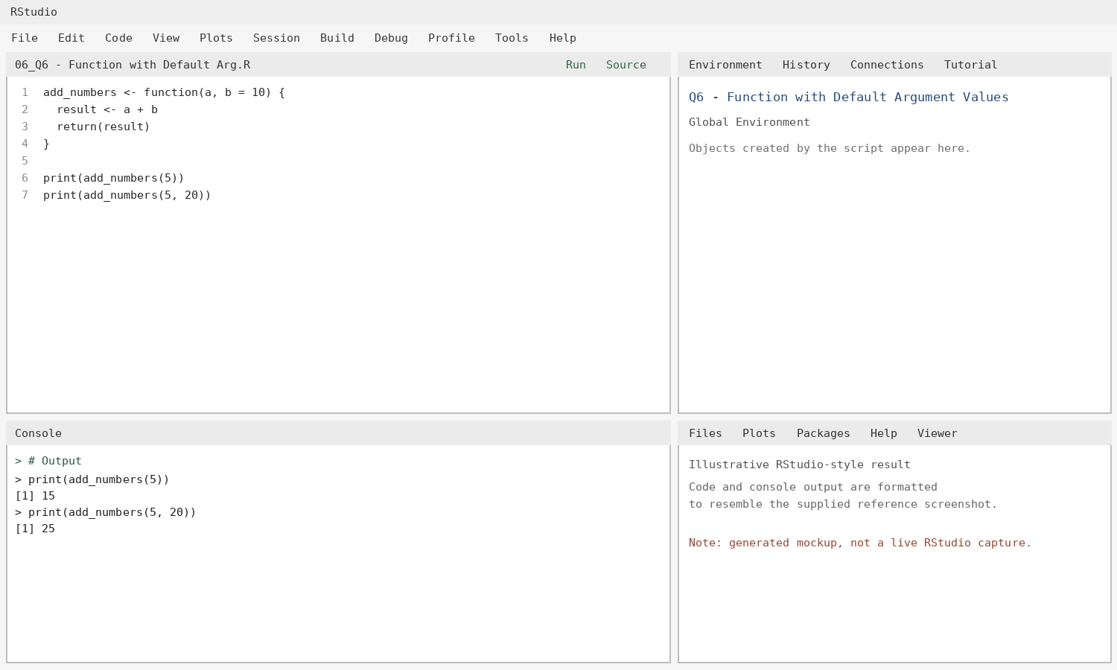

Q7 - Explicit and Implicit Return Values
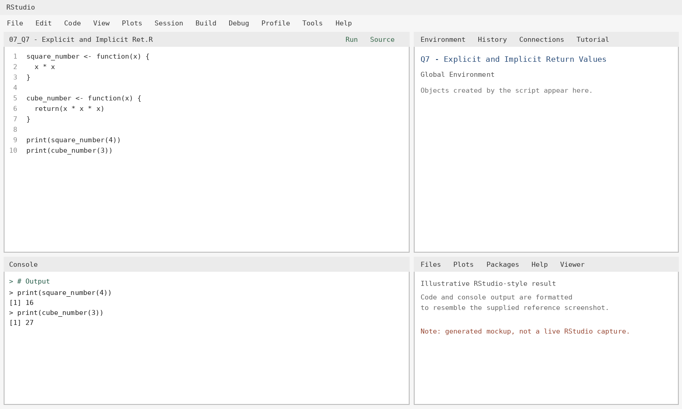

Q8 - Return Multiple Values Using a List
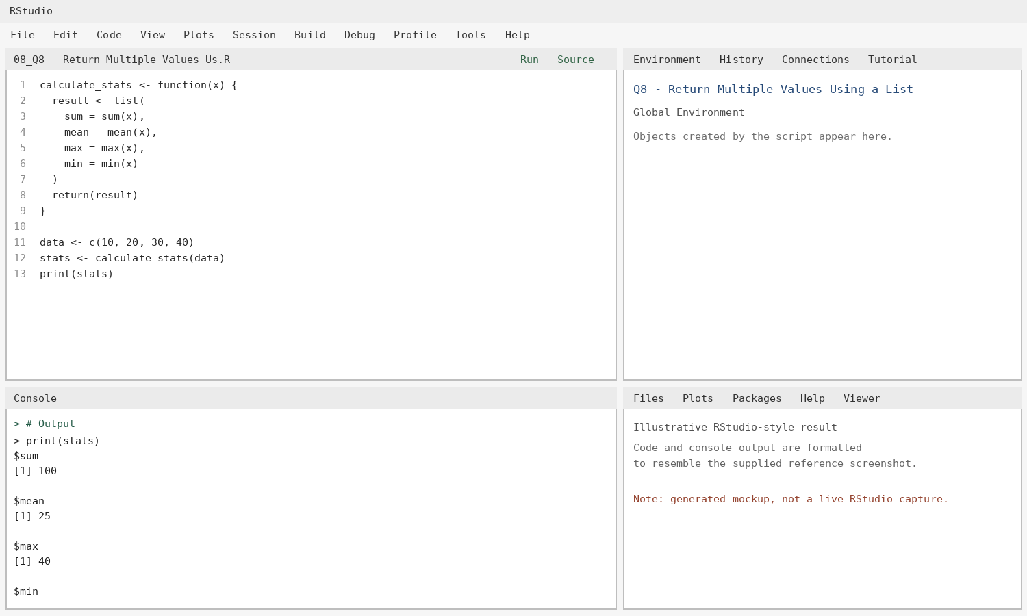

Q9 - Functions Are Objects in R
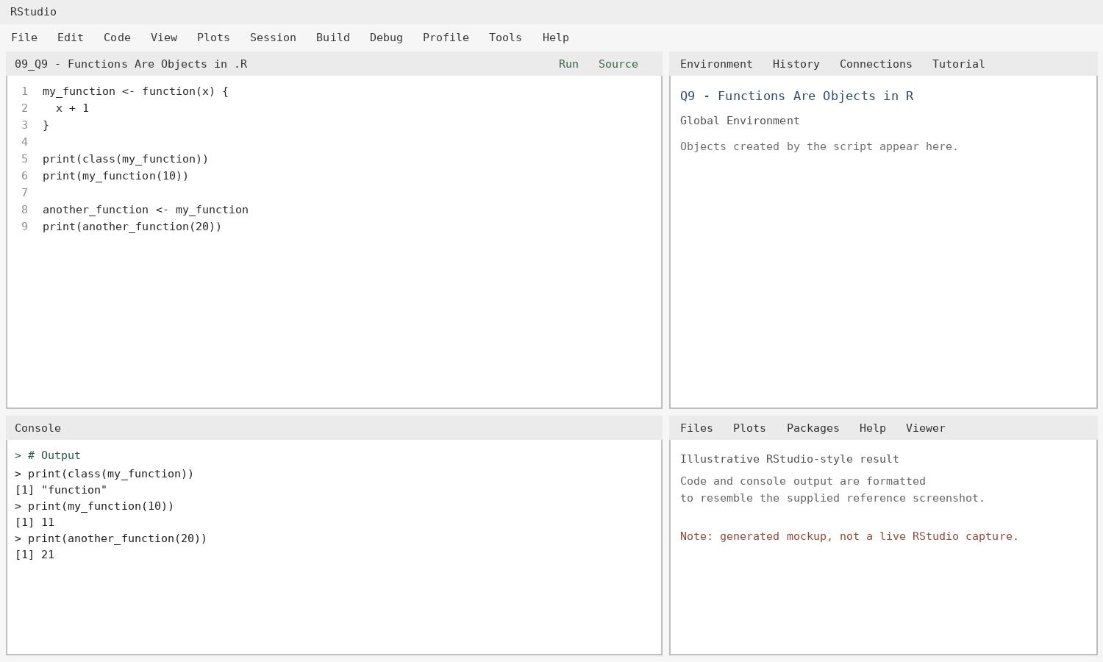

Q10 - Recursion: Factorial
