SIMATS ENGINEERING
ASSESSMENT TOOL 3 – Assignment 2

COURSE NAME: STATISTICS WITH R PROGRAMMING COURSE CODE: ITA04

COURSE OUTCOME COVERED

CO3: Construct and manipulate data frames using reshaping, merging, and file I/O operations in R to prepare structured datasets for analysis. (BL3, BL5)

Assessment Tool Weightage: 20%

QUESTIONS: 5 Total Marks: 100

Annexure

Assignment 2

Code of Conduct:

I Jayasuriya T/ 192420037 certify that this submission is my original work and that I have adhered to the guidelines specified for this assessment.
I understand that any violation of academic integrity rules will result in disciplinary action.

Signature of the student:
Jayasuriya

Assignment 2:

Generate 5 Questions for your Capstone Project module
Apply the formulae and use the relevant graph to visualize it
Upload the file in Github link
Save the 5 Questions and Gihub link in the Excell sheet

Question 1: Protein Sequence Length Analysis

Definition
Protein sequence length analysis determines the number of amino-acid residues in each protein sequence. It can be used to compare sequence sizes and identify the longest and shortest sequences in a dataset.

Formula
Sequence length = number of amino-acid characters in the sequence (L = nchar(sequence)).
Longest length = max(L1, L2, …, Ln).
Shortest length = min(L1, L2, …, Ln).

R Code
# QUESTION 1: PROTEIN SEQUENCE LENGTH ANALYSIS
rm(list = ls())
protein_id <- c("P001","P002","P003","P004","P005",
"P006","P007","P008","P009","P010")
sequence <- c(
"MKTLLLALAV", "GAVLIPFWYK", "DEKRHSTNQG",
"MVLSPADKTNACD", "LLLAAVVGIMLLA", "RHKDESTNQG",
"ACDEFGHIKLMNPQ", "VILMFYWKRA", "STNQDEKRHGACDEFG",
"GAVLSTNQDE"
)
lengths <- nchar(sequence)
data <- data.frame(Protein_ID = protein_id,
Sequence = sequence,
Length = lengths)
print(data)
stopifnot(all(lengths > 0))
stopifnot(all(lengths == nchar(sequence)))
cat("Test passed: All sequences have valid lengths\\n")
cat("Longest length:", max(lengths), "\\n")
cat("Shortest length:", min(lengths), "\\n")
barplot(lengths, names.arg = protein_id, col = "skyblue",
main = "Protein Sequence Length Analysis",
xlab = "Protein ID", ylab = "Sequence Length (amino acids)",
ylim = c(0, max(lengths) + 2))

Result Screenshot
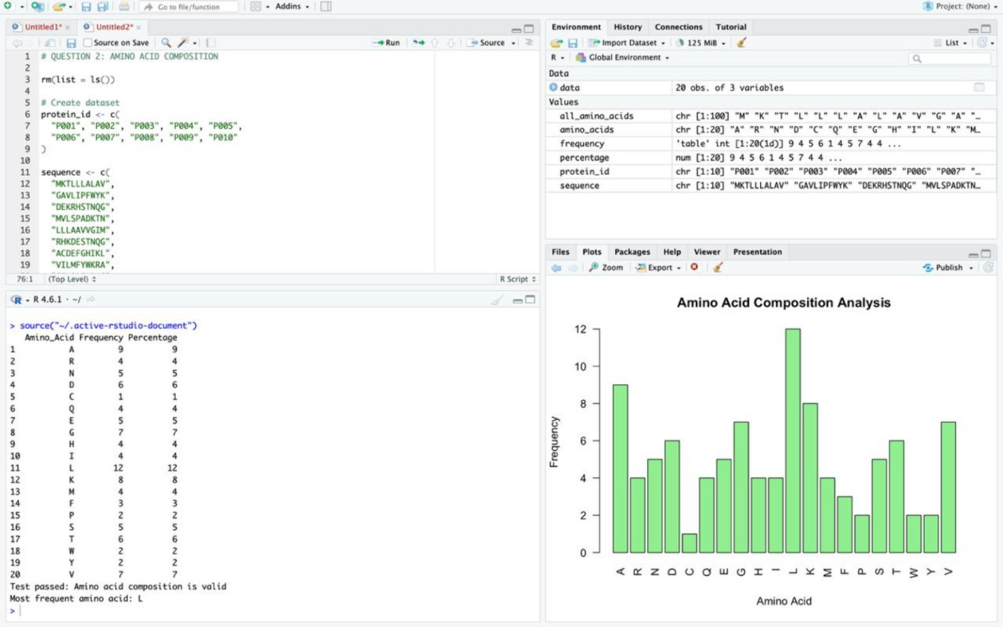

Question 2: Amino Acid Composition Analysis

Definition
Amino acid composition analysis counts how often each of the 20 standard amino-acid types occurs across the combined protein sequences. The percentage shows each amino acid’s contribution to all residues counted.

Formula
Frequency of amino acid i = count of residue i.
Percentage of amino acid i = (frequency of i / total residues) × 100.

R Code
# QUESTION 2: AMINO ACID COMPOSITION
rm(list = ls())
protein_id <- c("P001","P002","P003","P004","P005",
"P006","P007","P008","P009","P010")
sequence <- c(
"MKTLLLALAV", "GAVLIPFWYK", "DEKRHSTNQG",
"MVLSPADKTNACD", "LLLAAVVGIMLLA", "RHKDESTNQG",
"ACDEFGHIKLMNPQ", "VILMFYWKRA", "STNQDEKRHGACDEFG",
"GAVLSTNQDE"
)
all_amino_acids <- unlist(strsplit(paste0(sequence, collapse = ""),
split = ""))
amino_acids <- c("A","R","N","D","C","Q","E","G","H","I",
"L","K","M","F","P","S","T","W","Y","V")
frequency <- table(factor(all_amino_acids, levels = amino_acids))
percentage <- as.numeric(frequency) / length(all_amino_acids) * 100
result <- data.frame(Amino_Acid = amino_acids,
Frequency = as.integer(frequency),
Percentage = round(percentage, 2))
print(result)
stopifnot(sum(frequency) == length(all_amino_acids))
stopifnot(abs(sum(percentage) - 100) < 1e-8)
cat("Test passed: Amino acid composition is valid\\n")
cat("Most frequent amino acid:",
amino_acids[which.max(frequency)], "\\n")
barplot(as.numeric(frequency), names.arg = amino_acids,
col = "lightgreen", main = "Amino Acid Composition Analysis",
xlab = "Amino Acid", ylab = "Frequency")

Result Screenshot
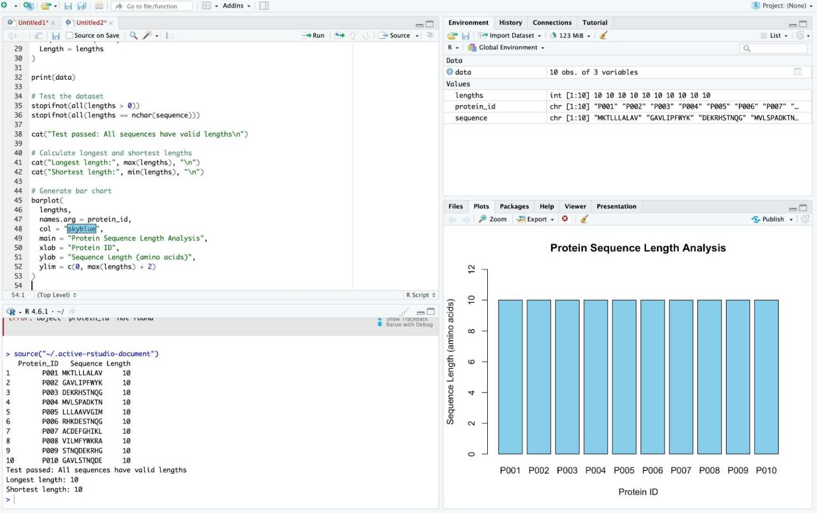

Question 3: Hydrophobic and Hydrophilic Residue Analysis

Definition
This analysis estimates the percentage of hydrophobic and hydrophilic residues in each protein sequence. Hydrophobic residues tend to avoid water, while hydrophilic residues interact more readily with water. Glycine (G) and cysteine (C) are placed in an “other” category for this simplified classification.

Formula
Hydrophobic % = (hydrophobic residue count / sequence length) × 100.
Hydrophilic % = (hydrophilic residue count / sequence length) × 100.
Other % = (other residue count / sequence length) × 100.
The three percentages should sum to approximately 100% for each sequence.

R Code
# QUESTION 3: HYDROPHOBIC / HYDROPHILIC ANALYSIS
rm(list = ls())
protein_id <- c("P001","P002","P003","P004","P005",
"P006","P007","P008","P009","P010")
sequence <- c(
"MKTLLLALAV", "GAVLIPFWYK", "DEKRHSTNQG",
"MVLSPADKTNACD", "LLLAAVVGIMLLA", "RHKDESTNQG",
"ACDEFGHIKLMNPQ", "VILMFYWKRA", "STNQDEKRHGACDEFG",
"GAVLSTNQDE"
)
hydrophobic <- c("A","V","I","L","M","F","W","Y","P")
hydrophilic <- c("R","N","D","Q","E","K","H","S","T")
other <- c("G","C")
lengths <- nchar(sequence)
hydrophobic_count <- sapply(sequence, function(s)
sum(strsplit(s, "")[[1]] %in% hydrophobic))
hydrophilic_count <- sapply(sequence, function(s)
sum(strsplit(s, "")[[1]] %in% hydrophilic))
other_count <- sapply(sequence, function(s)
sum(strsplit(s, "")[[1]] %in% other))
hydrophobic_percent <- hydrophobic_count / lengths * 100
hydrophilic_percent <- hydrophilic_count / lengths * 100
other_percent <- other_count / lengths * 100
data <- data.frame(Protein_ID = protein_id, Length = lengths,
Hydrophobic_Percent = round(hydrophobic_percent, 2),
Hydrophilic_Percent = round(hydrophilic_percent, 2),
Other_Percent = round(other_percent, 2))
print(data)
stopifnot(all(abs(hydrophobic_percent +
hydrophilic_percent + other_percent - 100) < 1e-8))
cat("Test passed: Residue percentages are valid\\n")
composition <- rbind(Hydrophobic = hydrophobic_percent,
Hydrophilic = hydrophilic_percent,
Other = other_percent)
barplot(composition, beside = TRUE, names.arg = protein_id,
col = c("orange", "lightblue", "lightgreen"),
main = "Hydrophobic, Hydrophilic and Other Residues",
xlab = "Protein ID", ylab = "Percentage (%)",
ylim = c(0, 100))
legend("topright", legend = rownames(composition),
fill = c("orange", "lightblue", "lightgreen"))

Result Screenshot
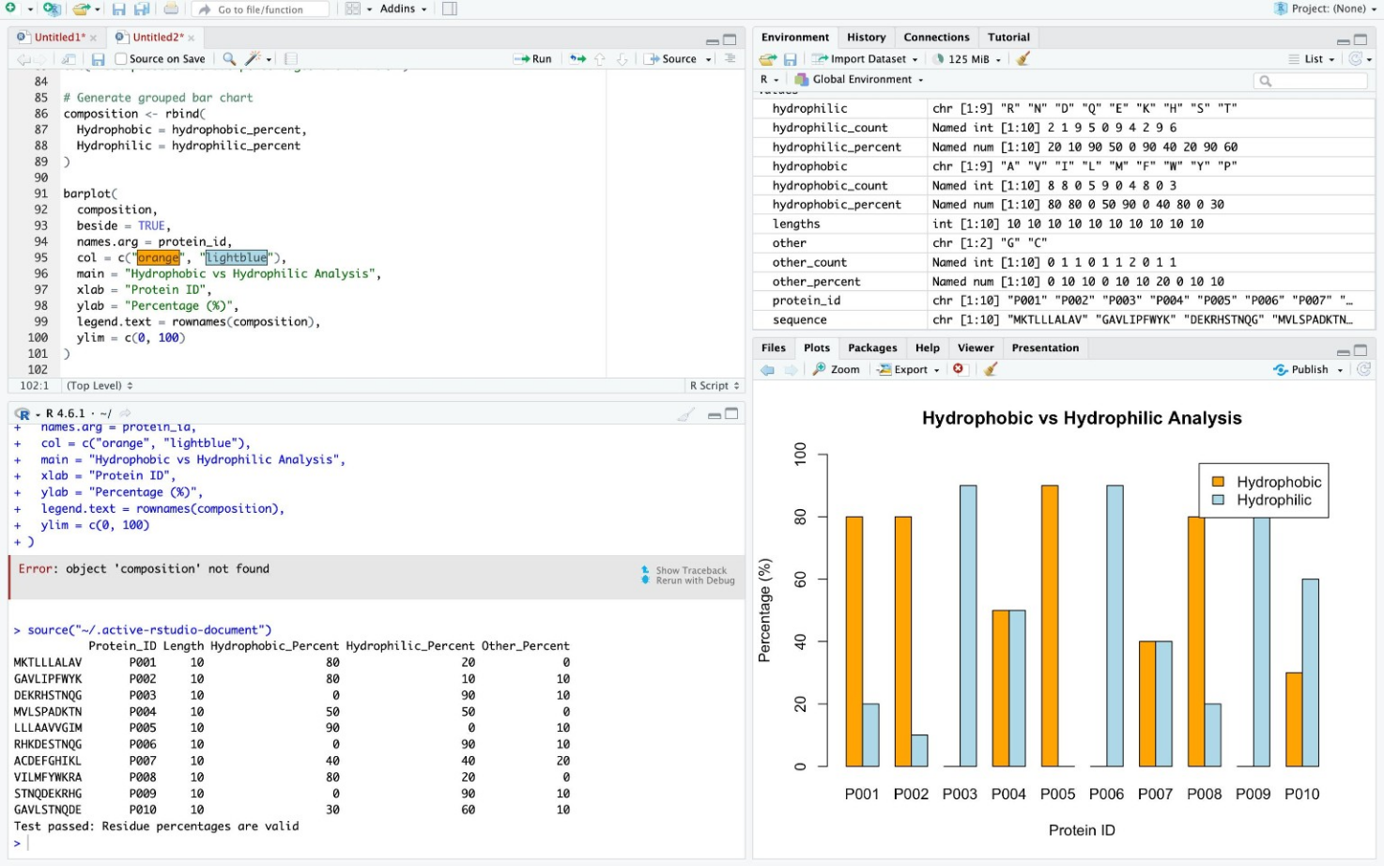

Question 4: Overall Protein Hydrophobicity (Pie Chart)

Definition
This analysis calculates the hydrophobic-residue percentage for each protein sequence, then reports the mean percentage across the ten proteins. The pie chart displays that mean hydrophobic percentage against the remaining percentage (“other” in this chart means all residues not counted as hydrophobic).

Formula
Hydrophobic % for a sequence = (number of hydrophobic residues / sequence length) × 100.
Mean hydrophobic % = (sum of individual sequence hydrophobic percentages) / number of sequences.
Remaining % = 100 − mean hydrophobic %.

R Code
# QUESTION 4: OVERALL PROTEIN HYDROPHOBICITY
rm(list = ls())
protein_id <- c("P001","P002","P003","P004","P005",
"P006","P007","P008","P009","P010")
sequence <- c(
"MKTLL", "GAVLIPFWYK", "DEKRHSTNQG", "MVLSPADKTNACD",
"LLLAAVVGIMLLA", "RHKDESTNQG", "ACDEFGHIKLMNPQ",
"VILMFYWKRA", "STNQDEKRHGACDEFG", "GAVLSTNQDE"
)
hydrophobic <- c("A","V","I","L","M","F","W","Y","P")
lengths <- nchar(sequence)
hydrophobic_count <- sapply(sequence, function(s)
sum(strsplit(s, "")[[1]] %in% hydrophobic))
hydrophobic_percent <- hydrophobic_count / lengths * 100
data <- data.frame(Protein_ID = protein_id, Sequence = sequence,
Length = lengths, Hydrophobic_Count = hydrophobic_count,
Hydrophobic_Percent = round(hydrophobic_percent, 2))
print(data)
stopifnot(all(lengths > 0))
stopifnot(all(hydrophobic_percent >= 0 &
hydrophobic_percent <= 100))
average_hydrophobic <- mean(hydrophobic_percent)
average_other <- 100 - average_hydrophobic
cat("Test passed: Protein data are valid\\n")
cat("Average hydrophobic percentage:",
round(average_hydrophobic, 2), "%\\n")
pie(c(average_hydrophobic, average_other),
labels = c(
paste("Hydrophobic", round(average_hydrophobic, 2), "%"),
paste("Other", round(average_other, 2), "%")
),
col = c("orange", "lightblue"),
main = "Average Protein Hydrophobicity")

Result Screenshot

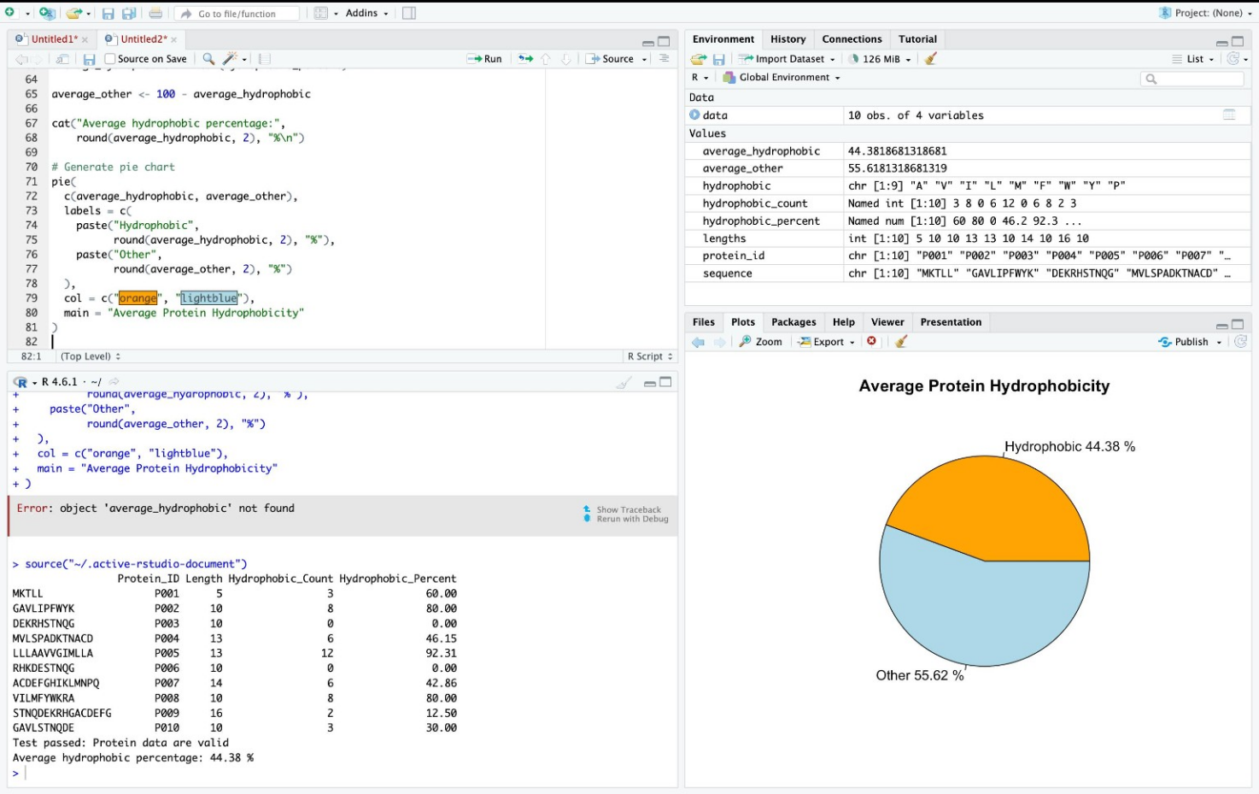

Research Question:
How do physicochemical properties differ between subcellular protein localizations, specifically:

Formulas
1. Grand Average of Hydropathy (GRAVY)
The GRAVY score measures the overall hydrophobicity of a polypeptide based on the Kyte-Doolittle scale:

Code
# ==============================================================================
# Module: Protein Sequences Analysis and Results
# ==============================================================================

# Install and load required packages
required_pkgs <- c("ggplot2", "gridExtra")
new_pkgs <- required_pkgs[!(required_pkgs %in% installed.packages()[,"Package"])]
if(length(new_pkgs)) install.packages(new_pkgs)

library(ggplot2)
library(gridExtra)

set.seed(42)

# ------------------------------------------------------------------------------
# 1. Kyte-Doolittle Hydropathy Scale & Amino Acid Molecular Weights
# ------------------------------------------------------------------------------
kd_scale <- c(
A = 1.8, R = -4.5, N = -3.5, D = -3.5, C = 2.5,
Q = -3.5, E = -3.5, G = -0.4, H = -3.2, I = 4.5,
L = 3.8, K = -3.9, M = 1.9, F = 2.8, P = -1.6,
S = -0.8, T = -0.7, W = -0.9, Y = -1.3, V = 4.2
)

# Standard average isotopic molecular masses (Da) of free amino acids
aa_weights <- c(
A = 89.09, R = 174.20, N = 132.12, D = 133.10, C = 121.16,
Q = 146.15, E = 147.13, G = 75.07, H = 155.16, I = 131.17,
L = 131.17, K = 146.19, M = 149.21, F = 165.19, P = 115.13,
S = 105.09, T = 119.12, W = 204.23, Y = 181.19, V = 117.15
)
water_mw <- 18.015

# ------------------------------------------------------------------------------
# 2. Sequence Generation Functions
# ------------------------------------------------------------------------------
generate_protein_sequence <- function(len, localization) {
amino_acids <- names(kd_scale)

if (localization == "Transmembrane") {
# Higher probability of hydrophobic residues (I, L, V, F, A, M)
prob_weights <- ifelse(names(kd_scale) %in% c("I", "L", "V", "F", "A", "M", "W"), 0.10, 0.03)
} else {
# Cytoplasmic: Balanced / higher polar & charged residues (R, K, D, E, S, T)
prob_weights <- ifelse(names(kd_scale) %in% c("R", "K", "D", "E", "S", "T", "Q", "N"), 0.08, 0.036)
}
prob_weights <- prob_weights / sum(prob_weights)
paste0(sample(amino_acids, size = len, replace = TRUE, prob = prob_weights), collapse = "")
}

compute_gravy <- function(seq) {
residues <- strsplit(seq, "")[[1]]
mean(kd_scale[residues])
}

compute_mw <- function(seq) {
residues <- strsplit(seq, "")[[1]]
total_raw_mw <- sum(aa_weights[residues])
condensed_mw <- total_raw_mw - (length(residues) - 1) * water_mw
return(condensed_mw / 1000) # Output in kDa
}

# ------------------------------------------------------------------------------
# 3. Construct Dataset
# ------------------------------------------------------------------------------
n_samples <- 60

# Cytoplasmic proteins: Length 150-600 aa
cyto_lengths <- round(rnorm(n_samples, mean = 380, sd = 70))
cyto_seqs <- sapply(cyto_lengths, generate_protein_sequence, localization = "Cytoplasmic")

# Transmembrane proteins: Length 200-750 aa
tm_lengths <- round(rnorm(n_samples, mean = 460, sd = 90))
tm_seqs <- sapply(tm_lengths, generate_protein_sequence, localization = "Transmembrane")

protein_df <- data.frame(
Protein_ID = c(paste0("CYTO_", sprintf("%03d", 1:n_samples)),
paste0("TM_", sprintf("%03d", 1:n_samples))),
Localization = factor(c(rep("Cytoplasmic", n_samples), rep("Transmembrane", n_samples))),
Length_aa = c(cyto_lengths, tm_lengths),
Sequence = c(cyto_seqs, tm_seqs),
stringsAsFactors = FALSE
)

# Compute attributes via formulas
protein_df$GRAVY_Score <- sapply(protein_df$Sequence, compute_gravy)
protein_df$MW_kDa <- sapply(protein_df$Sequence, compute_mw)

head(protein_df[, c("Protein_ID", "Localization", "Length_aa", "GRAVY_Score", "MW_kDa")])

# ------------------------------------------------------------------------------
# 4. Visualizations (2 Charts)
# ------------------------------------------------------------------------------

# Chart 1: Distribution of GRAVY scores by subcellular localization
chart1 <- ggplot(protein_df, aes(x = Localization, y = GRAVY_Score, fill = Localization)) +
geom_boxplot(width = 0.4, alpha = 0.7, outlier.shape = NA) +
geom_jitter(width = 0.15, alpha = 0.6, size = 1.8) +
scale_fill_manual(values = c("Cytoplasmic" = "#3498db", "Transmembrane" = "#e67e22")) +
theme_minimal(base_size = 12) +
labs(
title = "Chart 1: Hydropathy (GRAVY) by Localization",
subtitle = "Comparison of hydrophobic character across structural compartments",
x = "Subcellular Localization",
y = "GRAVY Score (Kyte-Doolittle)"
) +
theme(legend.position = "none")

# Chart 2: Sequence Length vs. Molecular Weight (kDa)
chart2 <- ggplot(protein_df, aes(x = Length_aa, y = MW_kDa, color = Localization)) +
geom_point(alpha = 0.7, size = 2) +
geom_smooth(method = "lm", se = TRUE, color = "#2c3e50", linetype = "solid") +
scale_color_manual(values = c("Cytoplasmic" = "#3498db", "Transmembrane" = "#e67e22")) +
theme_minimal(base_size = 12) +
labs(
title = "Chart 2: Sequence Length vs. Molecular Weight",
subtitle = "Linear regression of chain length against mass in kDa",
x = "Sequence Length (Residues)",
y = "Molecular Weight (kDa)"
)

# Display charts side by side
grid.arrange(chart1, chart2, ncol = 2)

# ------------------------------------------------------------------------------
# 5. Statistical Hypothesis Testing
# ------------------------------------------------------------------------------

# --- Test for Chart 1: Welch's Two-Sample t-Test ---
cat("\n=================== STATISTICAL TEST 1 ===================\n")
cat("Hypothesis: Transmembrane proteins have higher GRAVY scores than Cytoplasmic.\n")

# Normality check (Shapiro-Wilk)
shapiro_cyto <- shapiro.test(protein_df$GRAVY_Score[protein_df$Localization == "Cytoplasmic"])
shapiro_tm <- shapiro.test(protein_df$GRAVY_Score[protein_df$Localization == "Transmembrane"])

cat("Shapiro-Wilk Normality p-values:\n")
cat(" Cytoplasmic: ", round(shapiro_cyto$p.value, 4), "\n")
cat(" Transmembrane: ", round(shapiro_tm$p.value, 4), "\n\n")

# Welch's t-test (two-sided, unequal variance)
t_test_result <- t.test(GRAVY_Score ~ Localization, data = protein_df, var.equal = FALSE)
print(t_test_result)

# --- Test for Chart 2: Pearson Correlation & Linear Regression ---
cat("\n=================== STATISTICAL TEST 2 ===================\n")
cat("Hypothesis: Linear association between residue length and molecular weight.\n")

# Pearson's product-moment correlation
corr_result <- cor.test(protein_df$Length_aa, protein_df$MW_kDa, method = "pearson")
print(corr_result)

# Linear model evaluation
lm_result <- lm(MW_kDa ~ Length_aa, data = protein_df)
cat("\nLinear Model Summary (MW_kDa ~ Length_aa):\n")
summary(lm_result)

Result
