EXPERIMENT 4

Aim
To calculate entropy, cross-entropy and KL divergence using NumPy and SciPy, compare two weather forecasting models against the observed weather distribution, verify the relationship between entropy, cross-entropy and KL divergence, demonstrate the asymmetry of KL divergence, and visualize binary cross-entropy loss using Matplotlib.

Algorithm

Task 1: Compute Entropy of the Observed Weather Distribution
Algorithm:
- Start the program.
- Import NumPy and SciPy libraries.
- Define the observed weather data for 30 days.
- Consider the weather categories as Sunny, Cloudy and Rainy.
- Create a NumPy array containing the observed weather counts as [15, 9, 6].
- Convert the observed counts into probabilities by dividing each count by 30.
- Store the observed probability distribution in P.
- Calculate entropy using scipy.stats.entropy(P).
- Display the observed probability distribution.
- Display the calculated entropy value.
- Stop.

Task 2: Compute Cross-Entropy and KL Divergence of Two Models
Algorithm:
- Start the program.
- Initialize the observed distribution P as [0.5, 0.3, 0.2].
- Define the predicted distribution of Model 1 as [0.4, 0.4, 0.2].
- Define the predicted distribution of Model 2 as [0.6, 0.2, 0.2].
- Store both predicted distributions in a list.
- Select the predicted distribution of Model 1.
- Calculate cross-entropy using CE = -sum(Pi * log(Qi)).
- Calculate KL divergence using scipy.stats.entropy(P, Q).
- Display the cross-entropy and KL divergence values of Model 1.
- Repeat the calculation for Model 2.
- Compare the cross-entropy and KL divergence values of both models.
- Identify the model with the lower cross-entropy and KL divergence.
- Stop.

Task 3: Verify Cross-Entropy = Entropy + KL Divergence
Algorithm:
- Start the program.
- Calculate the entropy of the observed distribution P.
- Calculate the cross-entropy of the predicted distribution Q.
- Calculate the KL divergence between P and Q.
- Add the entropy and KL divergence values.
- Store the result in a variable.
- Compare the calculated cross-entropy with the sum using np.isclose().
- If both values are approximately equal, display the verification as True.
- Otherwise, display the verification as False.
- Repeat the verification for both forecasting models.
- Stop.

Task 4: Demonstrate the Asymmetry of KL Divergence
Algorithm:
- Start the program.
- Initialize the observed distribution P and predicted distribution Q1.
- Calculate KL divergence from P to Q1 using entropy(P, Q1).
- Calculate KL divergence from Q1 to P using entropy(Q1, P).
- Store both values in separate variables.
- Display both KL divergence values.
- Compare the two values using np.isclose().
- If the values are not equal, display a message stating that KL divergence is asymmetric.
- Stop.

Task 5: Plot Binary Cross-Entropy Loss Against Predicted Probability
Algorithm:
- Start the program.
- Import NumPy and Matplotlib libraries.
- Generate predicted probabilities from 0.001 to 0.999 using np.linspace().
- Calculate binary cross-entropy loss for actual output 1 using L1 = -log(p).
- Calculate binary cross-entropy loss for actual output 0 using L0 = -log(1-p).
- Create a figure using plt.figure().
- Plot the loss values for actual output 1 and actual output 0.
- Add labels to the X-axis and Y-axis.
- Add a title to the graph.
- Display the legend and grid.
- Display the graph using plt.show().
- Stop.

Code
import numpy as np
import matplotlib.pyplot as plt
from scipy.stats import entropy

np.set_printoptions(precision=6, suppress=True)

# Task 1: Compute Entropy of Observed Distribution
P = np.array([15, 9, 6]) / 30

print("TASK 1: ENTROPY")
print("Observed Weather Distribution:", P)

H = entropy(P)
print("Entropy =", H)

# Task 2: Cross-Entropy and KL Divergence
Q1 = np.array([0.4, 0.4, 0.2])
Q2 = np.array([0.6, 0.2, 0.2])
models = [Q1, Q2]

print("\nTASK 2: CROSS-ENTROPY AND KL DIVERGENCE")
for i, Q in enumerate(models, start=1):
CE = -np.sum(P * np.log(Q))
KL = entropy(P, Q)

print("\nModel", i)
print("Predicted Distribution:", Q)
print("Cross-Entropy =", CE)
print("KL Divergence =", KL)

# Task 3: Verify Cross-Entropy = Entropy + KL Divergence
print("\nTASK 3: VERIFICATION")
for i, Q in enumerate(models, start=1):
CE = -np.sum(P * np.log(Q))
KL = entropy(P, Q)
result = H + KL

print("\nModel", i)
print("Cross-Entropy =", CE)
print("Entropy + KL Divergence =", result)
print("Verification:", np.isclose(CE, result))

# Task 4: KL Divergence Asymmetry
print("\nTASK 4: KL DIVERGENCE ASYMMETRY")
KL_P_Q1 = entropy(P, Q1)
KL_Q1_P = entropy(Q1, P)

print("KL(P || Q1) =", KL_P_Q1)
print("KL(Q1 || P) =", KL_Q1_P)

if not np.isclose(KL_P_Q1, KL_Q1_P):
print("KL Divergence is Asymmetric")
else:
print("KL Divergence is Symmetric")

# Task 5: Binary Cross-Entropy Loss Plot
probability = np.linspace(0.001, 0.999, 200)

loss1 = -np.log(probability) # Actual output = 1
loss0 = -np.log(1 - probability) # Actual output = 0

plt.figure(figsize=(8, 5))
plt.plot(probability, loss1, label="Actual Output = 1")
plt.plot(probability, loss0, label="Actual Output = 0")

plt.xlabel("Predicted Probability")
plt.ylabel("Binary Cross-Entropy Loss")
plt.title("Binary Cross-Entropy Loss")
plt.legend()
plt.grid(True)
plt.tight_layout()
plt.show()

Output
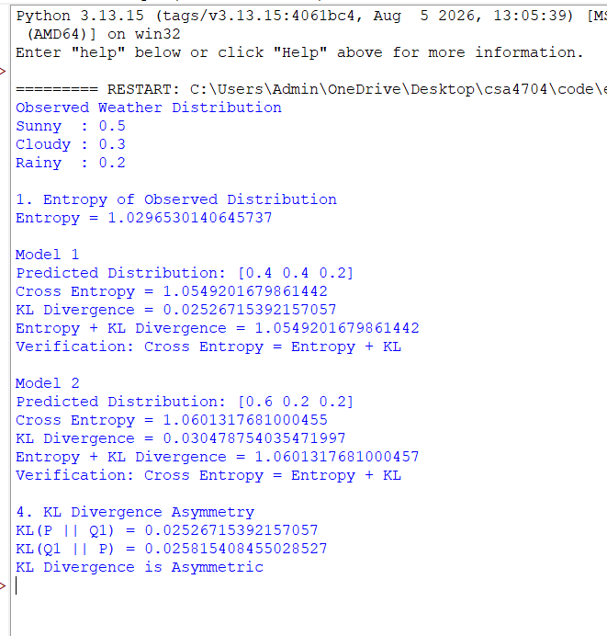
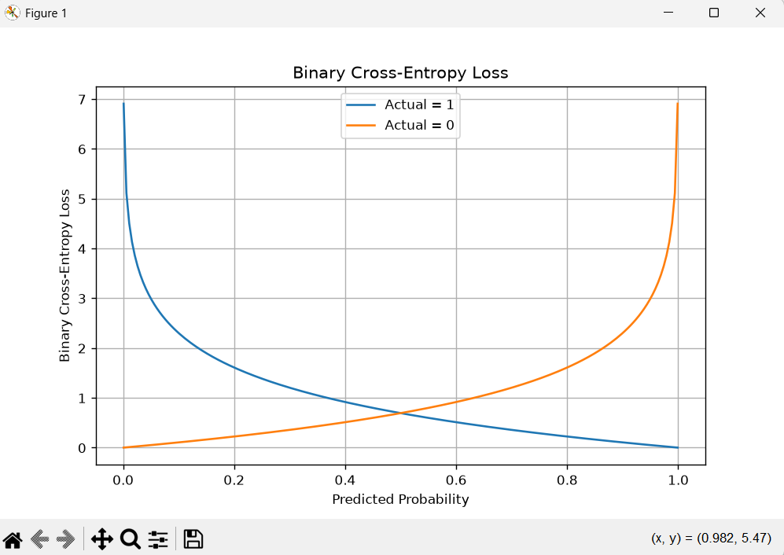

Result
Thus, entropy, cross-entropy and KL divergence were successfully calculated using NumPy and SciPy. The relationship between cross-entropy, entropy and KL divergence was verified for both weather forecasting models. The asymmetry of KL divergence was demonstrated by calculating it in both directions. Binary cross-entropy loss was plotted against predicted probability using Matplotlib. Model 1 achieved lower cross-entropy and KL divergence than Model 2, indicating that Model 1 provides predictions closer to the observed weather distribution.

