EXPERIMENT 5
BIAS–VARIANCE, OVERFITTING AND UNDERFITTING ANALYSIS

Aim
To fit polynomial regression models of different degrees using Scikit-learn, analyze underfitting and overfitting, calculate training and validation errors, estimate bias² and variance through repeated resampling, and select the best model.

Algorithm

Task 1: Generate House Data and Fit Polynomial Regression Models
Algorithm:
- Start the program.
- Import NumPy, Matplotlib and Scikit-learn libraries.
- Generate 150 random samples representing house floor area.
- Define a non-linear function to calculate house prices.
- Add random noise to the house prices.
- Split the dataset into training and validation sets.
- Select polynomial degrees 1, 3, 9 and 15.
- Create polynomial regression models using PolynomialFeatures and LinearRegression.
- Train each model using the training data.
- Store the trained models and display the fitted models.
- Stop.

Task 2: Plot Polynomial Regression Curves
Algorithm:
- Start the program.
- Initialize the polynomial regression models.
- Generate evenly spaced floor-area values.
- Plot the training data as a scatter plot and plot the actual non-linear function.
- Predict house prices using each polynomial model.
- Plot predicted curves for degrees 1, 3, 9 and 15.
- Add titles, axis labels and legends.
- Display the graphs using plt.show().
- Stop.

Task 3: Calculate Training and Validation Error
Algorithm:
- Start the program.
- Use each polynomial regression model to predict training and validation prices.
- Calculate training and validation error using Mean Squared Error (MSE).
- Store and display the calculated errors.
- Plot both errors against polynomial degree.
- Display the graph and stop.

Task 4: Estimate Bias² and Variance Through Resampling
Algorithm:
- Start the program.
- Generate fixed test points and calculate their actual house prices.
- Select polynomial degrees 1, 3, 9 and 15.
- Randomly select training samples with replacement.
- Train a polynomial regression model for each sample and repeat the process.
- Store predictions and calculate the mean prediction for each test point.
- Calculate bias² from mean predictions and actual values.
- Calculate variance from the variation in predictions.
- Display and plot bias² and variance against polynomial degree.
- Stop.

Task 5: Select the Best Polynomial Degree
Algorithm:
- Start the program.
- Compare validation errors of all polynomial models.
- Identify the model with the lowest validation error.
- Examine its bias² and variance.
- Display the selected polynomial degree and validation error.
- Stop.

Code
import numpy as np
import matplotlib.pyplot as plt

from sklearn.preprocessing import PolynomialFeatures
from sklearn.linear_model import LinearRegression
from sklearn.pipeline import make_pipeline
from sklearn.model_selection import train_test_split
from sklearn.metrics import mean_squared_error

np.random.seed(42)

# Task 1: Generate House Data
X = np.random.uniform(0, 10, 150).reshape(-1, 1)

def true_function(x):
return 50 + 8*x + 2*x**2 + 10*np.sin(1.2*x)

y = true_function(X) + np.random.normal(
0, 15, 150
).reshape(-1, 1)

degrees = [1, 3, 9, 15]

X_train, X_val, y_train, y_val = train_test_split(
X, y, test_size=0.25, random_state=42
)

models = {}
train_error = []
val_error = []

for d in degrees:
model = make_pipeline(
PolynomialFeatures(d),
LinearRegression()
)
model.fit(X_train, y_train)
models[d] = model
train_error.append(
mean_squared_error(y_train, model.predict(X_train))
)
val_error.append(
mean_squared_error(y_val, model.predict(X_val))
)

print("TASK 1: POLYNOMIAL REGRESSION")
for d in degrees:
print("Degree", d, "fitted successfully")

# Task 2: Plot Fitted Curves
X_plot = np.linspace(0, 10, 300).reshape(-1, 1)
plt.figure(figsize=(10, 8))

for i, d in enumerate(degrees):
plt.subplot(2, 2, i + 1)
plt.scatter(X_train, y_train, label="Training Data")
plt.plot(X_plot, true_function(X_plot), label="True Curve")
plt.plot(X_plot, models[d].predict(X_plot),
label="Polynomial Degree " + str(d))
plt.title("Degree " + str(d))
plt.xlabel("Floor Area")
plt.ylabel("House Price")
plt.legend()
plt.grid()

plt.tight_layout()
plt.show()

# Task 3: Training and Validation Error
print("\nTASK 3: TRAINING AND VALIDATION ERROR")
for i, d in enumerate(degrees):
print("Degree", d,
"Training MSE =", round(train_error[i], 2),
"Validation MSE =", round(val_error[i], 2))

plt.figure(figsize=(8, 5))
plt.plot(degrees, train_error, marker="o", label="Training Error")
plt.plot(degrees, val_error, marker="s", label="Validation Error")
plt.xlabel("Polynomial Degree")
plt.ylabel("Mean Squared Error")
plt.title("Training and Validation Error")
plt.legend()
plt.grid()
plt.show()

# Task 4: Bias and Variance
X_test = np.linspace(0, 10, 100).reshape(-1, 1)
y_test = true_function(X_test).ravel()
bias_values = []
variance_values = []

for d in degrees:
predictions = []
for i in range(50):
index = np.random.choice(len(X), len(X), replace=True)
model = make_pipeline(
PolynomialFeatures(d),
LinearRegression()
)
model.fit(X[index], y[index])
predictions.append(model.predict(X_test).ravel())

predictions = np.array(predictions)
mean_pred = np.mean(predictions, axis=0)
bias2 = np.mean((mean_pred - y_test)**2)
var = np.mean(np.var(predictions, axis=0))
bias_values.append(bias2)
variance_values.append(var)
print("Degree", d, "Bias2 =", round(bias2, 2),
"Variance =", round(var, 2))

plt.figure(figsize=(8, 5))
plt.plot(degrees, bias_values, marker="o", label="Bias2")
plt.plot(degrees, variance_values, marker="s", label="Variance")
plt.xlabel("Polynomial Degree")
plt.ylabel("Error")
plt.title("Bias-Variance Analysis")
plt.legend()
plt.grid()
plt.show()

# Task 5: Select Best Polynomial Degree
best_index = np.argmin(val_error)
best_degree = degrees[best_index]
print("\nTASK 5: BEST MODEL")
print("Best Degree =", best_degree)
print("Lowest Validation MSE =", round(val_error[best_index], 2))

Output
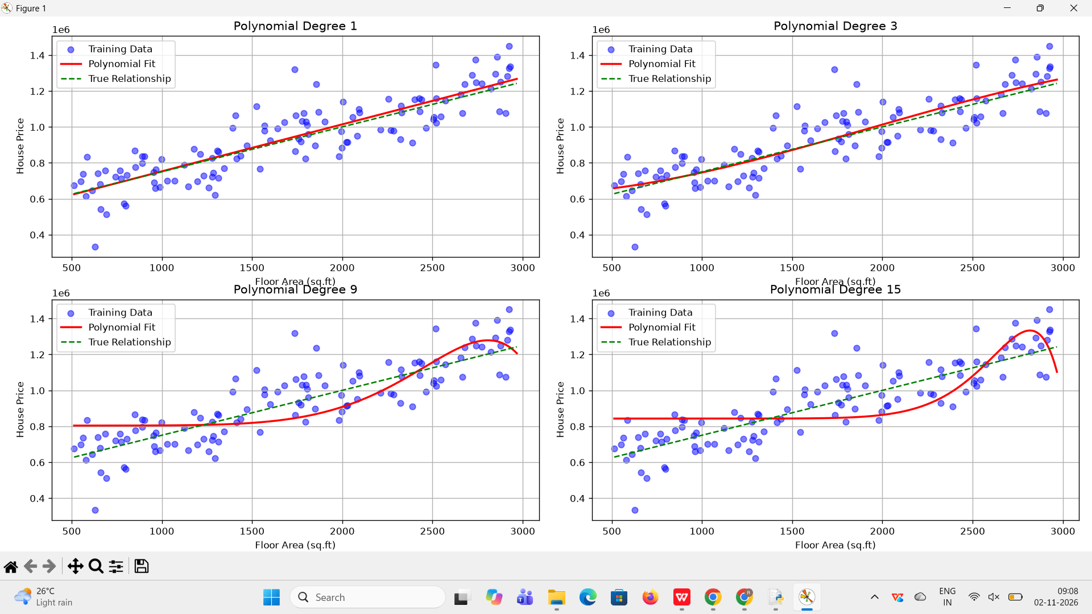
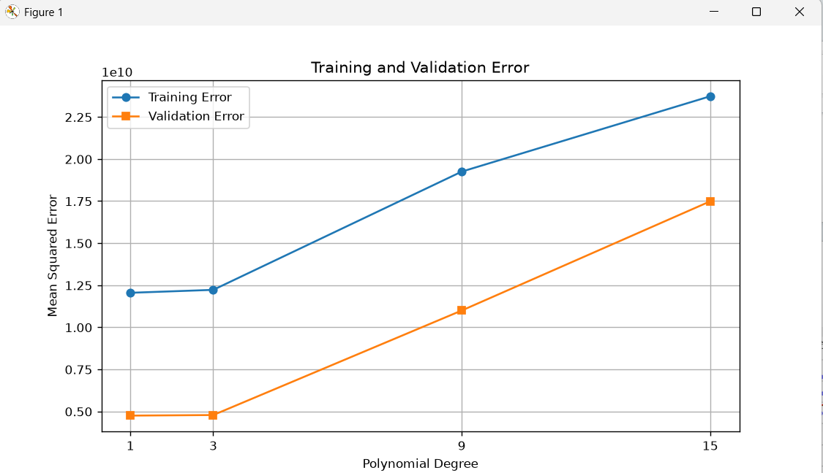
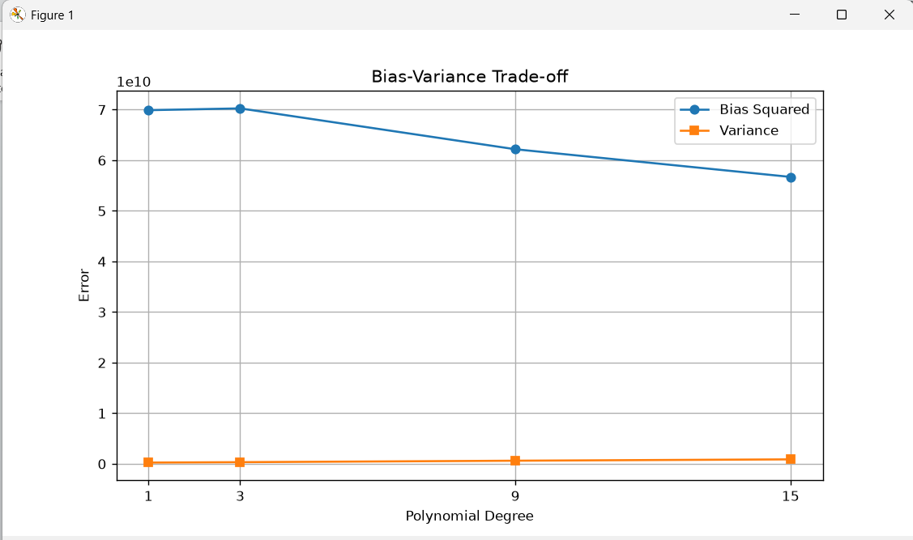
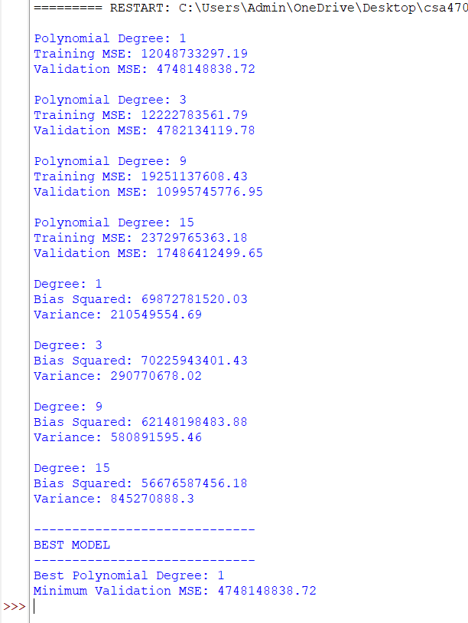

Result
Thus, polynomial regression models of degrees 1, 3, 9 and 15 were fitted using Scikit-learn. Training and validation errors were calculated, and bias² and variance were estimated through repeated resampling. The fitted curves and error graphs were visualized using Matplotlib. The best polynomial degree was selected based on validation error, balancing underfitting and overfitting.

