AIM
To study and implement integrity constraints such as PRIMARY KEY, FOREIGN KEY, UNIQUE, and CHECK constraints in MySQL using the Vehicle, Customer, and Showroom Branch tables.
PROCEDURE
- Select the AUTOHUB_SHOWROOM database.
- Create the VEHICLE table with vehicle details and insert 8 records.
- Add VehicleID as the PRIMARY KEY.
- Create the CUSTOMER table and insert 8 customer records.
- Add CustomerID as the PRIMARY KEY.
- Add VehicleID in the Customer table as a FOREIGN KEY referencing VEHICLE(VehicleID).
- Create the SHOWROOM_BRANCH table and insert 8 branch records.
- Add BranchID as the PRIMARY KEY.
- Add a UNIQUE constraint on BranchCode.
- Add a CHECK constraint to ensure vehicle Price > 0.
- Add a CHECK constraint to allow only M or F for customer Gender.
- Use DESC to display and verify the structures of all three tables.
OUTPUT: 1
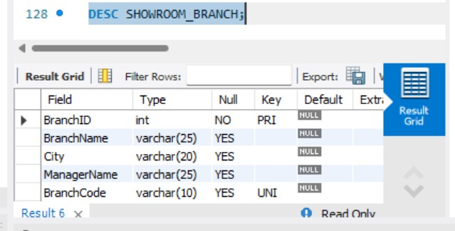
OUTPUT: 2
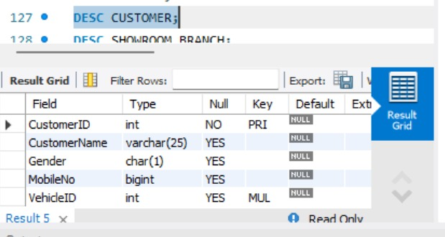
OUTPUT: 3
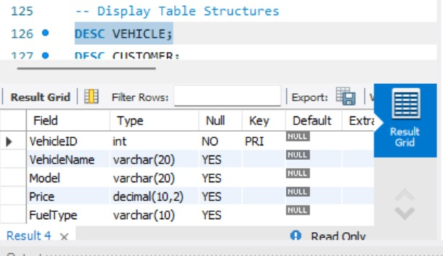
OUTPUT: 4
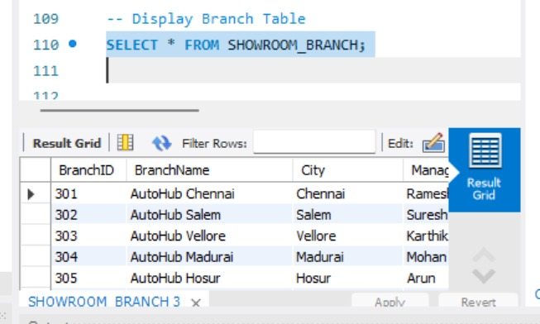
OUTPUT: 5
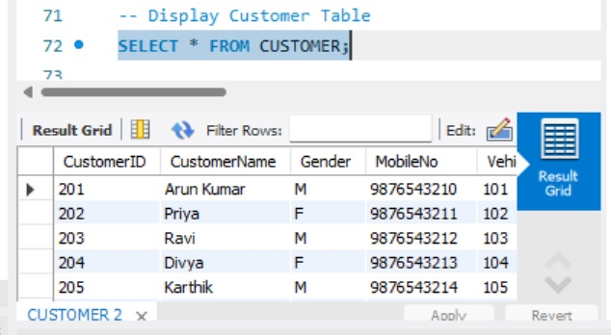
OUTPUT :6
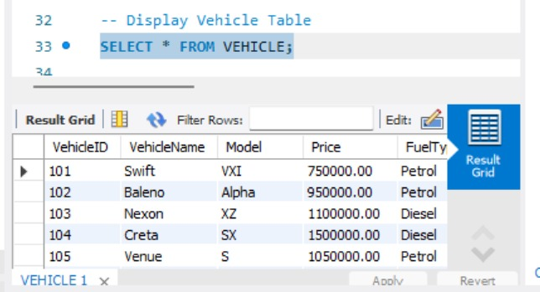

QUERY:
-- 1. VEHICLE TABLE
CREATE TABLE VEHICLE (
VehicleID INT,
VehicleName VARCHAR(20),
Model VARCHAR(20),
Price DECIMAL(10,2),
FuelType VARCHAR(10)
);
-- Insert 8 Vehicle Records
INSERT INTO VEHICLE
VALUES
(101, 'Swift', 'VXI', 750000, 'Petrol'),
(102, 'Baleno', 'Alpha', 950000, 'Petrol'),
(103, 'Nexon', 'XZ', 1100000, 'Diesel'),
(104, 'Creta', 'SX', 1500000, 'Diesel'),
(105, 'Venue', 'S', 1050000, 'Petrol'),
(106, 'i20', 'Sportz', 900000, 'Petrol'),
(107, 'Verna', 'SX', 1400000, 'Petrol'),
(108, 'Punch', 'Adventure', 850000, 'Petrol');
-- Add PRIMARY KEY
ALTER TABLE VEHICLE
ADD PRIMARY KEY (VehicleID);
-- Display Vehicle Table
SELECT * FROM VEHICLE;
-- 2. CUSTOMER TABLE
CREATE TABLE CUSTOMER (
CustomerID INT,
CustomerName VARCHAR(25),
Gender CHAR(1),
MobileNo BIGINT,
VehicleID INT
);
-- Insert 8 Customer Records
INSERT INTO CUSTOMER
VALUES
(201, 'Arun Kumar', 'M', 9876543210, 101),
(202, 'Priya', 'F', 9876543211, 102),
(203, 'Ravi', 'M', 9876543212, 103),
(204, 'Divya', 'F', 9876543213, 104),
(205, 'Karthik', 'M', 9876543214, 105),
(206, 'Meena', 'F', 9876543215, 106),
(207, 'Surya', 'M', 9876543216, 107),
(208, 'Anitha', 'F', 9876543217, 108);
-- Add PRIMARY KEY
ALTER TABLE CUSTOMER
ADD PRIMARY KEY (CustomerID);
-- Add FOREIGN KEY
ALTER TABLE CUSTOMER
ADD CONSTRAINT fk_vehicle
FOREIGN KEY (VehicleID)
REFERENCES VEHICLE(VehicleID);
-- Display Customer Table
SELECT * FROM CUSTOMER;
-- 3. SHOWROOM_BRANCH TABLE
CREATE TABLE SHOWROOM_BRANCH (
BranchID INT,
BranchName VARCHAR(25),
City VARCHAR(20),
ManagerName VARCHAR(25),
BranchCode VARCHAR(10)
);
-- Insert 8 Branch Records
INSERT INTO SHOWROOM_BRANCH
VALUES
(301, 'AutoHub Chennai', 'Chennai', 'Ramesh', 'CHN001'),
(302, 'AutoHub Salem', 'Salem', 'Suresh', 'SLM002'),
(303, 'AutoHub Vellore', 'Vellore', 'Karthik', 'VLR003'),
(304, 'AutoHub Madurai', 'Madurai', 'Mohan', 'MDU004'),
(305, 'AutoHub Hosur', 'Hosur', 'Arun', 'HSR005'),
(306, 'AutoHub Coimbatore', 'Coimbatore', 'Ravi', 'CBE006'),
(307, 'AutoHub Tiruvannamalai', 'Tiruvannamalai', 'Surya', 'TVM007'),
(308, 'AutoHub Kanchipuram', 'Kanchipuram', 'Vijay', 'KPM008');
-- Add PRIMARY KEY
ALTER TABLE SHOWROOM_BRANCH
ADD PRIMARY KEY (BranchID);
-- Add UNIQUE constraint
ALTER TABLE SHOWROOM_BRANCH
ADD CONSTRAINT unique_branch_code
UNIQUE (BranchCode);
-- Display Branch Table
SELECT * FROM SHOWROOM_BRANCH;
-- 4. CHECK CONSTRAINT
ALTER TABLE VEHICLE
ADD CONSTRAINT check_price
CHECK (Price > 0);
-- CHECK Gender in CUSTOMER
ALTER TABLE CUSTOMER
ADD CONSTRAINT check_gender
CHECK (Gender IN ('M','F'));
-- Display Table Structures
DESC VEHICLE;
DESC CUSTOMER;
DESC SHOWROOM_BRANCH;
RESULT
Thus, the PRIMARY KEY, FOREIGN KEY, UNIQUE, and CHECK constraints were successfully created and implemented on the Vehicle, Customer, and Showroom Branch tables, and their structures were verified successfully.

