EXPERIMENT 3 — Data Insertion and Retrieval
AIM:
To perform data insertion and retrieval operations on the VEHICLE, CUSTOMER, and SHOWROOM_BRANCH tables.
PROCEDURE:
- Select the AUTOHUB_SHOWROOM database.
- Insert 8 records into the VEHICLE table.
- Display all vehicle records using SELECT.
- Insert 8 records into the CUSTOMER table.
- Display all customer records.
- Insert 8 records into the SHOWROOM_BRANCH table.
- Display all showroom branch records.
OUT: 1
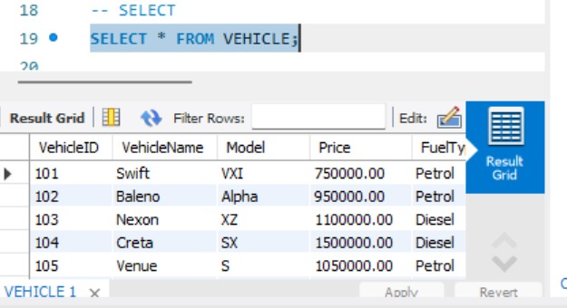
OUT:2
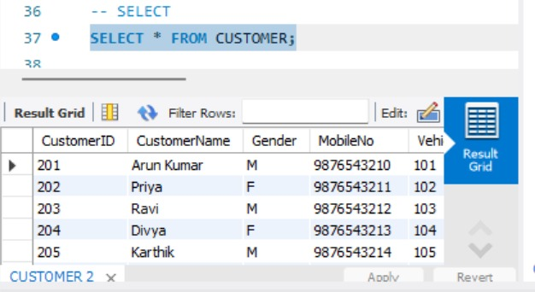
OUT: 3
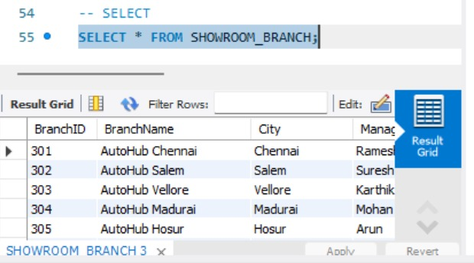
QUERY:
USE AUTOHUB_SHOWROOM;
-- 1. VEHICLE TABLE
INSERT INTO VEHICLE
(VehicleID, VehicleName, Model, Price, FuelType)
VALUES
(101, 'Swift', 'VXI', 750000, 'Petrol'),
(102, 'Baleno', 'Alpha', 950000, 'Petrol'),
(103, 'Nexon', 'XZ', 1100000, 'Diesel'),
(104, 'Creta', 'SX', 1500000, 'Diesel'),
(105, 'Venue', 'S', 1050000, 'Petrol'),
(106, 'i20', 'Sportz', 900000, 'Petrol'),
(107, 'Verna', 'SX', 1400000, 'Petrol'),
(108, 'Punch', 'Adventure', 850000, 'Petrol');

-- SELECT
SELECT * FROM VEHICLE
-- 2. CUSTOMER TABLE
INSERT INTO CUSTOMER
(CustomerID, CustomerName, Gender, MobileNo, VehicleID)
VALUES
(201, 'Arun Kumar', 'M', 9876543210, 101),
(202, 'Priya', 'F', 9876543211, 102),
(203, 'Ravi', 'M', 9876543212, 103),
(204, 'Divya', 'F', 9876543213, 104),
(205, 'Karthik', 'M', 9876543214, 105),
(206, 'Meena', 'F', 9876543215, 106),
(207, 'Surya', 'M', 9876543216, 107),
(208, 'Anitha', 'F', 9876543217, 108);
-- SELECT
SELECT * FROM CUSTOMER;
-- 3. SHOWROOM_BRANCH TABLE
INSERT INTO SHOWROOM_BRANCH
(BranchID, BranchName, City, ManagerName, BranchCode)
VALUES
(301, 'AutoHub Chennai', 'Chennai', 'Ramesh', 'CHN001'),
(302, 'AutoHub Salem', 'Salem', 'Suresh', 'SLM002'),
(303, 'AutoHub Vellore', 'Vellore', 'Karthik', 'VLR003'),
(304, 'AutoHub Madurai', 'Madurai', 'Mohan', 'MDU004'),
(305, 'AutoHub Hosur', 'Hosur', 'Arun', 'HSR005'),
(306, 'AutoHub Coimbatore', 'Coimbatore', 'Ravi', 'CBE006'),
(307, 'AutoHub Tiruvannamalai', 'Tiruvannamalai', 'Surya', 'TVM007'),
(308, 'AutoHub Kanchipuram', 'Kanchipuram', 'Vijay', 'KPM008');
-- SELECT
SELECT * FROM SHOWROOM_BRANCH;
RESULT:
Thus, records were successfully inserted and retrieved from the VEHICLE, CUSTOMER, and SHOWROOM_BRANCH tables.

