SIMATS ENGINEERING
ASSESSMENT TOOL 3

COURSE NAME: Artificial Intelligence COURSE CODE: CSA17

COURSE OUTCOME COVERED

CO2: Experiment search and game-solving techniques such as Greedy Search, A*, CSP, Minimax, and Alpha-Beta pruning with heuristic functions for solving complex AI problems efficiently. (BL3)

Assessment Tool Weightage: 40%

Duration: 1 Hour
QUESTIONS: 3 Total Marks:30

Annexure A

Dry Run Evaluation

Code of Conduct:

I K SRICHARAN (192424029) (Name / Reg No) certify that this submission is my original work and that I have adhered to the guidelines specified for this assessment.
I understand that any violation of academic integrity rules will result in disciplinary action.

Signature of the student:

K SRICHARAN

Annexure A

Dry Run Evaluation
1. Question 1 – Breadth-First Search (BFS)
Consider the following graph: A
/ \
B C
/ \ / \
D E F G
Task: Starting from node A, perform a Breadth-First Search (BFS). Complete the following table.
Iteration | Queue | Visited Node
1
2
3
4
5
6
7
Questions:
- Write the BFS traversal order.
- Show the queue contents after each iteration.

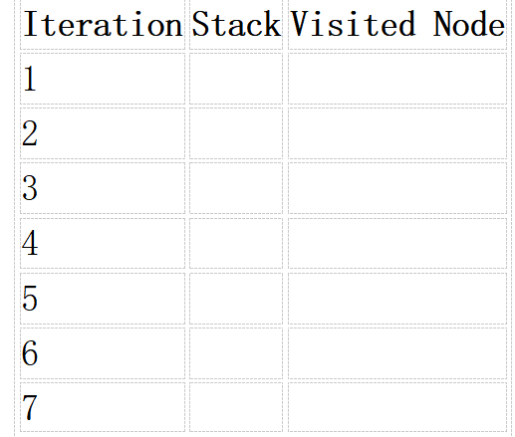
2. Depth-First Search (DFS) Using the same graph,
A
/ \
B C
/ \ / \
D E F G
Perform Depth-First Search (DFS) starting from A.
Complete the table.
- Initial State :
1 3 6
5 0 2
4 7 8

Goal State :
1 2 3
4 5 6
7 8 0

Task
Trace Breadth-First Search (BFS) until the goal state is reached.
Fill in the table.
Iteration | Current State | Queue Before Expansion | Queue After Expansion
1
2
3
4
5

Questions
- Which node is expanded in each iteration?
- How many states are generated in total?
- Write the complete solution path from the initial state to the goal state.
- Why does BFS always find the shortest solution in an unweighted 8-puzzle problem?

RUBRICS FOR CALCULATION

Criteria | Weightage (%) | Level 4 – Exemplary (4) | Level 3 – Proficient (3) | Level 2 – Developing (2) | Level 1 – Beginning (1)
Understanding of Search Problem | 20 | Clearly understands the search problem, initial state, goal state, and search strategy. | Understands the problem with minor misunderstandings. | Demonstrates partial understanding of the search problem. | Shows little or no understanding of the search problem.
State Expansion and Dry Run Execution | 30 | Correctly traces every iteration, expands nodes accurately, and maintains the Queue/Stack/Priority Queue without errors. | Performs most iterations correctly with minor mistakes in state expansion or data structure updates. | Performs only some iterations correctly; several errors in tracing or node expansion. | Unable to correctly perform the dry run or expand states.
Application of Search Algorithm | 20 | Applies the selected algorithm (BFS/DFS/UCS) correctly, following all algorithmic rules. | Applies the algorithm correctly with a few procedural errors. | Applies only basic algorithm steps with noticeable mistakes. | Fails to apply the correct search algorithm.
Accuracy of Solution Path | 20 | Identifies the correct traversal order/solution path and goal state with proper justification. | Solution path is mostly correct with minor errors. | Partially correct solution path; goal may not be reached correctly. | Incorrect or incomplete solution path.
Presentation and Logical Reasoning | 10 | Queue/Stack/Priority Queue updates, state diagrams, and explanations are neat, organized, and logically presented. | Presentation is clear with minor organizational issues. | Limited explanation and organization; reasoning is partially clear. | Poor presentation with unclear or missing reasoning.

PYTHON CODE :

from collections import deque

# Graph representation
graph = {
'A': ['B', 'C'],
'B': ['D', 'E'],
'C': ['F', 'G'],
'D': [],
'E': [],
'F': [],
'G': []
}

def bfs(start):
queue = deque([start])
visited = set()
traversal = []

iteration = 1

print("BFS Dry Run")
print("-" * 50)
print("Iteration\tQueue\t\tVisited Node")
print("-" * 50)

while queue:
print(f"{iteration}\t\t{list(queue)}", end="\t")

node = queue.popleft()

if node not in visited:
visited.add(node)
traversal.append(node)

for neighbour in graph[node]:
if neighbour not in visited:
queue.append(neighbour)

print(node)
iteration += 1

print("-" * 50)
print("BFS Traversal Order:", " -> ".join(traversal))

# Start BFS from A
bfs('A')

OUPUT:

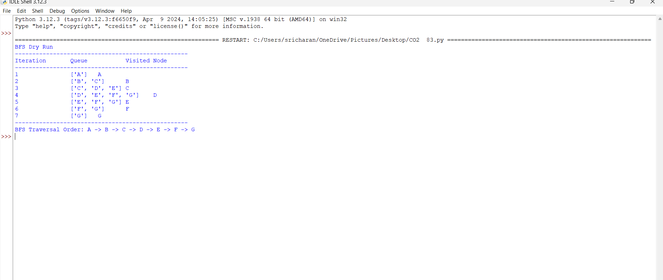

PYTHON CODE :

# Graph representation
graph = {
'A': ['B', 'C'],
'B': ['D', 'E'],
'C': ['F', 'G'],
'D': [],
'E': [],
'F': [],
'G': []
}

def dfs(start):
stack = [start]
visited = set()
traversal = []

iteration = 1

print("DFS Dry Run")
print("-" * 50)
print("Iteration\tStack\t\tVisited Node")
print("-" * 50)

while stack:
print(f"{iteration}\t\t{stack}", end="\t")

node = stack.pop()

if node not in visited:
visited.add(node)
traversal.append(node)

# Reverse order so B is processed before C
for neighbour in reversed(graph[node]):
if neighbour not in visited:
stack.append(neighbour)

print(node)
iteration += 1

print("-" * 50)
print("DFS Traversal Order:", " -> ".join(traversal))

# Start DFS from A
dfs('A')

OUTPUT:

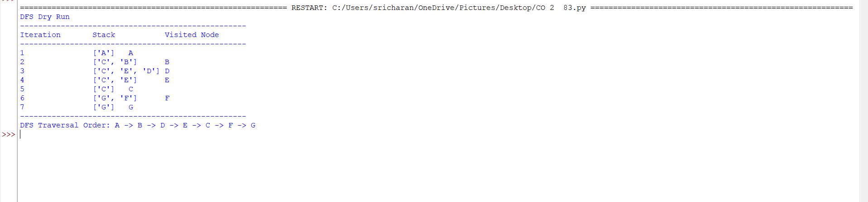

PYTHON CODE :

from collections import deque

# Initial State
initial = (
(1, 3, 6),
(5, 0, 2),
(4, 7, 8)
)

# Goal State
goal = (
(1, 2, 3),
(4, 5, 6),
(7, 8, 0)
)

# Display puzzle state
def display(state):
for row in state:
print(" ".join(map(str, row)))
print()

# Generate possible next states
def get_neighbors(state):

# Find position of blank (0)
for i in range(3):
for j in range(3):
if state[i][j] == 0:
x, y = i, j

# Up, Down, Left, Right
directions = [
(-1, 0),
(1, 0),
(0, -1),
(0, 1)
]

neighbors = []

for dx, dy in directions:

nx = x + dx
ny = y + dy

if 0 <= nx < 3 and 0 <= ny < 3:

# Convert tuple to list
new_state = [list(row) for row in state]

# Swap blank with adjacent tile
new_state[x][y], new_state[nx][ny] = \
new_state[nx][ny], new_state[x][y]

# Convert to tuple
new_state = tuple(tuple(row) for row in new_state)

neighbors.append(new_state)

return neighbors

# BFS Algorithm
def bfs():

# Queue contains (state, path)
queue = deque()

queue.append((initial, [initial]))

# Keep track of already visited states
visited = {initial}

expanded = 0

while queue:

current, path = queue.popleft()

expanded += 1

# Check goal
if current == goal:

print("GOAL STATE REACHED!")
print("--------------------------------")

print("Initial State:")
display(initial)

print("Solution Path:")

for step, state in enumerate(path):
print("Step", step)
display(state)

print("Total Moves:", len(path) - 1)
print("States Expanded:", expanded)

return

# Generate next states
for next_state in get_neighbors(current):

if next_state not in visited:

visited.add(next_state)

new_path = path + [next_state]

queue.append((next_state, new_path))

print("No solution exists.")

# Run BFS
bfs()

OUTPUT : 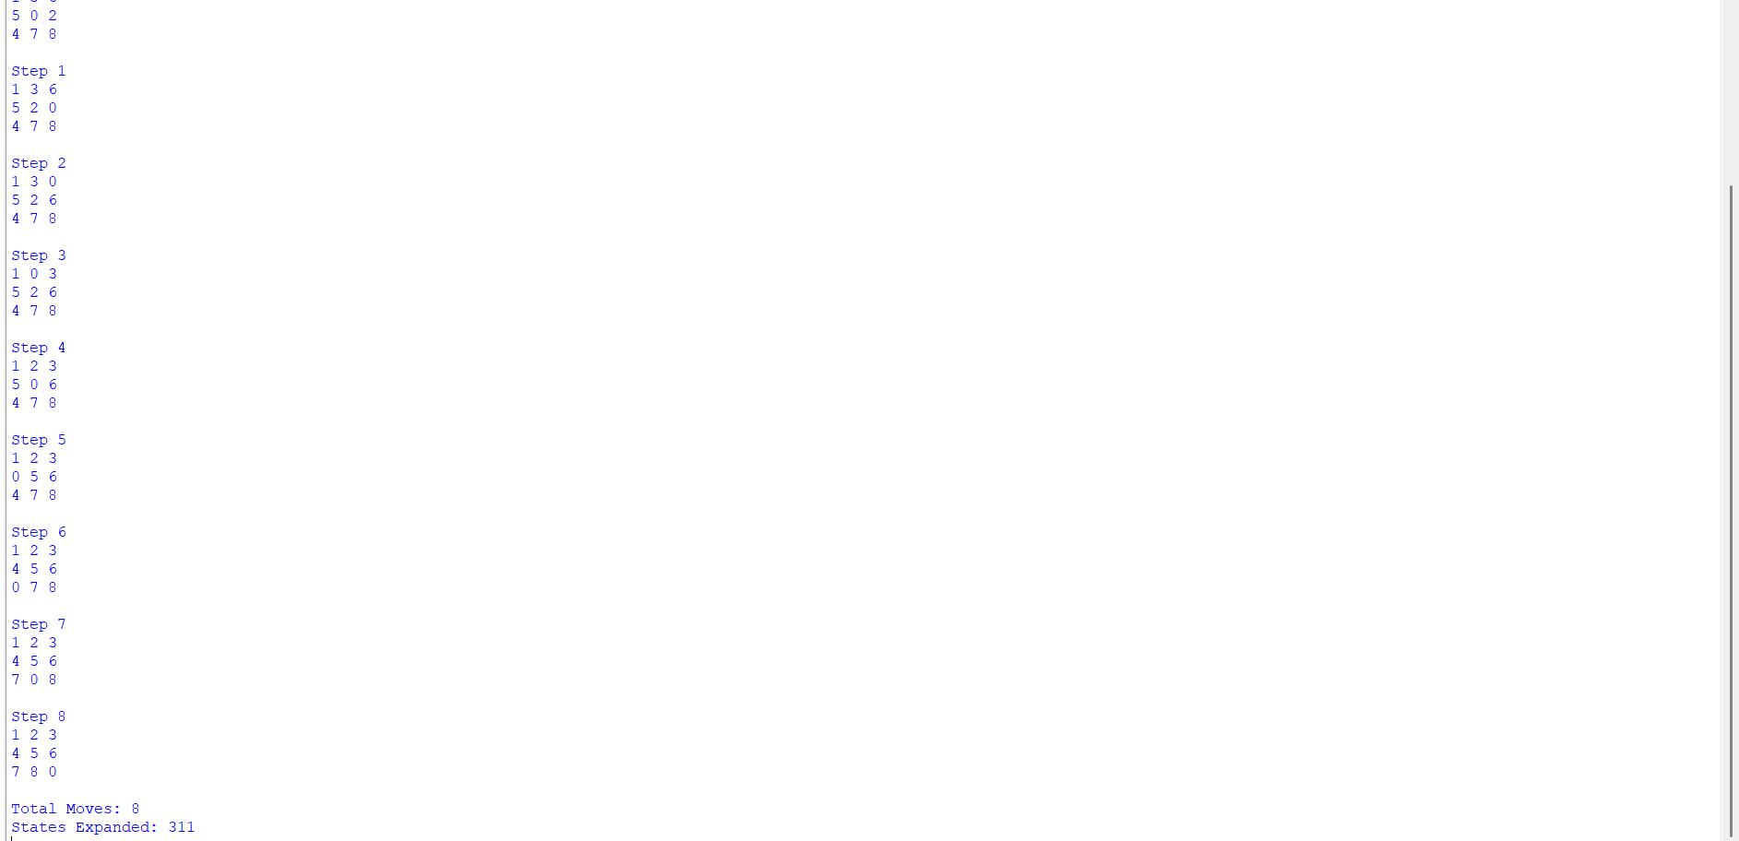

PYTHON CODE :

from collections import deque

initial = (1, 3, 6, 5, 0, 2, 4, 7, 8)
goal = (1, 2, 3, 4, 5, 6, 7, 8, 0)

moves = {
0: [1, 3],
1: [0, 2, 4],
2: [1, 5],
3: [0, 4, 6],
4: [1, 3, 5, 7],
5: [2, 4, 8],
6: [3, 7],
7: [4, 6, 8],
8: [5, 7]
}

def bfs():
queue = deque([(initial, [initial])])
visited = {initial}

while queue:
state, path = queue.popleft()

if state == goal:
print("Goal reached!")
print("Number of moves:", len(path) - 1)

print("\nSolution Path:")
for step in path:
print()
for i in range(0, 9, 3):
print(step[i:i+3])

return

blank = state.index(0)

for position in moves[blank]:

new_state = list(state)

new_state[blank], new_state[position] = \
new_state[position], new_state[blank]

new_state = tuple(new_state)

if new_state not in visited:
visited.add(new_state)
queue.append((new_state, path + [new_state]))

bfs()

OUTPUT :

