SIMATS ENGINEERING (SAVEETHA SCHOOL OF ENGINEERING)
Department of Computer Science and Engineering ASSESSMENT TOOL 1 – Coding Challenge Task

Course Code: | CSA06 | Course Title: | Design and Analysis of Algorithms
CO Assessed: | CO4: Articulation (BL4, BL5) | Assessment: | Assessment Tool 1 – Coding Challenge Task
Weightage: | 40% of CIA | Total Marks: | 100
CO4 Statement: | Solve optimization problems using dynamic programming and greedy strategies.
Student Name: | Shyam sundhar Y | Reg. No.: | 192424082
Section / Batch: | SLOT B | Date: | 19.08.2026

Instructions to Students
- Answer the following question. Total Marks: 100.
- Carefully analyze the given questions.
- Write clear code for the given problem.
- Analyze the Time complexity and Space complexity of your code using dynamic programming and greedy strategies

Question Type | Focus Area | Questions
Coding Challenge Task | Focus on Code and analyze optimization problems using dynamic programming and greedy strategies | Q1

SECTION A – Coding Challenge Task


Shyam sundhar

Code

of
Conduct

I
Shyam sundhar
(
Name / Reg No) certify that this submission is my original work and that I have adhered

to

the

guidelines

specified

for

this

assessment.

I

understand

that

any

violation

of

academic

integrity

rules

will result in disciplinary action.

Signature of the

Student:

RUBRICS FOR CALCULATION

Coding Challenge Task

Criteria | Weightage | Level 4 (Exemplary) | Level 3 (Proficient) | Level 2 (Developing) | Level 1 (Beginning)
Problem  Understanding | 20% | Clearly understands problem constraints, edge cases, and competitive requirements | Understands problem with  minor gaps in constraints | Partial understanding; misses key constraints | Misinterprets problem or constraints
Algorithm | 25% | Selects optimal algorithm with best time and space complexity for  competitive constraints | Uses efficient algorithm with minor scope for improvement | Uses basic/inefficient approach | No clear algorithmic approach
Code Implementation | 20% | Writes correct, efficient, and clean  code that passes all constraints | Code works with minor errors or inefficiencies | Partially correct code; fails for some  cases | Code does not execute or gives incorrect results
Competitive  Performance | 20% | Solves problem within time limits and  handles large inputs effectively | Solves within acceptable time with minor delays | Struggles with time limits or larger inputs | Unable to solve within time constraints
Test Case Handling | 15% | Handles all test cases including edge and hidden cases | Handles most test cases | Misses important edge cases | Fails on multiple test cases

Marks Evaluation:
Level 4
Criteria Wt. – Level 3 – Level 2 – Level 1 –
Exemplary Proficient Developing Beginning
 | Problem Understanding | 20%
 | Algorithm | 25%
 | Code Implementation | 20%
 | Competitive Performance | 20%
 | Test Case Handling | 15%
 | Total Marks (100):
Faculty In-charge | Course Coordinator | Head of Department
Name: | Name: | Name:
Signature: | Signature: | Signature:
Date: | Date: | Date:

CO4-AT1
Coding Challenge Task

NAME: S.SRI MATHI
REG.NO: 192424095
COURSE CODE: CSA0603
COURSE NAME: DESIGN AND ANALYSIS OF ALGORITHM
DATE: 19.08.2026

Q35. Minimum Path Sum in Triangle
A triangle of numbers is given, and the goal is to find the minimum path sum from top to bottom. At each step, you may move to adjacent numbers in the next row. The objective is to determine the minimum total sum. Use Dynamic Programming to solve efficiently.
Sample Input:
triangle =
2
3 4
6 5 7
Expected Output: Min Sum = 10

Minimum Path Sum in Triangle

Aim
To implement the Minimum Path Sum in a Triangle problem using Dynamic Programming and visualize the step-by-step computation to find the minimum sum path from the top to the bottom of the triangle.

Objective
- To understand the concept of Dynamic Programming.
- To find the minimum possible path sum from the top to the bottom of a number triangle.
- To use a bottom-up DP approach to solve the problem efficiently.
- To store previously calculated results and avoid repeated calculations.
- To identify and display the actual minimum path.
- To provide an interactive visualization using Back, Play/Pause, and Next controls.

Minimum Path Sum in Triangle
Minimum Path Sum in Triangle is an optimization problem where the goal is to find the path from the top to the bottom of a number triangle with the minimum total sum.
At each step, we can move to either of the two adjacent numbers in the next row.
Example:
2
/ \
3 4
/ \ / \
6 5 7
The minimum path is:
2 → 3 → 5 = 10
Dynamic Programming is used by solving the problem bottom-up. For each element, we add its value to the smaller of its two children:
DP[i][j] = triangle[i][j] + min(DP[i+1][j], DP[i+1][j+1])
This avoids repeated calculations and efficiently finds the minimum path sum. Algorithm
Input: A triangle of numbers.
Output: Minimum path sum from top to bottom.
Step 1: Read the triangle.

Step 2: Copy the triangle into a DP table.

Step 3: Start from the second-last row.

Step 4: For every element in the current row: a. Get its two children.
- Find the minimum of the two children.
- Add this minimum to the current element.
- Store the result in DP.

Step 5: Move to the previous row.

Step 6: Repeat until the top row is reached.

Step 7: The top DP value is the minimum path sum.

Step 8: Trace the minimum child at each level to find the actual minimum path.

Step 9: Display the minimum path and minimum sum.

Pseudocode
MINIMUM_PATH_SUM(triangle)

dp ← copy of triangle

for i ← last row - 1 down to 0

for j ← 0 to length(triangle[i]) - 1

dp[i][j] ← triangle[i][j] + min(dp[i+1][j], dp[i+1][j+1])

minimum_sum ← dp[0][0]

return minimum_sum

Path Reconstruction
i ← 0 j ← 0 path ← triangle[0][0]

while i < last row

if dp[i+1][j] <= dp[i+1][j+1] choose left child else choose right child

move to next row add selected value to path

return path

Output
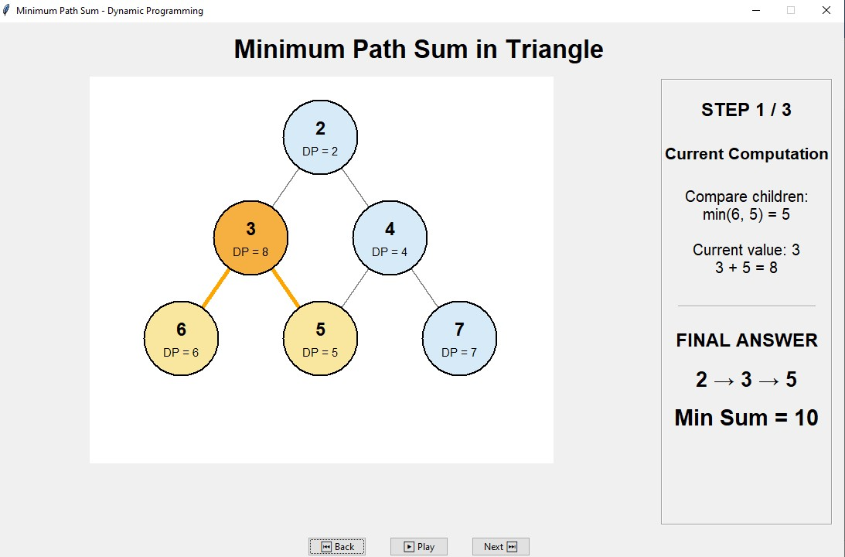

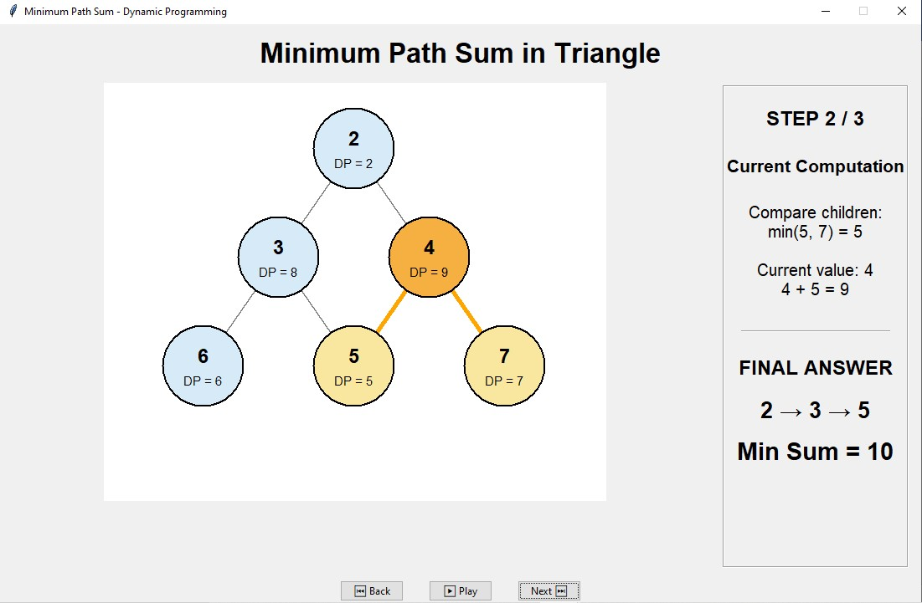
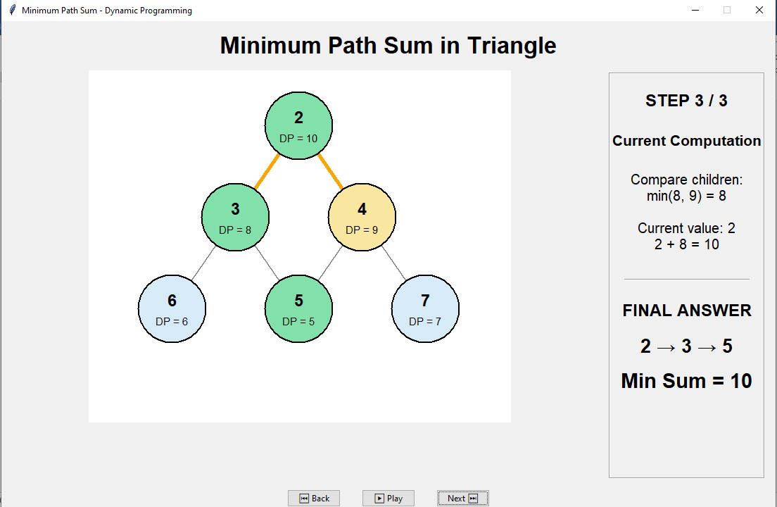

Conclusion
The Minimum Path Sum in Triangle was successfully solved using the Dynamic Programming technique. The bottom-up approach calculates the minimum cost for each position by choosing the smaller of its two adjacent children. This avoids unnecessary repeated calculations and efficiently obtains the minimum path sum.
For the given input, the minimum path is:
2 → 3 → 5 and the minimum path sum is:
10
The interactive visualization makes the DP process easier to understand by displaying each computation step and allowing the user to move backward, forward, or play/pause the process.

