7/13/2026
Activity 3
DSA0601-Data Handling And Visulaization
R SAI HASNIKA
192424178
Activity 1: Heatmap – Student Performance Analysis
Question
Student Marks
\ | Mathematics | Physics | Chemistry | Programming | English
S1 | 92 | 88 | 84 | 95 | 81
S2 | 76 | 72 | 69 | 80 | 74
S3 | 81 | 78 | 83 | 85 | 79
S4 | 65 | 70 | 68 | 72 | 75
S5 | 90 | 94 | 91 | 96 | 89
S6 | 58 | 62 | 60 | 65 | 70
S7 | 84 | 86 | 82 | 88 | 80
S8 | 71 | 75 | 73 | 77 | 72
S9 | 95 | 91 | 93 | 98 | 94
S10 | 79 | 81 | 77 | 83 | 78
Questions
- Construct a Heatmap.
- Identify highest overall performer.
- Find highest average subject.
- Identify students needing support.
- Explain Heatmap advantages.
Python Code
import pandas as pd
import seaborn as sns
import matplotlib.pyplot as plt

data = {
"Mathematics":[92,76,81,65,90,58,84,71,95,79],
"Physics":[88,72,78,70,94,62,86,75,91,81],
"Chemistry":[84,69,83,68,91,60,82,73,93,77],
"Programming":[95,80,85,72,96,65,88,77,98,83],
"English":[81,74,79,75,89,70,80,72,94,78]
}

students=["S1","S2","S3","S4","S5","S6","S7","S8","S9","S10"]

df=pd.DataFrame(data,index=students)

plt.figure(figsize=(8,6))
sns.heatmap(df,annot=True,cmap="Greens",linewidths=0.5,linecolor="white",fmt="d")
plt.title("Student Performance Heatmap")
plt.xlabel("Subjects")
plt.ylabel("Students")
plt.show()

average=df.mean(axis=1)
print("Highest Overall Performer:",average.idxmax())

subject_avg=df.mean()
print("Highest Average Subject:",subject_avg.idxmax())

print("Students Needing Support:")
print(average[average<75])

Output
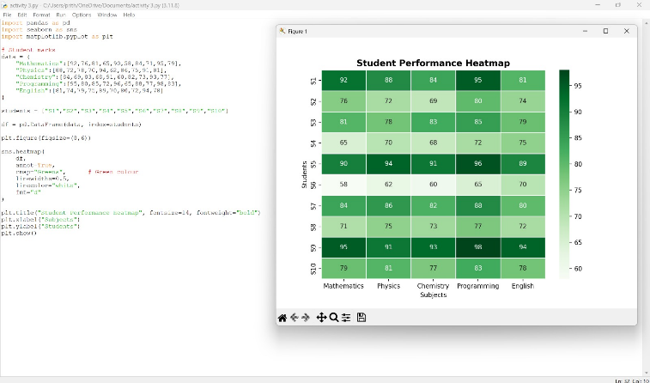

Activity 2: Violin Plot & Boxplot – Employee Salary Analysis
Question
Employee Salary Data
Employee | HR | IT | Finance | Marketing
E1 | 4.2 | 6.5 | 5.8 | 5.1
E2 | 4.5 | 7.0 | 6.2 | 5.3
E3 | 4.7 | 7.4 | 6.0 | 5.5
E4 | 4.1 | 6.8 | 5.9 | 5.4
E5 | 4.6 | 8.2 | 6.7 | 5.8
E6 | 4.3 | 7.6 | 6.4 | 5.6
E7 | 4.8 | 8.5 | 6.9 | 5.9
E8 | 4.4 | 7.1 | 6.1 | 5.2
E9 | 4.9 | 8.8 | 7.2 | 6.0
E10 | 4.5 | 7.3 | 6.3 | 5.4
Questions
- Draw violin plots.
- Construct boxplots.
- Largest variation?
- Highest median?
- Which plot better represents distribution?
Python Code
import pandas as pd
import seaborn as sns
import matplotlib.pyplot as plt

data={
"HR":[4.2,4.5,4.7,4.1,4.6,4.3,4.8,4.4,4.9,4.5],
"IT":[6.5,7.0,7.4,6.8,8.2,7.6,8.5,7.1,8.8,7.3],
"Finance":[5.8,6.2,6.0,5.9,6.7,6.4,6.9,6.1,7.2,6.3],
"Marketing":[5.1,5.3,5.5,5.4,5.8,5.6,5.9,5.2,6.0,5.4]
}

df=pd.DataFrame(data)

plt.figure(figsize=(8,5))
sns.violinplot(data=df,color="#D4A017")
plt.title("Employee Salary - Violin Plot")
plt.show()

plt.figure(figsize=(8,5))
sns.boxplot(data=df,color="#D4A017")
plt.title("Employee Salary - Boxplot")
plt.show()

print("Largest Variation:",(df.max()-df.min()).idxmax())
print("Highest Median:",df.median().idxmax())

Output
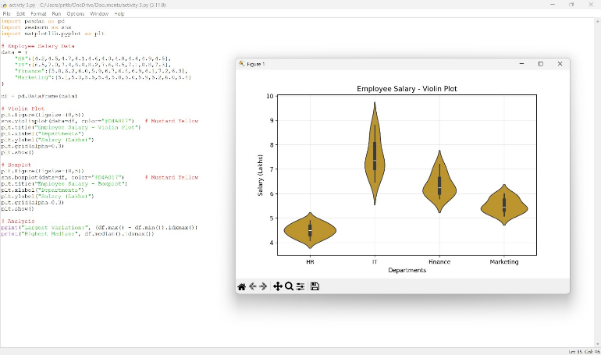

Activity 3: Histogram & Density Plot – Website Response Time
Question
Response Time (ms)
210, 225, 230, 240, 250, 260, 270, 280, 285, 290, 300, 305, 310, 315, 320, 330, 340, 350, 360, 380
Questions
- Draw histogram.
- Plot density.
- Determine skewness.
- Common range.
- Which plot better represents distribution?
Python Code
import pandas as pd
import matplotlib.pyplot as plt
import seaborn as sns

response=[210,225,230,240,250,260,270,280,285,290,300,305,310,315,320,330,340,350,360,380]

df=pd.DataFrame({"Response Time":response})

plt.figure(figsize=(8,5))
plt.hist(df["Response Time"],bins=8,color="#FF00FF",edgecolor="black")
plt.title("Histogram of Website Response Time")
plt.xlabel("Response Time")
plt.ylabel("Frequency")
plt.show()

plt.figure(figsize=(8,5))
sns.kdeplot(df["Response Time"],fill=True,color="#FF00FF")
plt.title("Density Plot")
plt.show()
print("Mean:",df["Response Time"].mean())
print("Median:",df["Response Time"].median())

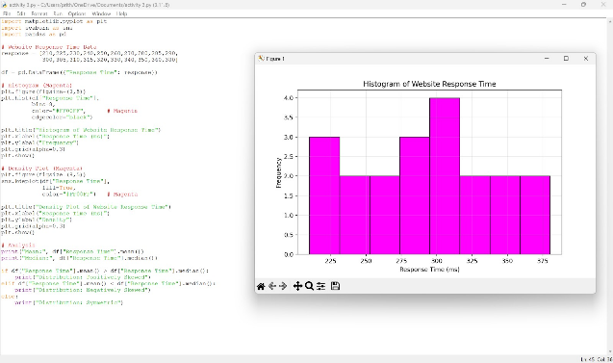
Output

Activity 4: Ridgeline Plot – Electricity Consumption
Question
House | Jan | Feb | Mar | Apr | May
H1 | 220 | 235 | 250 | 275 | 295
H2 | 240 | 245 | 260 | 285 | 305
H3 | 230 | 238 | 255 | 280 | 300
H4 | 215 | 228 | 248 | 270 | 292
H5 | 225 | 240 | 258 | 282 | 298
H6 | 245 | 250 | 265 | 290 | 310
H7 | 235 | 242 | 259 | 284 | 302
H8 | 228 | 236 | 252 | 278 | 297
H9 | 238 | 246 | 262 | 287 | 307
H10 | 232 | 239 | 256 | 281 | 301
Questions
- Create ridgeline plot.
- Highest average month?
- Widest spread?
- Describe trend.
- Why ridgeline?
Python Code
import pandas as pd
import matplotlib.pyplot as plt
import joypy

data={
"Jan":[220,240,230,215,225,245,235,228,238,232],
"Feb":[235,245,238,228,240,250,242,236,246,239],
"Mar":[250,260,255,248,258,265,259,252,262,256],
"Apr":[275,285,280,270,282,290,284,278,287,281],
"May":[295,305,300,292,298,310,302,297,307,301]
}

df=pd.DataFrame(data)

joypy.joyplot(df,figsize=(8,6),color="#A8DADC")
plt.title("Ridgeline Plot - Electricity Consumption")
plt.show()

print(df.mean())
print("Highest Average Month:",df.mean().idxmax())
print("Widest Spread:",(df.max()-df.min()).idxmax())

Output

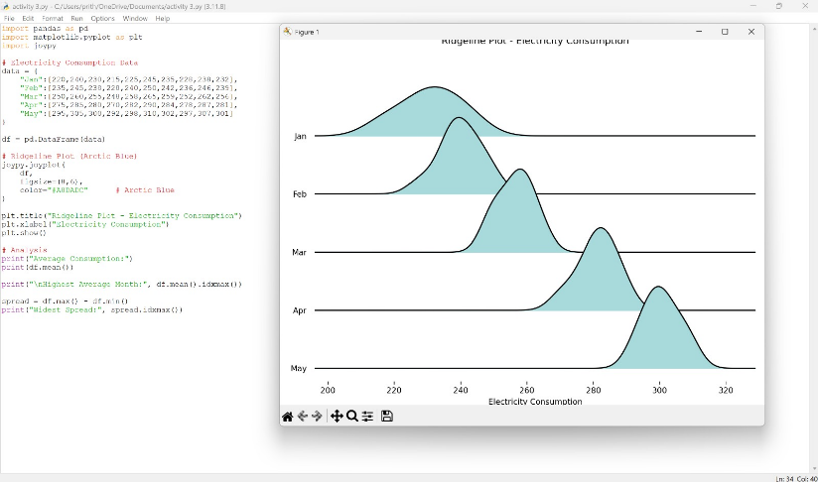

Activity 5: Histogram, Density & Boxplot – Daily Steps
Question
Person | 20–30 | 31–45 | 46–60
P1 | 9500 | 8200 | 6500
P2 | 10200 | 8600 | 6700
P3 | 9800 | 8400 | 6900
P4 | 11000 | 9000 | 7200
P5 | 10500 | 8900 | 7000
P6 | 9700 | 8500 | 6800
P7 | 10100 | 8700 | 7100
P8 | 10800 | 9100 | 7300
P9 | 11200 | 9200 | 7400
P10 | 9900 | 8600 | 6950
Questions
- Draw histograms.
- Plot density curves.
- Create boxplots.
- Highest median group?
- Best visualization and justify.
Python Code
import pandas as pd
import matplotlib.pyplot as plt
import seaborn as sns

data={
"20-30":[9500,10200,9800,11000,10500,9700,10100,10800,11200,9900],
"31-45":[8200,8600,8400,9000,8900,8500,8700,9100,9200,8600],
"46-60":[6500,6700,6900,7200,7000,6800,7100,7300,7400,6950]
}

df=pd.DataFrame(data)

slate="#708090"

for col in df.columns:
plt.figure(figsize=(6,4))
plt.hist(df[col],bins=5,color=slate,edgecolor="black")
plt.title("Histogram - "+col)
plt.show()

plt.figure(figsize=(8,5))
for col in df.columns:
sns.kdeplot(df[col],label=col,color=slate)

plt.legend()
plt.title("Density Curves")
plt.show()

plt.figure(figsize=(8,5))
sns.boxplot(data=df,color=slate)
plt.title("Boxplot")
plt.show()

print(df.median())
print("Highest Median Group:",df.median().idxmax())

Output
