Name: R.Sai Hasnika-192424178

Question 1 – Empirical Cumulative Distribution Function (ECDF) Scenario
A teacher recorded the marks of students in a Data Science quiz. The teacher wants to determine the cumulative proportion of students scoring at or below a given mark.

Dataset

Student | Marks
S1 | 45
S2 | 52
S3 | 58
S4 | 60
S5 | 65
S6 | 68
S7 | 72
S8 | 75
S9 | 80
S10 | 90

Question
Construct the Empirical Cumulative Distribution Function (ECDF) for the above dataset. Calculate the cumulative probability for each observation and interpret the ECDF plot.
Code:
# Student Marks
marks <- c(45, 52, 58, 60, 65, 68, 72, 75, 80, 90)
# Create ECDF
F <- ecdf(marks)
# Plot ECDF
plot(F,
main = "Empirical Cumulative Distribution Function (ECDF)",
xlab = "Marks",
ylab = "Cumulative Probability",
verticals = TRUE,
do.points = TRUE,
pch = 19,
col = "blue",
lwd = 2)
# Add grid
grid()
# Display cumulative probabilities
result <- data.frame(
Student = paste0("S", 1:10),
Marks = marks,
ECDF = F(marks)
)
print(result)
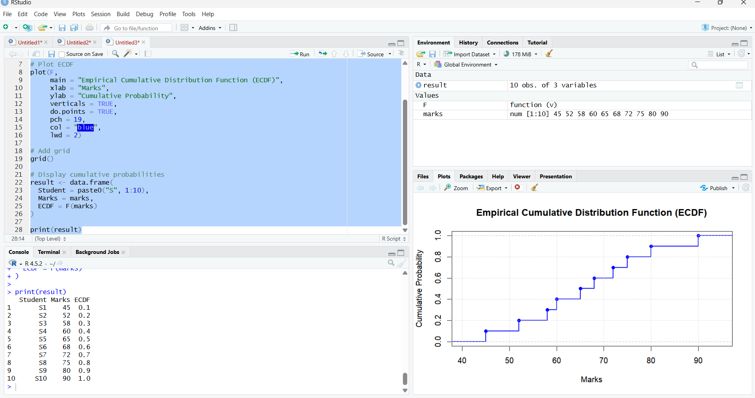

Question 2 – Empirical Cumulative Distribution Function (ECDF) Scenario
A fitness trainer recorded the number of daily steps completed by ten participants during a health challenge.

Dataset

Participant | Daily Steps
P1 | 4200

Participant | Daily Steps
P2 | 5000
P3 | 5600
P4 | 6100
P5 | 6800
P6 | 7200
P7 | 8100
P8 | 9200
P9 | 10400
P10 | 12000

Question
Using the dataset, create an ECDF plot. Determine the proportion of participants who walked 8,000 steps or fewer and explain the significance of the ECDF.
Code:
# Daily steps dataset
steps <- c(4200, 5000, 5600, 6100, 6800, 7200, 8100, 9200, 10400, 12000)
# Create ECDF
ecdf_fun <- ecdf(steps)
# Plot ECDF
plot(ecdf_fun,
main = "Empirical Cumulative Distribution Function (ECDF)",
xlab = "Daily Steps",
ylab = "Cumulative Probability",
col = "blue",
lwd = 2,
verticals = TRUE,
do.points = TRUE,
pch = 19)
# Add grid
grid()
# Calculate cumulative probabilities
participants <- paste0("P", 1:10)
ecdf_values <- ecdf_fun(steps)

# Display table
result <- data.frame(
Participant = participants,
Daily_Steps = steps,
ECDF = ecdf_values
)
print(result)
# Proportion of participants with 8000 steps or fewer
prop_8000 <- ecdf_fun(8000)
cat("\nProportion of participants who walked 8000 steps or fewer =", prop_8000, "\n")
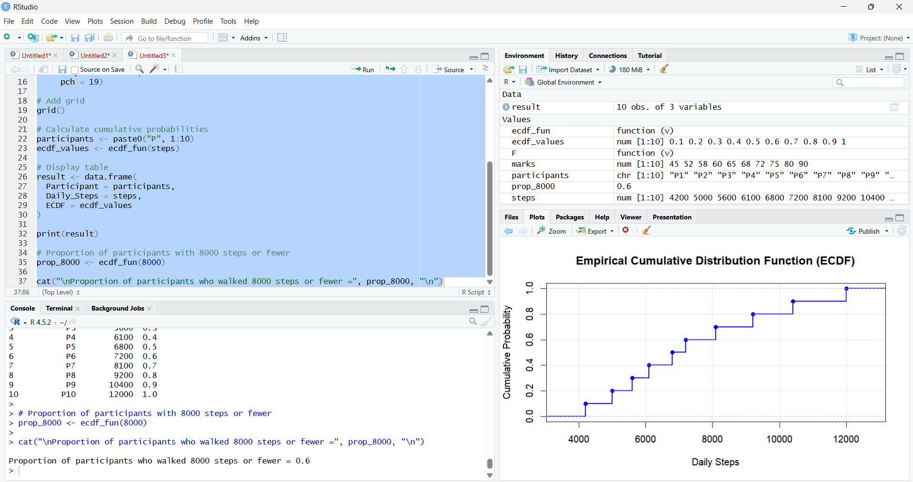

Question 3 – Highly Skewed Distribution (Histogram and Density Plot) Scenario
An online shopping company recorded the purchase amount (₹) made by customers during a promotional sale. Most customers purchased inexpensive items, while a few made very expensive purchases.

Dataset

Customer | Purchase Amount (₹)
C1 | 250
C2 | 300
C3 | 320
C4 | 350
C5 | 380
C6 | 450

Customer | Purchase Amount (₹)
C7 | 520
C8 | 650
C9 | 1800
C10 | 5200

Question
Create a Histogram and a Density Plot for the purchase amounts. Determine whether the distribution is positively skewed or negatively skewed, and justify your answer.
Code:
# Purchase amount dataset
purchase <- c(250, 300, 320, 350, 380, 450, 520, 650, 1800, 5200)
# Show summary statistics
cat("Mean =", mean(purchase), "\n")
cat("Median =", median(purchase), "\n")
# Display plots side by side
par(mfrow = c(1, 2))
# Histogram
hist(purchase,
main = "Histogram of Purchase Amounts",
xlab = "Purchase Amount (Rs)",
ylab = "Frequency",
col = "lightblue",
border = "blue")
# Density Plot
plot(density(purchase),
main = "Density Plot of Purchase Amounts",
xlab = "Purchase Amount (Rs)",
ylab = "Density",
col = "red",
lwd = 2)
# Add rug marks for observations
rug(purchase)
# Reset plotting layout
par(mfrow = c(1, 1))
# Determine skewness
if(mean(purchase) > median(purchase)) {
cat("\nThe distribution is positively (right) skewed.\n")
} else {
cat("\nThe distribution is negatively (left) skewed.\n")
}

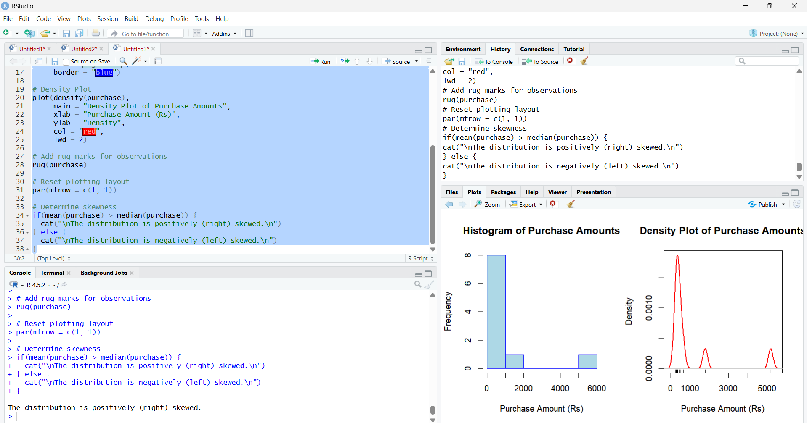

Question 4 – Quantile-Quantile (Q-Q) Plot Scenario
A hospital administrator collected the waiting times (in minutes) for patients in the
outpatient department and wants to verify whether the data follows a normal distribution.

Dataset

Patient | Waiting Time (minutes)
P1 | 12
P2 | 15
P3 | 18
P4 | 20
P5 | 22
P6 | 24
P7 | 25
P8 | 28
P9 | 30
P10 | 32

Question

Construct a Normal Q-Q Plot using the waiting time data. Based on the plot, determine whether the waiting times approximately follow a normal distribution.
Code:
# Waiting Time Dataset
waiting_time <- c(12, 15, 18, 20, 22, 24, 25, 28, 30, 32)
# Display Dataset
patient <- paste0("P", 1:10)
data <- data.frame(Patient = patient, Waiting_Time = waiting_time)
print(data)
# Create Normal Q-Q Plot
qqnorm(waiting_time,
main = "Normal Q-Q Plot of Waiting Times",
xlab = "Theoretical Quantiles",
ylab = "Sample Quantiles",
pch = 19,
col = "blue")
# Add Reference Line
qqline(waiting_time,
col = "red",
lwd = 2)
# Interpretation
cat("\nInterpretation:\n")
if(shapiro.test(waiting_time)$p.value > 0.05){
cat("The waiting times approximately follow a normal distribution.\n")
} else {
cat("The waiting times do not follow a normal distribution.\n")
}
# Display Shapiro-Wilk Test Result
cat("\nShapiro-Wilk Test\n")
print(shapiro.test(waiting_time))

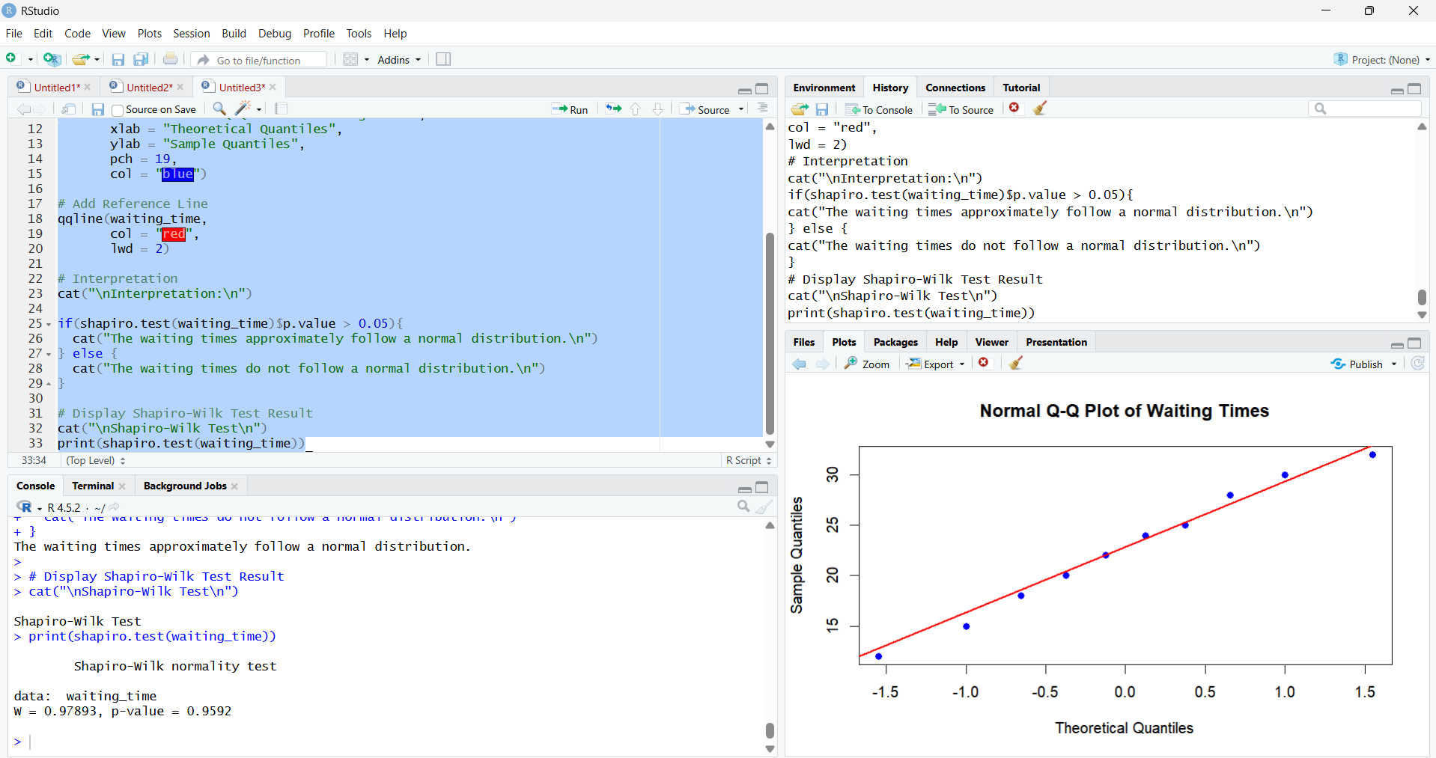

Question 5 – Highly Skewed Distribution and Q-Q Plot Scenario
A bank analyzed the monthly income (₹) of ten customers applying for home loans. A few customers have exceptionally high incomes compared to the majority.

Dataset

Customer | Monthly Income (₹)
C1 | 18000
C2 | 22000
C3 | 24000
C4 | 26000
C5 | 28000
C6 | 30000
C7 | 34000
C8 | 42000
C9 | 85000
C10 | 200000

Question
- Plot a Histogram of the monthly income data.
- Generate a Normal Q-Q Plot.
- Determine whether the income data is normally distributed or highly skewed.
- Explain how the Q-Q plot supports your conclusion.
# Monthly Income Dataset
income <- c(18000, 22000, 24000, 26000, 28000, 30000, 34000, 42000, 85000, 200000)
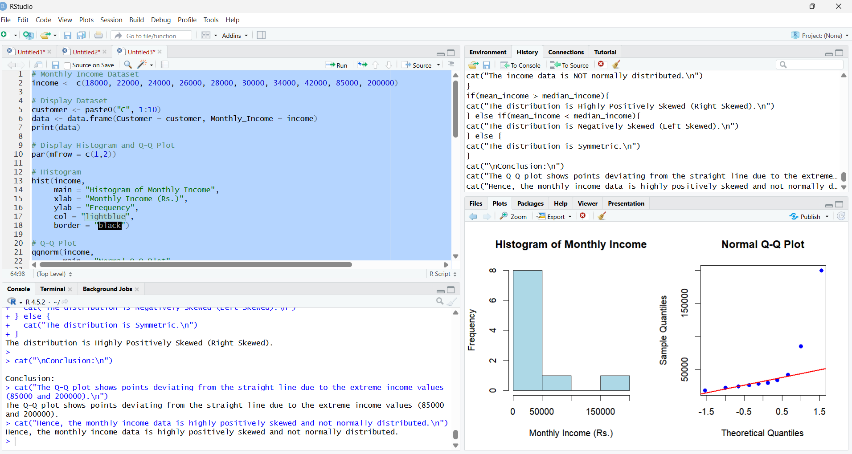
Code:
# Display Dataset
customer <- paste0("C", 1:10)
data <- data.frame(Customer = customer, Monthly_Income = income)
print(data)
# Display Histogram and Q-Q Plot
par(mfrow = c(1,2))
# Histogram
hist(income,
main = "Histogram of Monthly Income",
xlab = "Monthly Income (Rs.)",
ylab = "Frequency",
col = "lightblue",
border = "black")
# Q-Q Plot
qqnorm(income,
main = "Normal Q-Q Plot",
pch = 19,
col = "blue")
qqline(income,
col = "red",
lwd = 2)
# Reset plotting window
par(mfrow = c(1,1))
# Mean and Median
mean_income <- mean(income)
median_income <- median(income)
cat("\nMean =", mean_income, "\n")
cat("Median =", median_income, "\n")
# Shapiro-Wilk Test
test <- shapiro.test(income)
cat("\nShapiro-Wilk Test\n")
print(test)
# Interpretation
cat("\nInterpretation:\n")
if(test$p.value > 0.05){
cat("The income data approximately follows a normal distribution.\n")
} else {
cat("The income data is NOT normally distributed.\n")
}
if(mean_income > median_income){
cat("The distribution is Highly Positively Skewed (Right Skewed).\n")
} else if(mean_income < median_income){
cat("The distribution is Negatively Skewed (Left Skewed).\n")
} else {
cat("The distribution is Symmetric.\n")
}
cat("\nConclusion:\n")
cat("The Q-Q plot shows points deviating from the straight line due to the extreme income values (85000 and 200000).\n")
cat("Hence, the monthly income data is highly positively skewed and not normally distributed.\n")

