SET-05

9.Write a Pandas program to create a Pivot table and find the total sale amount region
wise, manager wise, sales man wise.
Code:
import pandas as pd
df = pd.read_csv("sales.csv")
pivot = pd.pivot_table(df,
values="Sale",
index=["Region","Manager","Salesman"],
aggfunc="sum")
print(pivot)
Output:
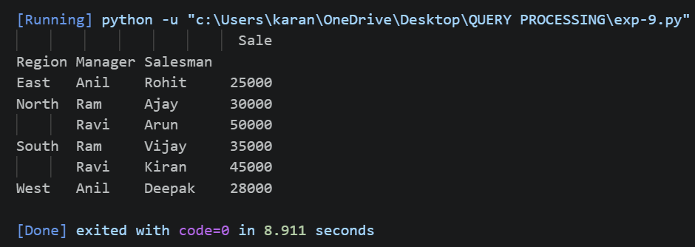
10.Create a dataframe of ten rows, four columns with random values. Write a Pandas
program to highlight the negative numbers red and positive numbers black.
Code:
import pandas as pd
import numpy as np
df = pd.DataFrame(np.random.randint(-50,50,size=(10,4)),
columns=["A","B","C","D"])
def color(val):
if val < 0:
return "color:red"
else:
return "color:black"
print(df)
df.style.applymap(color)
Output:
