17.Write a Pandas program to split the following dataframe by school code and get mean, min, and max value of age for each school.
Code:
import pandas as pd
df = pd.read_csv("school.csv")
result = df.groupby("School_Code")["Age"].agg(["mean","min","max"])
print(result)
Output:
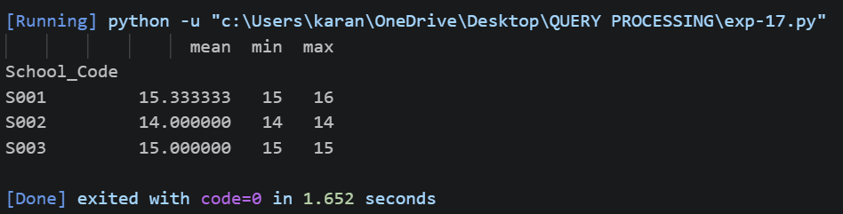
18.Write a Pandas program to split the following given dataframe into groups based on
school code and class.
Code:
import pandas as pd
df = pd.read_csv("school.csv")
group = df.groupby(["School_Code","Class"])
for name,data in group:
print("\nGroup:",name)
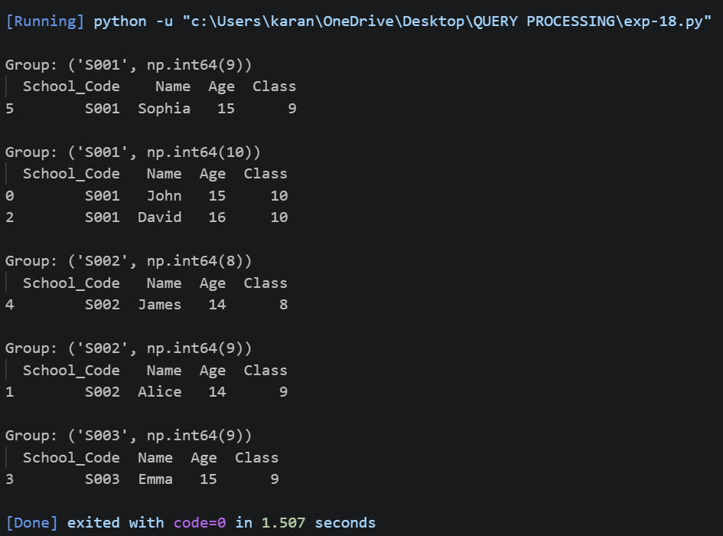
print(data)
Output:

