11.Create a dataframe of ten rows, four columns with random values. Convert some
values to nan values. Write a Pandas program which will highlight the nan values.
Code:
import pandas as pd
import numpy as np
df = pd.DataFrame(np.random.randn(10,4),
columns=["A","B","C","D"])
df.iloc[2,1]=np.nan
df.iloc[5,3]=np.nan
def highlight_nan(x):
return "background-color:yellow" if pd.isna(x) else ""
print(df)
df.style.applymap(highlight_nan)
Output:
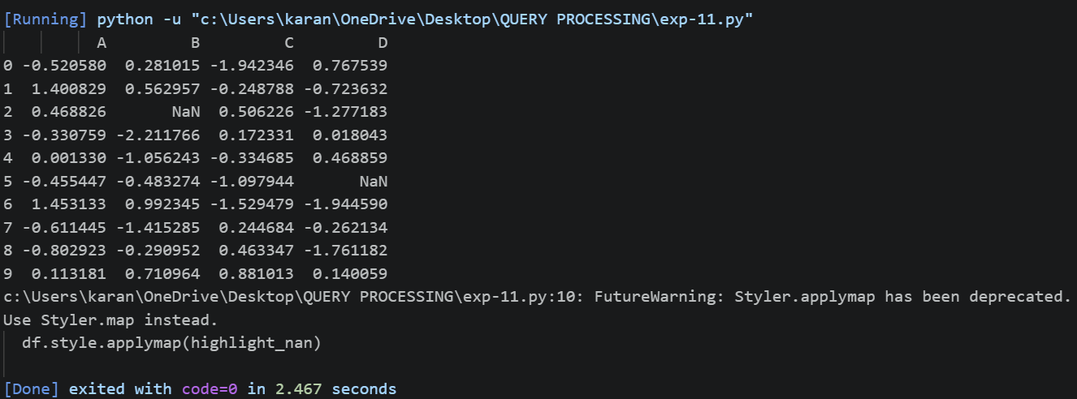
12.Create a dataframe of ten rows, four columns with random values. Write a Pandas
program to set dataframe background Color black and font color yellow.
Code:
import pandas as pd
import numpy as np
df = pd.DataFrame(np.random.randint(1,100,size=(10,4)),
columns=["A","B","C","D"])
print(df)
df.style.set_properties(**{
"background-color":"black",
"color":"yellow"
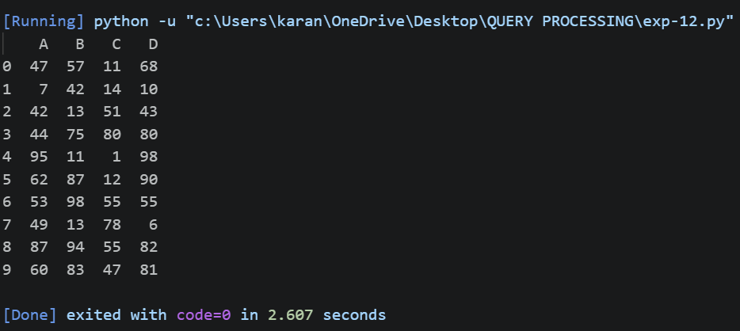
})
Output:

