13.Write a Pandas program to detect missing values of a given DataFrame. Display True
or False.
Code:
import pandas as pd
import numpy as np
data = {
"A":[1,2,np.nan,4],
"B":[5,np.nan,7,8],
"C":[9,10,11,np.nan]
}
df = pd.DataFrame(data)
print(df.isnull())
Output:
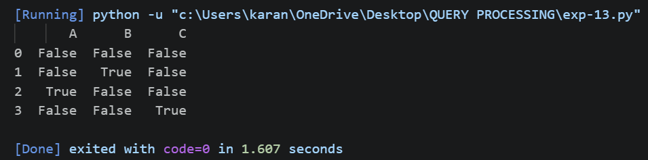
14. Write a Pandas program to find and replace the missing values in a given DataFrame
which do not have any valuable information.
Code:
import pandas as pd
import numpy as np
data = {
"A":[1,2,np.nan,4],
"B":[5,np.nan,7,8],
"C":[9,10,11,np.nan]
}
df = pd.DataFrame(data)
print("Original DataFrame")
print(df)
df = df.fillna(0)
print("\nAfter Replacing NaN")
print(df)
Output:
