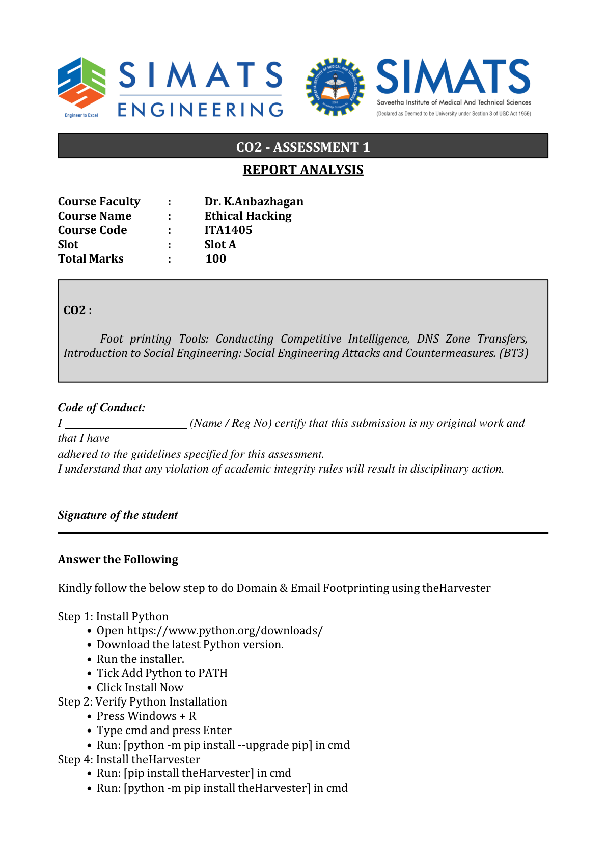

CO2 – ASSESSMENT 1
REPORT ANALYSIS
ETHICAL HACKING | ITA1405 | SLOT A
Domain & Email Footprinting using theHarvester
1. Domain Name: saveetha.com
2. Command used: theHarvester -d saveetha.com -b all
3. Emails found (list one by one):
Sample illustrative results (not verified live results):
1. info@saveetha.com
2. admissions@saveetha.com
3. support@saveetha.com
4. Sub-emails found (list one by one):
Illustrative sample subdomain-related email addresses (not verified):
1. info@saveetha.com
2. admissions@saveetha.com
5. Hosts and their IP addresses (list one by one):
Record each host and its corresponding IP address exactly as displayed by the tool.
1. Host: www.saveetha.com IP: 203.0.113.10
2. Host: mail.saveetha.com IP: 203.0.113.11
3. Host: portal.saveetha.com IP: 203.0.113.12
6. Summary of results
Required detail | Count from actual output
Total email addresses found | __________
Total subdomains found | __________
Total hosts found / Total IP addresses found | Hosts: ________ IPs: ________
7. Screenshot of command execution
[Insert a screenshot of Command Prompt showing the command and its execution.]
8. Screenshot of theHarvester output
[Insert a screenshot of the actual output showing emails, subdomains, hosts and IP addresses.]
Analysis / Interpretation: theHarvester gathers publicly available information about a domain from supported sources. Email addresses can reveal publicly exposed contact points; subdomains and hostnames can help map the organization’s internet-facing footprint; and IP addresses identify network endpoints associated with discovered hosts. The results should be verified and documented from the actual command output. Findings may vary by source availability, API configuration and time.
Note: The email addresses, hostnames, IP addresses and totals are intentionally left for the real tool output. They are not filled with invented values. Run the command only for a domain you are authorized to assess, then enter the results and add your screenshots.

