Exp1: 1: Monthly Sales Data
- R code:
# Dataset
sales <- data.frame(
Month = c("January", "February", "March", "April", "May"),
Sales = c(15000, 18000, 22000, 20000, 23000)
)

# Line Chart
plot(sales$Sales,
type = "o",
xaxt = "n",
xlab = "Month",
ylab = "Sales ($)",
main = "Monthly Sales Trend",
col = "blue",
lwd = 2,
pch = 16)

axis(1,
at = 1:nrow(sales),
labels = sales$Month)
output:
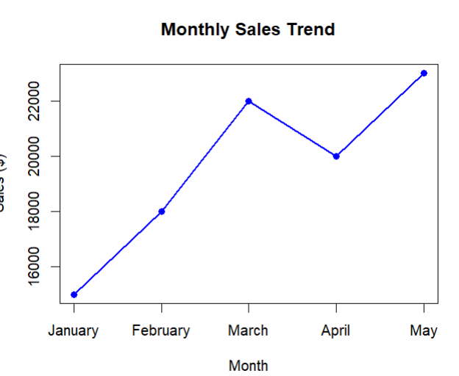
- Generate a Bar Chart for Top-Selling Products
R code:
# Dataset
sales <- data.frame(
Month = c("January", "February", "March", "April", "May"),
Sales = c(15000, 18000, 22000, 20000, 23000)
)

# Bar Chart
barplot(sales$Sales,
names.arg = sales$Month,
col = "skyblue",
xlab = "Month",
ylab = "Sales ($)",
main = "Monthly Sales Comparison")
output:
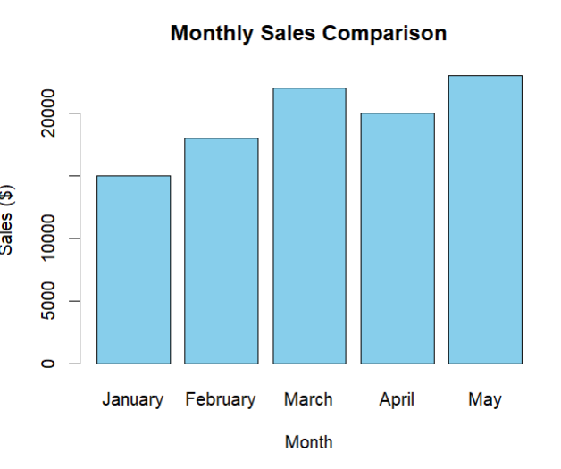
- Scatter Plot Between Advertising Budget and Monthly Sales
R code:
# Dataset
sales <- data.frame(
Month = c("January", "February", "March", "April", "May"),
Sales = c(15000, 18000, 22000, 20000, 23000),
Advertising = c(2000, 2500, 3000, 2800, 3500)
)

# Scatter Plot
plot(sales$Advertising,
sales$Sales,
pch = 19,
col = "red",
xlab = "Advertising Budget ($)",
ylab = "Monthly Sales ($)",
main = "Advertising Budget vs Monthly Sales")

# Regression Line
abline(lm(Sales ~ Advertising, data = sales),
col = "blue",
lwd = 2)
output:
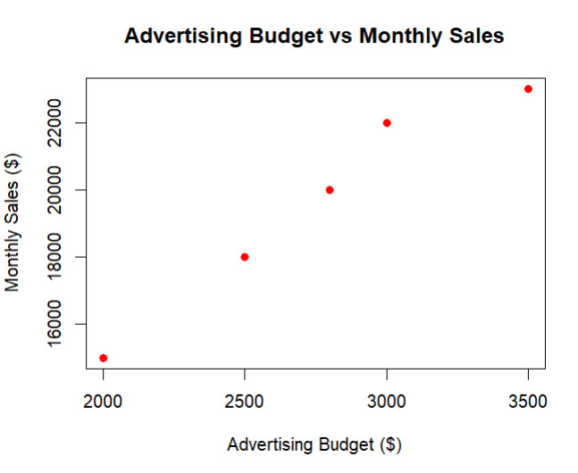
- Interactive Dashboard (Using Shiny)
R code:
library(shiny)

sales <- data.frame(
Month = c("January", "February", "March", "April", "May"),
Sales = c(15000, 18000, 22000, 20000, 23000)
)

ui <- fluidPage(

titlePanel("Monthly Sales Dashboard"),

sidebarLayout(

sidebarPanel(

selectInput("chart",
"Choose Chart:",
choices = c("Line Chart",
"Bar Chart"))

),

mainPanel(

plotOutput("salesPlot")

)

)

)

server <- function(input, output){

output$salesPlot <- renderPlot({

if(input$chart == "Line Chart"){

plot(sales$Sales,
type = "o",
xaxt = "n",
xlab = "Month",
ylab = "Sales ($)",
main = "Monthly Sales Trend",
col = "blue",
lwd = 2)

axis(1,
at = 1:nrow(sales),
labels = sales$Month)

}else{

barplot(sales$Sales,
names.arg = sales$Month,
col = "orange",
xlab = "Month",
ylab = "Sales ($)",
main = "Monthly Sales Comparison")

}

})

}

shinyApp(ui = ui, server = server)
output:
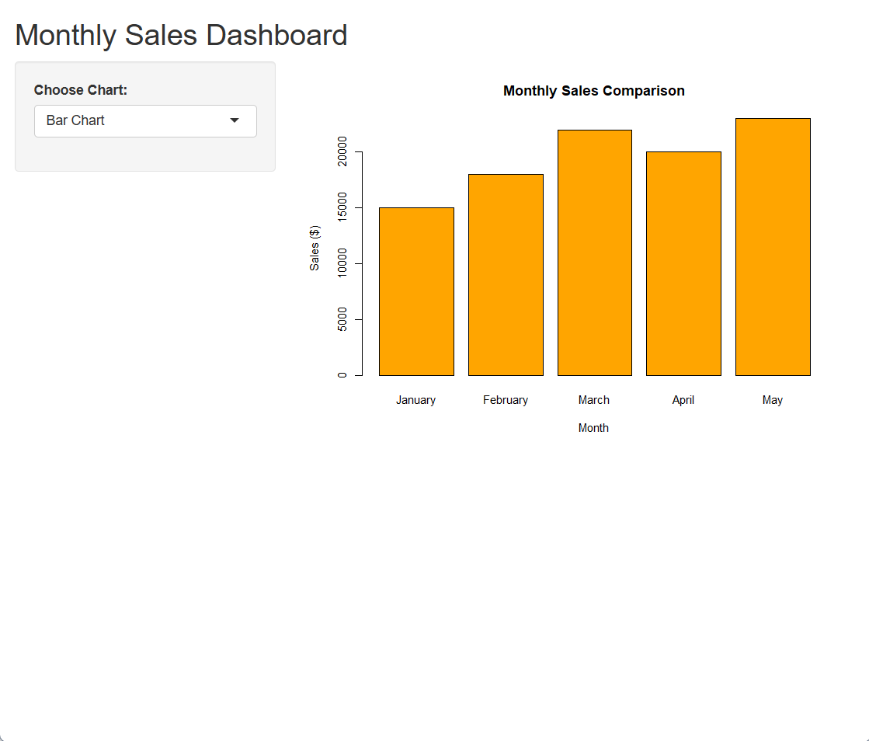
Set 2: Customer Feedback Analysis
- Create a Histogram for Customer Ages
R code:
# Dataset
customer <- data.frame(
CustomerID = c(1, 2, 3, 4, 5),
Age = c(25, 30, 35, 28, 40),
Satisfaction = c(4, 5, 3, 4, 5)
)

# Histogram
hist(customer$Age,
main = "Distribution of Customer Ages",
xlab = "Age",
ylab = "Frequency",
col = "lightblue",
border = "black",
breaks = 5)
output:
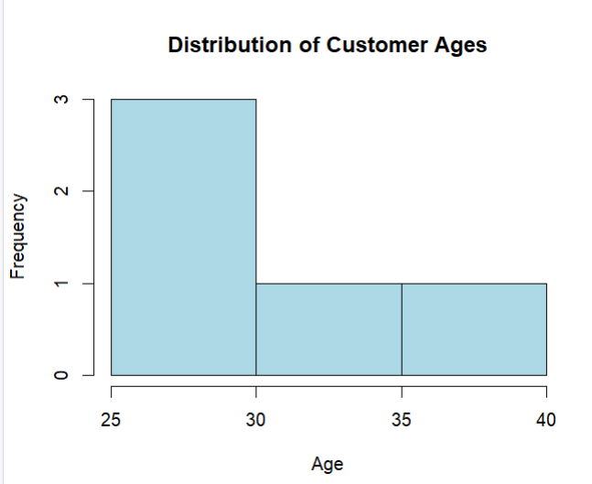
- Generate a Pie Chart for Satisfaction Scores
R code:
customer <- data.frame(
CustomerID = c(1, 2, 3, 4, 5),
Age = c(25, 30, 35, 28, 40),
Satisfaction = c(4, 5, 3, 4, 5)
)

# Count satisfaction scores
score_count <- table(customer$Satisfaction)

# Pie Chart
pie(score_count,
labels = paste(names(score_count), "Stars"),
col = rainbow(length(score_count)),
main = "Customer Satisfaction Scores")
output:
- Create a Stacked Bar Chart by Age Group
R code:
# Dataset
customer <- data.frame(
CustomerID = c(1, 2, 3, 4, 5),
Age = c(25, 30, 35, 28, 40),
Satisfaction = c(4, 5, 3, 4, 5)
)

# Create Age Groups
customer$AgeGroup <- cut(customer$Age,
breaks = c(20, 30, 40, 50),
labels = c("21-30", "31-40", "41-50"))

# Frequency Table
table_data <- table(customer$AgeGroup, customer$Satisfaction)

# Stacked Bar Chart
barplot(table_data,
beside = FALSE,
col = rainbow(ncol(table_data)),
main = "Customer Satisfaction by Age Group",
xlab = "Age Group",
ylab = "Number of Customers")

legend("topright",
legend = colnames(table_data),
fill = rainbow(ncol(table_data)),
title = "Satisfaction Score")
output:
- Create a Word Cloud from Customer Feedback
R code:
library(tm)
library(wordcloud)
library(RColorBrewer)

# Sample Feedback
feedback <- c(
"Excellent service and friendly staff",
"Very satisfied with the product quality",
"Good experience but delivery was slow",
"Excellent customer support",
"Fast delivery and excellent quality"
)

# Create Corpus
corpus <- Corpus(VectorSource(feedback))

# Clean Text
corpus <- tm_map(corpus, content_transformer(tolower))
corpus <- tm_map(corpus, removePunctuation)
corpus <- tm_map(corpus, removeNumbers)
corpus <- tm_map(corpus, removeWords, stopwords("english"))

# Create Word Cloud
wordcloud(
words = unlist(sapply(corpus, as.character)),
max.words = 50,
random.order = FALSE,
colors = brewer.pal(8, "Dark2")
)
Output:

Set 3: Employee Performance Evaluation
- Create a Line Chart for Employee Performance Trend

R code:
# Dataset
employee <- data.frame(
EmployeeID = c(1, 2, 3, 4, 5),
Department = c("Sales", "HR", "Marketing", "Sales", "HR"),
YearsService = c(5, 3, 7, 4, 2),
Performance = c(85, 92, 78, 90, 76)
)

# Line Chart
plot(employee$YearsService,
employee$Performance,
type = "o",
col = "blue",
pch = 16,
lwd = 2,
xlab = "Years of Service",
ylab = "Performance Score",
main = "Employee Performance Trend")

legend("topright",
legend = "Performance",
col = "blue",
lty = 1,
pch = 16)
output:
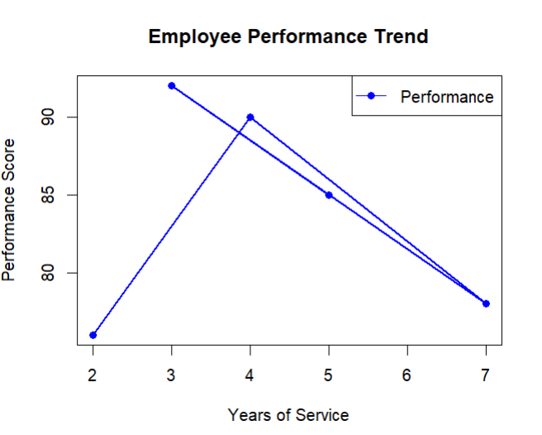

- Generate a Bar Chart Showing Employees Across Departments
R code:
R code:
# Dataset
employee <- data.frame(
EmployeeID = c(1, 2, 3, 4, 5),
Department = c("Sales", "HR", "Marketing", "Sales", "HR"),
YearsService = c(5, 3, 7, 4, 2),
Performance = c(85, 92, 78, 90, 76)
)

# Line Chart
plot(employee$YearsService,
employee$Performance,
type = "o",
col = "blue",
pch = 16,
lwd = 2,
xlab = "Years of Service",
ylab = "Performance Score",
main = "Employee Performance Trend")

legend("topright",
legend = "Performance",
col = "blue",
lty = 1,
pch = 16)
output:


Output:
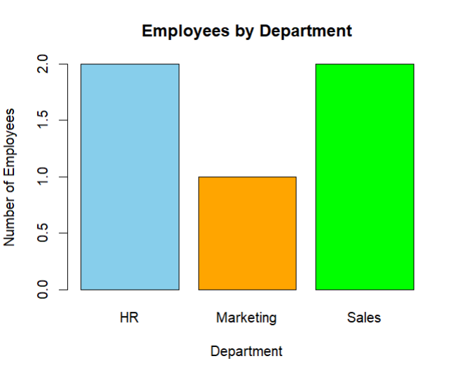
- Create a Scatter Plot for Years of Service vs Performance Score
R code:
# Dataset
employee <- data.frame(
EmployeeID = c(1, 2, 3, 4, 5),
Department = c("Sales", "HR", "Marketing", "Sales", "HR"),
YearsService = c(5, 3, 7, 4, 2),
Performance = c(85, 92, 78, 90, 76)
)

# Scatter Plot
plot(employee$YearsService,
employee$Performance,
pch = 19,
col = "red",
xlab = "Years of Service",
ylab = "Performance Score",
main = "Years of Service vs Performance Score")

# Regression Line
abline(lm(Performance ~ YearsService, data = employee),
col = "blue",
lwd = 2)
output:
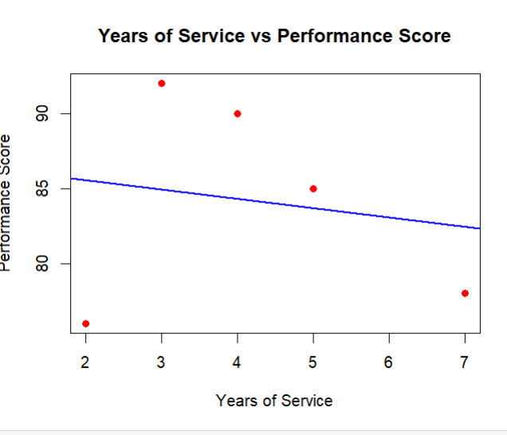
- Interactive Dashboard (Using Shiny)
R code:
library(shiny)

employee <- data.frame(
EmployeeID = c(1, 2, 3, 4, 5),
Department = c("Sales", "HR", "Marketing", "Sales", "HR"),
YearsService = c(5, 3, 7, 4, 2),
Performance = c(85, 92, 78, 90, 76)
)

ui <- fluidPage(

titlePanel("Employee Performance Dashboard"),

sidebarLayout(

sidebarPanel(

selectInput("chart",
"Choose Chart:",
choices = c("Line Chart",
"Bar Chart"))

),

mainPanel(

plotOutput("employeePlot")

)

)

)

server <- function(input, output){

output$employeePlot <- renderPlot({

if(input$chart == "Line Chart"){

plot(employee$YearsService,
employee$Performance,
type = "o",
col = "blue",
pch = 16,
lwd = 2,
xlab = "Years of Service",
ylab = "Performance Score",
main = "Employee Performance Trend")

legend("topright",
legend = "Performance",
col = "blue",
lty = 1,
pch = 16)

}else{

dept_count <- table(employee$Department)

barplot(dept_count,
col = c("skyblue", "orange", "green"),
xlab = "Department",
ylab = "Number of Employees",
main = "Employees by Department")

}

})

}

shinyApp(ui = ui, server = server)
output: 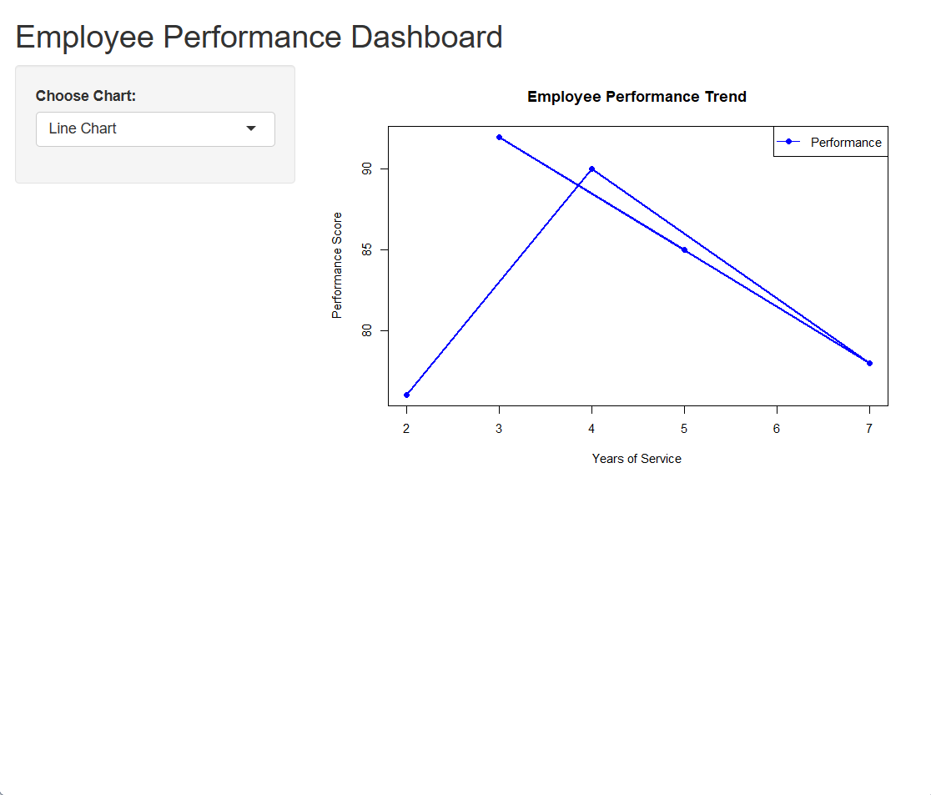
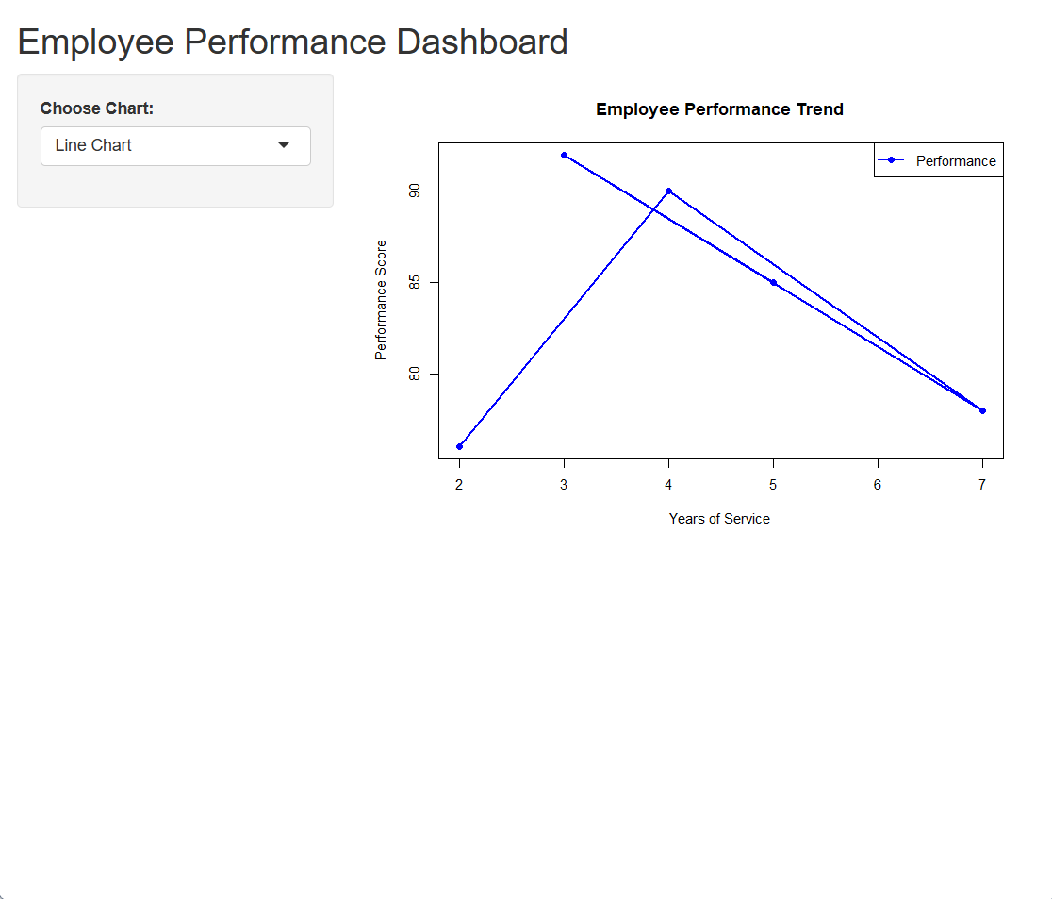
Set 4: Product Inventory Management
- Create a Bar Chart for Product Inventory
R code: # Dataset
inventory <- data.frame(
ProductID = c(1, 2, 3, 4, 5),
ProductName = c("Product A", "Product B", "Product C", "Product D", "Product E"),
Quantity = c(250, 175, 300, 200, 220)
)

# Bar Chart
barplot(inventory$Quantity,
names.arg = inventory$ProductName,
col = "skyblue",
xlab = "Product Name",
ylab = "Quantity Available",
main = "Product Inventory")
output:
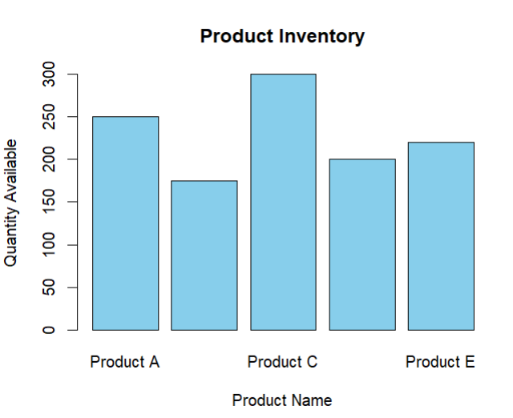
- Generate a Stacked Bar Chart for Product Categories
R code:
# Dataset
inventory <- data.frame(
ProductName = c("Product A", "Product B", "Product C", "Product D", "Product E"),
Quantity = c(250, 175, 300, 200, 220),
Category = c("Electronics", "Electronics", "Furniture", "Furniture", "Furniture")
)

# Create Table
table_data <- xtabs(Quantity ~ Category + ProductName, data = inventory)

# Stacked Bar Chart
barplot(table_data,
beside = FALSE,
col = rainbow(ncol(table_data)),
main = "Product Quantity by Category",
xlab = "Category",
ylab = "Quantity")

legend("topright",
legend = colnames(table_data),
fill = rainbow(ncol(table_data)),
title = "Products")
output:
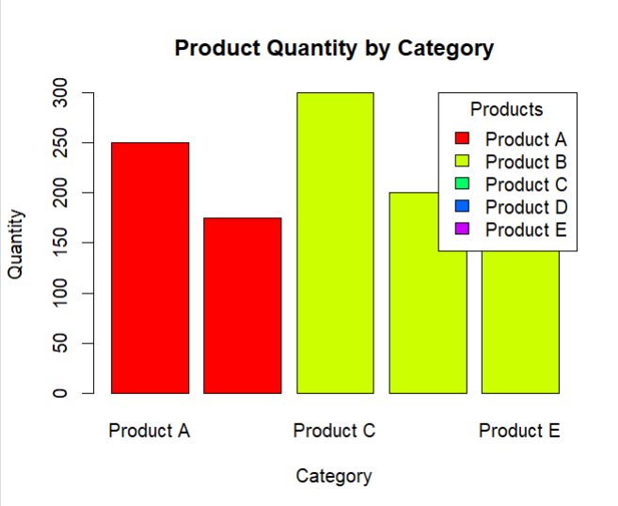
- Create a Scatter Plot for Product Price vs Quantity
R code:
# Dataset
inventory <- data.frame(
ProductName = c("Product A", "Product B", "Product C", "Product D", "Product E"),
Quantity = c(250, 175, 300, 200, 220),
Price = c(100, 150, 80, 120, 90)
)

# Scatter Plot
plot(inventory$Price,
inventory$Quantity,
pch = 19,
col = "red",
xlab = "Product Price ($)",
ylab = "Quantity Available",
main = "Price vs Quantity Available")

# Regression Line
abline(lm(Quantity ~ Price, data = inventory),
col = "blue",
lwd = 2)
output:
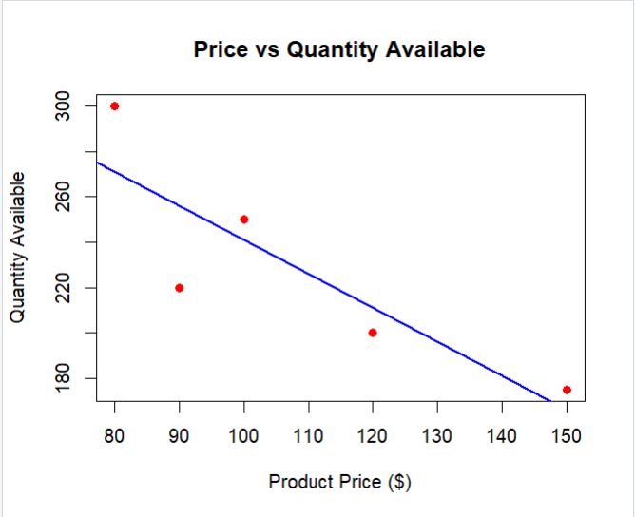
- Interactive Dashboard (Using Shiny)
R code:
library(shiny)

inventory <- data.frame(
ProductID = c(1, 2, 3, 4, 5),
ProductName = c("Product A", "Product B", "Product C", "Product D", "Product E"),
Quantity = c(250, 175, 300, 200, 220),
Category = c("Electronics", "Electronics", "Furniture", "Furniture", "Furniture")
)

ui <- fluidPage(

titlePanel("Product Inventory Dashboard"),

sidebarLayout(

sidebarPanel(

selectInput("chart",
"Choose Chart:",
choices = c("Bar Chart",
"Stacked Bar Chart"))

),

mainPanel(

plotOutput("inventoryPlot")

)

)

)

server <- function(input, output){

output$inventoryPlot <- renderPlot({

if(input$chart == "Bar Chart"){

barplot(inventory$Quantity,
names.arg = inventory$ProductName,
col = "skyblue",
xlab = "Product Name",
ylab = "Quantity Available",
main = "Product Inventory")

}else{

table_data <- xtabs(Quantity ~ Category + ProductName,
data = inventory)

barplot(table_data,
beside = FALSE,
col = rainbow(ncol(table_data)),
main = "Product Quantity by Category",
xlab = "Category",
ylab = "Quantity")

legend("topright",
legend = colnames(table_data),
fill = rainbow(ncol(table_data)),
title = "Products")

}

})

}

shinyApp(ui = ui, server = server)
output:
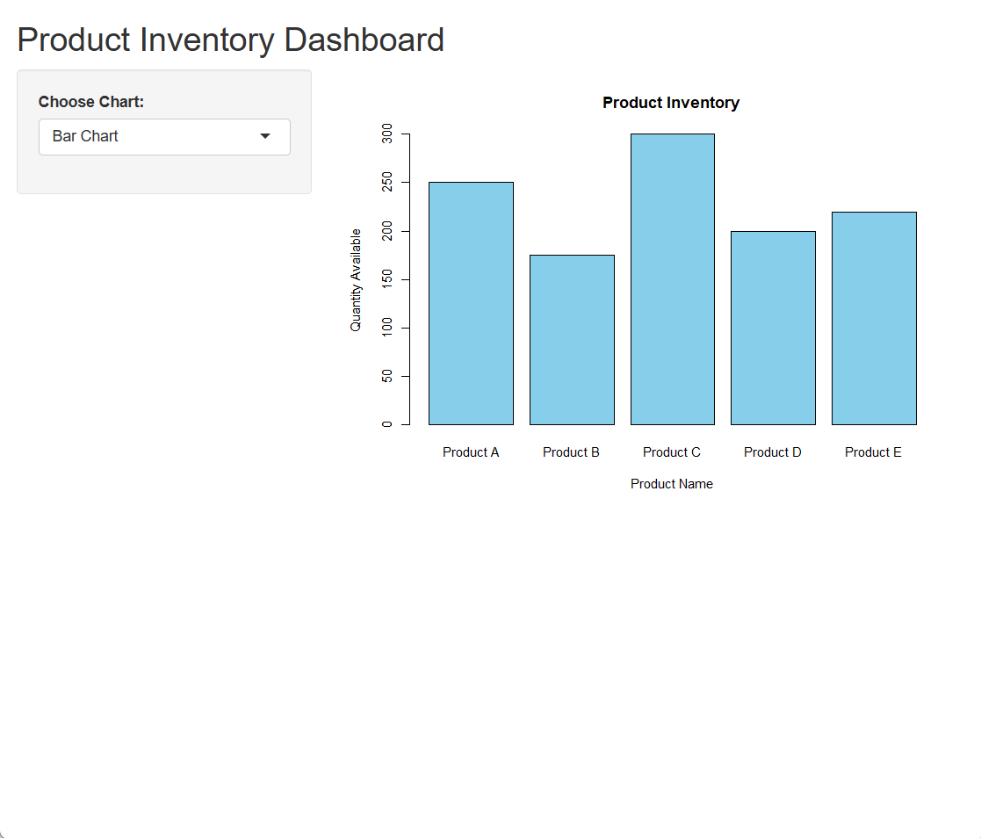
Set 5: Website Analytics
- Create a Line Chart for Daily Page Views
R code:
# Dataset
traffic <- data.frame(
Date = as.Date(c("2023-01-01", "2023-01-02", "2023-01-03",
"2023-01-04", "2023-01-05")),
PageViews = c(1500, 1600, 1400, 1650, 1800),
CTR = c(2.3, 2.7, 2.0, 2.4, 2.6)
)

# Line Chart
plot(traffic$Date,
traffic$PageViews,
type = "o",
col = "blue",
pch = 16,
lwd = 2,
xlab = "Date",
ylab = "Page Views",
main = "Daily Website Page Views")
output:
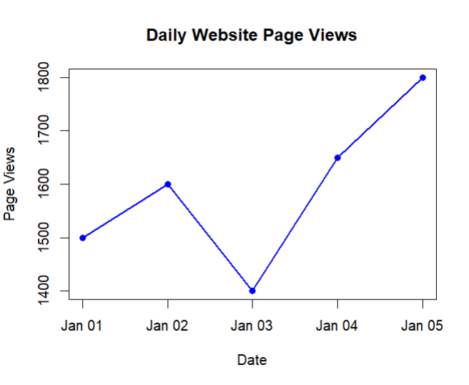
- Generate a Bar Chart for Highest Click-through Rates
R code:
# Dataset
traffic <- data.frame(
Date = c("2023-01-01", "2023-01-02", "2023-01-03",
"2023-01-04", "2023-01-05"),
PageViews = c(1500, 1600, 1400, 1650, 1800),
CTR = c(2.3, 2.7, 2.0, 2.4, 2.6)
)

# Sort by CTR
traffic <- traffic[order(-traffic$CTR), ]

# Bar Chart
barplot(traffic$CTR,
names.arg = traffic$Date,
col = "orange",
xlab = "Date",
ylab = "Click-through Rate (%)",
main = "Top Days by Click-through Rate")
output:
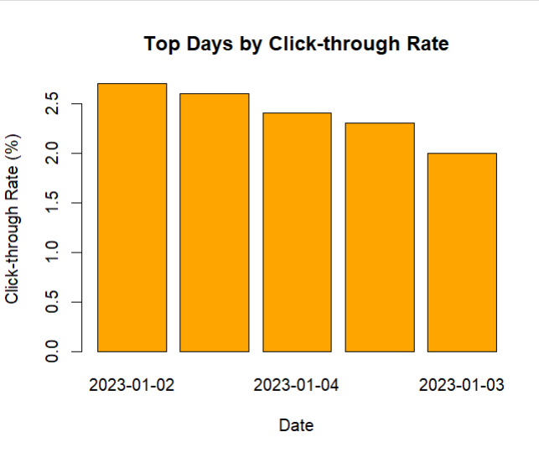
- Create a Stacked Area Chart for User Interactions
R code:
# Sample Dataset
traffic <- data.frame(
Date = as.Date(c("2023-01-01", "2023-01-02", "2023-01-03",
"2023-01-04", "2023-01-05")),
Likes = c(200, 220, 180, 240, 260),
Shares = c(80, 90, 70, 85, 95),
Comments = c(40, 50, 35, 45, 55)
)

# Install package once
install.packages("ggplot2")
install.packages("reshape2")

library(ggplot2)
library(reshape2)

# Convert data to long format
traffic_long <- melt(traffic, id.vars = "Date")

# Stacked Area Chart
ggplot(traffic_long,
aes(x = Date,
y = value,
fill = variable)) +
geom_area() +
labs(title = "User Interactions Over Time",
x = "Date",
y = "Count")
output:
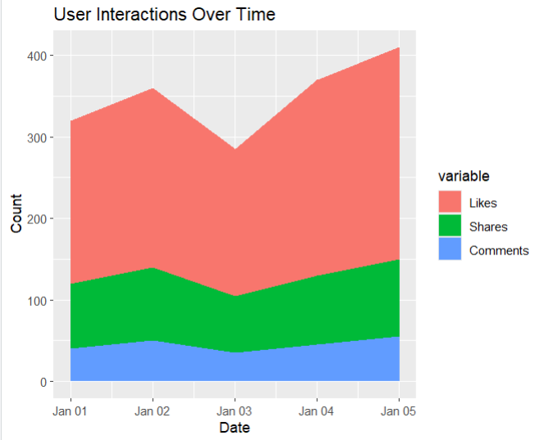
- Interactive Dashboard (Using Shiny)
R code:
library(shiny)

traffic <- data.frame(
Date = as.Date(c("2023-01-01", "2023-01-02", "2023-01-03",
"2023-01-04", "2023-01-05")),
PageViews = c(1500, 1600, 1400, 1650, 1800),
CTR = c(2.3, 2.7, 2.0, 2.4, 2.6)
)

ui <- fluidPage(

titlePanel("Website Analytics Dashboard"),

sidebarLayout(

sidebarPanel(

selectInput("chart",
"Choose Chart:",
choices = c("Line Chart",
"Bar Chart"))

),

mainPanel(

plotOutput("trafficPlot")

)

)

)

server <- function(input, output){

output$trafficPlot <- renderPlot({

if(input$chart == "Line Chart"){

plot(traffic$Date,
traffic$PageViews,
type = "o",
col = "blue",
pch = 16,
lwd = 2,
xlab = "Date",
ylab = "Page Views",
main = "Daily Website Page Views")

}else{

temp <- traffic[order(-traffic$CTR), ]

barplot(temp$CTR,
names.arg = temp$Date,
col = "orange",
xlab = "Date",
ylab = "Click-through Rate (%)",
main = "Top Days by CTR")

}

})

}

shinyApp(ui = ui, server = server)
output:
