EXPERIMENT:4
AIM: To build an Artificial Neural Network (ANN) by implementing the Backpropagation algorithm and test it using an appropriate dataset.
ALGORITHM:
1. Import the required libraries.
2.Load the dataset.
3. Split the dataset into training and testing sets.
4. Normalize the input features.
5. Create an Artificial Neural Network with one hidden layer.
6. Train the network using the Backpropagation algorithm.
7. Test the model using the test data.
8. Display the accuracy and predictions.
PROGRAM:
# Artificial Neural Network using Backpropagation

from sklearn.datasets import load_iris
from sklearn.model_selection import train_test_split
from sklearn.preprocessing import StandardScaler
from sklearn.neural_network import MLPClassifier
from sklearn.metrics import accuracy_score

# Load Iris Dataset
iris = load_iris()

X = iris.data
y = iris.target

# Split dataset
X_train, X_test, y_train, y_test = train_test_split(
X, y, test_size=0.3, random_state=1
)

# Feature Scaling
scaler = StandardScaler()
X_train = scaler.fit_transform(X_train)
X_test = scaler.transform(X_test)

# Build ANN using Backpropagation
model = MLPClassifier(
hidden_layer_sizes=(5,),
activation='logistic',
solver='sgd',
learning_rate_init=0.1,
max_iter=1000,
random_state=1
)

# Train Model
model.fit(X_train, y_train)

# Predict
y_pred = model.predict(X_test)

# Accuracy
accuracy = accuracy_score(y_test, y_pred)

print("Accuracy =", round(accuracy * 100, 2), "%")

print("\nActual Classes:")
print(y_test)

print("\nPredicted Classes:")
print(y_pred)
SAMPLE INPUT:
Iris Dataset
SAMPLE INPUT:
Sepal Length Sepal Width Petal Length Petal Width Class
-----------------------------------------------------------
5.1 3.5 1.4 0.2 Setosa
4.9 3.0 1.4 0.2 Setosa
5.8 2.7 5.1 1.9 Virginica
6.0 2.2 4.0 1.0 Versicolor
SAMPLE OUTPUT:
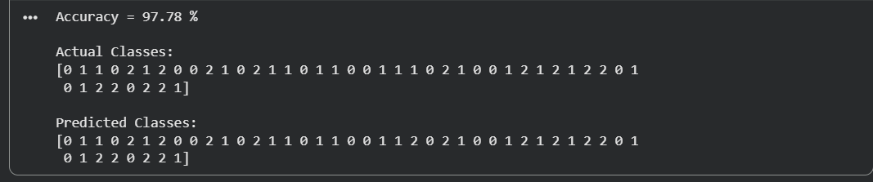
RESULT:
The Artificial Neural Network was successfully built using the Backpropagation algorithm. The model was trained and tested on the Iris dataset, achieving high classification accuracy and correctly predicting the class labels.

